Program Ad Form

There are a variety of investment opportunities with Shakesperience Productions available to you over the coming months! Purchasing an advertisement in one of our two Fall shows (either Radium Girls or The Gift of Peace) will also give you advertising space in our other Fall production. See second page for additional details on individual shows.

 | Full Color | Black & White
Full Page - 7.5”h x 4.5”w | $500 | $300
Half Page - 3.625”h x 4.5”w | $300 | $175
Quarter Page - business card |  | $100

Advertiser: Contact:
Address: City: State: Zip:
Phone: Fax: Email:

AD ARTWORK AND COMMITMENT DEADLINES: To reserve ad space, please return this completed form with payment to Shakesperience Productions, Inc., 117 Bank Street, Waterbury, CT 06702.
ARTWORK NOTES:
- For camera-ready artwork, please supply black print on white paper with no staples or tape. Do not fold through image.
- You may also supply digital files in .pdf or hi-res (300 dpi) .jpeg format on disk or email to: jlapham@shakesperienceproductions.org
- We are unable to return your hardcopy or disc to you, so please plan accordingly.
- Editing of artwork that does not fit advertisement aspect ratio, as well as placement, will be at the discretion of Shakesperience.

ADVERTISING OPTIONS:
- Advertising rates include design of simple text ads (up to 5 lines / approx. 30 words).
- Contact Shakesperience for significant ad design, if needed, at an additional charge.
- Advertising space may be used for business promotion, personal messages and tributes.

Agreement Date: Total Payment: $

Sponsor Signature Shakesperience Signature

PLEASE MAKE PAYABLE TO:

Shakesperience Productions, Inc.
117 Bank Street
Waterbury, CT 06702
Ph: 203-754-2531
Fax: 203-759-0971
info@shakesperienceproductions.org
www.shakesperience.org


Directors
Claudio Capone ■ Althea Coleman
Bill DeMaida ■ Gina Donato
Heather Wood Johnson ■ Bob Kelly
Joshua Novo ■ Jim O'Rourke
Diane Stewart ■ Dan Vollaro ■ Kathryn Walker
Investment Opportunities
Staff

Emily Mattina - Artistic Director
Jeffrey Lapham - Executive Director
Peter Mulholland– Education Manager
Teresa Moran - Company Dramaturge

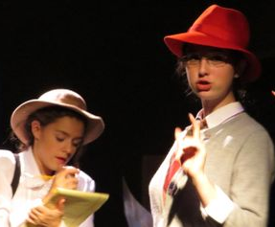
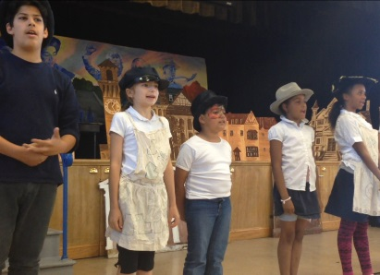
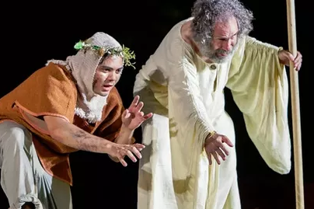

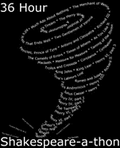

Radium Girls September 2017
Directed by Emily Mattina, this harrowing and true story is a piece of Waterbury history. In 1926 radium was a miracle cure, Madame Curie was an international celebrity, and luminous watches were all the rage—until the girls who painted them began to fall ill with a mysterious disease. Radium Girls traces the efforts of Grace Fryer, a dial painter, as she battles the U.S
Radium Corporation and her own family and friends, who fear that her campaign for justice will backfire. Sept. 28th — Oct. 1st. Showings in Waterbury and Woodbury.
The Gift of Peace, December 2017
Shakesperience's holiday show in which our professional actors work alongside a group of multi-generational, experienced, and dedicated community theatre members is The Gift of Peace. It showcases community and good will, as well as a multi-denominational and non-materialistic focus on the season of giving. Our holiday show is also an
excellent opportunity for students in our 8-week fall acting class to perform in front of their friends and family and to highlight their strengths, their skills, and their passions. Performances will take place in our company theatre locate in downtown Waterbury as well as in Woodbury, CT. December 7th-10th.
Waterbury Interactive: Our City, Our Neighborhoods 2017-2018 School Year
Funded by the CT Community, the Ion Bank, and the George A. & Grace L. Long Foundations,
Neighborhoods is a cutting-edge program with Waterbury PAL, Osher Lifelong Learning Institute, Palace Theater, and other partners. Using a multi-generational approach, elementary students create visual art, sing, and dance; high school students help write scripts and act; older adults share their experiences and anecdotes for script development. Check in to see how you can get involved in one of Shakesperience’s most exciting projects!
The Tempest
July & August, 2017
Emily Mattina once again brings Shakespeare to life for thousands of theatre-goers during her production of
Shakespeare’s most magical work, the Tempest. Starring Dr. David Richman, published author, actor, director, and professor at the University of New Hampshire, as Prospero. It is performed 5 times for Shakespeare on the Shoreline on the Guilford Green, as well as July 22nd for Shakespeare in Hollow Park in Woodbury! The cast and crew give preshow discussions and Ms. Mattina tours to various venues during the production to give informative and engaging talks! August 2nd-6th (Guilford).
Shakespeare-a-thon, April 2018
As part of Give Local America, a
nationwide, grassroots initiative to get people donating to local nonprofits, we host 36 hours of free, public, and fun programs in our studio! Coffee and tea
are always brewing and friends from the community always bring freshly baked snacks and treats! During Shakespeare-a-thon, select school classrooms are invited to bring free shows, local celebrities come through and engage audience members on community topics, and we even have a sonnet reading marathon at midnight! Yes, all 154 sonnets read one after the other! We always anticipate at least 300 guests!
Sweets to the Sweet March 2018
One of our biggest
fundraisers of the year, Sweets to the Sweet
isn’t just a Shakespeare
Quotation - it’s the theme of the evening! Dessert tasting, live auctions, and special guest stars come together for an evening of fun and laughter! While guests circumambulate around goodies of all varieties, our special guests take on Shakespeare scenes— and each other— to help raise funds for arts, education, and the good work we do throughout CT and in parts of NY, MA, and RI!

