This document has been approved by the Crooked Tree Homeowners Association Board at the November 2020 Board Meeting.

Purpose and Authority
These Descriptive Criteria, Rules and Procedures (hereinafter referred to as “Criteria”) were created to maintain a consistent application of the Covenants and Restrictions for the Crooked Tree Estates Homeowners Association. These Criteria were designed for the benefit of the homeowners, who may use this document as a guide when requesting approval for fences, decks and outbuildings, and for the benefit of the members of the Architectural Committee and Board of Directors, who may use this document to apply reasonable and consistent criteria when evaluating a homeowner’s particular request.

Article V (Architectural Control), Section 5.1 of the Declaration states:

5.1 Approval Required. No building, fence, wall, or other structure shall be commenced, erected or maintained upon the Properties, nor shall any exterior addition or change or alteration therein be made until the plans and specifications showing the nature, kind, shape, height, materials and location of the same shall have been submitted to and approved in writing by the appropriate entity. Review of new construction shall be by the Declarant and all other review shall be by the Board of Directors of the Association or by an architectural committee comprised of three (3) members appointed by the Board. Such plans and specifications shall be reviewed as to harmony of external design and location in relation to surrounding structures and topography in accordance with the requirements hereinafter set forth…

At all times, these Criteria are subject to and shall be in concordance with the rules and restrictions of the City of Mason as applied to construction, structure design, placement on property, and all other governing rules. Further, these Criteria are meant to augment the Covenants and Restrictions of Crooked Tree Estates and shall not be used to extend or avoid any restrictions set forth therein.

With the variety of houses, topography, lot sizes and shapes within Crooked Tree Estates, these Criteria attempt to clarify “harmony of external design” and “location in relation to surrounding structures” in a meaningful and practical way.

This document was originally published May 1998. Revisions were made September 1999, November 2003, June 2008, June 2020, and October 2020.

Fences
Fences or walls erected upon any Lot shall be ornamental in character. Split-rail, three-board wood fencing (see Figure 1) or picket fencing are examples of acceptable fence styles, with or without mesh. Metal chain link fencing is specifically prohibited by the Covenants and Restrictions.

Fences chosen should be of high-quality construction and visual appearance so as not to negatively impact the neighborhood. Such fences shall be no more than four (4) feet in height and shall not extend toward the front of the property beyond the lines of the rear corners of the house. On corner lots, all fences shall extend no closer to the street that the front-building set-back line, assuming the corner lot has two (2) front-building set-back lines. Some cul-de-sac properties may also fall under this guideline.

It is the responsibility of the homeowner to maintain the appearance and structural integrity of the fence. At the discretion of the Architectural Committee, privacy fences (which shall not exceed six (6) feet in height), may be allowable in conjunction with small private areas adjacent to the rear of the house, such as a patio, deck or hot tub. A privacy fence, which shall not exceed four (4) feet in height, is allowable around the exterior of an in-ground swimming pool.

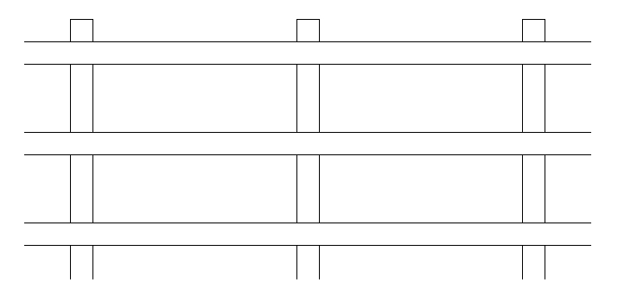

Figure 1 – Acceptable Fence Style

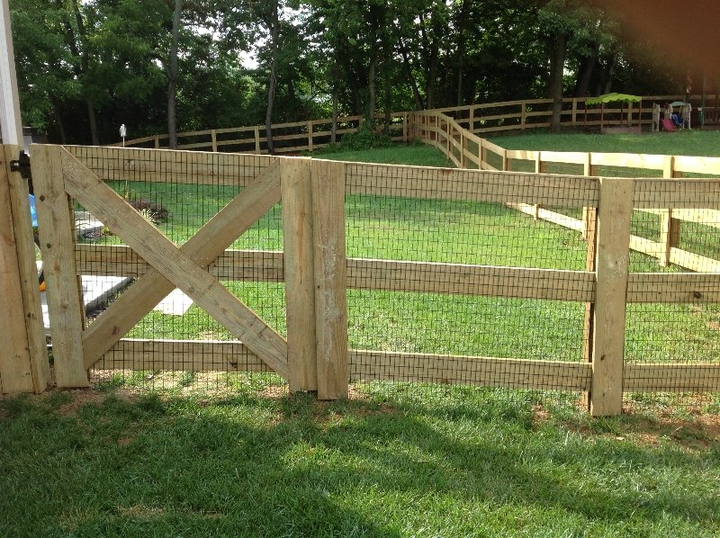
Picture 1 – Kentucky 3 Board Fence Example
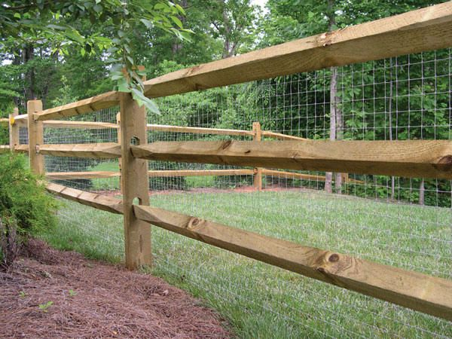
Picture 2 – Split Rail Fence Example

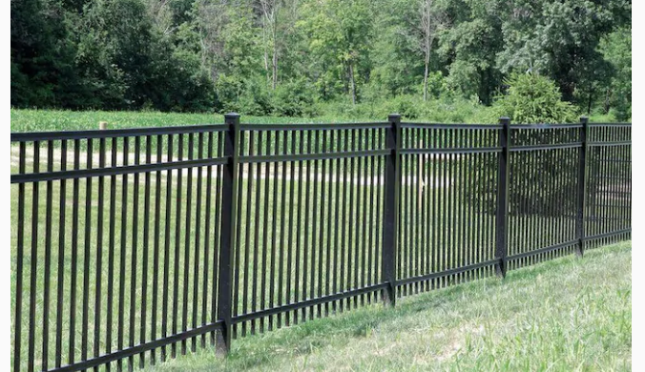
Picture 3 – Aluminum fence example (4-ft to 5-ft tall)

NOTE: It is the Homeowners responsibility to ensure the fence is install on their property. A survey is recommended.

Decks

Decks must comply with the City of Mason Building Code for structural integrity, step and rail height, and other construction requirements. Owners contemplating a deck should ensure that the proposed addition blends with the aesthetic character of the house and the neighborhood with regard to design, materials and color scheme.

Outbuildings

Any permanent structure contemplated for construction on property in Crooked Tree Estates other than the primary residence is considered an outbuilding; synonymous names include but are not limited to “shed”, “storage shed”, “storage area”, “barn”, “structure”, “outbuildings”, and “playhouse”.

Article VI (Use Restrictions and Maintenance), Section 6.1.7 of the Declaration states:

6.1.7 Storage Sheds. Storage sheds shall only be permitted in the rear of the premises and only if permanent in nature, of conventional construction, and may not be made of unsightly material. Storage sheds will only be allowed on deep lots (over one-hundred fifty (150) feet deep) which do not have open visibility to rear lots.

By way of definition, “rear of the premises” shall be construed as a rectangular area, the length of which is roughly parallel to the back of the house and any driveway located to the side of the house, and the width of which extends back to the rear set-back line of the property and excepting further lot line setbacks as specified by the City of Mason and the Covenants and Restrictions. Figure 2 presents a diagram of an example of the permissible area in which an outbuilding may be placed upon a Lot.

As with fences and decks, an outbuilding should be in design and harmony with the house as well as its location. The Board will assist the homeowner if there is a question regarding “unsightly material.” The homeowner has the ongoing responsibility for keeping the outbuilding free of unsightly debris, clutter and building material; the homeowner shall also provide landscaping to blend the outbuilding into the surrounding area.

Other Exterior Structures on the Property

Other items that may appear on a homeowner’s property include swimming pools, swing sets and other outdoor recreational equipment. Article VI (Use Restrictions and Maintenance), Section 6.1.9 states:

6.1.9 Fencing, Storage, Pools. No fences or other Lot dividers, swing sets, clothes hanging fixtures or swimming pools may be erected or installed by any Lot owner unless such owner has first obtained the written approval. The Declarant and Association shall promulgate guidelines for fence styles which may deny or restrict installation on specific Lots. All allowed fencing shall be to the rear of the dwelling. Exceptions may be made for corner Lots. Chain link fences and above-ground pools are prohibited. Installation of permanent recreational equipment such as sand boxes and swing sets shall be limited to rear yards only.

This section, in conjunction with Sections 5.1 (Approval Required) and 6.1.7 (Storage Sheds) are consistent and complementary on two points: (1) written approval is required for any exterior structure, and (2) in general, the location of the exterior structure is in the rear of the property, behind the house, and within the street profile of the house and driveway.

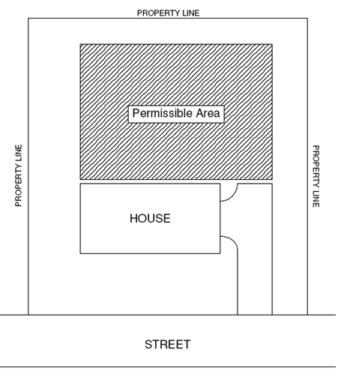
Figure 2 – Permissible Area = Rear of Premises
NOTE: Applies for exterior structures and lots that are allowed Outbuildings.

Process
When a homeowner wishes to construct or erect an exterior structure, the homeowner must complete the attached application.

When the application is complete and includes all relevant documents (building permit, drawings, sketches, product brochures, etc), the application package should be submitted to a member of the Architectural Committee or a member of the Board of Directors.

From the date of submission, the homeowner should expect a decision within 30 days. As stated in Article V (Architectural Control), Section 5.1 of the Declaration:

In the event that the Declarant, the Board, or its designated committee, fails to approve or disapprove said plans and specifications within thirty (30) days after submission, approval will not be required, and this Article shall be deemed fully complied with.

The Architectural Committee or Board of Directors will review the submission. The Committee or Board will also notify those neighbors whose properties abut the applicant’s property, soliciting their comments about the proposed improvement. Using the application package and neighbor feedback, the Committee or Board will then make its determination and notify the applicant accordingly in writing.

Crooked Tree Estates Architectural Request Form
Submit this form to the Architecture/Landscaping Committee Leader or a CTE HOA Board member.
The board must provide a response within 30 days
TITLE OF REQUEST:
RESIDENT’S NAME:
LOT #:
DETAILED DESCRIPTION OF REQUEST (Include reason why you believe this request should be approved. You can attach documents and/or provide copies of emails.)

Architecture & Landscaping Committee Recommendation
APPROVED ◻ DECLINED ◻ (Include reason for your recommendation)

Committee Members providing recommendation:

Crooked Tree Estates HOA Board Decision APPROVED ◻ DECLINED ◻
Comments:

________________________________ ______________
Crooked Tree Estates HOA President Date

