




Annual Impact Report

2024-2025



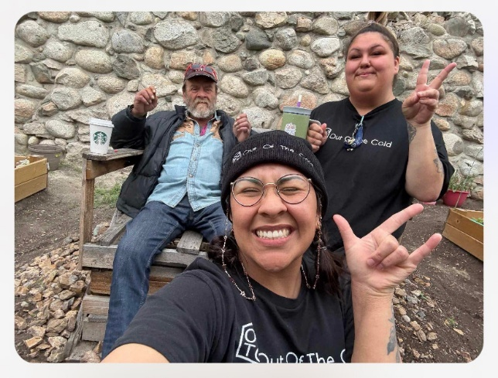
The Inspiring Journey of Out of the Cold (OOTC):
A Community Beacon

Out of the Cold (OOTC) ignited hope in the heart of Kamloops during the winter of 2007, opening its doors as Kamloops first shelter at the St. Vincent de Paul church then moving to St. Paul’s Anglican Cathedral from 2012-2019. What began as a humble refuge soon blossomed into a movement—fuelled by grants, community donations, and a modest summer budget from the City of Kamloops, the initiative thrived, ensuring no one was left out in the cold.
Fast forward to 2019/2020—OOTC packed up its roots from the Cathedral, proudly emerged as a recognized society under the Society’s Act, and claimed its status as a Not for Profit. This new era saw the team roll up their sleeves and throw open their arms to the community during the pandemic, providing a lifeline through meal programs, safe shelter, warm clothing, and cultural activities—making sure everyone could access essential care, no matter the storm.
The story soared in 2022 as OOTC found a dynamic new home at Stuart Wood Elementary School with overnight shelter services seven nights a week. Spring 2023 brought growth in every sense: the launch of a vibrant garden wellness program. Guests and staff joined forces, their hands in the earth—planting seeds, building garden boxes, nurturing crops—while nourishing bodies and minds. Their harvest supported hearty meals, ensuring that up to 5–30 more guests, in addition to 35 sheltered guests, would always find a plate, because in this house of hope, no one goes hungry.
OOTC’s innovation didn’t stop there. In 2024, they broke new ground with Kamloops’ first ‘Seniors & Persons with Mobility Shelter’—the Olive Branch. This pioneering space offers round-the-clock support for those 55+ and individuals with mobility challenges, embodying dignity, safety, and
community care.
Through every season and every challenge, OOTC stands as a beacon—a vibrant, ever-evolving hub where compassion grows, voices are heard, and everyone finds warmth, support, and hope.

Board Presidents Report
Hello and welcome to Kamloops Out of the Cold Shelter Society’s Annual General Meeting for 2025. The Board guided by policy and collaboration, provides high level oversight to our Executive Director, Renee Stein, as she operationalizes both the strategic plan and inner workings of OOTC to provide a welcome safe harbour and stable base for many.
The Board has experienced another full year of activity. We revisited OOTC’s strategic plan this year and have adapted it to accommodate future expansion. At the initiative of the ED, we have explored potential opportunities; unfortunately, we are still in search of a permanent site. Through our Fund Raising and Awareness Committee we are working to maintain a positive presence in our community Actions to support this included: outreach at the Farmers’ Market by inviting discussion and feedback while sharing coffee and a special OOTC cookie; the Santa Claus parade, and the ED’s quick response to any community concerns. The Finance Committee meets monthly to monitor the budget spending and disbursements. The committee has made changes to facilitate quick turn around in reports to the Board. New members participate in a Board Governance workshop.to get them up and running. The ED Review Committee completed its work and contract revision with the generous assistance of Cates Ford Soll & Epp.
Renee and her staff continue to build and maintain a culture of care, non-judgement and possibility even though their work is incredibly challenging and complex. They work to instill hope in our guests and foster a positive relationship with the community. The Board continues to support the ED in her efforts to promote a healthy workplace for employees.
Current members since the last AGM include Kathy Moore, Barb Waters, David Lidster, Kyla Briscoe, Marlo Garcia, Tony Erlank and me. Domenica Spina joined our team in the spring and Brendan Matthews stepped down in late winter.
Each member of this volunteer Board brings with them their unique perspective, knowledge, compassion and kindness that make things work. Thank you for your willingness to step up and respond to emergent needs and multiple requests. Your patience, and enthusiasm with the process, willingness to listen and debate supports the established culture of care in the service of our guests that makes OOTC special.
In closing, Out of the Cold continues to grow and address the ever changing and complex needs of our guests. Our Board is committed to supporting our guests, Executive Director, staff, and our community while ensuring financial due diligence and accountability. Thank you to everyone involved.

Judy Reed, Board President
Kamloops Out of the Cold Shelter Society

22 LIVES SAVED!

3286 Showers

221 Attendances at Wellness Programming

12 Guests moved into housing

4 Guests moved into treatment

Year in Review

12,775 Nightly Shelter Beds

Over 3800 pieces of clothing provided
44,484 Meals Provided

"Be kind and merciful. Let no one ever come to you without coming away better and happier"- Mother Teresa

A message from our Director 

The year 2025 has been remarkable at Out of the Cold. Out of the Cold continues to provide a unique shelter format in Kamloops with our ‘first come first serve’ shelter model that ensures that all people requiring shelter supports have an opportunity to receive a bed each night.

Our philosophy is to meet guests where they are and support their growth each day. By collaborating closely with our guests, we ensure that everyone can access life-saving services in a way that empowers, includes, and focuses on their goals.

As the Director of OOTC, I am continually inspired by what our program accomplishes. We serve some of the community’s most complex and marginalized members in an environment that honours individuality and respect—many guests call our shelter "home," reflecting the safety and support they experience here.

We’re privileged to have a skilled team who bring trauma-informed practices along with backgrounds in mental health, healthcare, and lived experience. This allows us to provide relevant, responsive care tailored to our guests’ unique needs.

With the guidance and encouragement of our dynamic Board of Directors, we persistently reimagine traditional shelter models. Our goal is to offer opportunities rarely found elsewhere, thanks to the Board’s ongoing vision and commitment to innovative, guest-focused care.

OOTC goes beyond offering shelter—we provide supportive programming like recovery resources, employment opportunities, wellness initiatives, an organic garden, seniors programs, and harm reduction. We make full use of our space and seize every chance to change lives.

We deeply appreciate the backing from our community, funding partner BC Housing and donors, and the dedication of both our team and guests to ensuring our message—“We are better…together”—is understood and embraced by all.

I’m truly grateful to be part of this compassionate, forward-thinking team and program. Thank you to our staff, the wonderful Board of Directors, and our supportive partners for believing in us and recognizing the ongoing success of Out of the Cold.

Renee Stein
Executive Director

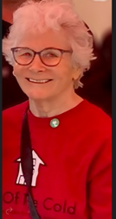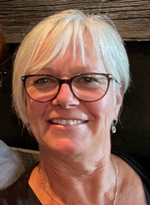

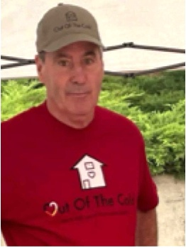

Board of Directors

Name | Position
Judy Reed | President
Kathy Moore | Vice President
Barb Waters | Treasurer
Kyla Briscoe | Secretary
Domenica Spina | Director
Marlo Garcia | Director
David Lister | Director
Tony Erlunk | Director

OOTC team participated in two Farmers Markets providing our famous cookies and coffee & conversation. What a wonderful opportunity to connect with our community. Over 160 cups of coffee and cookies served (with a smile)!

Farmers Market
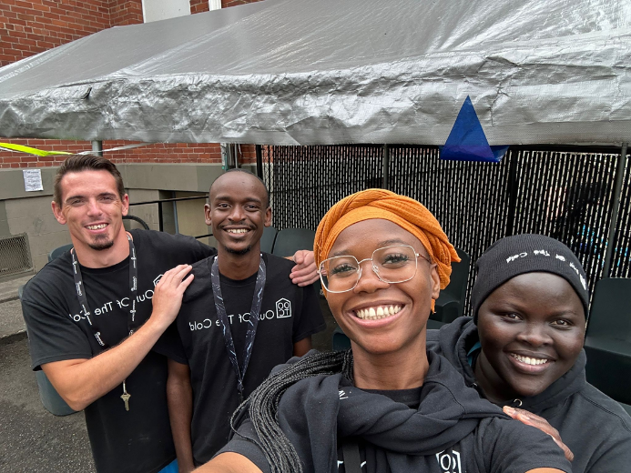

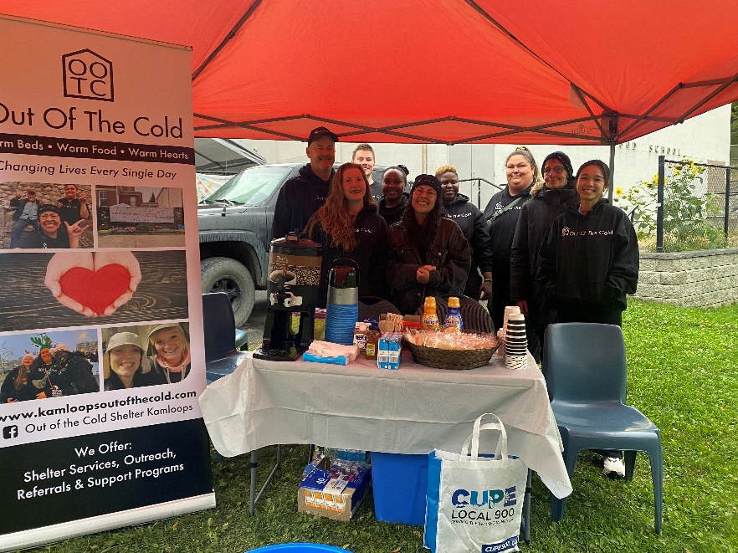

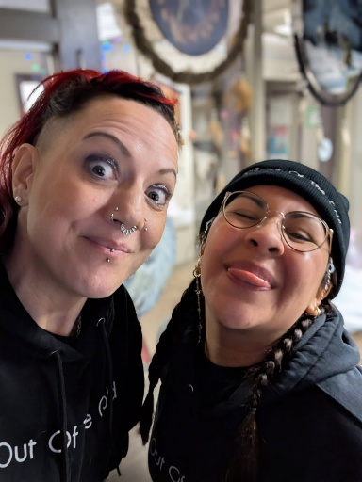

Shelter Garden
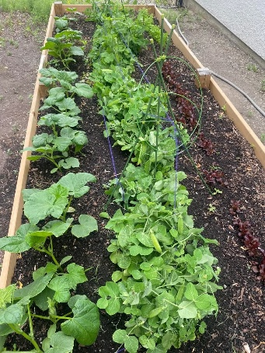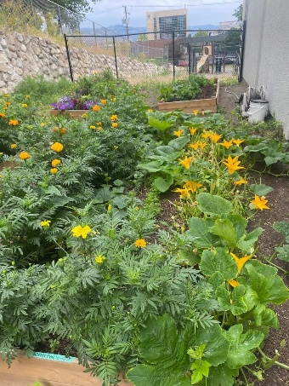

We had a record year of garden produce this year with abundant blessings! Our garden is celebrated by not only our guests and staff but also by the community. We were able to produce many salads this summer along with a space for reflection and a peaceful cup of coffee.

SANTA CLAUS PARADE
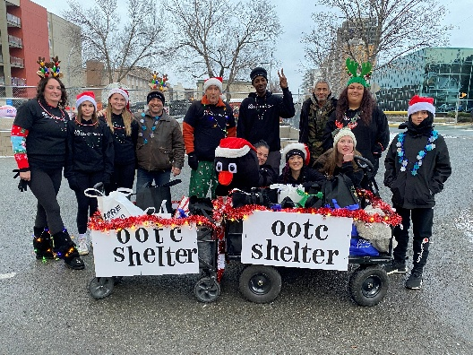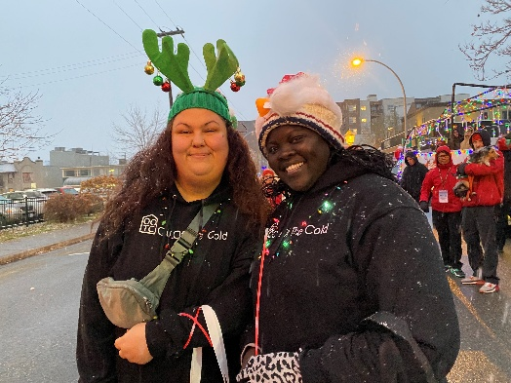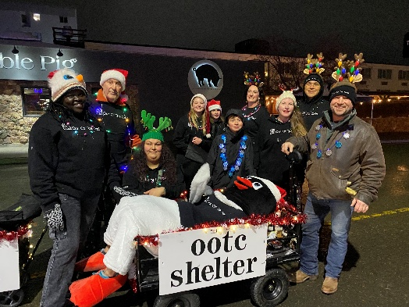

Our team attended our 3rd Santa Claus parade in 2024 working alongside the KCBIA providing candy and treats to the children along the route. What an incredible opportunity for the Board and Team to share Christmas cheer with the community.

Outreach Services
Our Outreach team, consisting of our Outreach worker and our Indigenous Wellness Advocate, work to support both shelter guests as well as multiple parts of the community.

The team works daily to ensure that everyone has a voice in the community and that we do our best to hear and assist when and where possible.

Our team provides support to our guests by assisting with referrals, housing supports, hospital visits, medical & mental health appointments, addictions support and connection.

In addition to guest support the team meets with businesses in the downtown core to build positive connections and to help and support business needs in relation to our unsheltered community members.

In addition to attending community meetings, support agency connections and housing support tables, the team also provides support through events such as Overdose awareness day, Point in Time Count, Farmers markets, and Community Information sessions.

OUTREACH SERVICES

Community Connections | Nov. 2024 -Oct. 2025
Guest | 5123
Non-Guest | 1560
Community member | 849
Businesses | 778
Support Agencies | 890
Hospital | 51
RCMP | 42
TOTAL CONNECTIONS | 9293

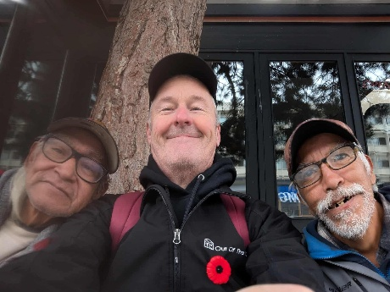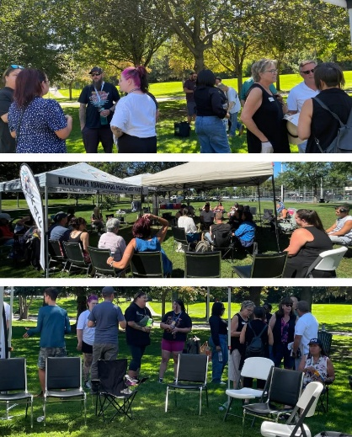

Community Information Events

At OOTC, we are committed to addressing stigma and creating opportunities for open dialogue regarding homelessness, addiction, and mental health. Over the past year, we have provided support to secondary students and community groups through educational sessions on topics including the history of substances and the criminal justice system, mental wellness, overdose prevention and Naloxone training, as well as brain injury and homelessness. In addition, we also support TRU students with practicum placements as well as Cap Stone opportunities for high school students.

Please contact our team at the email address given below if you would like us to speak to your community group or class.

Stay tuned for more exciting news in 2026! Please contact Out of the Cold at ootcexecutivedirectorrstein@gmail.com to become a member of OOTC and to receive our newsletter. We can also be found on Facebook!

