Out of the Cold

|  |
| --- |
| Annual Impact Report  Nov.2023 to Nov.2024 |

# 

|  |  |
| --- | --- |
| Out of the Cold Shelter Society 2023-2024 Annual Impact Report  **About Us**  **Wooden red heart on red wood background**  *Out of the Cold began operations as* ***Kamloops first shelter*** *in the winter season of 2007 based out of the St. Vincent De Paul Church. In 2013 operations moved to St. Paul Anglican Cathedral and the program continued to provide 2 night a week shelter service during the winter months. The program was based around the model of providing a warm, caring, and inclusive environment where all persons were welcomed as 'Guests'. The program was primarily volunteer based with a small handful of staff to provide leadership. In 2018 OOTC also provided summer shelter support as Out of the Heat.*  *The programs continued to be supported with grants, heart felt donations, and a small summer budget from the City of Kamloops. In 2019/2020 OOTC moved out of the Cathedral and became a society recognized under the Society's act and as a Not for Profit. Out of the Cold supported community agencies throughout the pandemic ensuring that life giving, and supportive care was available through meal programs, shelter care, clothing donations and cultural programing.*  *In 2022 OOTC expanded its care model to provide 7 day a week overnight shelter services based out of the Stuart Wood Elementary school in downtown Kamloops where we continue our services today.*  *The shelter at Stuart Wood began a garden wellness program in the spring of 2023 to increase guest mental wellness by utilizing organic gardening concepts, employment opportunities and meal preparation. Guests plant seeds in the spring, build and maintain garden boxes and assist with garden care throughout the growing season. This program sees guests working daily, alongside staff to support the shelter's meal program where we feed an additional 5-30 persons above our funding level to ensure no person is left without food options.*  *In 2024 we expanded our care reach in developing the first of its kind in Kamloops ‘Seniors & Persons with mobility Shelter’. OOTC’s Olive Branch provides 24/7 shelter supports for our 55+ population as well as for persons with increased mobility needs.*  *2024 also saw us work to decrease mental health stigma and increase wellness supports by designing and providing Mental Wellness Support Programming to community agencies such as the Downtown Central Business Improvement Association. OOTC supports our youth in their understanding of addiction and homelessness within school sessions at our local high schools’ speaking on homelessness, addiction, history of substances and legalities, mental health and support at a youth level in our community.*  *In addition to shelter we provide the following: harm reduction supplies, supervised consumption, donations, toiletries, showers, laundry services, mental wellness groups, supportive recovery groups, medical supportive care with weekly nursing session, detox and treatment referrals, Outreach services, community wellness programs and trainings.*   |  | | --- | | "Be kind and merciful. Let no one ever come to you without coming away better and happier"- Mother Teresa  **A message from our Director**  What an exciting year 2024 has been at Out of the Cold. We continue to be full every night providing care to up to 60 people each day.  We strongly believe in meeting all guests ‘where they are at’ and work daily for guest success. We work collaboratively with our guests to ensure that all people can receive life saving services in a way that is empowering, inclusive and goal orientated. As the Director of OOTC everyday I am amazed at the success of our program. We provide care for some of our communities most complex & marginalized citizens in a format that truly celebrates the individual, promotes respect and where guests refer to the shelter as ‘home’, speaking to the safety, support and care they feel within the shelter.  Out of the Cold is fortunate to have a wonderful team of highly trained staff who practice from a trauma informed lens with mental health, health care and lived experience backgrounds to relevantly and responsively care for the guests of this shelter population.  Backed by a supportive, encouraging and vibrant Board of Directors we continue to push forward the constraints of traditional shelter to ensure that guests accessing our programs receive program opportunities not found in many shelter programs. I am thankful to our Board for their continued support and vision to build a care model that is innovative, creative and guest centered.  Providing supportive programming, recovery opportunities, employment, mental wellness, organic garden program, seniors initiatives and harm reduction, OOTC utilizes every square inch and every opportunity to not just provide shelter but to change lives.  At a time where in many areas of the community residents are feeling overwhelmed by the needs of so many people experiencing homelessness, OOTC has received letters of support, praise for the professionalism of our program model with people coming forward to volunteer at our shelter. We are so thankful to our community’s support of our program model and the tireless efforts of our guests and team to ensure our message of “We are better..together” is heard and resonates with those we share community space with.  I am so incredibly grateful to be a part of this upstanding, compassionate and innovative program and team. Thank you to our team, our wonderful Board of Directors and our supportive funding partners for their belief and continued acknowledgment of the service being provided and the ongoing success of Out of the Cold.  *Renee Stein, Executive Director*    ***Board Presidents Report***  ***Hello and welcome to Kamloops Out of the Cold Shelter’s Annual General Meeting for the 2023-2024 season, our fourth since gaining charitable status with Revenue Canada. As many of you are aware Out of the Cold has served our community and guests for several years in a a few different formats. Our growth continues, as unfortunately do the needs of our guest who call Out of the Cold their home, albeit temporary. We provide a welcome safe harbour for those who probably do not experience much of that in the community.***  ***Over the past year, the Board has focused on building a strong foundation of fundamental policies from which we can move forward. We developed and adopted a strategic plan for the next 3 yrs facilitated by Dr. Tom Dickinson. One of our longer-term goals is to have a permanent site. Our Treasurer, Barb Waters, continues to collaborate with our ED and bookkeeper, Nadine Krueger, to build in systems that ensure fiscal accountability and accuracy while making them more streamlines and efficient.***  ***The Governance Committee led by Dr. Diane McKelvey, ushered in policies to guide our work as a Board, allowing for a high level of oversight. The day-to-day operations remain the responsibility of our ED Renee Stein.***  ***BC Housing Corporation remains our chief funder, and we appreciate their trust in OOTC to deliver our program and their openness in approving additional expense items as required. We have a savings account for donations separate from BCH. Our new fundraising committee is exploring ways to raise money for needed items not included in the BCH budget.***  ***Our Executive Director, Renee Stein continues to be incredibly busy again this year with expanding programs offered by OOTC; in addition to staffing, shelter management and commitments to various community tables related to assisting those who are unhoused and marginalized. She is also overseeing the development of the Olive Branch. This is a secondary shelter program model for those who are elderly and requiring additional supports. Renee and her staff continue to build and maintain a culture of care, non-judgement and possibility even though their work is incredibly challenging, they aim to instill hope in our guests.***  ***The Board is experiencing change again this year. Current members since the last AGM include Kathy Moore, Diane McKelvey, Barbara Waters, David Lidster, Kyla Briscoe, Sally Berry and myself, Judy Reed. Chris Hum, Jennifer Adams and Sally Berry moved onto new opportunities, and we thank you for your support of OOTC. Dr. Diane McKelvey will be completing her term at this AGM and moving on to focus on other commitment. We wish them well and thank them for their hard work, enthusiasm and dedication in their service to Out of the Cold. Recent additions to our Board include Dr. Brendan Matthews, Tony Erland and Marlo Garcia, welcome aboard!***  ***I would like to thank every Board member for their willingness to step up and respond to the emergent needs as they presented. Your patience with the process, willingness to listen and weigh different perspectives always appreciated.***  ***In closing, Out of the Cold continues to grow and address the ever changing and complex needs of our guests. Our Board is committed to support our guests, Executive Director, staff and our community while ensuring financial due diligence and accountability. As one! Thank you to everyone involved.***  ***Judy Reed, Board President***  ***Kamloops Out of the Cold Shelter Society*** | |

|  |
| --- |
|  |

(not pictured: Dr. Diane McKelvey, Dr. Brendan Matthews, David Lidster)

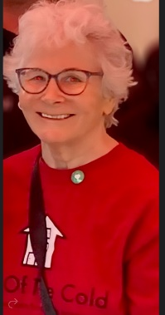  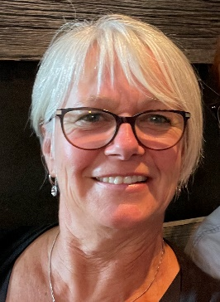

|  |
| --- |
| Judy Reed – President |
| Kathy Moore – Vice President |
| Barb Waters - Treasurer |
| Kyla Briscoe – Secretary |
| Dr. Diane McKelvey |
| David Lidster |
| Dr. Brendan Matthews |
| Tony Erlank |
| Marlo Garcia |

Judy Reed Barb Waters Tony Erlank Marlo Garcia Kathy Moore Kyla Brisco

***Our Board of Directors***

# 

Nov 2023 to Nov 2024

* **22 lives saved due to drug poisonings**

# 10,570 intakes into shelter supports

# Over 30,000 meals served

# Over 3600 pieces of clothing provided

# 2555 showers

# 240 employment opportunities

Impact

**685 Attendances at Wellness Groups**

**5 Guests moved into housing – 3 guests assisted in moving to their home communities – 4 guests moved into treatment**.

**OOTC is at 100% capacity or above EVERY night of the Year**

# 

|  |
| --- |
| Garden Program |
| *The shelter at Stuart Wood began a garden wellness program in the spring of 2023 to increase guest mental wellness by utilizing organic gardening concepts, employment opportunities and meal preparation. Guests plant seeds in the spring, build and maintain garden boxes and assist with garden care throughout the growing season. This program sees guests working daily, alongside staff to support the shelter's meal program where we feed an additional 5-30 persons above our funding level to ensure no person is left without food options.* |

|  |
| --- |
|  |

|  |
| --- |
|  |

Since November 2022 at our Stuart Wood site we have welcomed in:

* Over 25,387 guest intakes into shelter
* 1270 different persons provided service.
* 853 males / 397 females
* 284 persons of Indigenous heritage
* Over 56,000 meals served

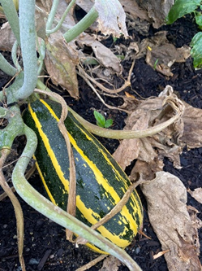

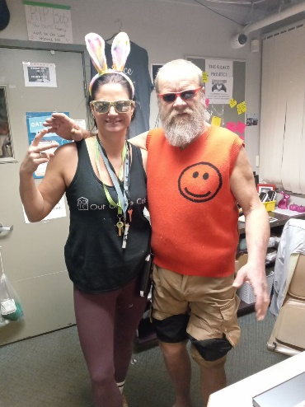

The shelter mindfully creates a space where our guests see themselves as having a place of belonging. Family picture boards line the hallway, showing both guests and staff engaging in activities such as karaoke, pizza nights, games, crafts, decorating cookies, and everyday shelter life. This provides a sense of inclusion in their space and is a space for celebration, relationship, remembrance, and community building.

At OOTC we desire to see Guests have every opportunity to move forward in their journeys and experience growth and success. Guests are supported while in shelter with the following programs:

* Stories of Hope - recovery programming where community members share their addiction recovery journeys. Guest speakers provide a one-hour share of their various recovery journeys, sharing the struggles of their addictions as well as the story of hope in their recovery.
* Mood Management Group - This is a new series of mental wellness support in group format. The program focuses on identifying moods, communication skills, language, self discovery, relationships, and self esteem.
* Street Nurse care – We have welcomed the ASK Wellness Telus van team to provide in shelter care for guests, on Tuesday mornings, attending the shelter to assist with: wound care, referrals, medication renewals and assessment of symptoms.
* Cultural meals and crafts - over the course of the winter and spring we celebrated the diversity of our guests providing Indigenous meals as well as crafts.
* SMART Recovery – We support staff training for SMART recovery facilitation. We began this program once a week during the winter months for guests to provide support in their recovery journey.
* Harm Reduction / Safe Consumption - Though we encourage and support recovery, we understand that guests come to OOTC on all different journeys. Providing non judgemental and supportive care provides the respectful space for conversation related to safe substance use, clean supplies, alternative therapies, support options and overdose awareness. Guests have the ability to access all harm reduction supplies on site as well as staff are trained in overdose/naloxone therapies.

Staff Trainings

* Naloxone (Harm Reduction - Safe Consumption)
* First Aid
* Food Safe
* Trauma Informed Care
* Cultural Sensitivity Training
* Bullying and Harassment in the workplace
* Legal Charting (Subjective vs Objective)
* Non-Violent Crisis Intervention
* Professional Communication and boundaries
* Attachment Styles and disorders
* Addiction (substance use, withdrawal, and overdose)
* SMART recovery

Staff Support

Staff participated in a well received Wellness Workshop with the focus of the “Wounded Healer”. This program was presented by Clinician Grace Graham and was a four-part workshop providing shelter staff with self care strategies, awareness and self assessment tools.

OUTREACH SERVICES

Since January of 2024 Outreach has provided the following support:

* 1133 community connections with shelter guests
* 680 support connections with non guests experiencing homelessness.
* 414 connections with support agencies for guest’s referral, collaboration, and advocacy
* 343 responses to businesses contacting for support with persons on property, naloxone training, and crisis response.
* 353 connections with community members/neighbours to provide support, information, education, and information about services.
* 35 assists to the RCMP
* 36 assists/visits with persons requiring support at Royal Inland Hospital

**Outreach**

*We have a strong and vibrant Outreach team who provides collaborative care to help bridge the gap between shelter and community support. Our Outreach team works daily to support shelter guests in connection with medical, mental health, housing, addiction services, probation, family and court services. Our Outreach team also provides hospital and prison visitation to assist with guests transition back to their community, supportive planning and assistance for guests co supported by shelter services.*

*Team members provide street service to connect guests to support agencies, provide referrals, attend appointments, provide connection to supportive programming, and attend community advocacy meetings to assist with housing connections for persons experiencing homelessness.*

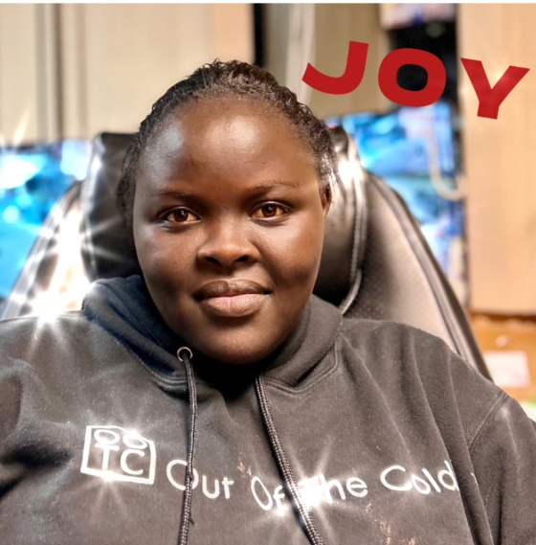

**Celebrating each other**

# Two girls standing in front of a table Description automatically generatedWonderful community helpers

Our commitment to our community…

|  |
| --- |
|  |

|  |
| --- |
|  |
|  |

Though Out of the Cold originated as a community shelter, run by volunteers on a donation basis with a heart to care for their neighbours in need, we continue with that same mindset and value system today. OOTC strives to end stigma around addiction, provide culturally supportive and inclusive care and be an integrated and positive community member. Some of the projects and programs we have organized and supported this past year:

* 'Coffee & Conversation' at our local Farmers Market providing free coffee, juice and goodies to all persons looking to learn more about our shelter services. BC Housing, our Board of Directors, staff and guests all took part to make this a huge success serving over 135 persons.
* Shelter garden project - guests began growing seeds in March and in May constructed a 2000 square foot garden growing many of the vegetables to support our summer dinners. Guests helped plant, tend, water and weed our large garden which became a positive focal point in the neighbourhood receiving many compliments from our neighbours.
* Community Art Project - We partnered with the Parasol Daycare for a second year to make a large art banner for our front courtyard with the theme of children’s handprints and guests handprints sharing space together with the words, "When we plant GRACE and sow KINDNESS…Lives Blossum”.
* Youth Education - our Executive Director was the guest presenter at Westsyde Secondary School Law class for the second year to provide a presentation on homelessness, addiction, trauma and stigma. Over 50 students attend each year, and we have been requested to present again in the spring.
* OOTC provided Mental Wellness training to assist with onboarding new staff members with Downtown Business Association Customer care and Patrol (CAP) Team.
* Partnered with Kamloops Loud Voice Society in the provision of weekly Indigenous Talking Circles for guests of the shelter.
* OOTC was invited and presented at ASK Wellness’ new initiative of the Telus Health Van. This mobile nurse program attends the shelter once a week to ensure supportive medical care to all shelter guests.

***Can’t wait to see what the next year has in store……………***

|  |
| --- |
|  |

|  |
| --- |
|  |

|  |
| --- |
|  |
|  |