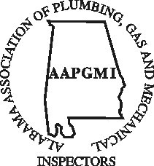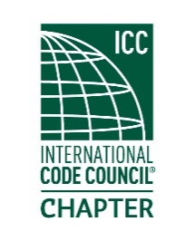
Alabama Association of Plumbing, Gas & Mechanical Inspectors 63rd Annual Educational Conference, Orange Beach, Alabama, September 29-October 2, 2026

Island House Hotel—Orange Beach 26650 Perdido Beach Blvd. Orange Beach, AL 36561
Discounted rates are available UNTIL August 28, 2026.
Rooms are $169.00 per night plus tax
To book by phone, call (251) 981-6100 and use code CDT904,
To book online, copy and paste the following link into your browser https://group.doubletree.com/kq3oye or simply click on the link on our website www.aapgmi.com The Conference Rate is $169.00/Night + tax

Vendor Sponsors and Exhibit Registration Form
Our attendees include plumbing, gas and mechanical contractors, building professionals, municipal, county and state regulatory officials/inspectors. Attendance averages between 100-125 individuals from year to year. These individuals are eager to gain new product knowledge that can be taken back to their respective business, city, county or state office. Our vendors enjoy opportunities to not only show their company’s products, but to discuss the application of those products one on one with the individuals who will purchase, install, approve and inspect those products, as well as making contacts across the State of Alabama.
.

Vendor/Exhibitor Sponsorship
$500.00 Includes lunch 2 days, registration gift, booth space, hospitality room.
*Additional guests $100.00
Company Name______________________________ Contact Person__________________________
Address___________________________ City____________________ State_____ Zip____________
Phone Number_______________________________ Email_________________________________
Website_________________________________ Additional Guest ___________________________
Guest Email_______________________________ Guest Phone _____________________________
*Mail check payable to AAPGMI
216 Aquarius Drive, Suite 319
Homewood, AL 35209

King Room
Two Queen Room

