[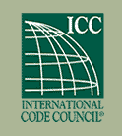](http://www.iccsafe.org/)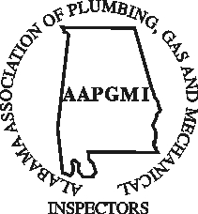



The 2021 AAPGMI Golf Tournament

Will be held on Tuesday, March 23, 2021

At the

Auburn University Golf Course

1650 Yarbrough Farms Blvd

Auburn, AL 36832

(334) 821-8381

This year’s Tournament will kick off the

58th Annual Educational Conference

The International Code Council

Will provide Lunch beginning at 10:30 AM

Shotgun Start at 11:00 AM

* AAPGMI Scholarship* 

*Golf Tournament*

Hole Sponsorship

Company Name:_________________________________________________________________________

Contact Person: _________________________________________________________________________

Address: _______________________________________________________________________________

Email: _________________________________________________________________________________

Phone: _________________________________________________________________________________

Hole Sponsorship is $150

Please make check out to **AAPGMI Scholarship Fund** and mail to:

**PO Box 12333, Huntsville, Alabama 35815**