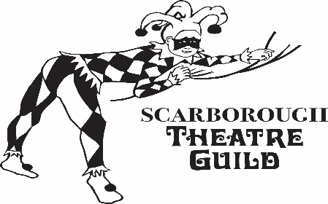

Scarborough Theatre Guild

Over the River and Through the Woods
Play by Joe DiPietro

Director: Jim Hyslop
Producer: Heather Hyslop
Stage Manager: TBD

** This production is Non-Paying/Non-Equity **

AUDITION DATES
Sunday, May 31, 2026 1 – 4 p.m.
Monday, June 1, 2026 7 – 10 p.m.

CALLBACKS
Thursday, June 4, 2026 7- 10 p.m.

AUDITION & REHEARSAL LOCATION
Scarborough Theatre Guild Rehearsal Unit – 2105 Midland Avenue, Unit 16, Scarborough, Ontario (The building is immediately north of the (defunct) Midland LRT station on east side, south of Progress. The unit and both driveway exits face Cosentino Drive)
REHEARSALS
Commence: Sunday, July 5, 2026 (read-through) 7 – 10 p.m.
Continue: Tuesdays & Thursdays 7 – 10 p.m.
Sundays 1 – 5 p.m.
Tech week: Sunday, September 6 to September 10
Additional rehearsals may be added if required.

PERFORMANCE DATES – 2026
September 11,12,17,18,19, 24 and 25, 2026 at 8 p.m.
September 13,20 and 26, 2026 at 2 p.m.

All performances at Scarborough Village Theatre, 3600 Kingston Road at Markham Road, Scarborough.

SYNOPSIS

A heartwarming comedy about family, food, and the tug-of-war between tradition and change.

When a young Italian-American man announces he’s leaving New Jersey for a new job across the country, his four loving — and meddling — grandparents scheme to keep him close to home. Filled with laughter, love, and Sunday dinner chaos, this play reminds us that family ties can stretch, but never truly break.

SCRIPT

Please read the play before auditioning, if possible.

AUDITION REQUIREMENTS

Storytelling is a big part of this play, so tell us a story! Pick something that will evoke some kind of emotion from us. Remember that a monologue is a story. Please aim for 1-2 minutes.
You may be redirected with your story.
You may be required to attend a callback so that we can have a chance to experiment with different pairings/ groupings of actors.

BOOK AN AUDITION

For information, or to book an audition time, email Heather Hyslop at: producersstg@gmail.com

Please bring a copy of most recent theatre resume and headshot.

If you must cancel on the night of your audition, please phone Scarborough Theatre Guild at 416-439-5349.

CHARACTERS:

Nick
Male-presenting, approx. 30 years Nick is a high-strung Yuppie (Young Urban Professional). He’s going places in his job. He loves his grandparents.

Emma
Female-presenting, late 70sNick’s paternal grandmother. The most religious of the family. She looks to the priest to solve everything. Very loud and outgoing.

Nunzio
Male-presenting, late 70sNick’s paternal grandfather. Family bonds are very important to him, but he recognizes that Nick needs to follow his career. Very loud and outgoing.

Aida
Female-presenting, late 70sNick’s maternal grandmother. Her philosophy is that everything can be solved with food, and everybody’s always hungry.

Frank
Male-presenting, late 70sNick’s maternal grandfather. Refuses to admit it’s time to give up his driver’s license. The ability to play the mandolin would be an asset.

Caitlin
Female-presenting, late 20sThe calm in the storm. Isn’t intimidated by the
grandparents. She is the most sensible and down-to-earth of the lot.

Note on accents:

Grandparents could have a mild Italian accent; Nick and Caitlin could have New Jersey (Hoboken) accents. Accents are optional; the director’s philosophy is that no accent is preferable over a bad, stereotypical accent.

Scarborough Theatre Guild welcomes diversity in casting and actors of all backgrounds, identities and abilities are encouraged to apply!

