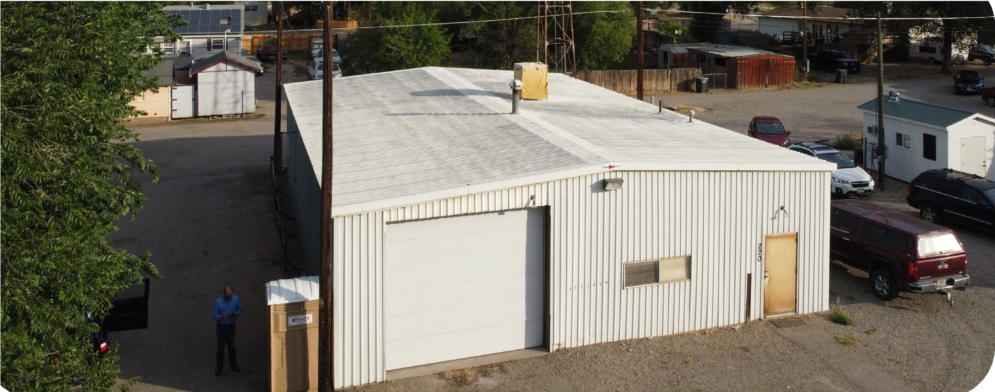

220 E 1ST ST
Parachute, CO 81635
ABOUT THE PROPERTY

GREAT CONDITION
Site and building in excellent condition
04

ZONED COMMERCIAL
This building is zoned C1, commercial
03
PROPERTY OWNER INFORMATION
View Website
Outlined on the below map are areas where the community has put a prioritization for facade and architectural changes/restoration. Various areas have been prioritized to maximize impact and economic return to the community.

OPEN FLOOR PLAN
This building currnetly has an open floor plan
02

2020
Year the building was last vacacted by a tenant
01
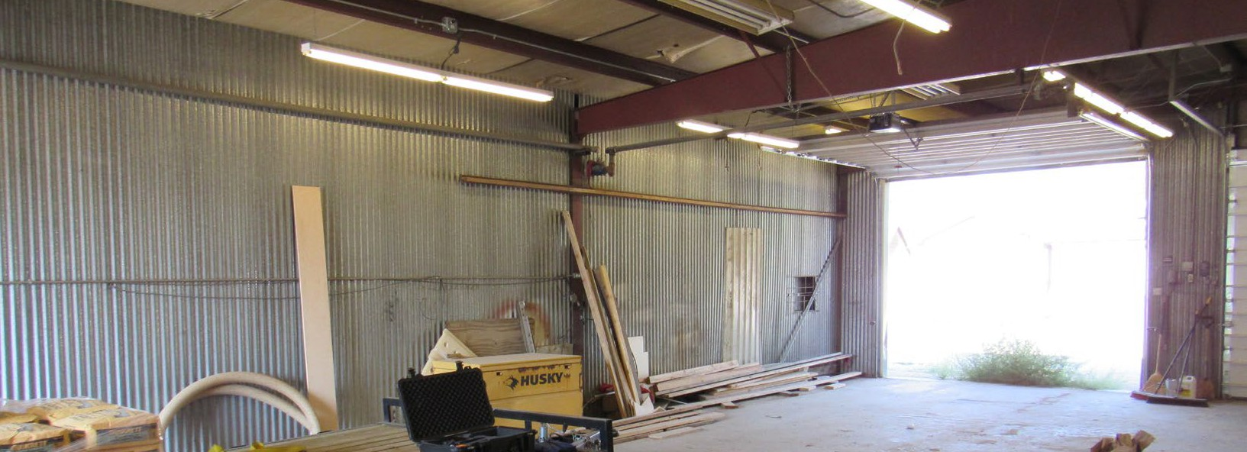

AGENCY REALTOR
CONTACT INFORMATION

SIGNAGE ALLOWED
Standard Signage Allowed on Property
06

CONGEUENT LAND USE
Adjacent properties have congruent land uses
05

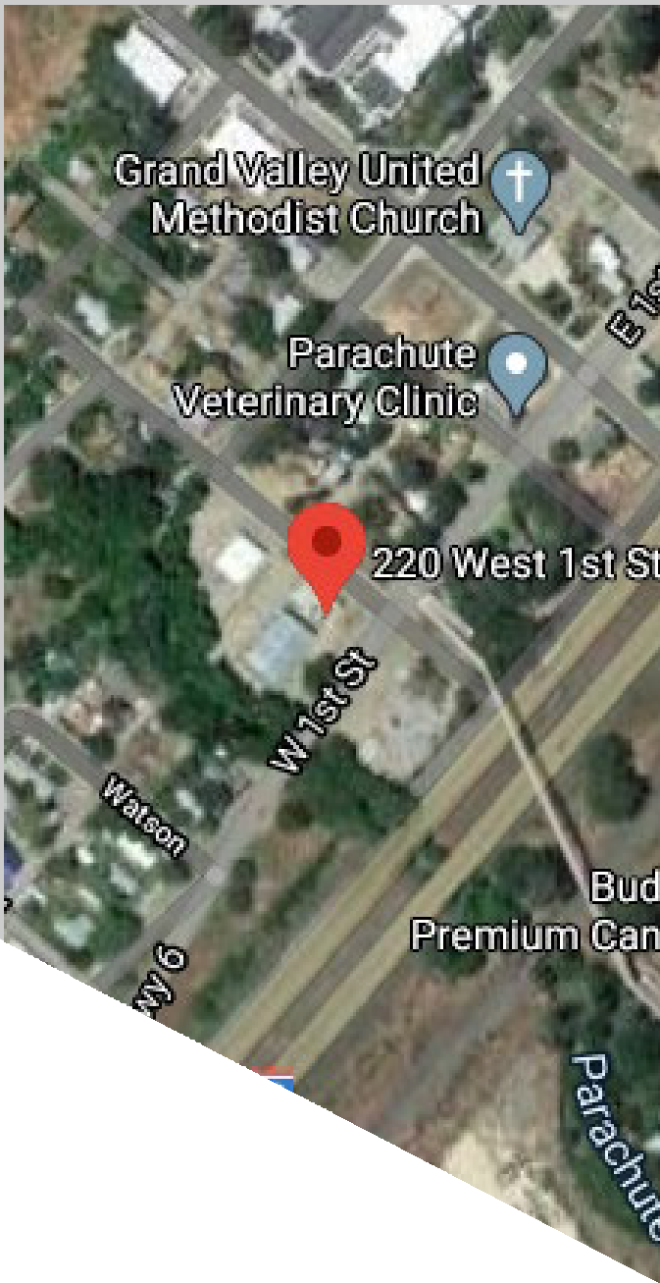
220 E 1ST ST

Community details – The Town of Parachute is a diverse com- munity boasting a strong economy based on .
Additional socio-economic or demographic factors are outlined below:
- Average household income of, $xx,xxx.XX, or 120% of the regional average
- Average expendable income (per household) –
- Average age of resident
- Median household price
- Undersaturated services include:
  - o XX
  - o XX
  - o XX
- Community has a regional draw with easy access to interstate XXX

The building is a structurally competent and well maintained structure that was recently vacated by the municipality. Since the building was vacated, utilities and regular maintenance have been kept up for the property. Additional building and parcel data includes:
- Structure built in XXXX and expanded in XXXX
- Building is a total of XX,XXX square feet on a X.XX parcel
- The building is a steel frame structure with a steel exterior
- AC and Heater were last replaces in 1990
- Roofing was last replaced in 2000
- The building is located in a C1district, which will allow the follow- ing uses without variance or conditional use: Retail, Commercial, Medical, Light manufacturing
- The structure currently has no life/safety upgrades required
- No sprinkler or fire suppression systems necessary, unless a restaurant use is requested
- New 6” water lateral and parking lot
PROPERTY HIGHLIGHTS
BUILDING HIGHLIGHTS
- XX,XXXX vehicles drive past the property daily
- The building is a XXX frame with XXXX exgterior surfaces
- Availability for XXXXX parking stalls on the X.XX acre parcel
- The facility is in excellent condition and had regular maintenance performed
- Allowed styles of signage will include: XXX, XXX, XXXX
- The building is a total of XX,XXX square foot and have XX doors (1 entry and 1 overhead)

– Page 2 - 220 E 2st St —
View Website

