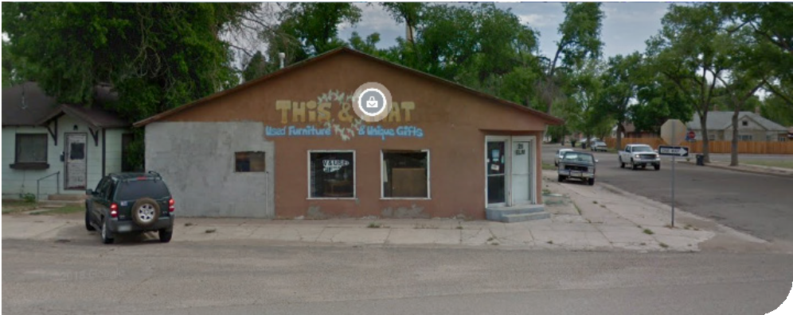

211 ELM RD

**Rocky Ford, CO 81067**

**ABOUT THE PROPERTY**

**ON-SITE PARKING**

This property has on-site parking available

**04**

**ZONED COMMERCIAL**

This building is located in a commercial zone along Elm RD

**03**

[WWW.NORMMURPHY.COM/PROPERTIES-1](http://WWW.NORMMURPHY.COM/PROPERTIES-1)

Outlined on this page are details about the above listed property. For additional details please refer to the back side of this page.



**OPEN FLOOR PLAN**

Open floor plan from previous retail tenant

**02**

**1936**

Year the building was built

**01**

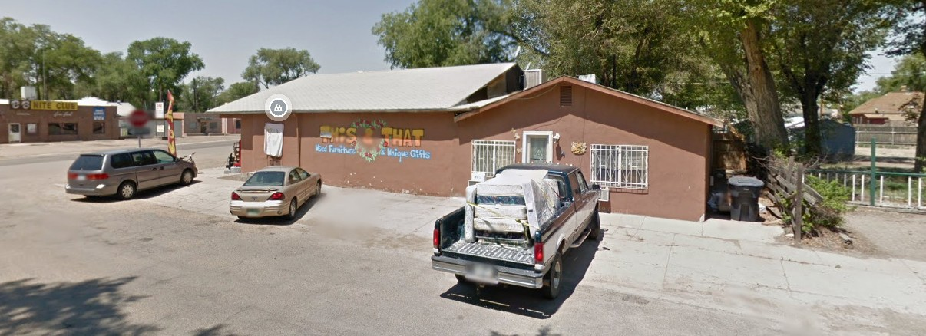



NORM MURPHY & ASSOCIATED TRACEY MARTIN

[TMARTINREALTOR1@GMAIL.COM](mailto:TMARTINREALTOR1@GMAIL.COM)

**ADDITIONAL USES**

Property has multiple uses available under zoning

**06**

**ADDITIONAL INCOME**

Rental income property attached to rear of building

**05**



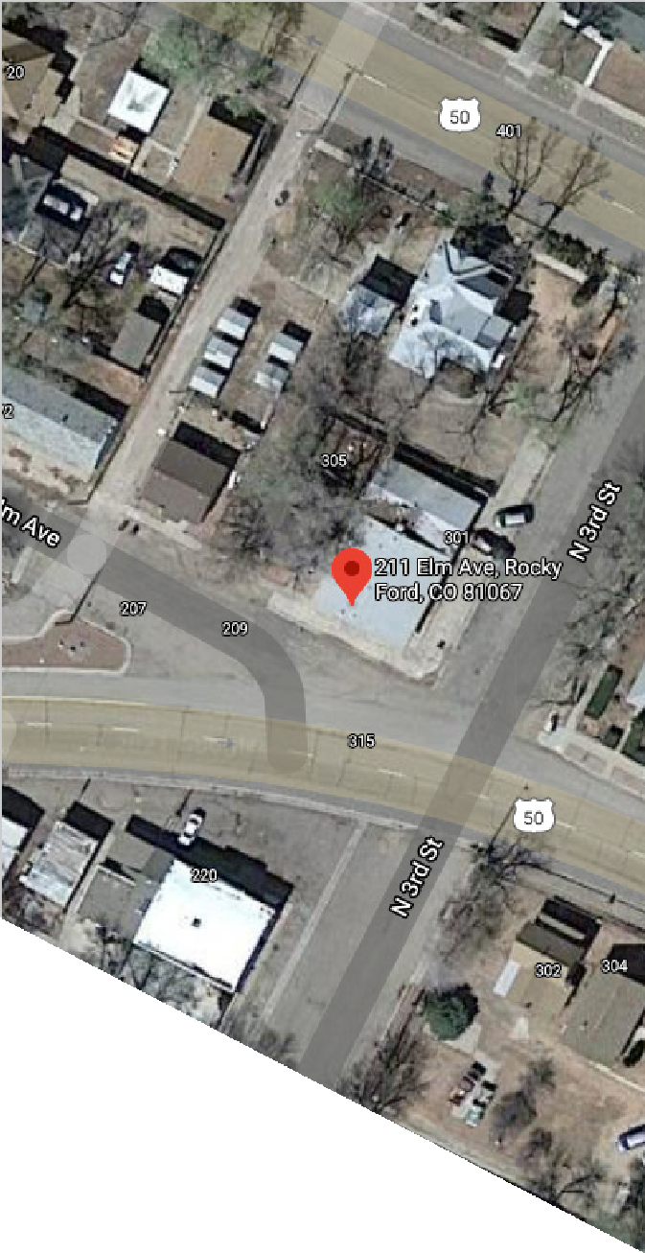**211 ELM RD**

**- COMMUNITY DETAILS -**

# The City of Rocky Ford is a small community with strong char- acter and attributes known for an improved quality of life. The downtown and commercial corridors of Rocky Ford are filled with buildings that boast both diverse and unique architecture styles. Additional socio-economic or demographic factors are outlined below:

* Average disposable income of $29,121 annually
* Household income average of $42,252 and is expected to grow by 9.2% over the next five years
* 15.6% of residents hold a bachelors degree or higher
* Median age of 34.8 years old
* An average of $2.797.24 spent annually on “food away from home”
* 21.1% of residents work from home
* Undersaturated services include:
  + Clothing stores
  + Sporting goods, Hobby & Book stores
  + Furniture store
* Community is only 10 miles from the regional hub of La Junta and located along a busy railroad corridor.

# The building has served numerous uses in its nearly 100 years of service. Since the building was last vacated, the structure has been maintained and remains connected to utilities, preserv- ing the structure. Additional details about the building are as follows:

* Structure built in 1936 (est.)
* Attached income generating residential property (3bed/1bath)
* Highway corner location, increasing visibility for retail
* Off street parking available on-site
* Low annual taxes at $1,082.33
* Open floor plan to accommodate multiple users

**PROPERTY HIGHLIGHTS**

**BUILDING HIGHLIGHTS**

* 4,300 vehicles drive past the property daily
* Low purchase price for the building
* Central location on primary East to West corridor
* Large show room area with stock room to support retail uses
* Multiple end user types allowed in commercial zoning designation
* Property is well maintained and will require limited upfront cost

– Page 2 - 221 Elm Rd —