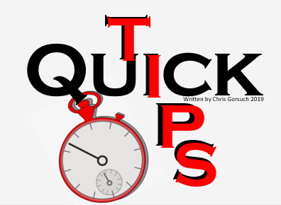
INBOARD JET
vs
OUTBOARD JET

This is a question that comes up often; Which is best… Inboard or Outboard Jet?

The answer is far more situational than some may realize. And

- EFFICIENCY & PERFORMANCE: Hands down, based on performance and power loss, and Inboard Jet has it all over an Outboard Jet. They tend to steer easier and will move similar sized boats faster. Looking at the diagram below, the water flow into the inboard pump is more direct (efficient). The horizontal shaft allows the impeller to pull water in without changing its direction. Advantage Inboard Jet

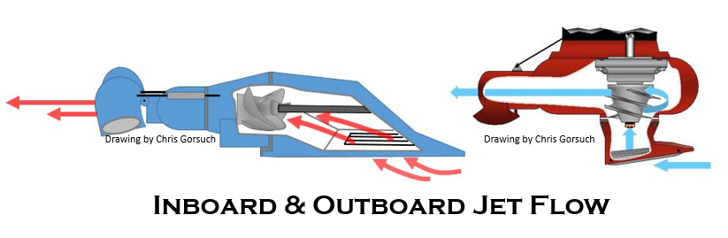

- WEIGHT to POWER Ratio: Here again, the Inboard Jet has it all over its Outboard Jet counterpart. To get an honest 150-250Hp out of the Outboard, the engine itself is going to need to be 200-300Hp before the conversion. The weight in the pump and motor is significantly more with an outboard of comparable power. This is especially true in the Four Stroke environment. Advantage Inboard Jet.

- MAINTENANCE Schedule & Cost: Even though the Inboard does not require the same level of daily maintenance (ie. greasing the pump) the overall maintenance cost to the inboard will be more expensive over the lifetime of the craft. Due to the high RPM speed in Inboard needs to operate at, the service interval to the pump and engine will add cost. Advantage Outboard Jet

- MANUFACTURING Options: After July or 2019, the Inboard Market is once again a one-horse race. Meaning, Mercury has left the Inboard Jet Market and BRP (Bombardier Recreational Products) and its Rotax 150, 200, 250 and soon to be 300Hp Inboard Jet is the only game in town for Production Aluminum Boats. Meanwhile, in the Outboard Jet Market, Honda, Yamaha, Suzuki, Evinrude, Mercury and Tohatsu all offer several outboard models that are compatible with an Outboard Jet Conversion. Advantage Outboard Jet

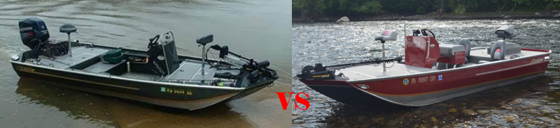

PROS & CONS?

There are clearly pros and cons in each. Speaking solely on production motors with a warranty and new boat construction, the inboards are out of the race for smaller jet craft options and areas that have a Hp Limits (quite common outside of our state). So those planning to build a smaller 14-16’ boats with less than 150HP are not looking at inboard.

Similarly, unlike the Outboard Jet Market, where switching engine manufactures is as simple as swapping the cables, harness and throttle remote. Once the choice is made to go Inboard, that boat is married to that Engine Manufacturer and Jet Pump. It isn’t to say that a Rotax 150Hp has to stay with the 150Hp, but it does have to stay with the Rotax power plant. Converting to another jet manufacture would require a significant amount of modification to the craft..
Written by Chris Gorsuch

