JET

Tunnels

&

Why

Taking advice these days is perhaps riskier than ever. You can blame social media and the internet; but to me, that’s throwing the baby away with the bath water. The bigger issue is that now-a-days, when people have a year or so experience with something, they are suddenly “Subject Matter Experts”. Pick a topic, any topic and do a search for yourself. It is perhaps generational, but quite comical at times.

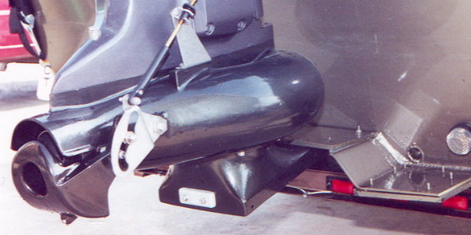Being mentored by some of the true pioneers in shallow water jetting has made me more willing to pass on solid information. Some taught, some seen firsthand and some the old fashion way. If making mistakes are the best teachers, and years of experience the best knowledge, then I’ve had quite an education. Few have made as many mistakes or spent as many days behind the helm as I have. But when you start 200+ days a year by backing a jetboat into the water, you learn a few things. For me personally, the experiences gained from running shallow water jet crafts for nearly 3 decades has made me more cautious and more willing to learn.

***To Tunnel, or NOT to Tunnel- that’s the question.***

Having jetted from Georgia to Maine and as far west as California, I can tell you that rivers are as diverse as people. I have been on rivers that are no more than sand and mud, those that have more wood than rock and those that have more rock showing than water. If all anyone has for experience is 2-3 bodies of water to base their advice, don’t be surprised to get some faulty information. It seems logical that the more a person experiences, the more ‘insight’ they gain.

Misinformation on Jet Tunnels is ramped. Often those who are most vocal, generally have the least experience and frankly offer little value to the conversation. This misinformation and parroting “what they’ve heard” is not always their fault. For years mass produced hull manufacturers and marinas without jet experience, have designed poor performing tunnels and worse yet, rigged outboard jets so poorly it is no wonder jet-tunnels get a bad rap. More on that later.

Those who DO NOT need a jet-tunnel and often have no value to add in the Jet-Tunnel conversation.

* If you run your local river in a non-tunnel hull and have never broken your intake shoe on an outboard jet or damaged the intake grill on your inboard jet. You do not need a jet tunnel.
* If you sell mass produced jet boats and the boat manufacturer(s) that you offer do not come with jet-tunnels. Then your information, advice and bias against jet-tunnels is no value.
* If you build, race or run boats in sandy rivers or flooded fields in excess of 70MPH, that flip over and crash into spectators. What you need a Jet-Tunnel can not fix.

I am hoping there was a chuckle/grin while reading the above, it was purely meant for amusement.

Snyder builds boats to get people from ***Point A*** to ***Point B*** and back. Our focus is rocky, treacherous rivers like the Susquehanna. If you never crack welds or dent the bottom of your mass-produced craft; or crack, break or damage your jet intake, you will not need one of our boats or a jet-tunnel for that matter.

***What is a Jet Tunnel?***

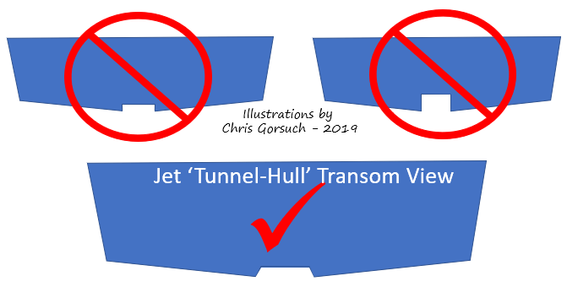A Jet-Tunnel is a short narrow ramp built into the stern of the boat. It allows the jet intake to sit above the bottom of a jet boat adding both protection to the intake and a shallower running craft.

Regardless of Inboard or Outboard Jet, the tunnel is only 2-3” deep depending on the deadrise of the craft at the stern. Deeper tunnels will only cause performance issues and not functional with a jet. The width is based on the size of the intake. For outboard jets, the shoe when turned to the left and right must still be in the opening of the tunnel. If it is too narrow it will blow out on turns and will starve the pump of water. The length should never be more than 2 feet and most are far less that that. Any longer or deeper will hinder the performance.

***Why use a Jet Tunnel?***

From our point of view, the main purpose of a Jet Tunnel is to protect the intake. Our shop isn’t fond of repairing intakes and the rate monthly from non-tunnel hulls is enough to warrant the value of a tunnel hull. In most cases the tunnel allows the intake foot to sit 2-3” higher than a standard hull. So when you are running, the intake sits further out of the water. The advantages are two-fold.

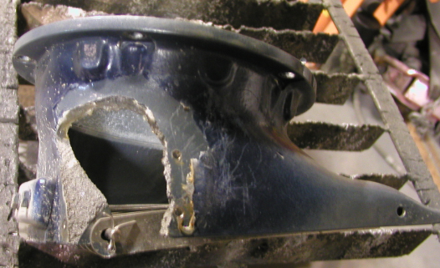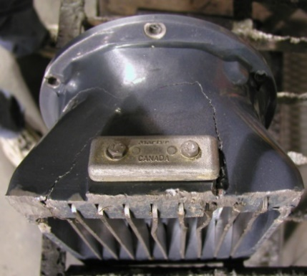***First*** ***Advantage:*** Intake protection and in the case of an outboard jet, both the intake and the shoe are vulnerable. A broken shoe can ruin that weekend outing you’ve been planning for weeks. Why risk it?

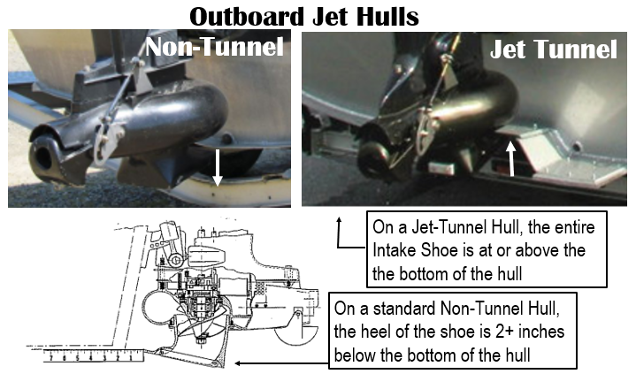***Second Advantage:*** A tunnel allows you to start the boat and take off in less water. As a guide I see this every day in the low water months. I am able to drift my boat further into the shallows before needing to power up and get out of there. This is a huge advantage. In both my Inboard and outboard Jet crafts without tunnels, I needed to be in deeper water or the jet-pump would immediately clog, rendering me DOA.

Net-Net for me are these two simple facts.

1,- A tunnel-hull takes less water to get on plane than a non-tunnel-hull of same size, weight and power. It also runs submerged grass more efficiently.

2.- While both hulls run shallow, the intake on a tunnel-hull is not in as much jeopardy when in extreme shallows. This is especially true on outboard jets,

Now that Jet-Tunnel *Advantages* are listed, what about the downside to a tunnel craft? An added risk of cavitation and loss in reverse propulsion

***Cavitation:***

When making a tight turn or maneuver at high speeds, 40mph or more, a tunnel hull will start to cavitate long before a non-tunnel hull. If pushed further into the turn the pump will lose suction.

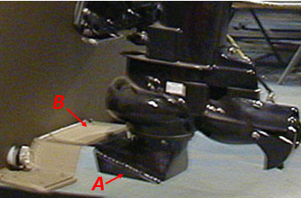***The Fix-***

On an Outboard Jet, a set of Intake Fins ‘***A***’ and a Tunnel Lid ‘**B**’ that extends out to the front of the intake are a must. We fabricate both items in our shop.

Both of these additions aid in directing the flow of water inti the intake.

Note that the upper-front edge of the intake tucks into the Poly Lid of the tunnel extension.

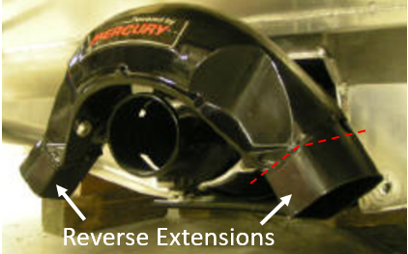***Lack of Reverse Propulsion:***

On the Inboard Jet side of things, when you raise the jet pump more than two inches the angle of the reverse gate outlet throws water into the transom rather than under the boat. The result is extremely poor revers propulsion.

**The Fix-**

Extending the Reverse gate a few inches will direct water back under the hull. It improves the reverse. Other enhancements such as deflectors have shone to further improve reverse on inboard tunnel hulls.

Chris Gorsuch