Dr. MJ Bulbrook is a clinical specialist in psychiatric mental health nursing with over 50 years practicing, teaching, and consulting with nursing, psychotherapy and holistic health/wellness throughout the US, CA, Australia, New Zealand, Peru, and South Africa.
Her energy therapy expertise includes Transform Your Life through Energy Medicine, Integral Health, Healing Touch, Energy Psychology, Touch For Health Transpersonal Psychology

Clinical Session / On-line & In-person DR. MARY JO BULBROOK, RN, CEMP/S/I, HTCP, HTP/I / Phone 1.919.923.2409 Energy Medicine Partnerships / maryjo@energymedicinepartnerships.com / akamaiuniversity.online
PAYMENT FOR SERVICES Thank our for your prompt payment. Please call if you have any questions about the care and information you received from me. ___________________________________________________________________
Client Name: Email: Phone:
Session Date(s): / Setting: Online Zoom Session
Session Fee: 1 hour = $200 ($50 for 15 minutes)
Payment Method check mailed to: Dr. MJ Bulbrook, 3211 Gibson Road, Durham, NC 27703
Presenting Need:
Summary of Session:
Treatment & Follow-up:
Return session:
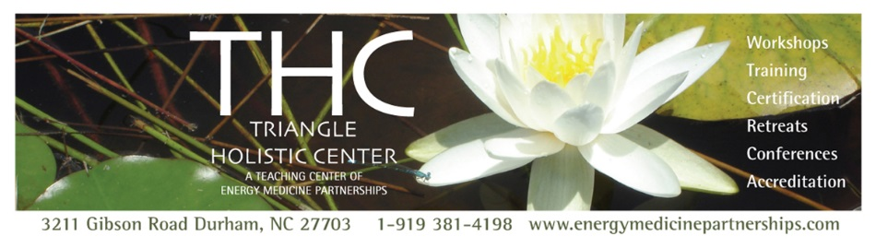
Respectfully submitted, Dr. Mary Jo Bulbrook, RN, CEMP/S/I, HTP/I, CIH/S/-BC

