Embers-guard
Thank you for your purchase of Embers-guard Rooftop Sprinkler system.
Embers-guard Rooftop sprinkler system for wildfire protection against ember attack. Many homes and buildings are burned from direct contact with flames or most often from embers that are blown ahead of the main fire and fall on roofs of homes and buildings, sometimes a long distance from the fire. Ember-S-Guard is designed to wet the rooftop of a building and a portion of the surrounding grounds to help prevent ignition of the building.
This multipurpose portable tool is primarily made to protect your property from ember attack, but can also be used as irrigation for garden and lawns, as well as cooling your roof (or misting your patio), and as an entertainment for kids on a hot days of summer.
Made from solid metal plates, galvanized steel, brass fittings and brass impulse sprinklers. The powder coated finish is electro-statically applied over galvannealed steel, which protects against corrosion and provides a proper base and adhesion for a durable and smooth powder coated finish. This surface is three times more resistant to humidity and salt spray than solvent based painted finishes and it is highly resistant to stains, scratching, scuffing, and corrosion.
Embers-guard™ system is a highly effective tool to help survive a wildfire – together with defensible space and other fire safe measures your home will have a much better chance of survival!

Built to last – no plastic parts!

Ember-Sprinkler-Guard™ (ESG) - is one of the most effective & efficient tools to protect your property from wildfire ember attack.

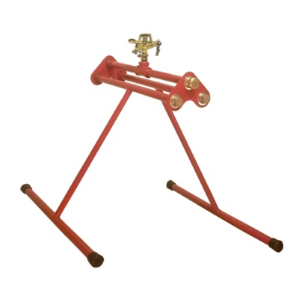  ESG-1 | 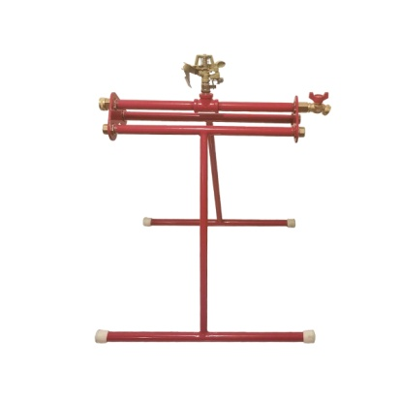  ESG-2 | 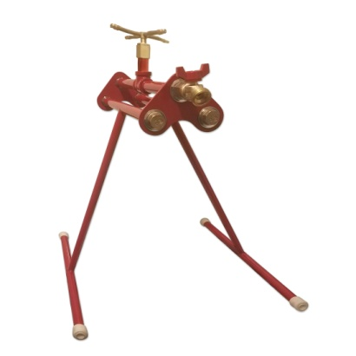  ESG-3

Ember-S-Guard Sprinkler systems are a temporary fire suppression system, they are not designed to put out a fire, but helps prevent ignition.

Fire safety is extremely important and should be taken seriously. Without a proper system in place, you risk losing everything due to fire damage.

Installation Instructions:

Please read the manual in its entirety before installing your Ember-guard unit.
Tools Needed: Crescent Wrench
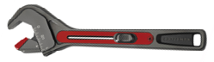
- After opening the shipping box, Tilt down the legs on you Embers-guard unit so it is in standing postion.
- Adjust the stand to your desired angle by loosening the brass hex nuts with a wrench and fasten after the desired postion Embers guard has the flexibility to be opened at a 180 degree flat position or a narrower angle to adjust to your roof position. Refer to the diagrams provided. 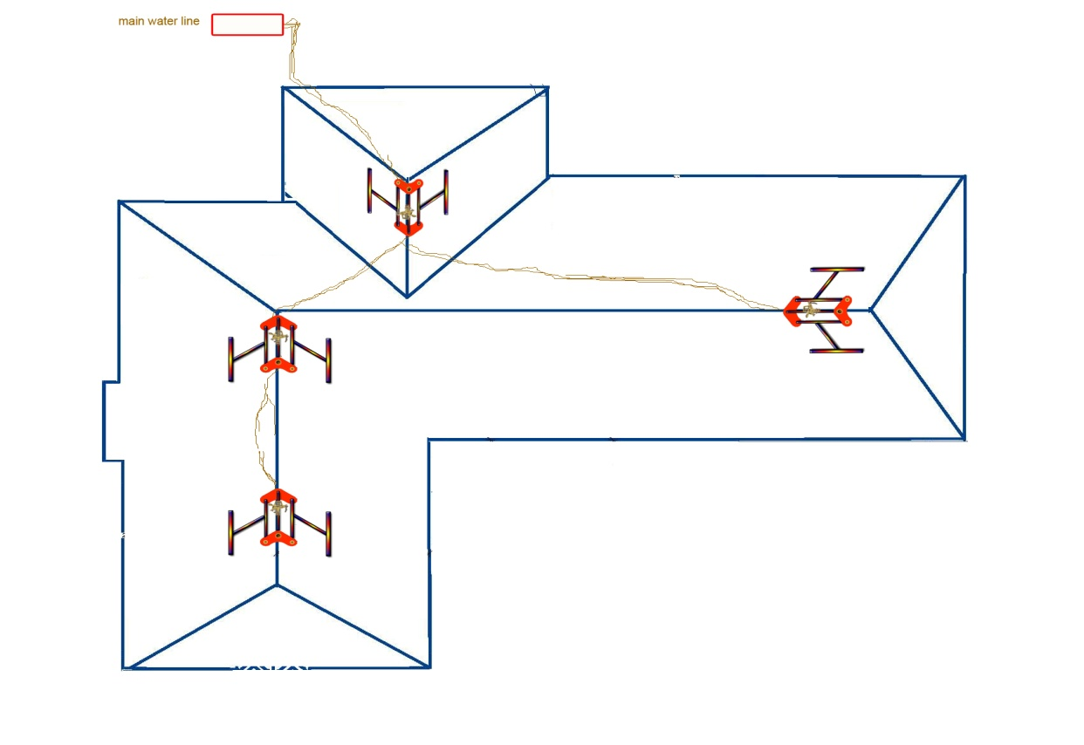

- Tighten the hex nuts after positioning the unit on the roof.
- Check the position of the tab on the sprinkler units if the embers-guard was ordered with an impact sprinkler. Adjusting the tab on the sprinkler to your desired spray position. Refer to sprinkler diagrams.

ADJUSTING THE SPRAY PATTERN.
Two methods can be used to adjust the spray pattern.
a. Part Circle Coverage
Push the trip lever into the DOWN position then adjust the friction collars to the required spray pattern boundaries.
b. Full Circle Coverage Lift the trip lever to the UP position and the sprinkler will water a full 360°
ADJUSTMENT OF THE SPRAY DISTANCE.
The diffuser pin has two functions.
a. To create maximum throw distance with a solid stream of water, ensure the diffuser pin is wound out.
b. To create a shorter throw distance, screw the diffuser pin into the water stream, this will interrupt the flow causing a mist type spray.
c. Deflector Shield: Using the arrows as a guide, turn the distance control knob on top of the sprinkler to either min or max to suit your application.
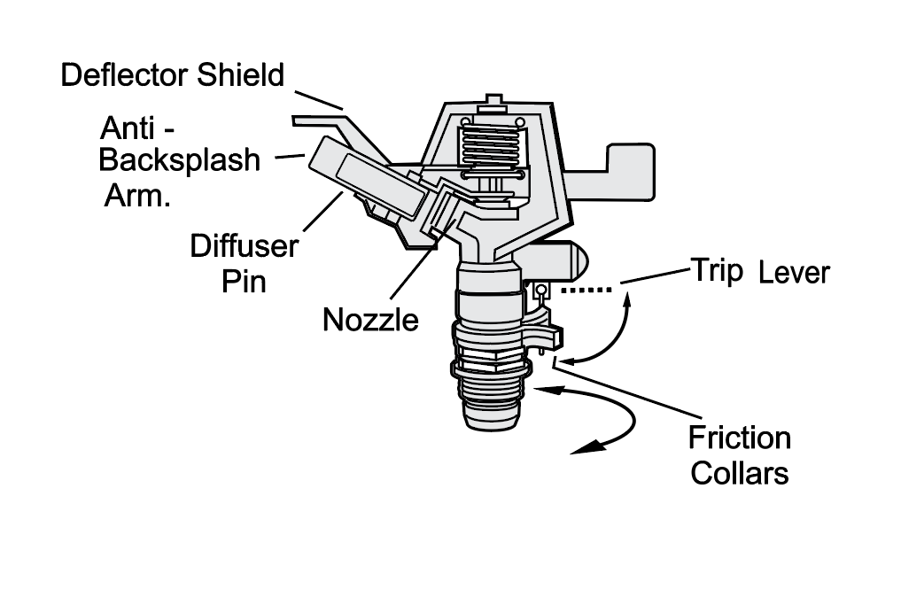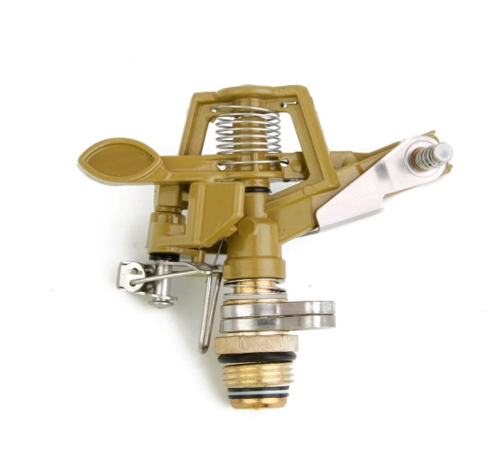

- Connect the water supply with your ordered fire hose or any other appropriate ¾ NPT hose fittings.
- Connecting multiple units, just connect additional hose to the supplied hose Bibb or hose connector.
- Place the units in desired locations and turn on the water source. Adjust the tabs on the sprinkler to achieve desired flow pattern.
- If the unit is placed permanently, test every few months to insure the sprinklers are in working condition. If the temperatures fall below 40 degrees Fahrenheit, disconnect hose.

Sprinklers will not protect your house and the occupant from the fire. This unit is to protect your property from embers.
In case of fire you must evacuate and follow local government instructions.

No apparatus, sprinkler, or device will protect houses, buildings and the occupants from fire.
If embers-guard is installed correctly and there is adequate water source will wet the roof and the surrounding area reducing the risk of your house or building catching fire from the flying embers.
Embers-guard will not protect the building or the occupants from the direct flame or heat.
Purchasers will install the sprinklers at their own risk and will hold harmless, and release and indemnify the manufacturer.
The purchaser will release and indemnify the directors, officers, agents and employees and assign from and against all actual, direct, or indirect alleged claims, demands, loses, and damages, liabilities, suits, actions, and all related expenses or proceedings arising under any statue or common law.
The purchasers installing and operating this system release and indemnify the manufacturer from any suits or actions in connection with injury or death of any person or destruction of any real or personal property from installation, operation or performance of the unit.
Manufacturer is not responsible for water flow to sprinkler in any event.
www.embersguard.com
www.rooftopsprinkler.com

