Automated Payment Processing Procare
SOLUTIONS Safe. Convenient. Easy.
We are excited to offer the safety, convenience and ease of Tuition Express@—a payment processing system that allows secure, on-time tuition and fee payments to be made from either your bank account or credit card.
ELECTRONIC FUNDS TRANSFER AUTHORIZATION FOR BANK ACCOUNT AND CREDIT CARD
I (we) hereby authorize (business name) to initiate credit card charges to the below-referenced credit card account (Section A) OR, initiate debit entries to my (our) checking or savings account, indicated below (Section B). To properly affect the cancellation of this agreement, I (we) are required to give 10 days written notice. Credit union members: please contact your credit union to verify account and routing numbers for automatic payments. Check with the center for accepted credit card types.
COMPLETE ONE SECTION ONLY
SECTION A (Credit card)
Cardholder Name |  | Phone #
Cardholder Address |  | City | State | Zip
Account Number |  | Expiration Date
Cardholder Signature  SECTION B (Bank Account) |  | Date
Your Name |  | Phone #
Address |  | City | State | Zip
Bank or Credit Union Name Bank or Credit Union Address City  Routing Transit Number (see sample below) Account Number (see sample below) |  |  | State  Checking | Zip  O Savings
Authorized Signature Date
Date Received
Employee Signature
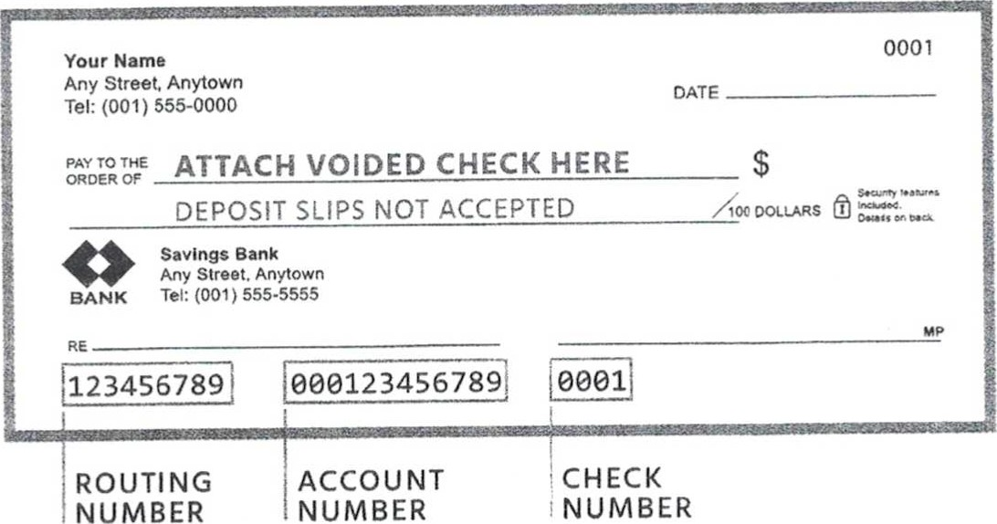
FOR OFFICIAL USE ONLY
800.338.3884 • procaresoftware.com
O Copyright 2020 Procare Software@, LLC

