**RAMAPO REFORMED CHURCH**

## **Fourth Sunday After Epiphany**

## **JANUARY 29th, 2023**

## **Approach to God**

Prelude: *Thy Will Be Done* Music: Anatole Ebongue

Greeting: (Responsively)

L: Our help is in the name of the Lord who made heaven and earth.

***P: Amen.***

Call to Worship:

L: Mighty God, we do not yet seethe glory you plan for all humankind, but in faith we do see Jesus.

***P: We thank you for the humility and holiness in which he lived and died.***

L: We praise you that he freed us from our sin,

***P: that he comforts and strengthens us through our struggles, and that he give us courage to follow him.***

L: For this, we now join with all creation and shout for joy:

***P: Holy, holy, holy are you Lord! Amen***

Prayer

Salutation:

L: Grace, peace, and mercy be yours from God the Father, Jesus Christ, his Son,

and the Holy Spirit always.

***P: Amen.***

*Song of Praise: “You Are Holy” Sing! #20

Sung Prayer of Confession and Words of Assurance: “Nearer, Still Nearer” #659

Passing of the Peace: Leader . . . The Peace of Christ be with you.

***People: And also with you.***

Sing: “Grace, Peace and Love” (see back of bulletin)

Responsive Reading: I Thessalonians 5: 12-24 (Insert)

Music Ministry: Praise Ye the Father Music and Words: Friedrich F. Flemming

**We Experience the Word of God**

Welcome

Prayer for Illumination

Scripture Lesson: Philippians 1: 12-26 pg. 196

**(Response: Thanks are to God!)**

Message for Children

Sermon: “One Way or Another”

Rev. Mary B. Stegink, Pastor

*Hymn: “Take My Life and Let It Be” #863

(Verses 1,3,5 and 6)

**We Respond to God’s Love**

*The Apostles’ Creed (Back of Hymnal)

Offering / Offertory

*Doxology #965

*Prayer of Dedication

Announcements & Prayer Concerns

Prayers of Thanksgiving and Intercession

The Lord’s Prayer

*Closing Praise “My Friends, May You Grow in Grace” #938

*Benediction

Postlude : *Christian Hearts in Love United* Music: Hernhut

__________________

*Indicates where those who are able may stand. Please join us after the service for coffee and refreshments. Kindly fill out a visitor card from the pew rack and place it in the collection plate. If we can be of help, please call the church office at 201-529-3075.

**Grace, Peace and Love**

Grace, Peace and Love my sister, in the name of God.

Grace, Peace and Love my brother, in the name of God.

Grace, Peace and Love be with all of you who are in this place.

Together all gathered, let us praise the Lord.

**ANNOUNCEMENTS**

**OUR ANNUAL MEETING** will take place after worship this morning. .

**SOUPER BOWL OF CARING** – Help fight hunger locally! We will once again be collecting cans of soup in support the “Souper Bowl of Caring.” Our collection will be given to the Center for Food Action in Mahwah. Donations will now be welcomed through February 5th. There are collection boxes in the coffee room.

**A WINTER FELLOWSHIP FAVORITE RETURNS!**  We’ll gather again after service **nex**t **Sunday, February 5th** for a WAFFLE FEST in Fellowship Hall.

**CLOTHING CLOSET**  is open on Wednesdays from 9:30am-12:00pm. Seasonal donations are welcome. Their next bag sale will be on Saturday, March 4th with “Buy One Get One Free.”

**MEN’S FELLOWSHIP** will meet at IHOP in Ramsey on Saturday morning, February 11th at 8:30 a.m. Come out for great food and fellowship!

**WOMEN’S FELLOWSHIP**  will meet again on Sunday, February 19th at 12:30 in Fellowship Hall. Bring your portable lunch and ideas about the coming year. As usual, you can come for a short time or for the whole meeting (about an hour).

**2023 CHURCH DIRECTORY** – If you have an updated address/phone number OR would like to have your email included in the 2023 RRC Directory - please email the changes/additions to Brenda at the church office. Directories will be available in February.

**CHILDREN & WORSHIP** – Our Sunday School program continues into the New Year for children and students ages 3 through 6th grade. They meet in the Education Building following the Message for Children.

**COFFEE HOUR** is a great chance for our community to spend time (and enjoy food and drink) together after church. But we have a shortage of volunteers. If you could take a turn, all you need to bring is milk, juice and something to eat. You take home whatever is left. All the rest will be provided for you (coffee, tea, plates, utensils, etc.) Please sign up on the board leading into the coffee room. Thank you!

***Anchored in the past – Sharing Christ’s message today – Growing in faith into the future!***

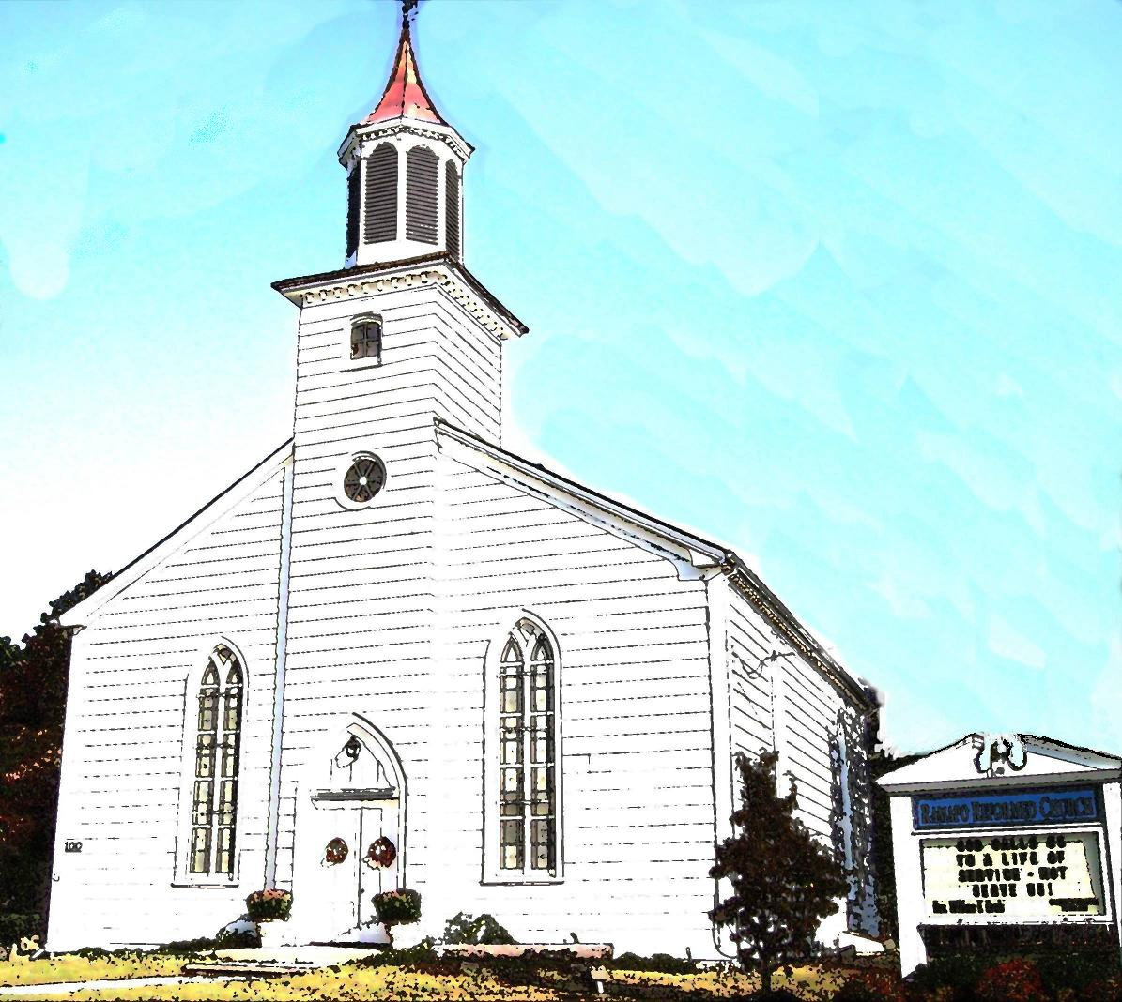

RAMAPO REFORMED CHURCH

100 Island Road, Mahwah

New Jersey 07430

201-529-3075

Rev. Mary B. Stegink, Pastor

[www.ramaporeformed](http://www.ramaporeformed)church.org

**Sunday, January 29, 2023**

**10:30AM**