
Primary Celebration of the Word Assembly Script
First Week of Advent, Year B

Slides | Script | Additional Notes
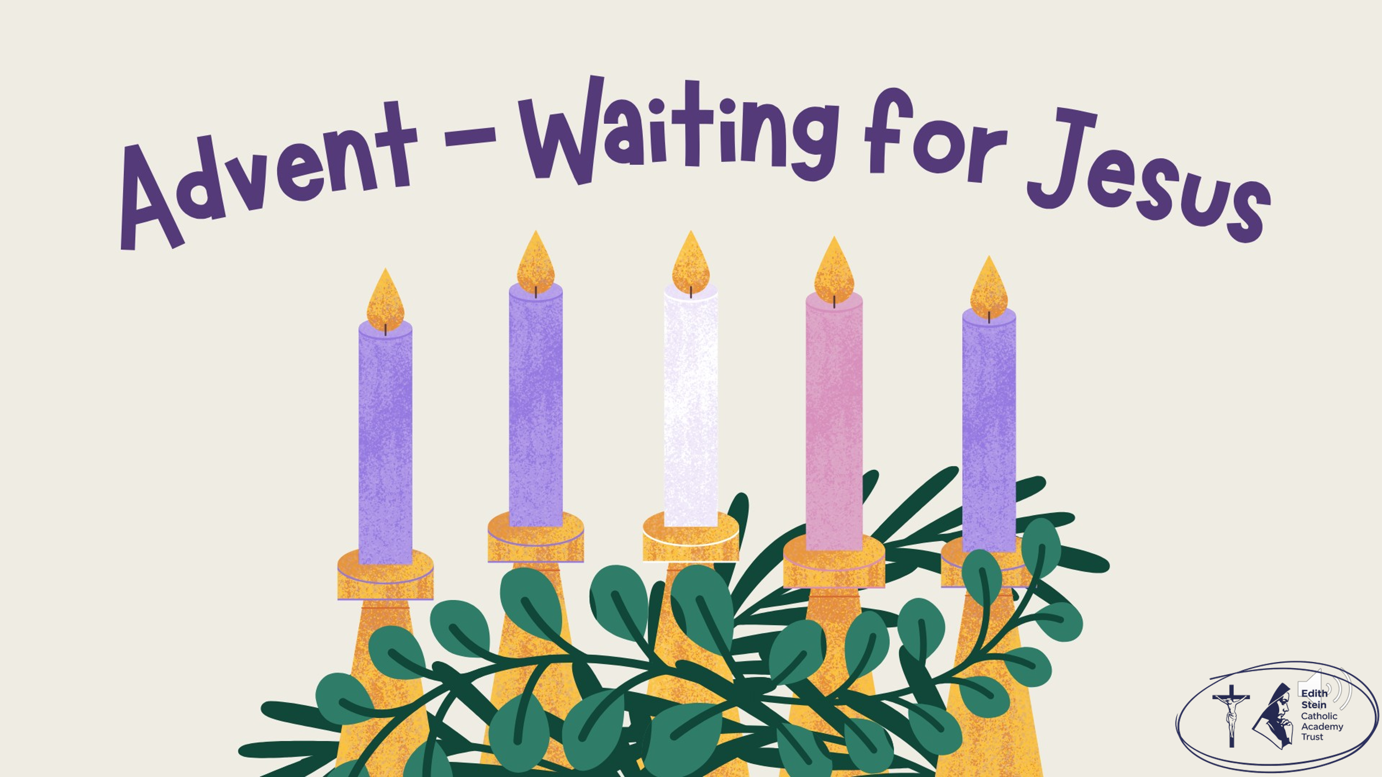 | SIGN OF THE CROSS  Good Morning/Afternoon! | There is some background music on this first slide that you might like to use while staff and children enter the assembly space.  Please check volume levels prior to the start of the assembly.
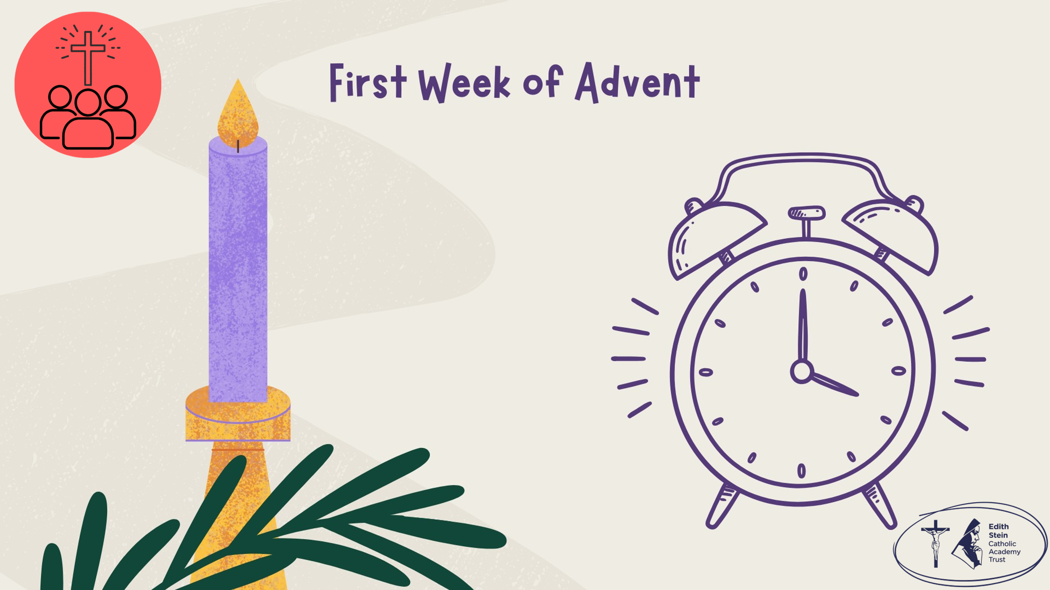 | Begin the assembly by setting a loud alarm on your phone or using the alarm clock. When it goes off, question to children gathered why they think you are using an alarm?  Because Jesus wants us to “WAKE UP!”  Before we hear the Word of God proclaimed, let us start our Advent journey together by lighting the first candle on our Advent Wreath. | Altar or prayer table set up: purple cloth, advent wreath, an old-fashioned alarm clock (if you have one).  A printable of an alarm clock is also available on ESCAT Space.
 | Lighting the Advent Wreath  Lord our God, we praise you for your Son, Jesus Christ:  he is Emmanuel, the hope of the peoples,  he is the wisdom that teaches and guides us,  he is the Saviour of every nation.  Lord God, let your blessing come upon us as we light the candles of this wreath.  May the wreath and its light be a sign of Christ’s promise to bring us salvation.  May he come quickly and not delay. We ask this through Christ our Lord. Amen  First Candle – Hope  Today we light the first candle, the Candle of Hope.  At the beginning of Advent, Jesus invites us to stay awake and be ready for his coming. Hope reminds us that God is always with us, even when life is difficult or uncertain. As we begin our journey to Bethlehem, we ask God to open our eyes to see his love at work in our lives.  Let us pray… | Light the first purple candle on the wreath.
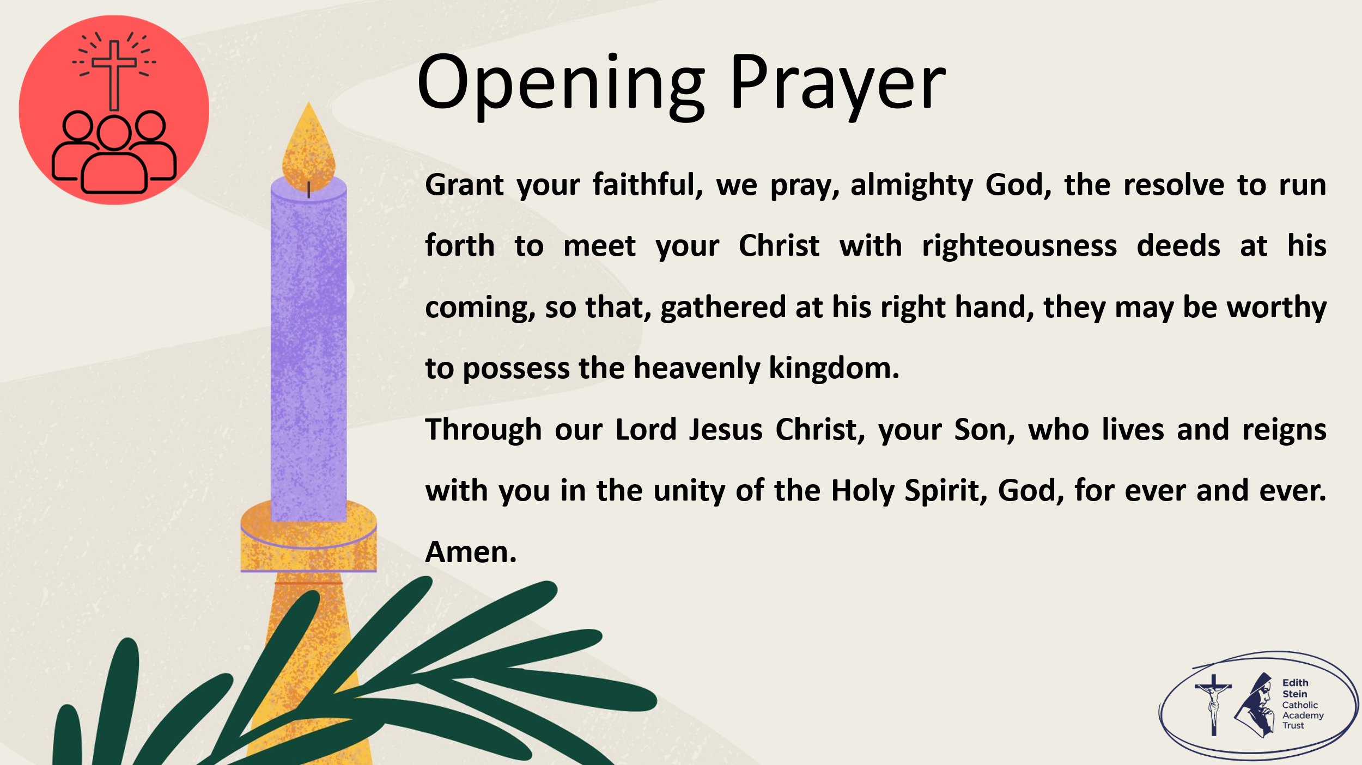 | Grant your faithful, we pray, almighty God, the resolve to run forth to meet your Christ with righteousness deeds at his coming, so that, gathered at his right hand, they may be worthy to possess the heavenly kingdom. Through our Lord Jesus Christ, your Son, who lives and reigns with you in the unity of the Holy Spirit, God, for ever and ever. Amen.  Collect from Mass for the First Sunday of Advent, Year B  Now let us prepare our hearts and minds to hear the Word of God.
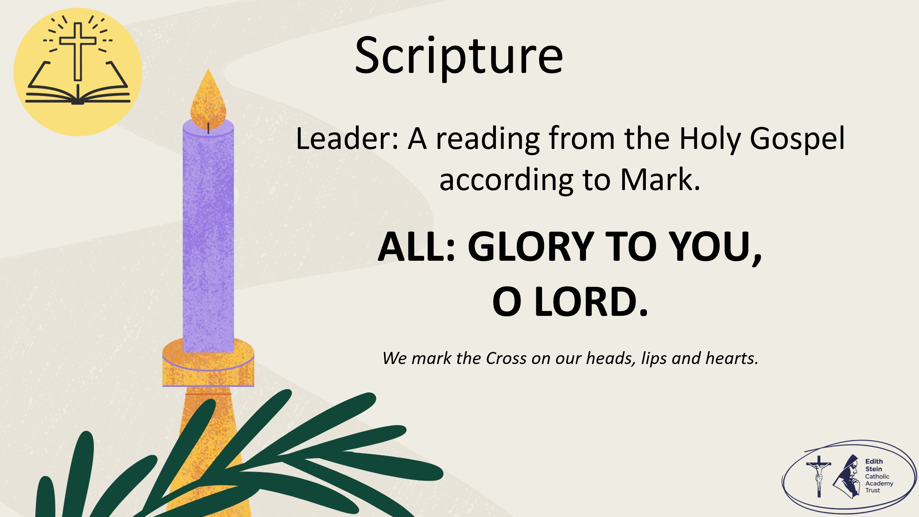 | See below or separate page for Gospel reading, but where possible, proclaim the Word from a Bible or lectionary.  Mark 13:33-37  A reading from the Holy Gospel according to Mark.  ALL: GLORY TO YOU, O LORD. | You may invite everyone to stand to listen to the Word proclaimed.  If you are not already doing so, please ensure that everyone crosses their foreheads, lips and hearts.
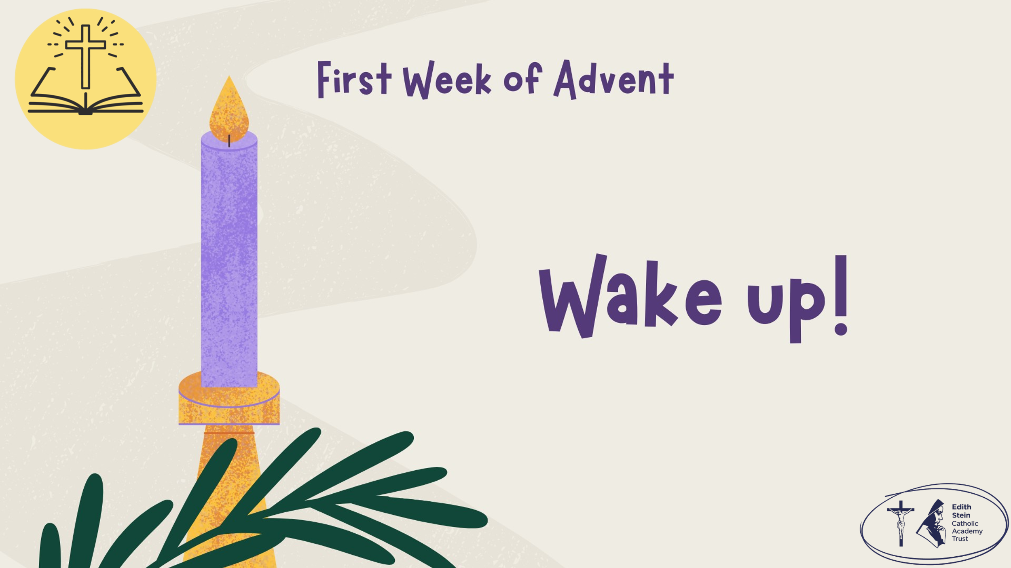 |  | This could be read by staff or student.  Please ensure whoever is proclaiming the Gospel has had appropriate preparation and will proclaim worthily and well.
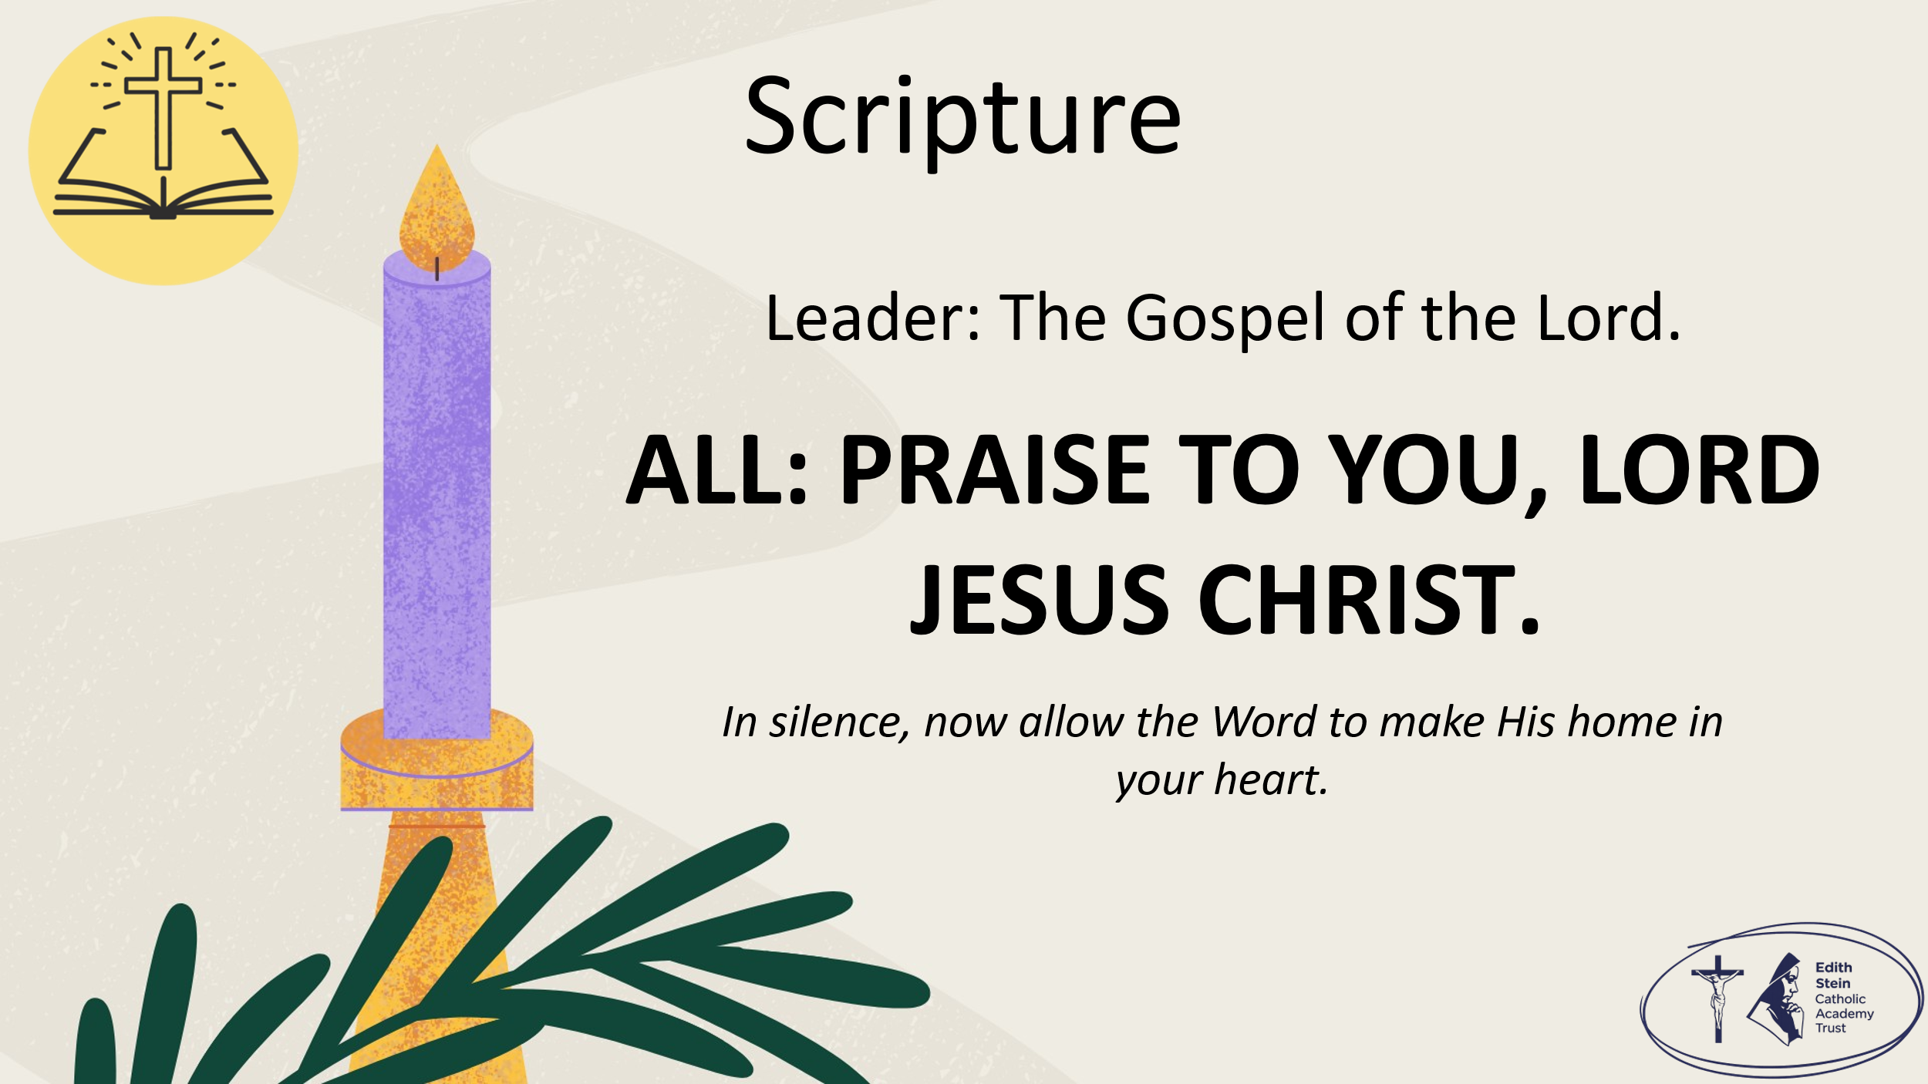 | The Gospel of the Lord.  ALL: PRAISE TO YOU, LORD JESUS CHRIST. | Allow a moment of silence at the end of the Gospel to allow the Word to make His home in everyone’s hearts.  Invite everyone to be seated if they have been standing for the Gospel.
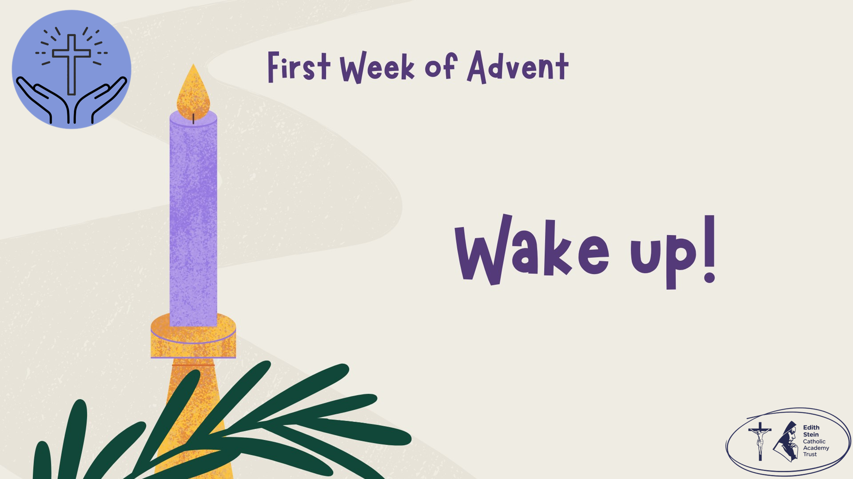 | Reflection  Jesus says, "Stay awake!" At first, that might sound a little strange. Surely, he isn't just talking about staying awake at bedtime! Jesus is talking about something much more important. He wants us to have hearts that are awake, hearts that notice God's love all around us.  Sometimes life can be so busy that we rush from one thing to the next. We forget to stop and notice the beauty of God's creation, the kindness of a friend, or someone who needs our help. Advent is God's gentle wake-up call. It is a time to slow down, to look carefully, and to remember that Jesus is coming to be with us.  As we begin our journey to Bethlehem, let us ask ourselves: What might God be asking me to wake up and notice today?  Have a moment of silence  Let us pray…
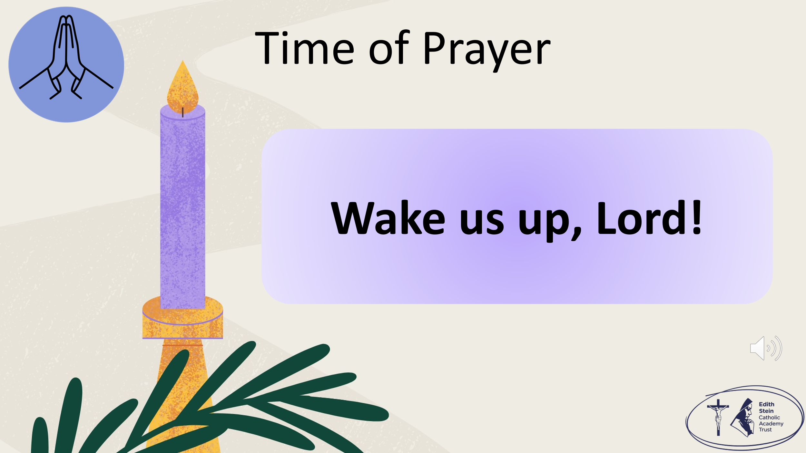 | The response to each line of the litany is,  WAKE US UP, LORD!  When we feel lazy or distracted… wake us up, Lord!  When we feel ungrateful or greedy… wake us up, Lord!  When we forget to notice what is good around us… wake us up, Lord!  When we fail to see your goodness… wake us up, Lord!  When we rush and don’t notice others… wake us up, Lord!  When we overlook someone in need… wake us up, Lord!  When we choose not to listen… wake us up, Lord!  When we miss the opportunity to be kind… wake us up, Lord!  When we forget that you are always close to us… wake us up, Lord!  When we feel tired of trying to do what is right or we want to give up… wake us up, Lord!  When we need hope in our hearts… wake us up, Lord! | There is music on this slide to accompany the time of prayer.
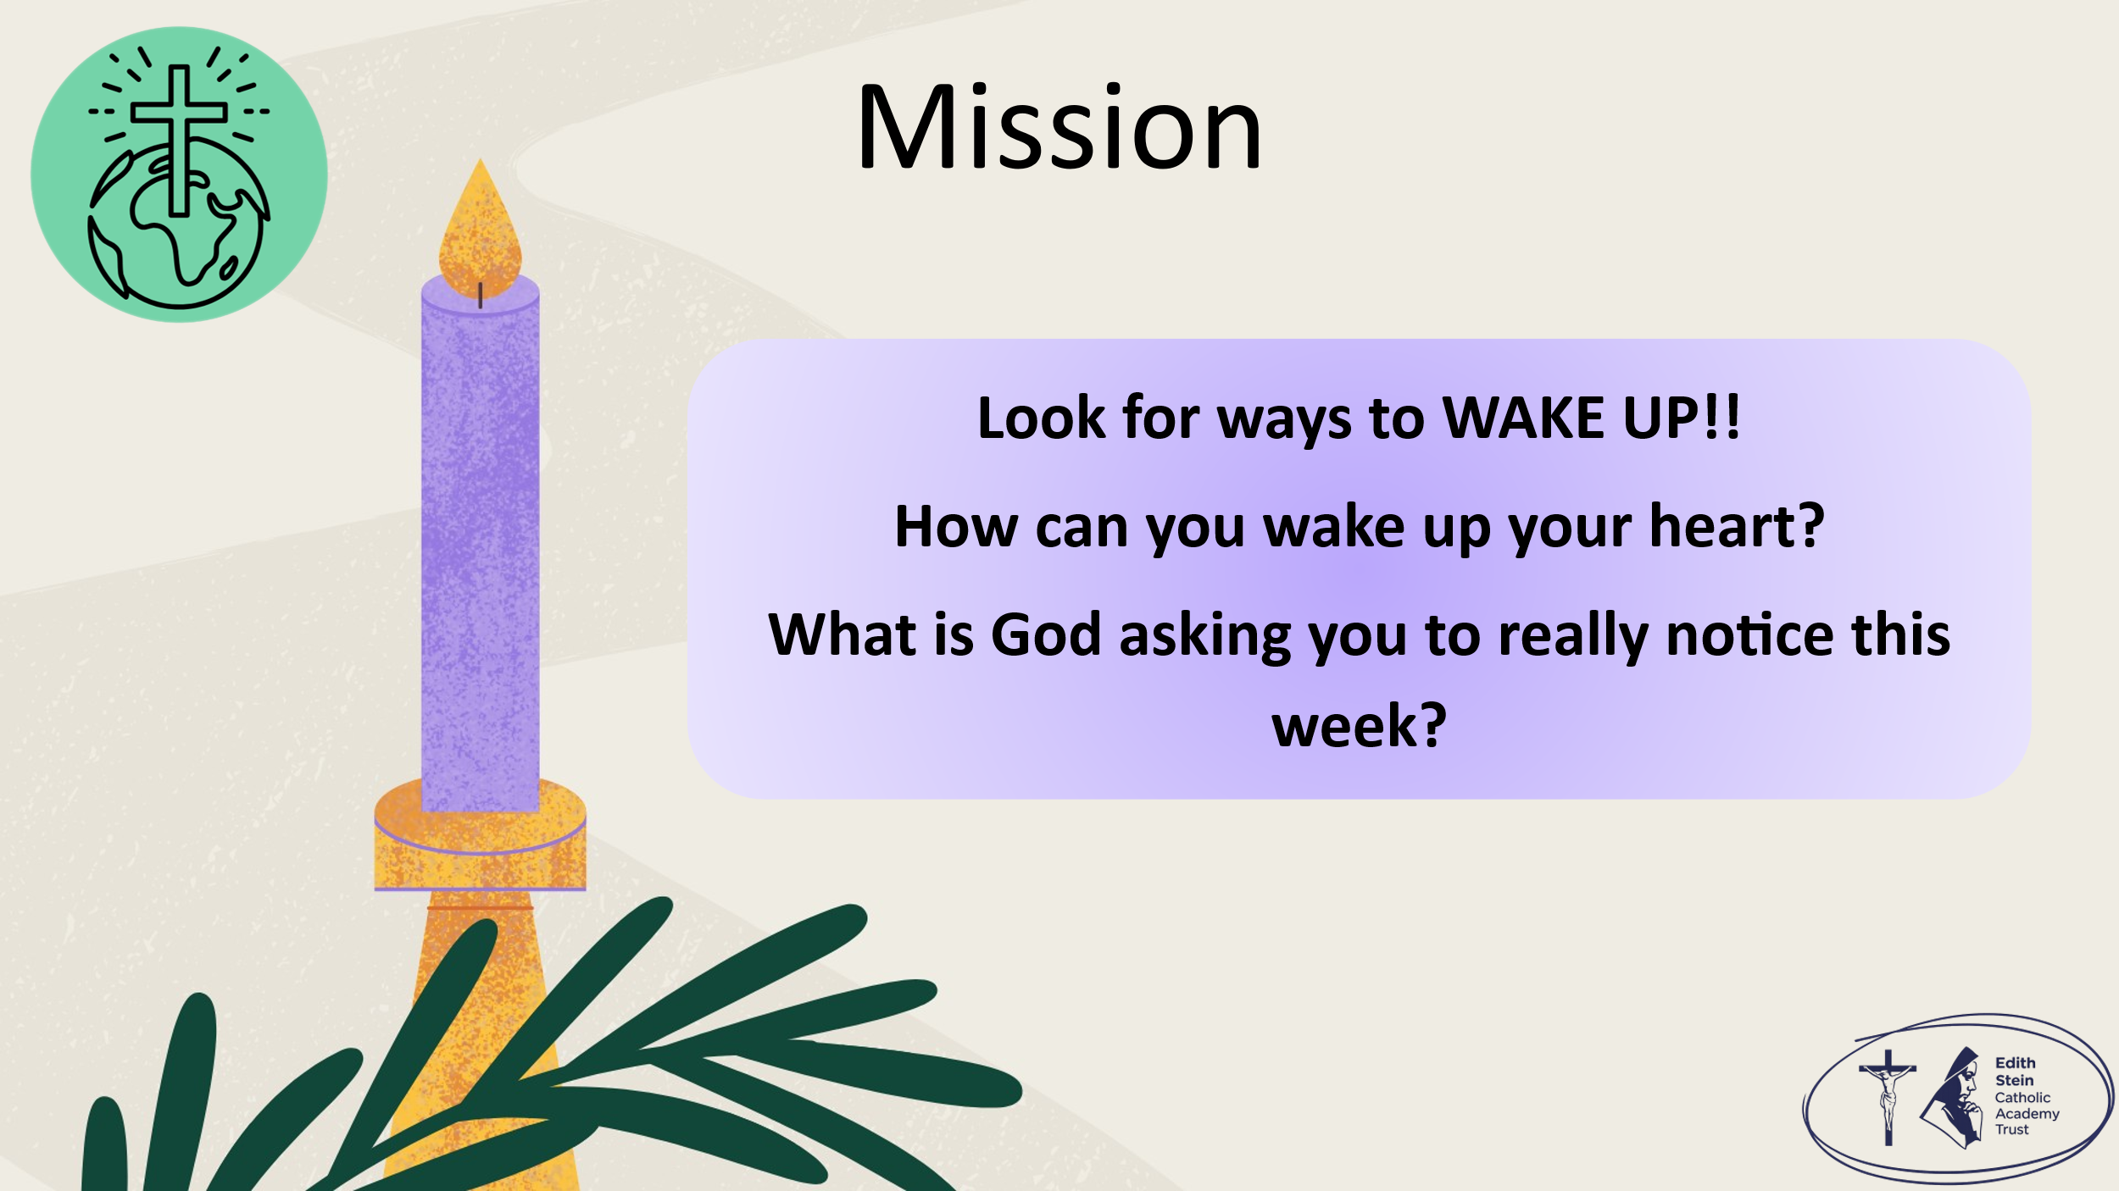 | Before we end in prayer, let us go forth from this time of worship with our mission:  How can you wake up your heart?  What is God asking you to really notice this week?  Remind the students that they will have a chance to make a personal response in their Advent Passport in class.
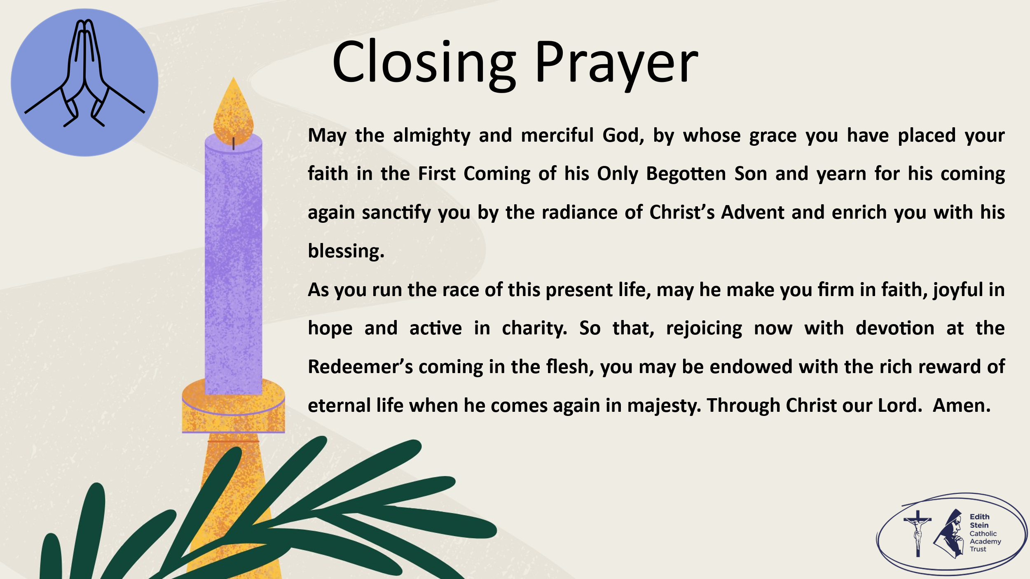 | Solemn Blessing  May the almighty and merciful God, by whose grace you have placed your faith in the First Coming of his Only Begotten Son and yearn for his coming again sanctify you by the radiance of Christ’s Advent and enrich you with his blessing.  As you run the race of this present life, may he make you firm in faith, joyful in hope and active in charity.  So that, rejoicing now with devotion at the Redeemer’s coming in the flesh, you may be endowed with the rich reward of eternal life when he comes again in majesty.  Through Christ our Lord. Amen.  Solemn Blessing for Advent from The Roman Missal  SIGN OF THE CROSS


*Can be read by pupil or staff.

A reading from the Holy Gospel according to Mark.
ALL: Glory to You, O Lord.

Be careful! Always be ready! You don’t know when that time will be. It is like a man who goes on a trip. He leaves his house and lets his servants take care of it. He gives each servant a special job to do. One servant has the work of guarding the door. The man tells this servant always to be watchful. This is what I am now telling you. You must always be ready. You don’t know when the owner of the house will come back. He might come in the evening, or at midnight, or in the early morning, or when the sun rises. He might come back quickly. If you are always ready, then he will not find you sleeping. I tell you this, and I say this to everyone: ‘Be ready!’”

The Gospel of the Lord.
ALL: Praise to You Lord, Jesus Christ.

