
Primary Celebration of the Word Assembly Script
Solemnity of The Epiphany, Year B

Slides | Script | Additional Notes
 | SIGN OF THE CROSS  Good Morning/Afternoon! | There is some background music on this first slide that you might like to use while staff and children enter the assembly space.  Please check volume levels prior to the start of the assembly.
 | ‘Big Reveal’  I am going to slowly reveal a picture. You may try and guess what the picture behind shows.  The children may see/say:  - Pastry  - Crown  - Sugar  - Wheat etc. | The tiles will be removed as you click through the slide. The picture is of a galette des rois.
 | This is a galette des rois, or a king cake. It is a traditional French puff pastry dessert, typically filled with frangipane (almond cream), eaten to celebrate Epiphany in January to commemorate the Three Kings. It often hides a small figurine, or fève, and the person who finds it becomes king or queen for the day, wearing a paper crown. | If you have a cracker crown, you may like to use this as a prop.
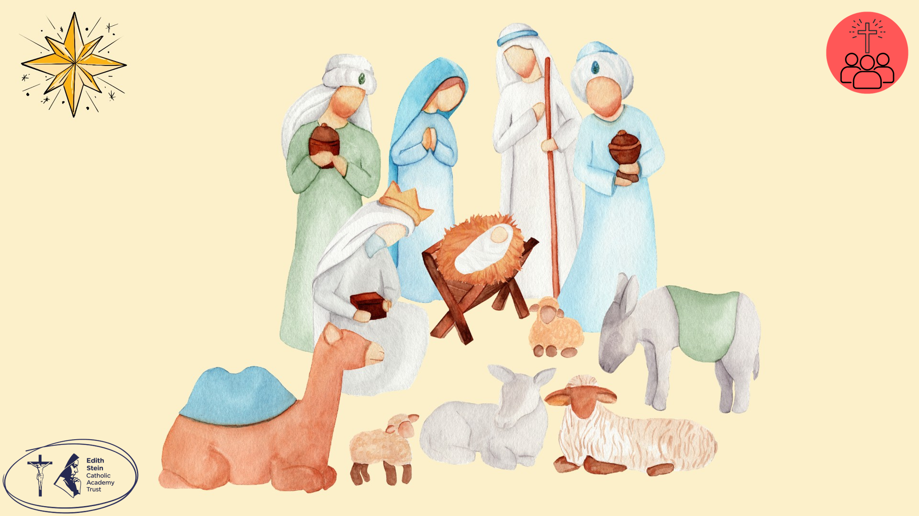 | Today, we are celebrating the great solemnity of the Epiphany. 12 days after Christmas Day, we celebrate the visit of the Wise Men to the baby Jesus. The word Epiphany, which comes from a Greek word, means “a revealing” or “a showing”.
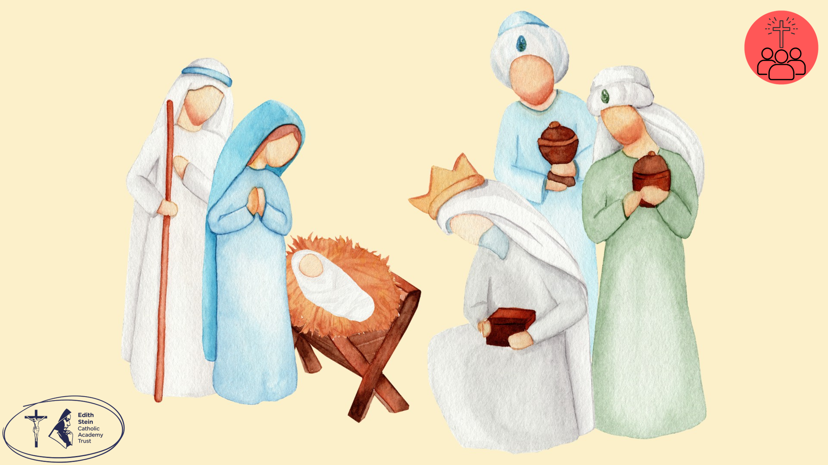 | The visit of the Wise Men (also called the Magi) were important visitors from far away who followed a bright star to find Jesus. When they arrived, they brought special gifts of gold, frankincense and myrrh. You might think these unusual gifts, especially for a baby, but each one had a very important meaning and helped reveal more of who Jesus is.
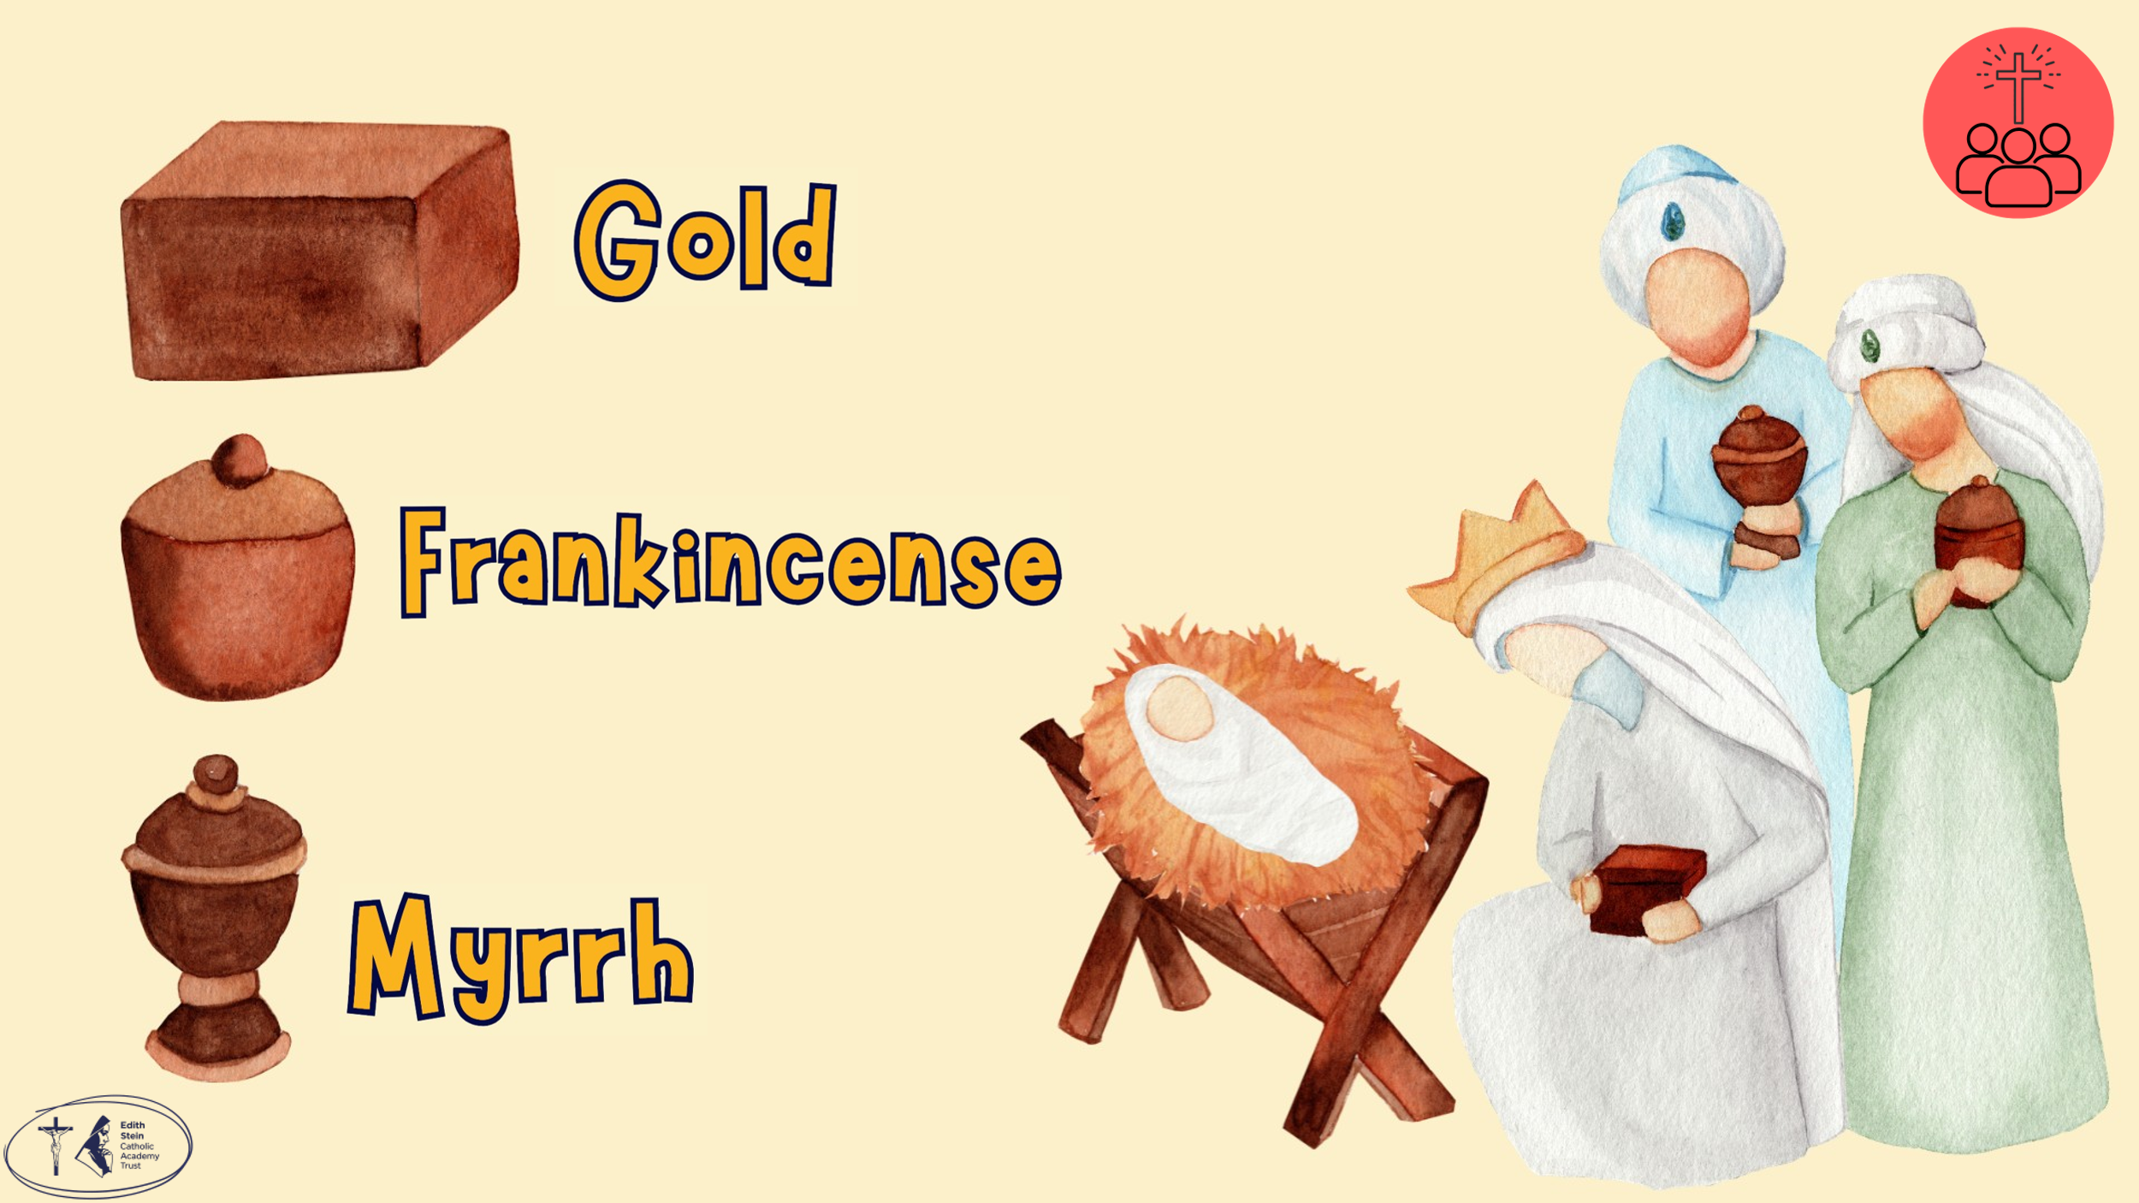 | Gold – this was given to show that Jesus is a King.  Frankincense – was used in worship and was given to show that Jesus is God.  Myrrh – was used to embalm bodies after death and foreshadowed Jesus’ suffering.  The story of the Epiphany also shows that Jesus came for everyone, not just one group of people. The Wise Men weren’t from Jesus’ country, so their visit reminds Christians that Jesus is important for the whole world.  Let us pray… | Each word will appear as you click through the slide.
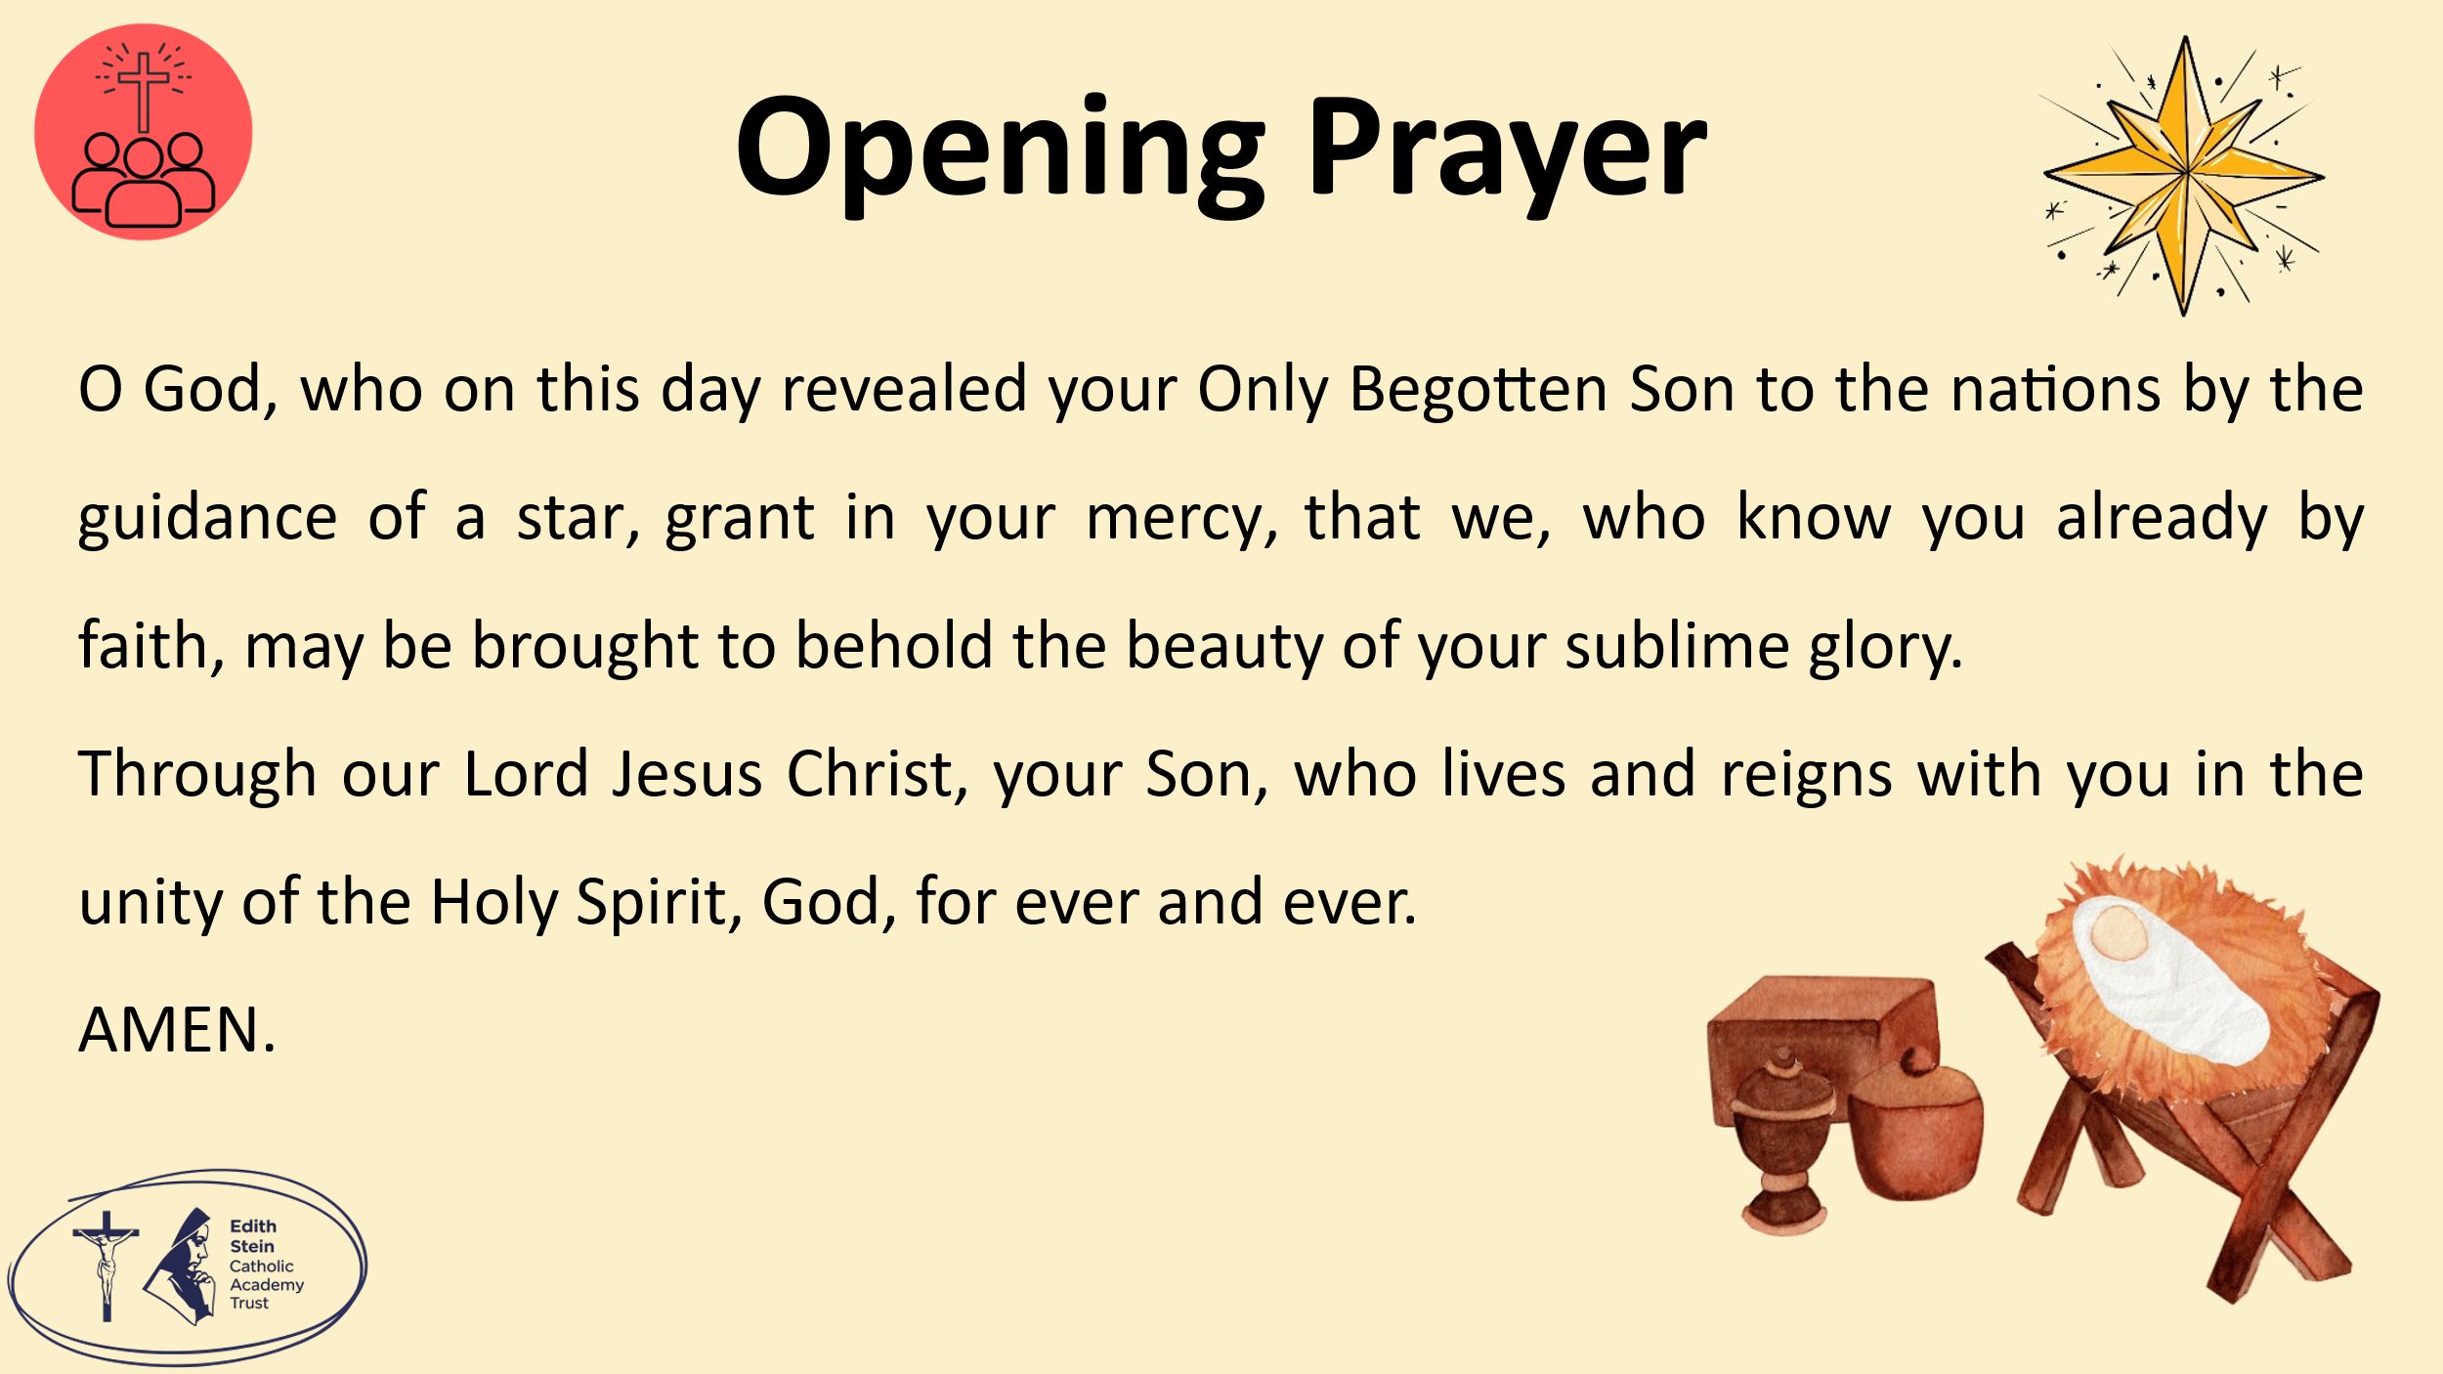 | O God, who on this day revealed your Only Begotten Son to the nations by the guidance of a star, grant in your mercy, that we, who know you already by faith, may be brought to behold the beauty of your sublime glory.  Through our Lord Jesus Christ, your Son, who lives and reigns with you in the unity of the Holy Spirit, God, for ever and ever.  Amen.  Collect from the Mass for the Solemnity of The Epiphany  Let us now prepare to meet the Lord in Sacred Scripture.
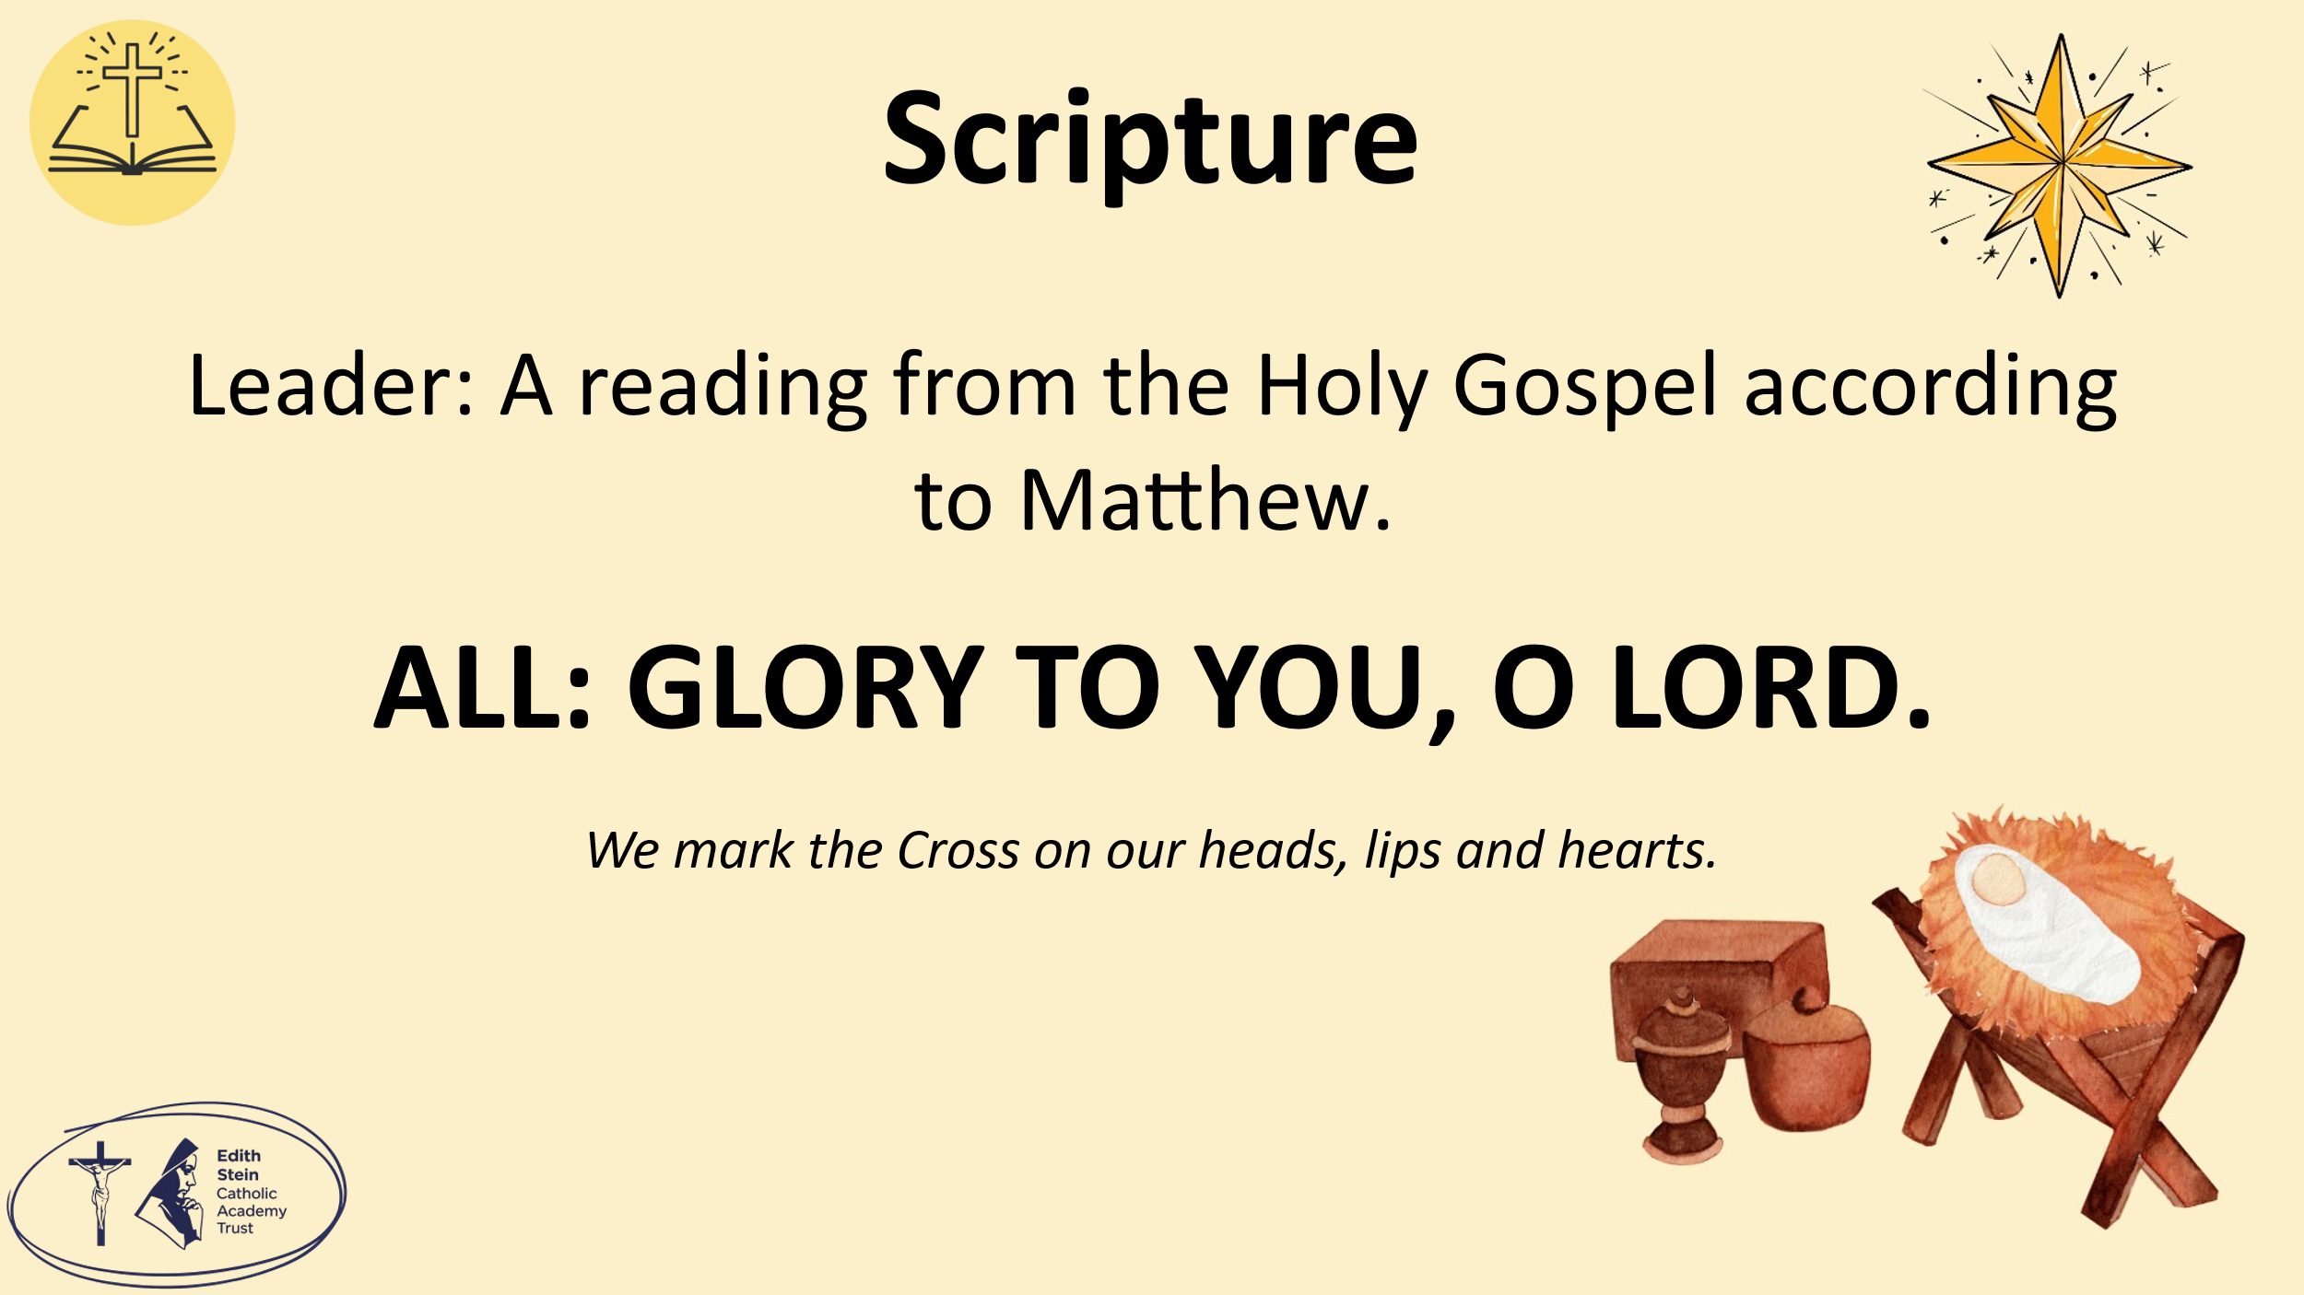 | See below or separate page for Gospel reading.  A reading from the Holy Gospel according to Matthew.  ALL: GLORY TO YOU, O LORD. | You may invite everyone to stand to listen to the Word proclaimed.  If you are not already doing so, please ensure that everyone crosses their foreheads, lips and hearts.
 |  | This could be read by staff or student. Please ensure whoever is proclaiming the Gospel has had appropriate preparation and will proclaim worthily and well.
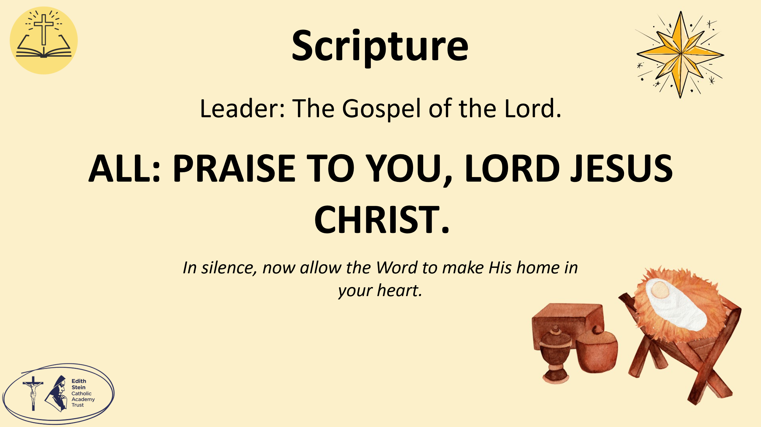 | The Gospel of the Lord.  ALL: PRAISE TO YOU LORD, JESUS CHRIST. | Allow a moment of silence at the end of the Gospel to allow the Word to make His home in everyone’s hearts.  Invite everyone to be seated if they have been standing for the Gospel.
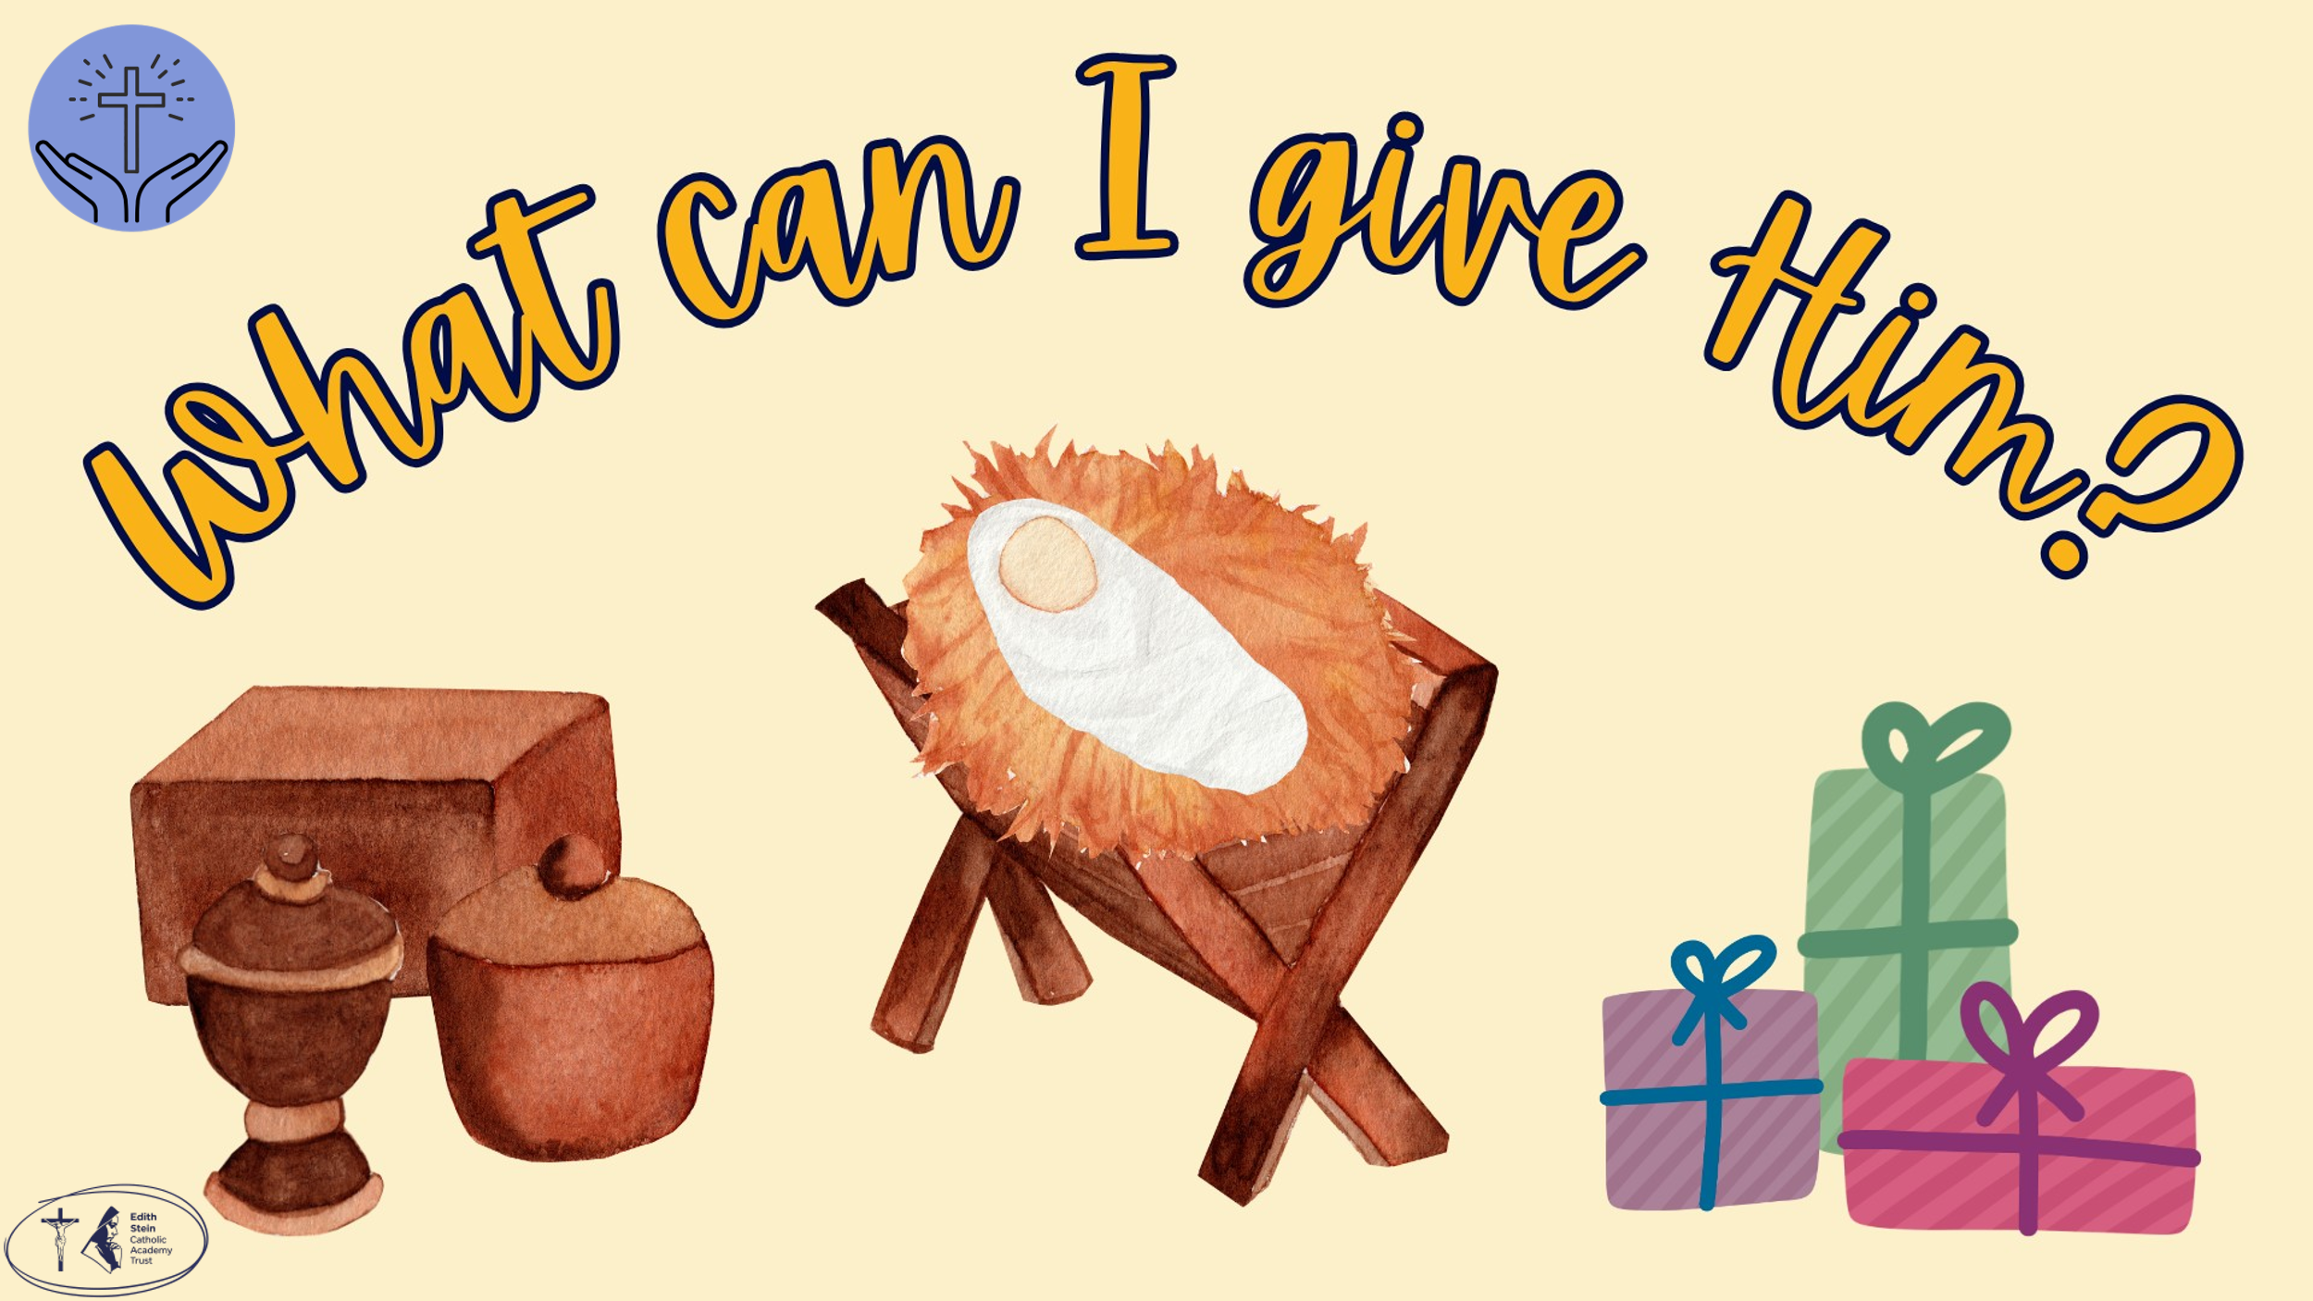 | What can I give Him,  Poor as I am?  If I were a Shepherd  I would bring a lamb;  If I were a Wise Man  I would do my part,  Yet what I can I give Him,  Give my heart.  This is the final verse of a much-beloved Christmas carol, ‘In the Bleak Midwinter’. The carol reminds us that Jesus was born into a cold, quiet, and simple world. There were no palaces or riches—just a stable, a baby, and a few visitors. Yet at the Epiphany, we see something amazing: even in that simple place, Jesus is recognised as someone truly special.  The Wise Men didn’t bring toys or ordinary presents; they brought gifts for a king. They saw what others might have missed: that this small baby was God’s Son, sent for everyone.  The carol ends by asking: “What can I give him, poor as I am?”  As we celebrate the Epiphany, we are invited to ask the same question. We may not have gold, frankincense or myrrh, but we can still give something just as important… our kindness, our love, and our hearts.  So just like the Wise Men, we are called to recognise Jesus and to respond with the best gift we can give: ourselves.  Let us now turn to the Lord in prayer to give Him our hearts as a gift. | Optional… this could be sung or played to the children from YouTube.
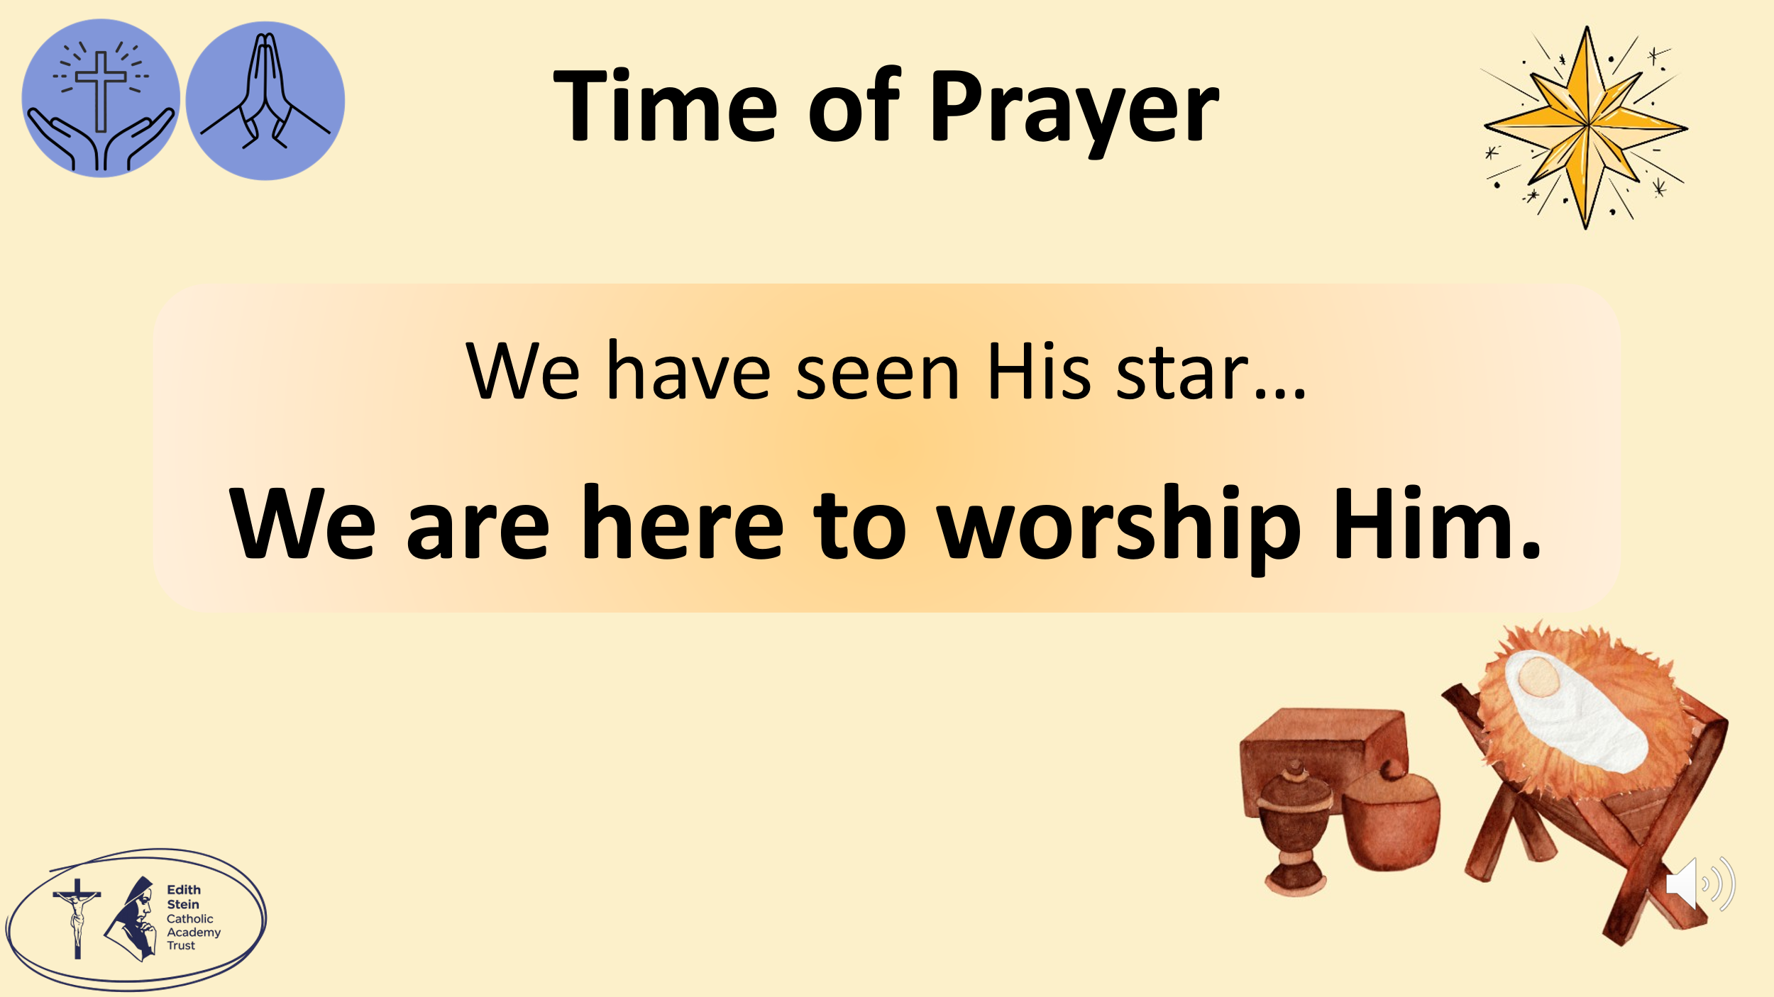 | The response to We have seen His star is… we are here to worship Him.  We have seen His star… we are here to worship Him.  Jesus was born in the town of Bethlehem… thank You, Jesus, for coming to be with us and living our life. Thank you for Your birth in Bethlehem. We have seen His star… we are here to worship Him.  Some wise men from the east came to Jerusalem… Lord we pray for all those wise people in our own lives who teach and guide us. We have seen His star… we are here to worship Him.  We saw his star in the east… We pray that we will always recognise the glory of God in our lives, shining brightly. We have seen His star… we are here to worship Him.  “We came to worship him” … Lord, help us to worship You with sincere hearts. May all that we say and do praise Your Holy Name. We have seen His star… we are here to worship Him.  They saw the same star they had seen in the east. It went before them until it stopped above the place where the child was… We pray that the Lord will send us our own stars to lead us closer to Him. We have seen His star… we are here to worship Him.  When the wise men saw the star, they were filled with joy… We pray that as we draw closer to the Lord, and seek Him in our lives, we too will be filled with incredible joy. We have seen His star… we are here to worship Him.  They went to the house where the child was and saw him with his mother, Mary… We pray that Mother Mary will always be close to us and direct us towards her Son. We have seen His star… we are here to worship Him.  They opened the gifts they brought for him… help us, Lord, to share our own gifts with You and with those around us. We have seen His star… we are here to worship Him.  They gave him treasures of gold, frankincense, and myrrh… Lord, You are our greatest treasure, help us to love you more. We have seen His star… we are here to worship Him.
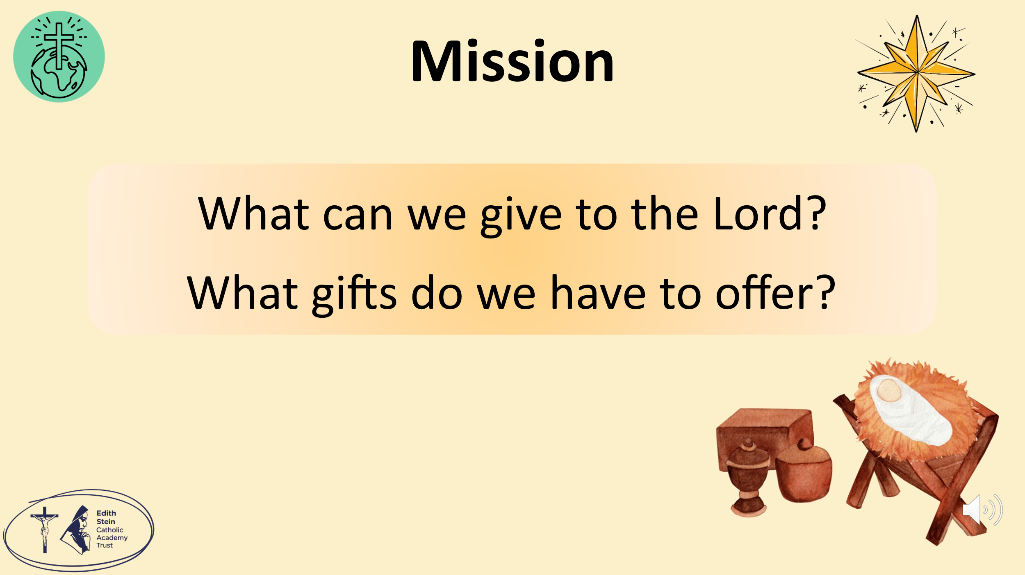 | So as we go from this time of worship, let us think about what gifts we can off to the Baby Jesus.  Let us pray… | The children will have more time to respond and reflect with the optional class worship.
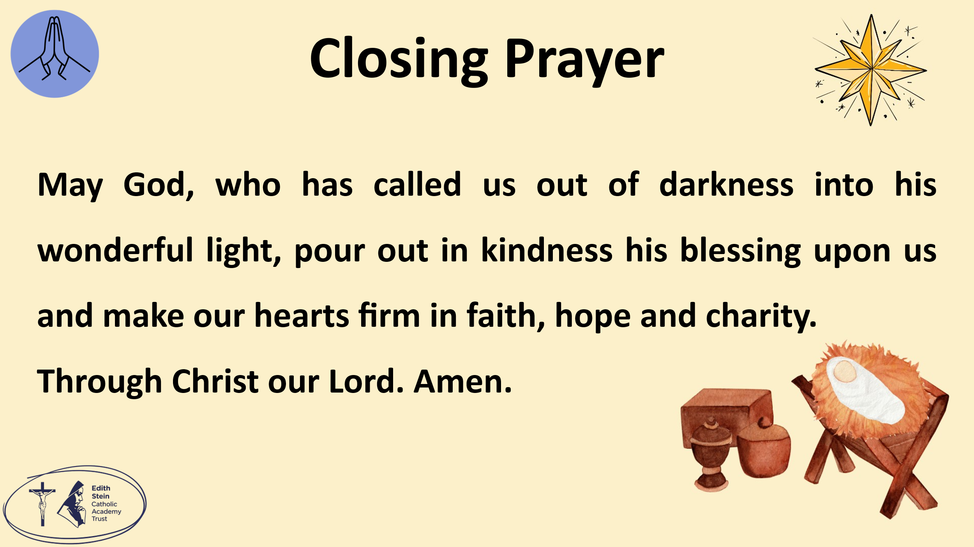 | May God, who has called us out of darkness into his wonderful light, pour out in kindness his blessing upon us and make our hearts firm in faith, hope and charity. Amen.  SIGN OF THE CROSS

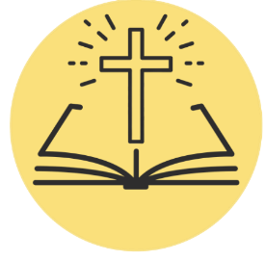
*Can be read by pupil or staff.

A reading from the Holy Gospel according to Matthew.
ALL: Glory to You, O Lord.

Jesus was born in the town of Bethlehem in Judea during the time when Herod was king. After Jesus was born, some wise men from the east came to Jerusalem. They asked, “Where is the baby who was born to be the king of the Jews? We saw his star in the east. We came to worship him.”
Herod sent the wise men to Bethlehem. He said to them, “Go and look carefully to find the child. When you find him, come tell me. Then I can go worship him too.”
The wise men heard the king and then left. They saw the same star they had seen in the east. It went before them until it stopped above the place where the child was. When the wise men saw the star, they were filled with joy. They went to the house where the child was and saw him with his mother, Mary.
They bowed down and worshiped the child. They opened the gifts they brought for him. They gave him treasures of gold, frankincense, and myrrh. But God warned the wise men in a dream not to go back to Herod. So they went home to their own country by a different way.

The Gospel of the Lord.
ALL: Praise to You Lord, Jesus Christ.

