
Primary Celebration of the Word Assembly Script
Third Week of Advent, Year B

Slides | Script | Additional Notes
 | SIGN OF THE CROSS  Good Morning/Afternoon! | There is some background music on this first slide that you might like to use while staff and children enter the assembly space.  Please check volume levels prior to the start of the assembly.
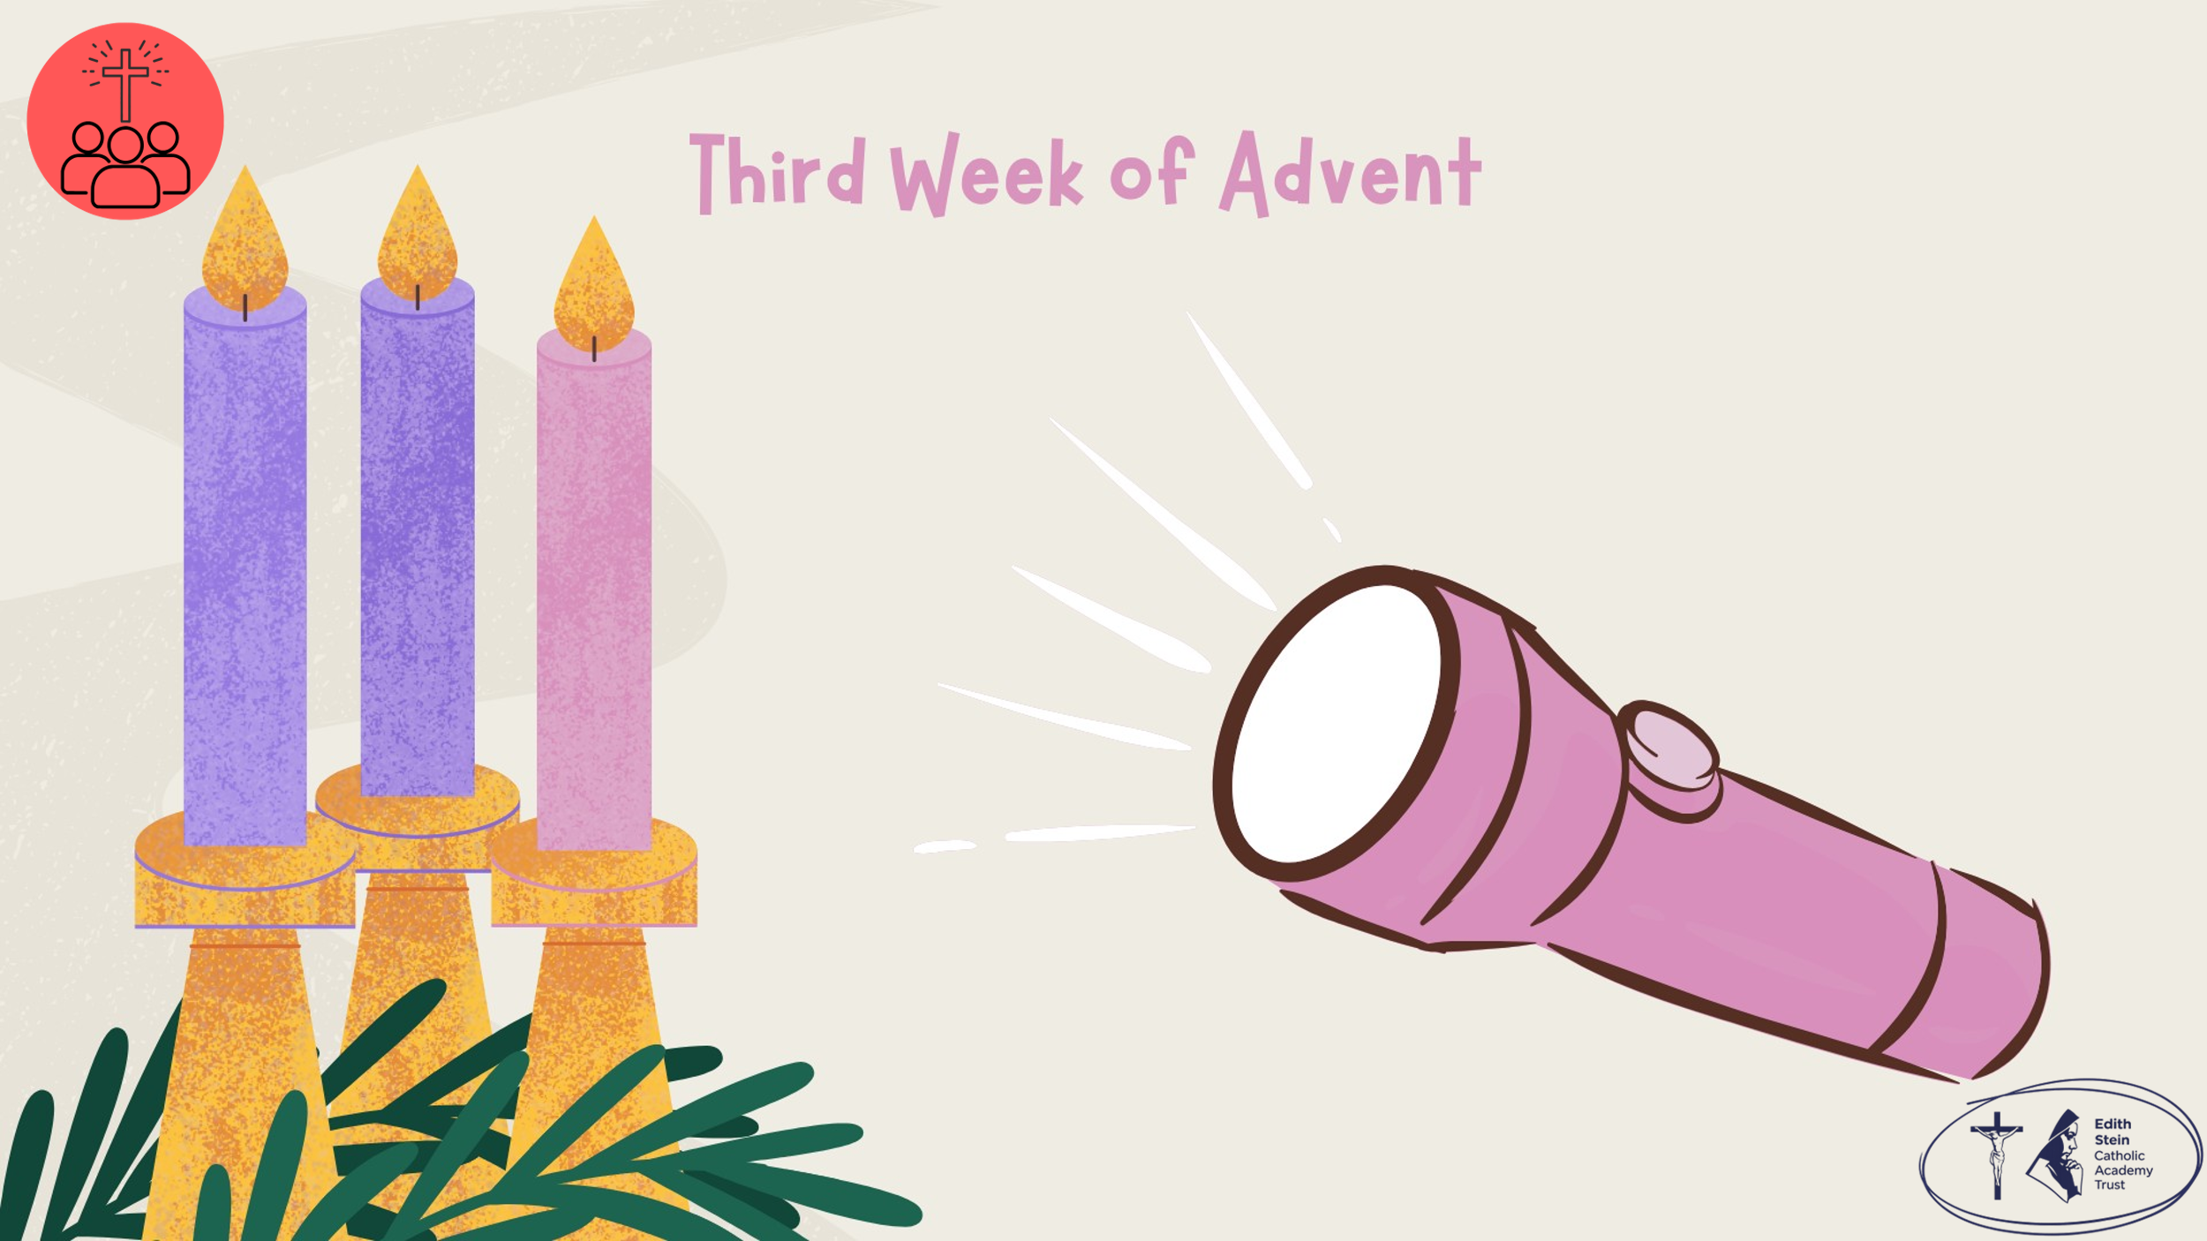 | Begin the assembly by switching the torch on and shining it around the room. Might be nice to have the room in darkness. Ask the children why they think you have a torch this week.  Because Jesus is the light of the world!  Before we hear the Word of God proclaimed, let us continue our Advent journey together by lighting the third candle on our Advent Wreath. | Purple cloth, advent wreath, the alarm clock and a large map from previous weeks, and a large torch.  (Printables of alarm clock, map and torch available from ESCAT Space).
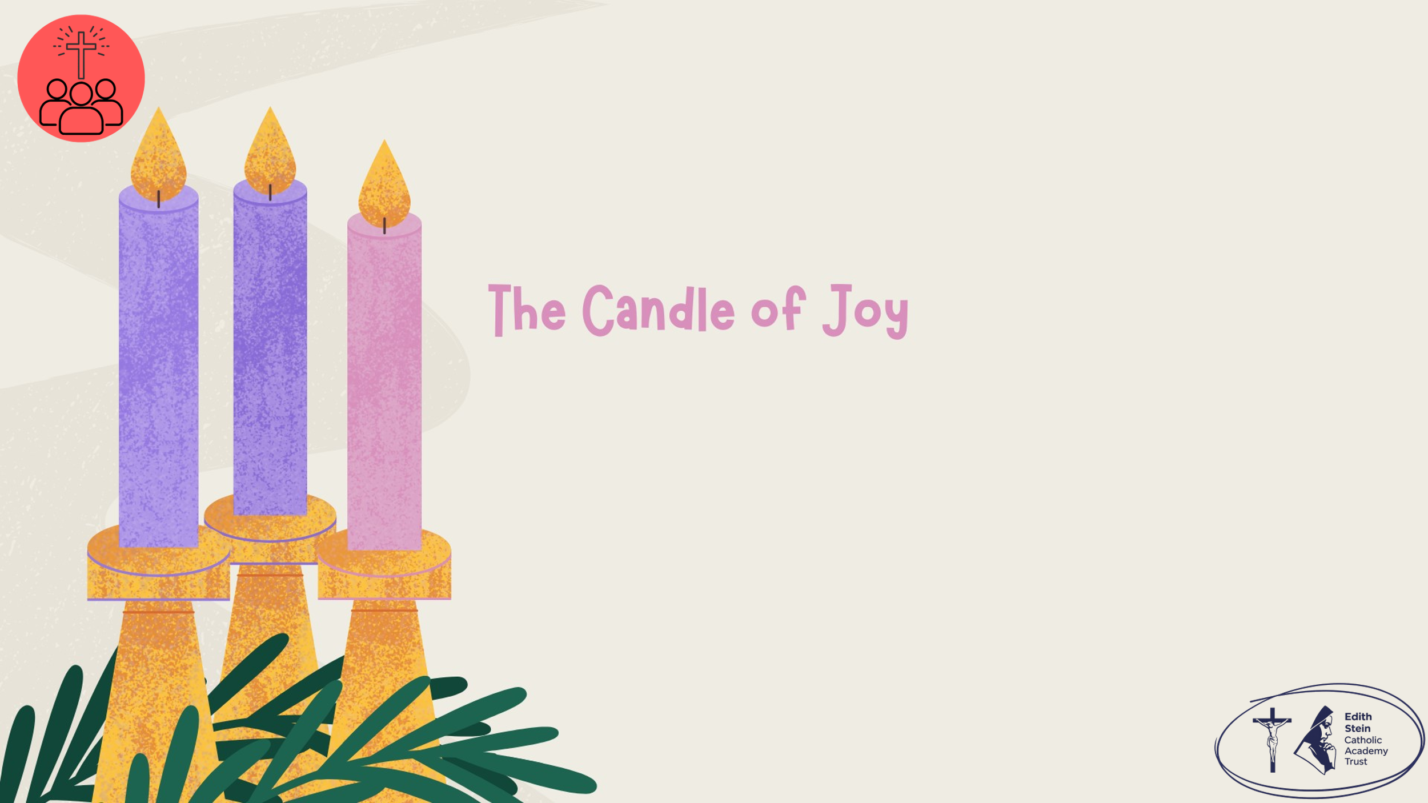 | Lighting the Advent Wreath  Lord our God, we praise you for your Son, Jesus Christ:  he is Emmanuel, the hope of the peoples,  he is the wisdom that teaches and guides us,  he is the Saviour of every nation.  Lord God, let your blessing come upon us as we light the candles of this wreath.  May the wreath and its light be a sign of Christ’s promise to bring us salvation.  May he come quickly and not delay. We ask this through Christ our Lord. Amen  Third Candle – Joy  Today we light the third candle, the Candle of Joy.  John the Baptist came to point people towards Jesus, the Light of the World. We are called to do the same. When we smile, encourage others, share what we have and live with kindness, we shine Christ's light wherever we go.  Let us pray… | Light the first and second purple candles and the pink candle on the wreath.
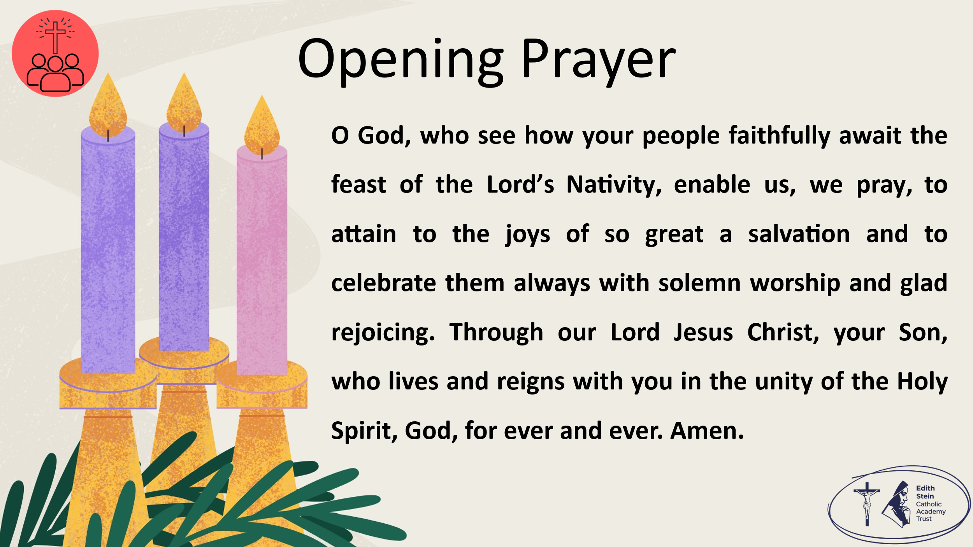 | O God, who see how your people faithfully await the feast of the Lord’s Nativity, enable us, we pray, to attain to the joys of so great a salvation and to celebrate them always with solemn worship and glad rejoicing. Through our Lord Jesus Christ, your Son, who lives and reigns with you in the unity of the Holy Spirit, God, for ever and ever. Amen.  Collect from the Mass for Third Sunday of Advent, Year B  Now let us prepare our hearts and minds to hear the Word of God.
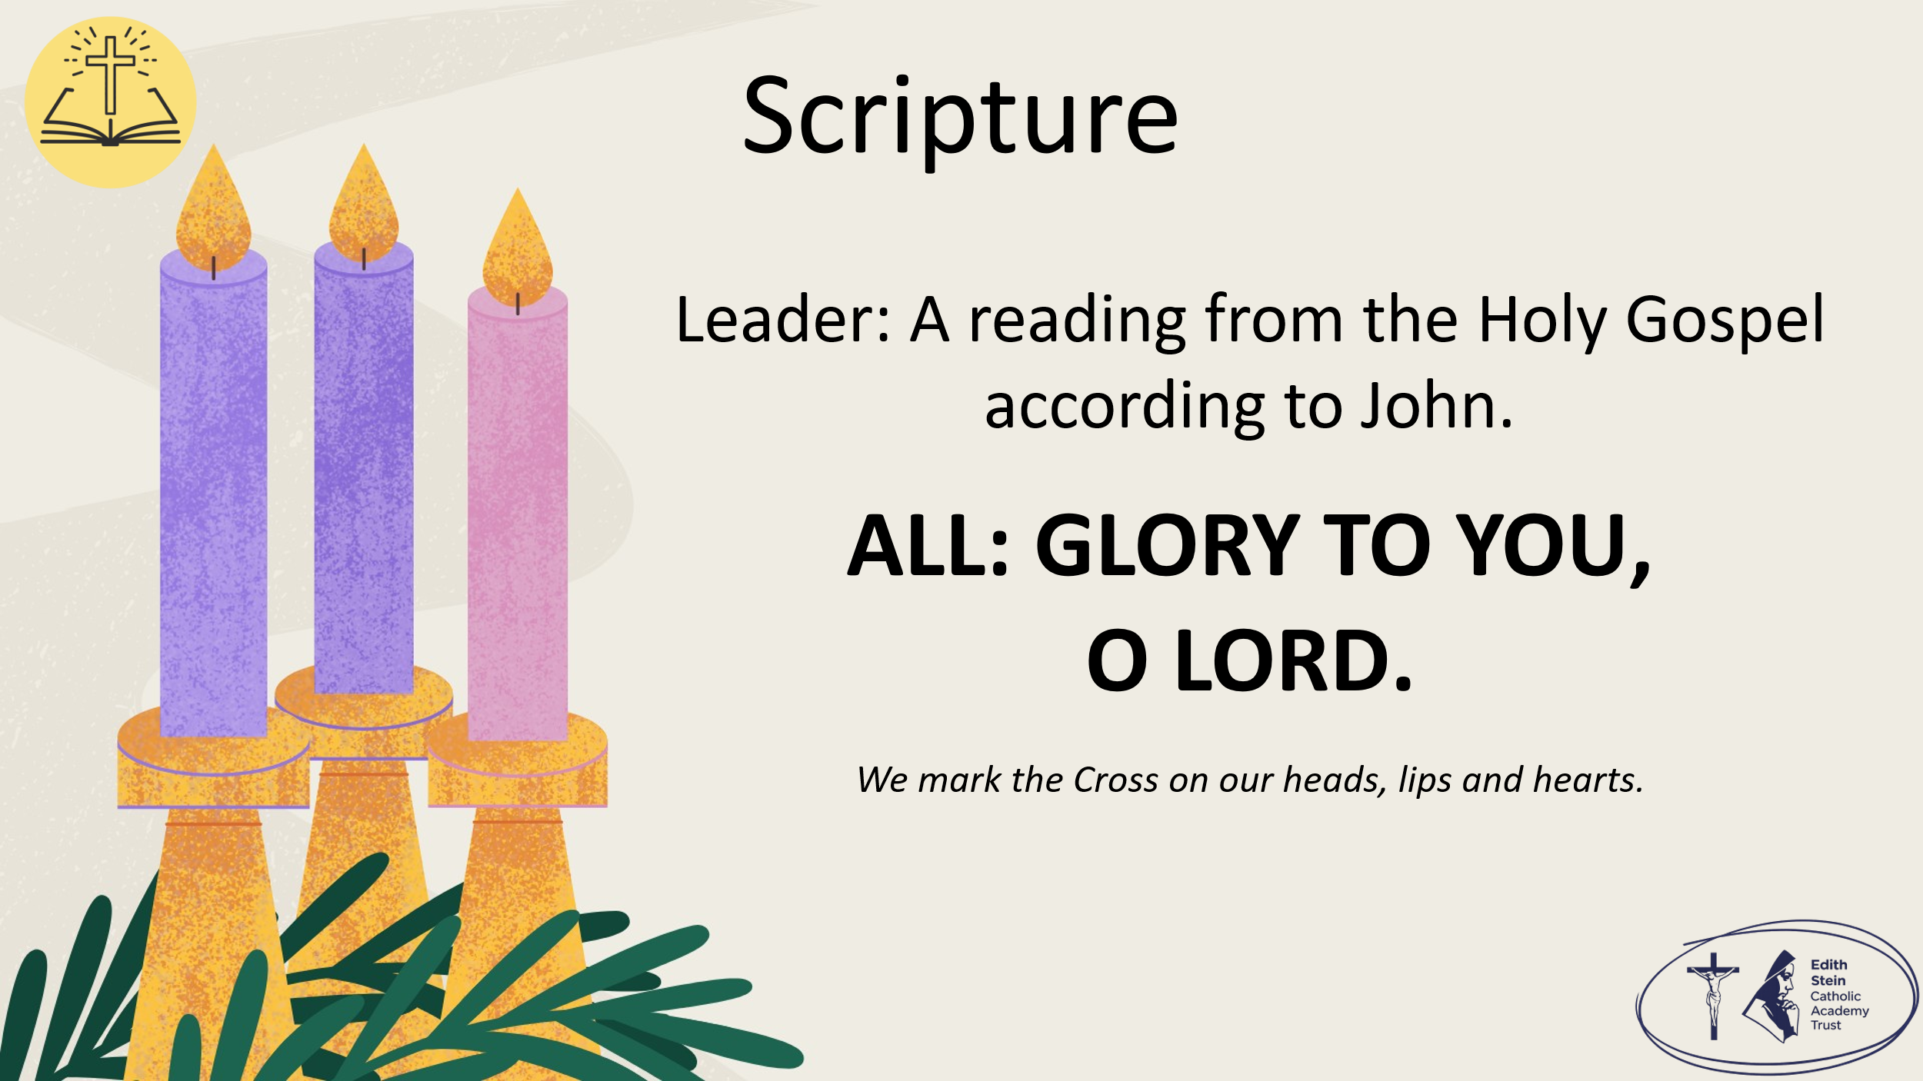 | See below or separate page for Gospel reading.  John 1:6-8, 19-28  A reading from the Holy Gospel according to John.  ALL: GLORY TO YOU, O LORD. | You may invite everyone to stand to listen to the Word proclaimed.  If you are not already doing so, please ensure that everyone crosses their foreheads, lips and hearts.
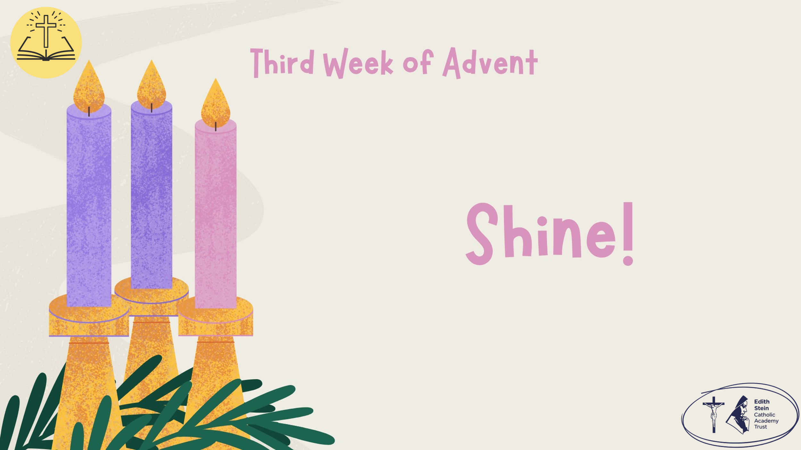 |  | This could be read by staff or student. Please ensure whoever is proclaiming the Gospel has had appropriate preparation and will proclaim worthily and well.
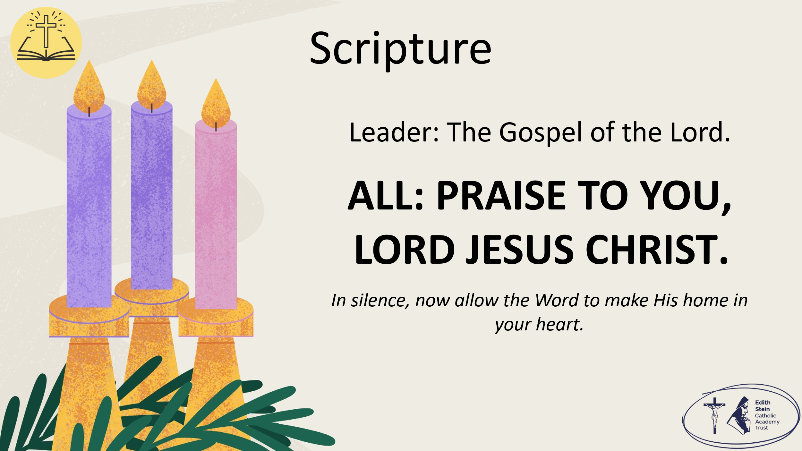 | The Gospel of the Lord.  ALL: PRAISE TO YOU, LORD JESUS CHRIST. | Allow a moment of silence at the end of the Gospel to allow the Word to make His home in everyone’s hearts.  Invite everyone to be seated if they have been standing for the Gospel.
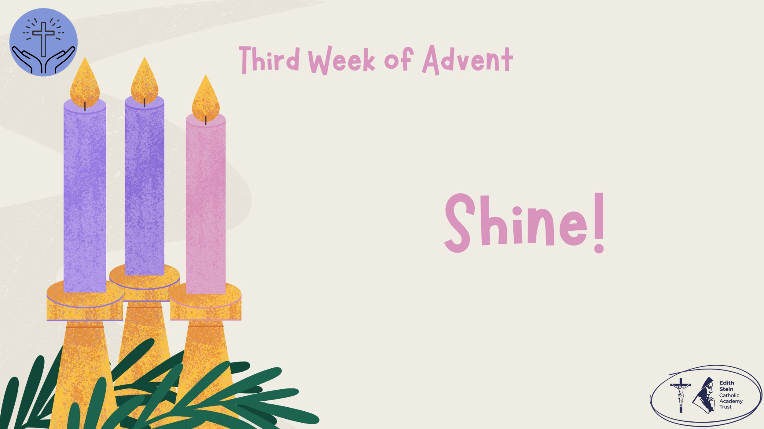 | Reflection  John the Baptist said something very important: "I am not the light." His job was simply to point everyone towards Jesus, the Light of the World.  That is our calling too. We don't have to do extraordinary things to shine God's light. Every smile, every kind word, every act of forgiveness, every moment we include someone who feels left out helps others to see Jesus through us.  The closer we come to Christmas, the brighter God's light becomes. This week, we are invited not only to enjoy that light ourselves, but to carry it wherever we go.  As we continue our journey to Bethlehem, let us ask ourselves:  How can I help someone else see the light of Christ this week?  Allow for a moment of prayerful silence.  Let us pray…
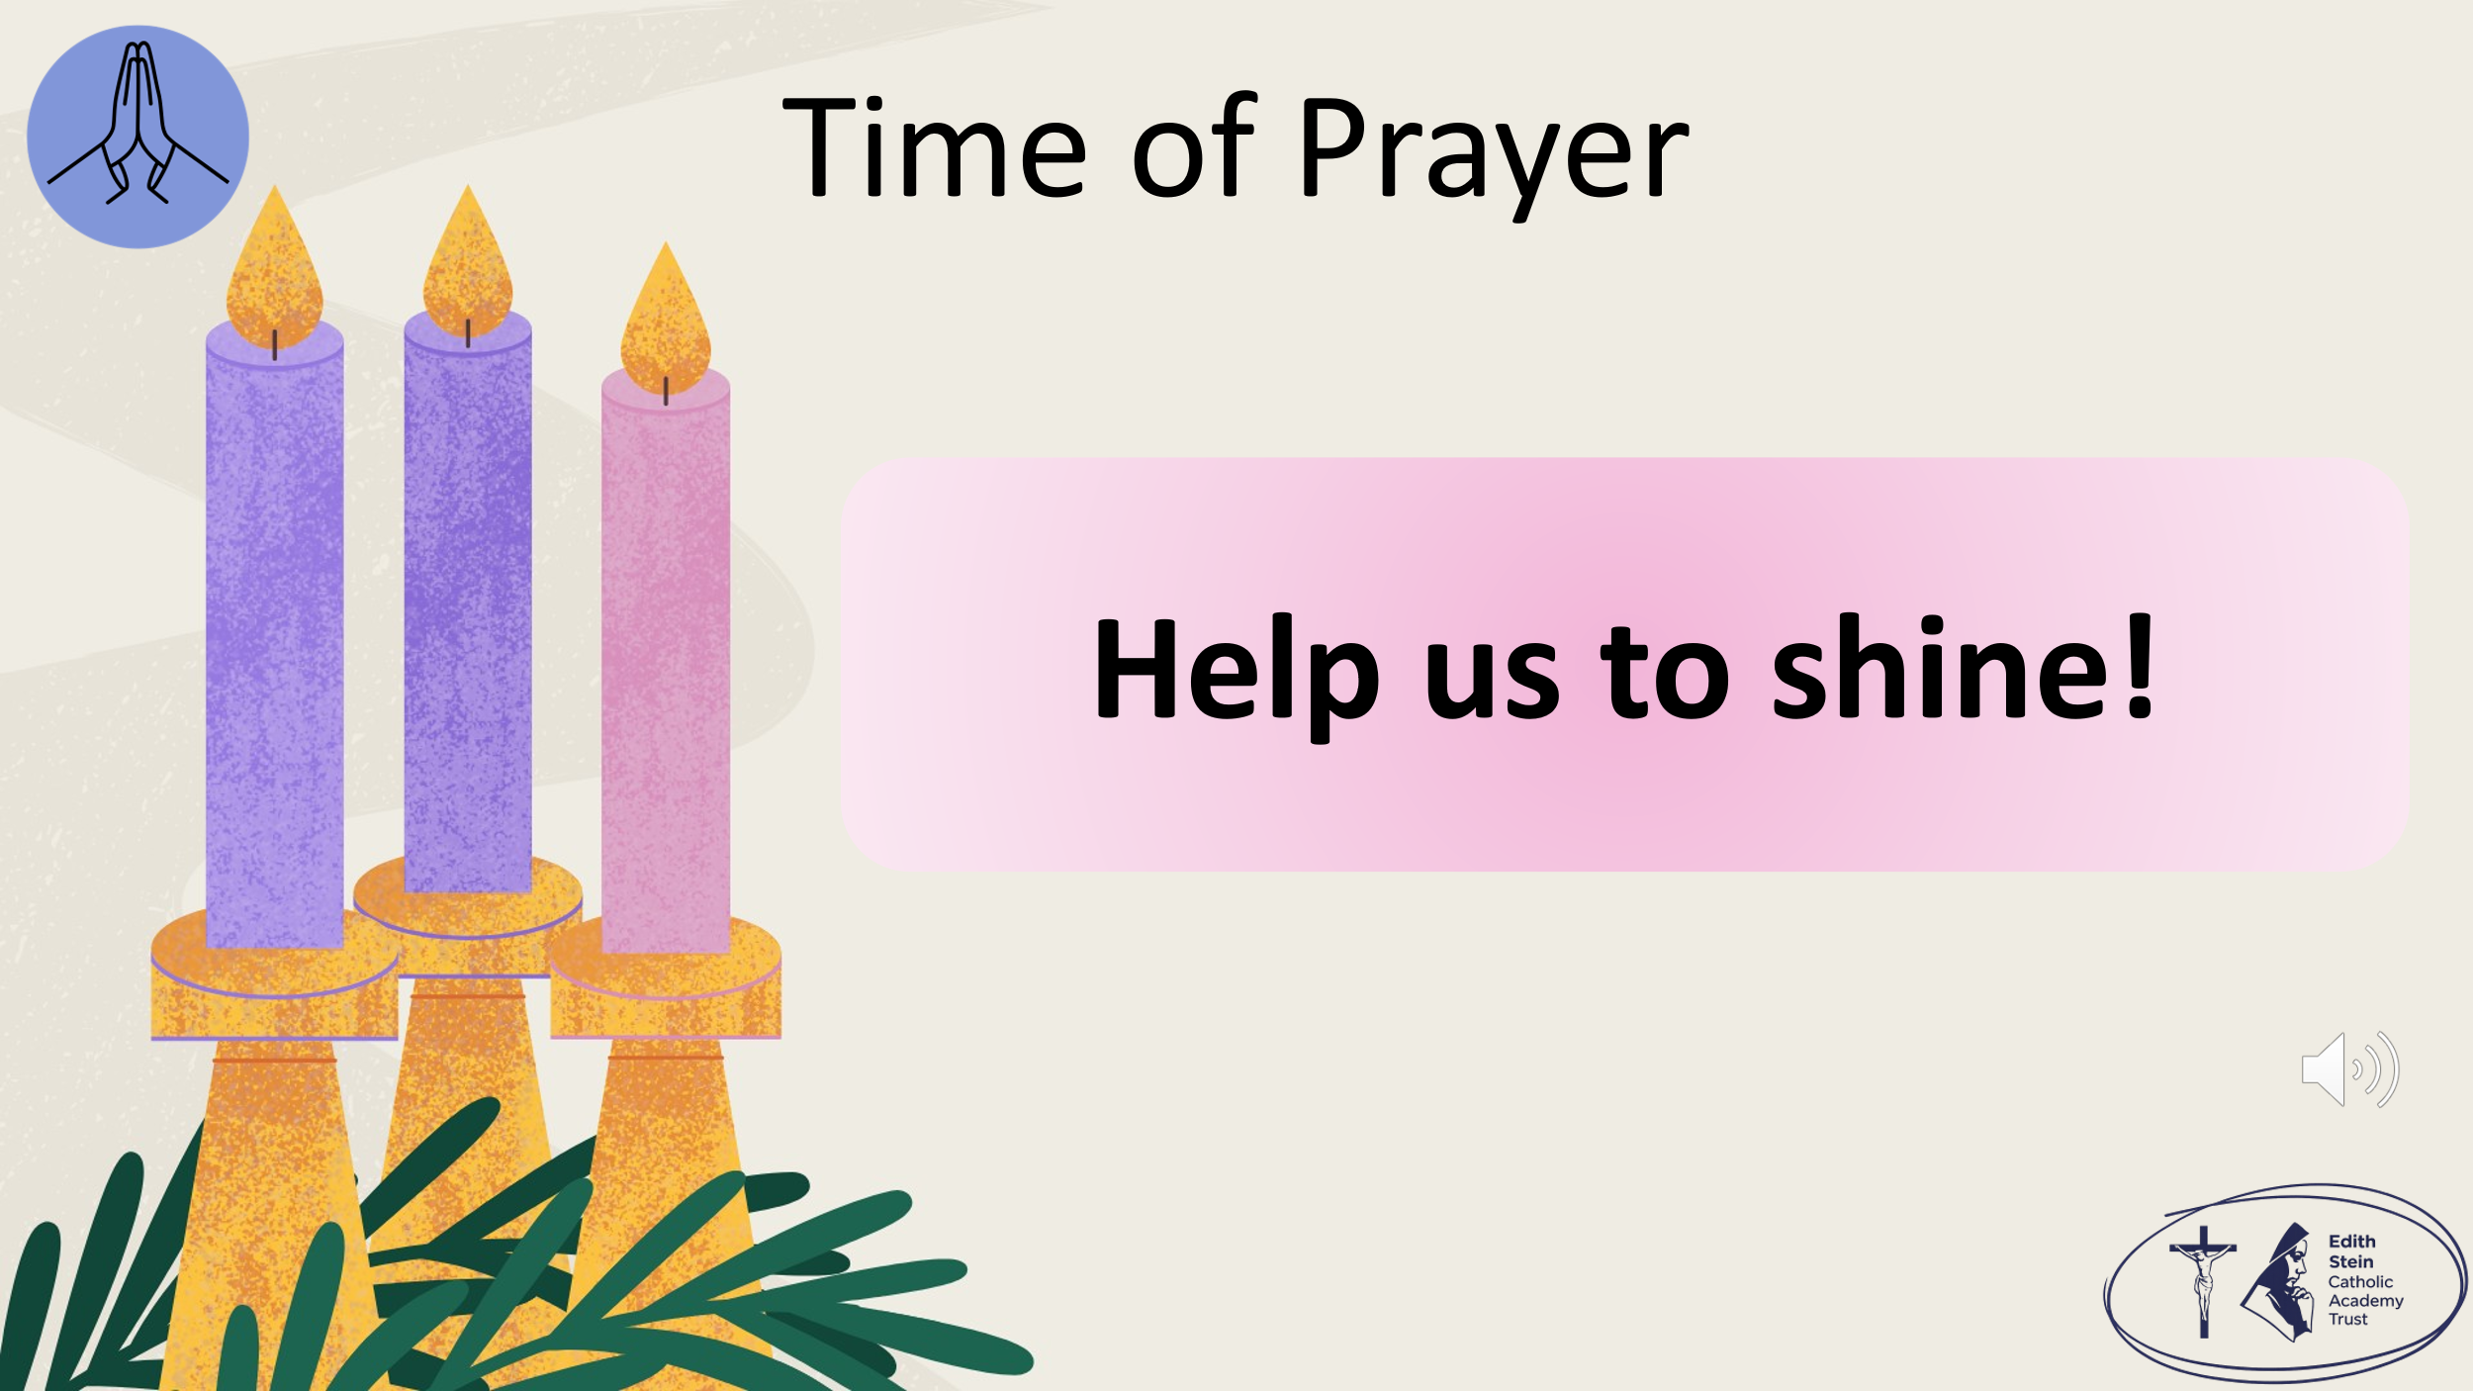 | The response to each line of the litany is,  Help us to shine!  When the world feels dark or sad… help us to shine.  When someone needs cheering up… help us to shine.  Through our words and actions… help us to shine.  When we can include someone who feels left out… help us to shine.  When we share what we have… help us to shine.  When we celebrate each other’s gifts… help us to shine.  When we bring happiness to our homes and school… help us to shine.  When we remember that Jesus is our light… help us to shine.  When we choose love, even when it is hard… help us to shine.  When we want to make a difference in the world… help us to shine.
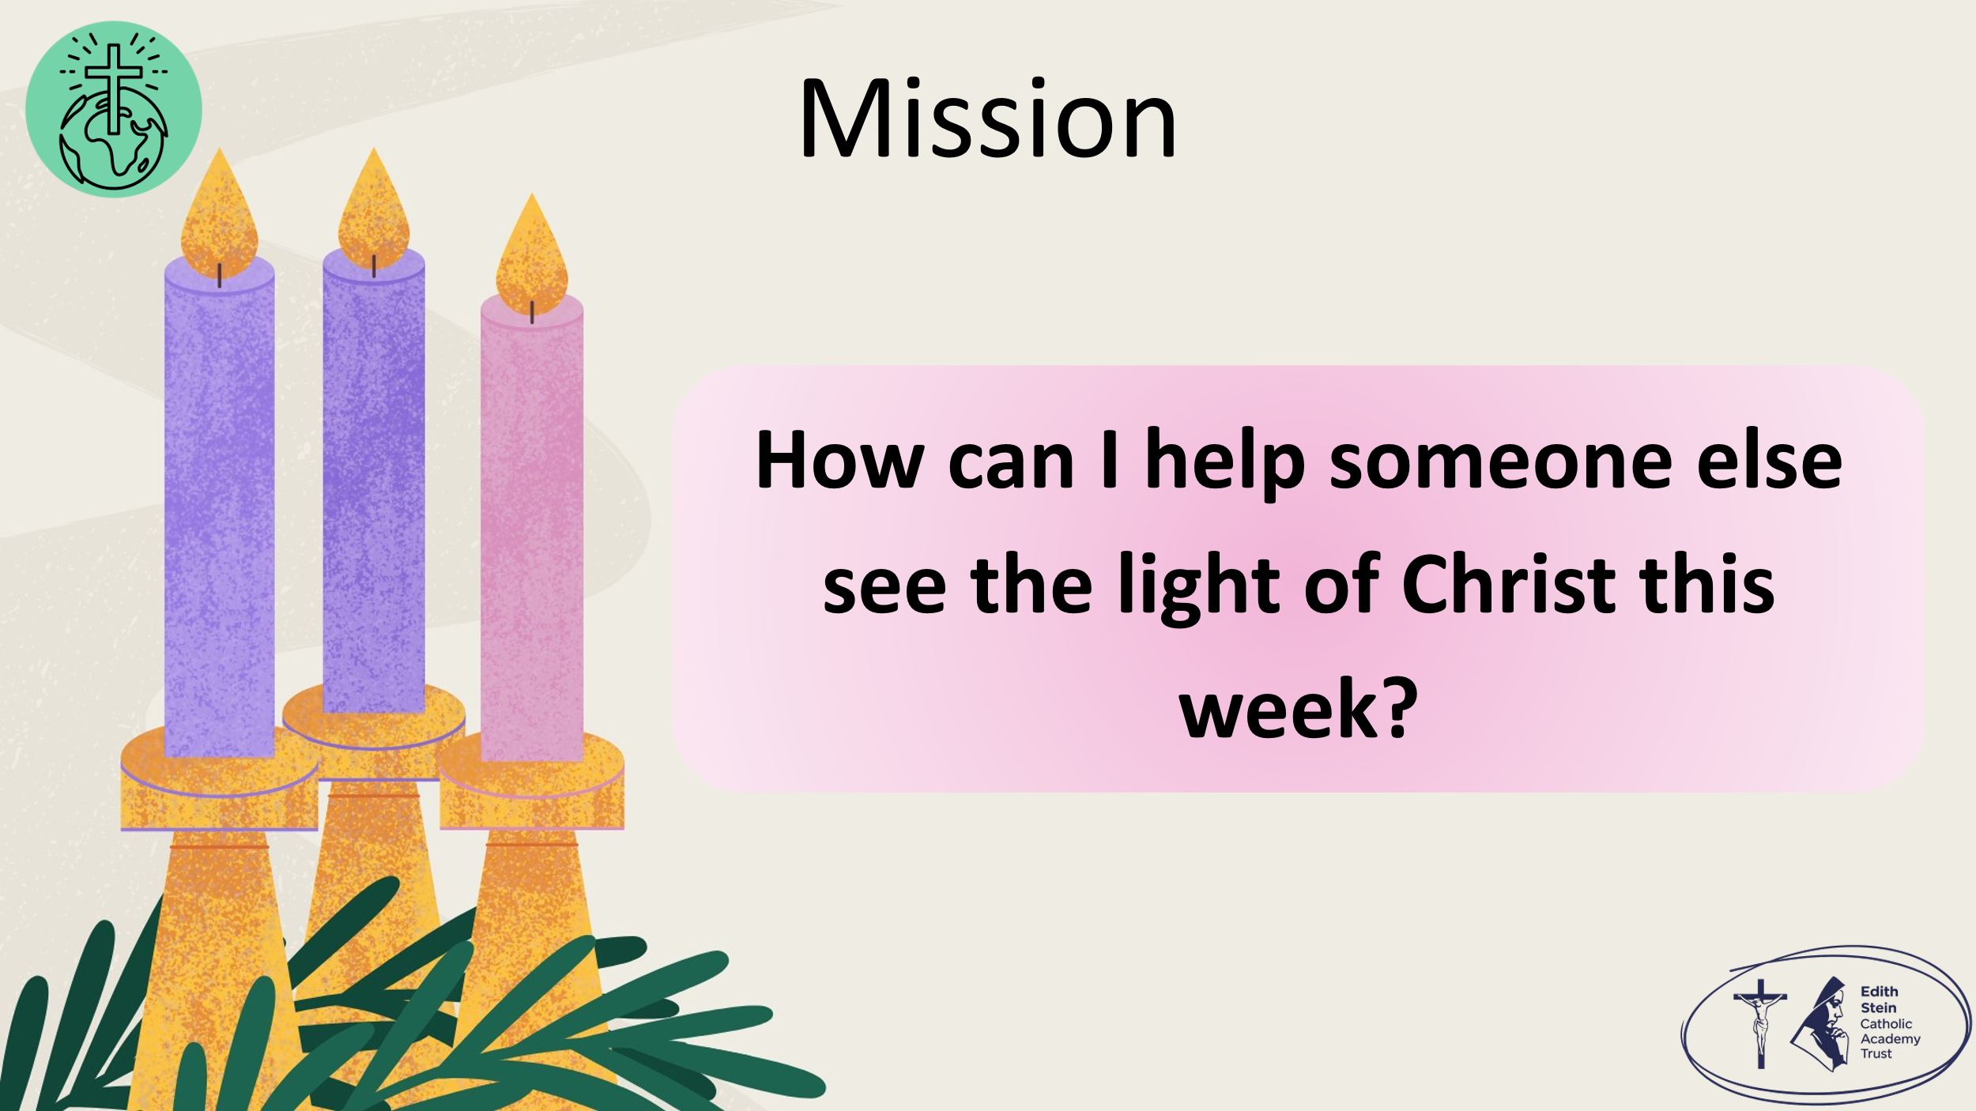 | Before we ask for God’s blessing, let us take up our mission:  How can we help someone see the light of Christ this week?  Remind the students that they will have a chance to make a personal response in their Advent Passport in class.
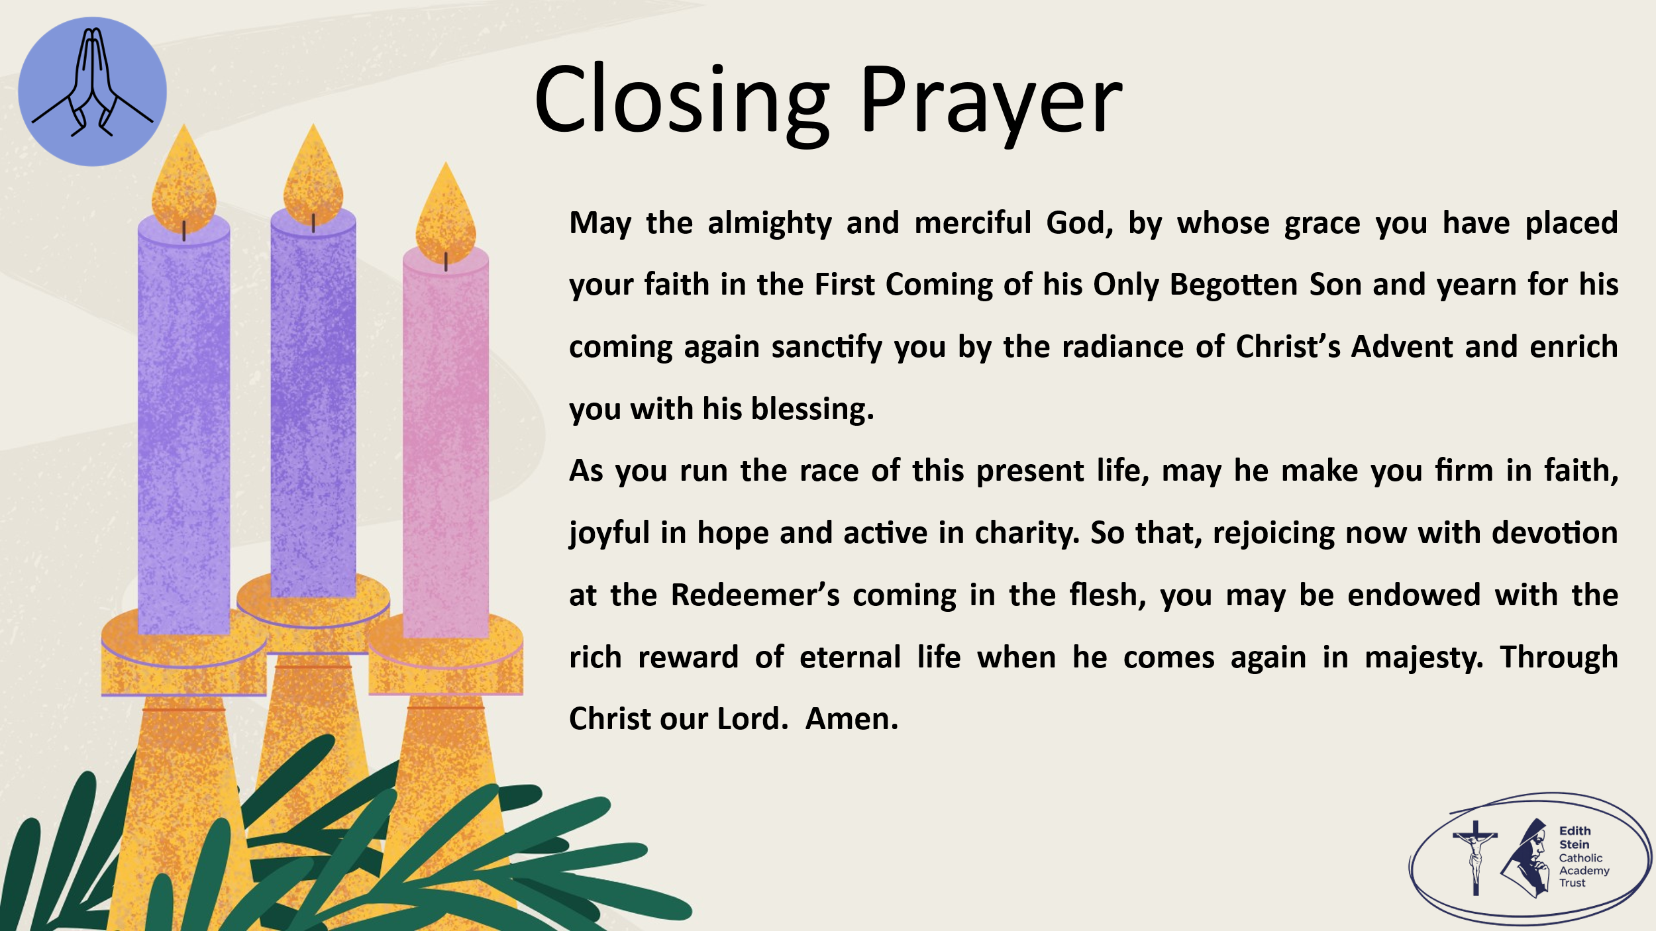 | Solemn Blessing  May the almighty and merciful God, by whose grace you have placed your faith in the First Coming of his Only Begotten Son and yearn for his coming again sanctify you by the radiance of Christ’s Advent and enrich you with his blessing.  As you run the race of this present life, may he make you firm in faith, joyful in hope and active in charity.  So that, rejoicing now with devotion at the Redeemer’s coming in the flesh, you may be endowed with the rich reward of eternal life when he comes again in majesty.  Through Christ our Lord.  Amen.  SIGN OF THE CROSS


*Can be read by pupil or staff.

A reading from the Holy Gospel according to John.
ALL: Glory to You, O Lord.

There was a man named John who was sent by God. He came to tell people about the Light. Through him all people could hear about the Light and believe. John was not the Light, but he came to tell people about the Light.
John told them in the words of the prophet Isaiah:
“I am the voice of a man
calling out in the desert:
‘Make the road straight for the Lord.’”
“I baptise people with water. But there is one here with you that you don’t know. He is the One who comes after me. I am not good enough to untie the strings of his sandals.”

The Gospel of the Lord.
ALL: Praise to You Lord, Jesus Christ.

