



NAME:

CLASS:

Welcome to your Advent prayer journey.
Advent is a special season when we prepare our hearts to welcome Jesus at Christmas. Just as Mary and Joseph travelled to Bethlehem, we are going on a journey too. Each week, through prayer, reflection and acts of kindness, we will take another step along the road towards Bethlehem. May this passport help you grow in hope, peace, joy and love as we prepare to welcome Jesus.

My Advent Promise:
This Advent I will try to:

□ Pray more often.
□ Be kinder to others.
□ Help at home.
□ Include others.
□ Care for God's world.
□ Support those who are in need.

My own Advent promise:

Each week, colour in the candle and light it with a flame.



First Week of Advent – HOPE
‘Wake up!’
Lord Jesus, awaken our hearts to your presence. Fill us with hope as we begin our Advent journey. Amen.
What might God be asking me to notice today?
Spend some quiet time reflecting on this question.
Ask Jesus to speak into your heart where He wants you to see His glory.
Use the space below to write your thoughts and ideas.


Design your own HOPE stamp
My Prayer Space
Use this space for prayer… write, draw, be creative!
Use this road to Bethlehem to keep a record of your Advent promise. You could maybe use a RAG rating for how you are getting on each day.
You could write small challenges for yourself each day or just colour in each step as you journey through Advent.
Reflect on the questions for each week.
First Week of Advent – HOPE
How did I notice God this week?




Third Week of Advent – JOY
How did I share my joy?
Second Week of Advent – PEACE
How did I bring peace?



Second Week of Advent – PEACE
‘Prepare the way!’
Lord Jesus, help us to prepare our hearts for you. Fill our homes, our school and our world with your peace. Amen.
What can I do this week to prepare my heart for Jesus?
Spend some quiet time reflecting on this question.
Ask Jesus to speak into your heart how He wants to make His home in you.
Use the space below to write your thoughts and ideas.

Design your own PEACE stamp
My Prayer Space
Use this space for prayer… write, draw, be creative!

Third Week of Advent – JOY
‘Shine!’
Lord Jesus, fill our hearts with joy. Help us to shine with your light so that others may see your love through us. Amen.
How can I help someone else see the light of Christ this week?
Spend some quiet time reflecting on this question.
Ask Jesus to speak into your heart and show you how you can truly shine!
Use the space below to write your thoughts and ideas.


Design your own JOY stamp
My Prayer Space
Use this space for prayer… write, draw, be creative!
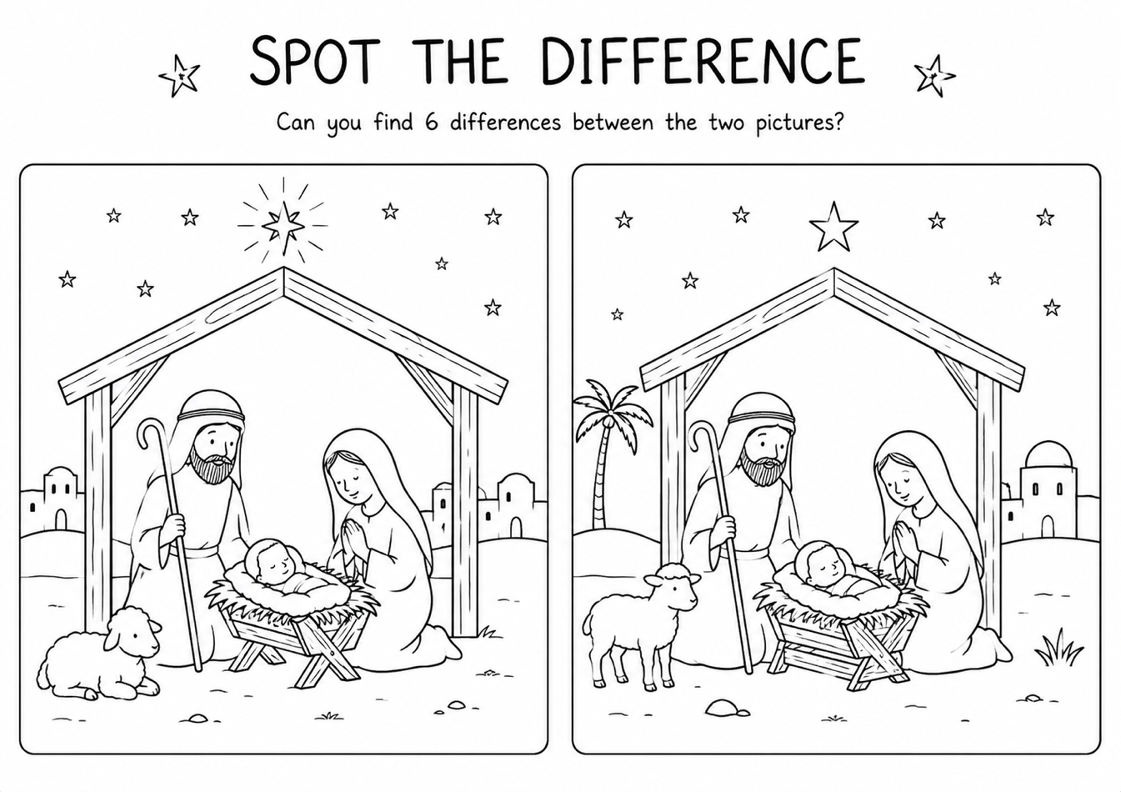
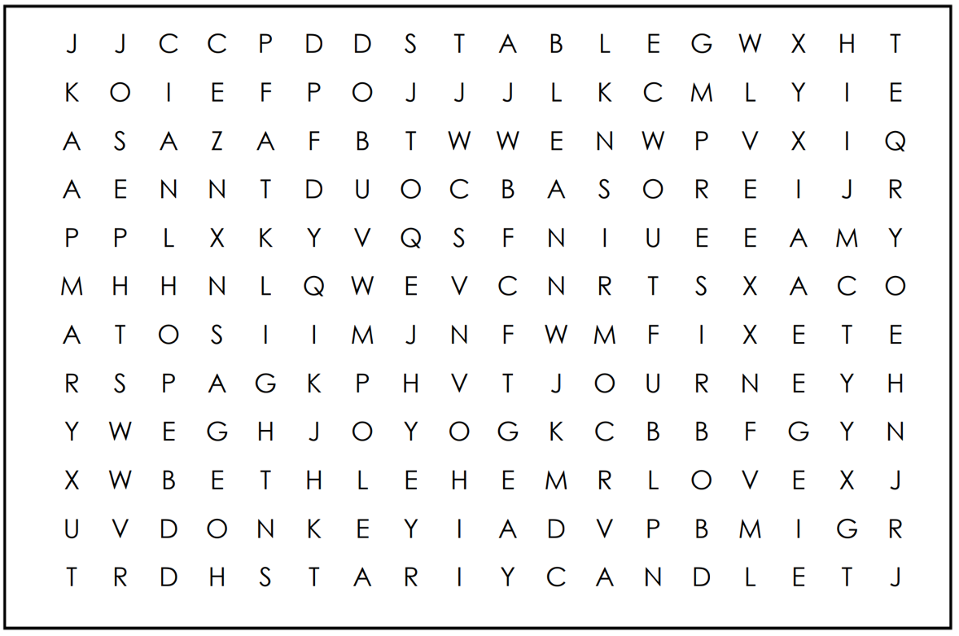
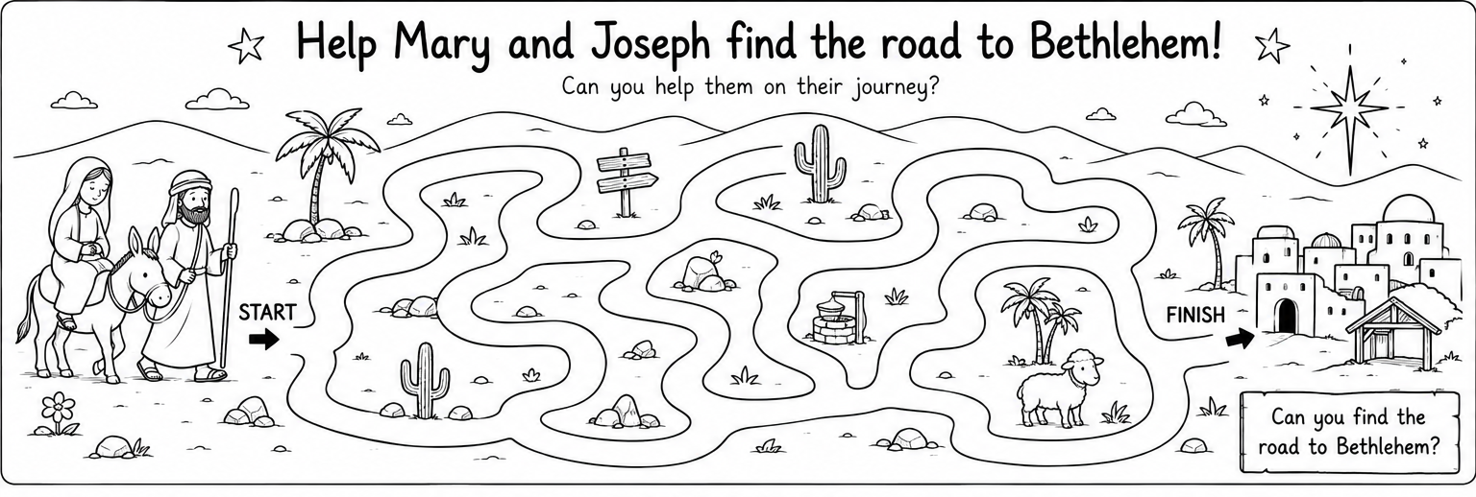
Advent Pilgims Challenge
HOPE
PEACE
JOY
LOVE
BETHLEHEM
JESUS
MARY
JOSEPH
STAR

LIGHT
ADVENT
JOURNEY
DONKEY
STABLE
WAITING
WREATH
CANDLE

