
Secondary Celebration of the Word Assembly Script
Third Week of Advent, Year B

Slides | Script | Additional Notes
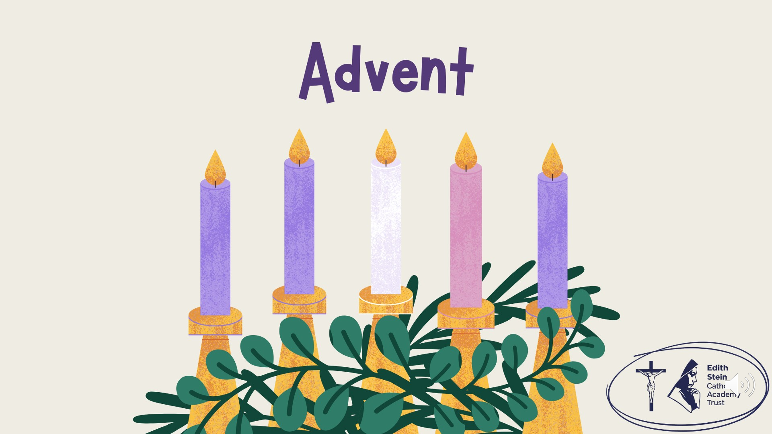 | SIGN OF THE CROSS  Good morning! | There is some background music on this first slide that you might like to use while staff and students enter the assembly space.  Please check volume levels prior to the start of the assembly.
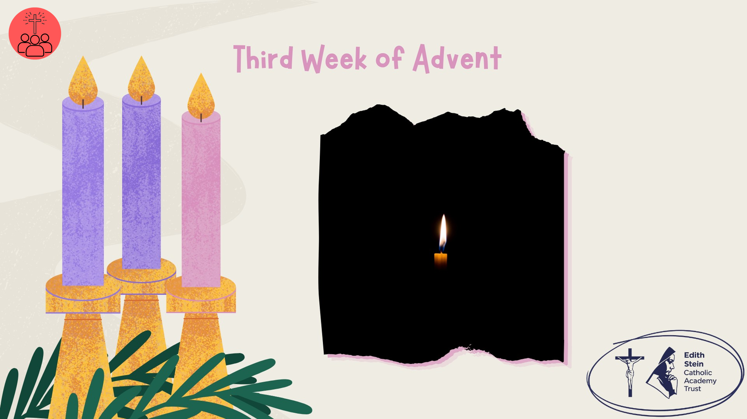 | Take a moment to look at the image; a small candle dispelling the darkness. Even a very small light can change the way we see a dark room. It doesn't remove all the darkness, but it helps us see what is there.  In today's Gospel, we hear the familiar words of John’s Gospel proclaiming that Jesus is the LIGHT!  As we continue our Advent journey, we're invited to think about light, joy and the difference one person can make. What difference can we make to the world around us?  Before we hear the Word of God proclaimed, let us continue our Advent journey together by lighting the third candle on our Advent Wreath. | Purple cloth and advent wreath.
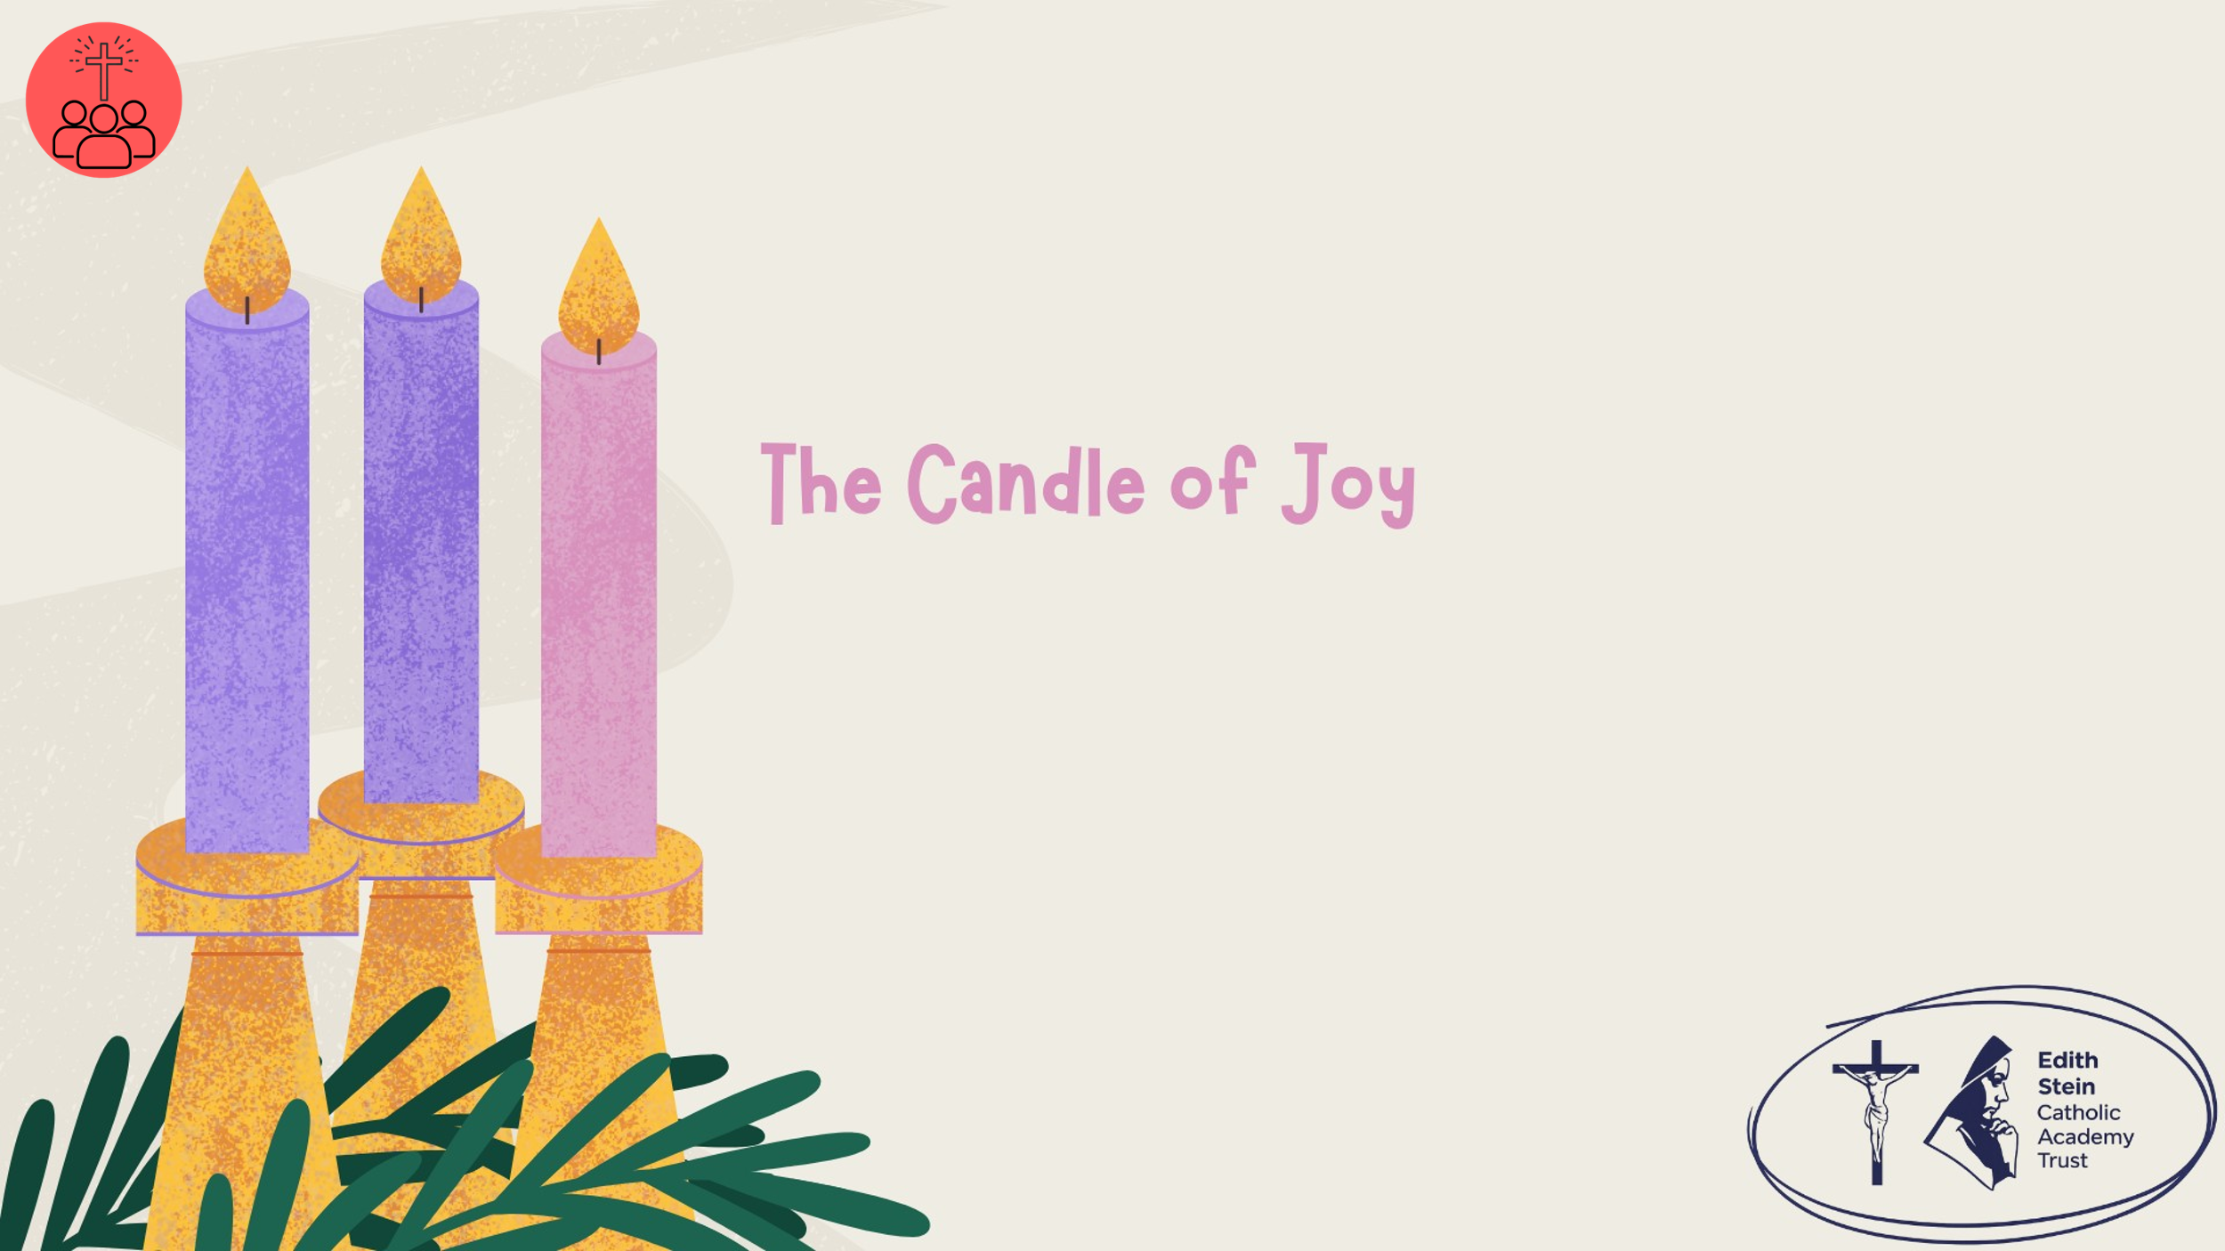 | Lighting the Advent Wreath  Lord our God, we praise you for your Son, Jesus Christ:  he is Emmanuel, the hope of the peoples,  he is the wisdom that teaches and guides us,  he is the Saviour of every nation.  Lord God, let your blessing come upon us as we light the candles of this wreath.  May the wreath and its light be a sign of Christ’s promise to bring us salvation.  May he come quickly and not delay. We ask this through Christ our Lord. Amen  Third Candle – Joy  Today we light the third candle, the Candle of Joy.  John the Baptist came to point people towards Jesus, the Light of the World. We are called to do the same. When we smile, encourage others, share what we have and live with kindness, we shine Christ's light wherever we go.  Let us pray… | Light the first and second purple candles and the pink candle on the wreath.
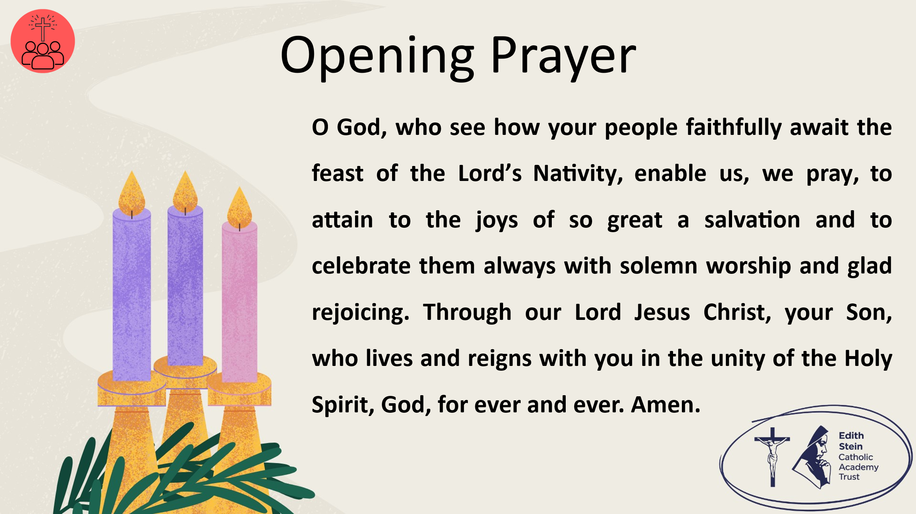 | O God, who see how your people faithfully await the feast of the Lord’s Nativity, enable us, we pray, to attain to the joys of so great a salvation and to celebrate them always with solemn worship and glad rejoicing. Through our Lord Jesus Christ, your Son, who lives and reigns with you in the unity of the Holy Spirit, God, for ever and ever. Amen.  Collect from the Mass for Third Sunday of Advent, Year B  Now let us prepare our hearts and minds to hear the Word of God.
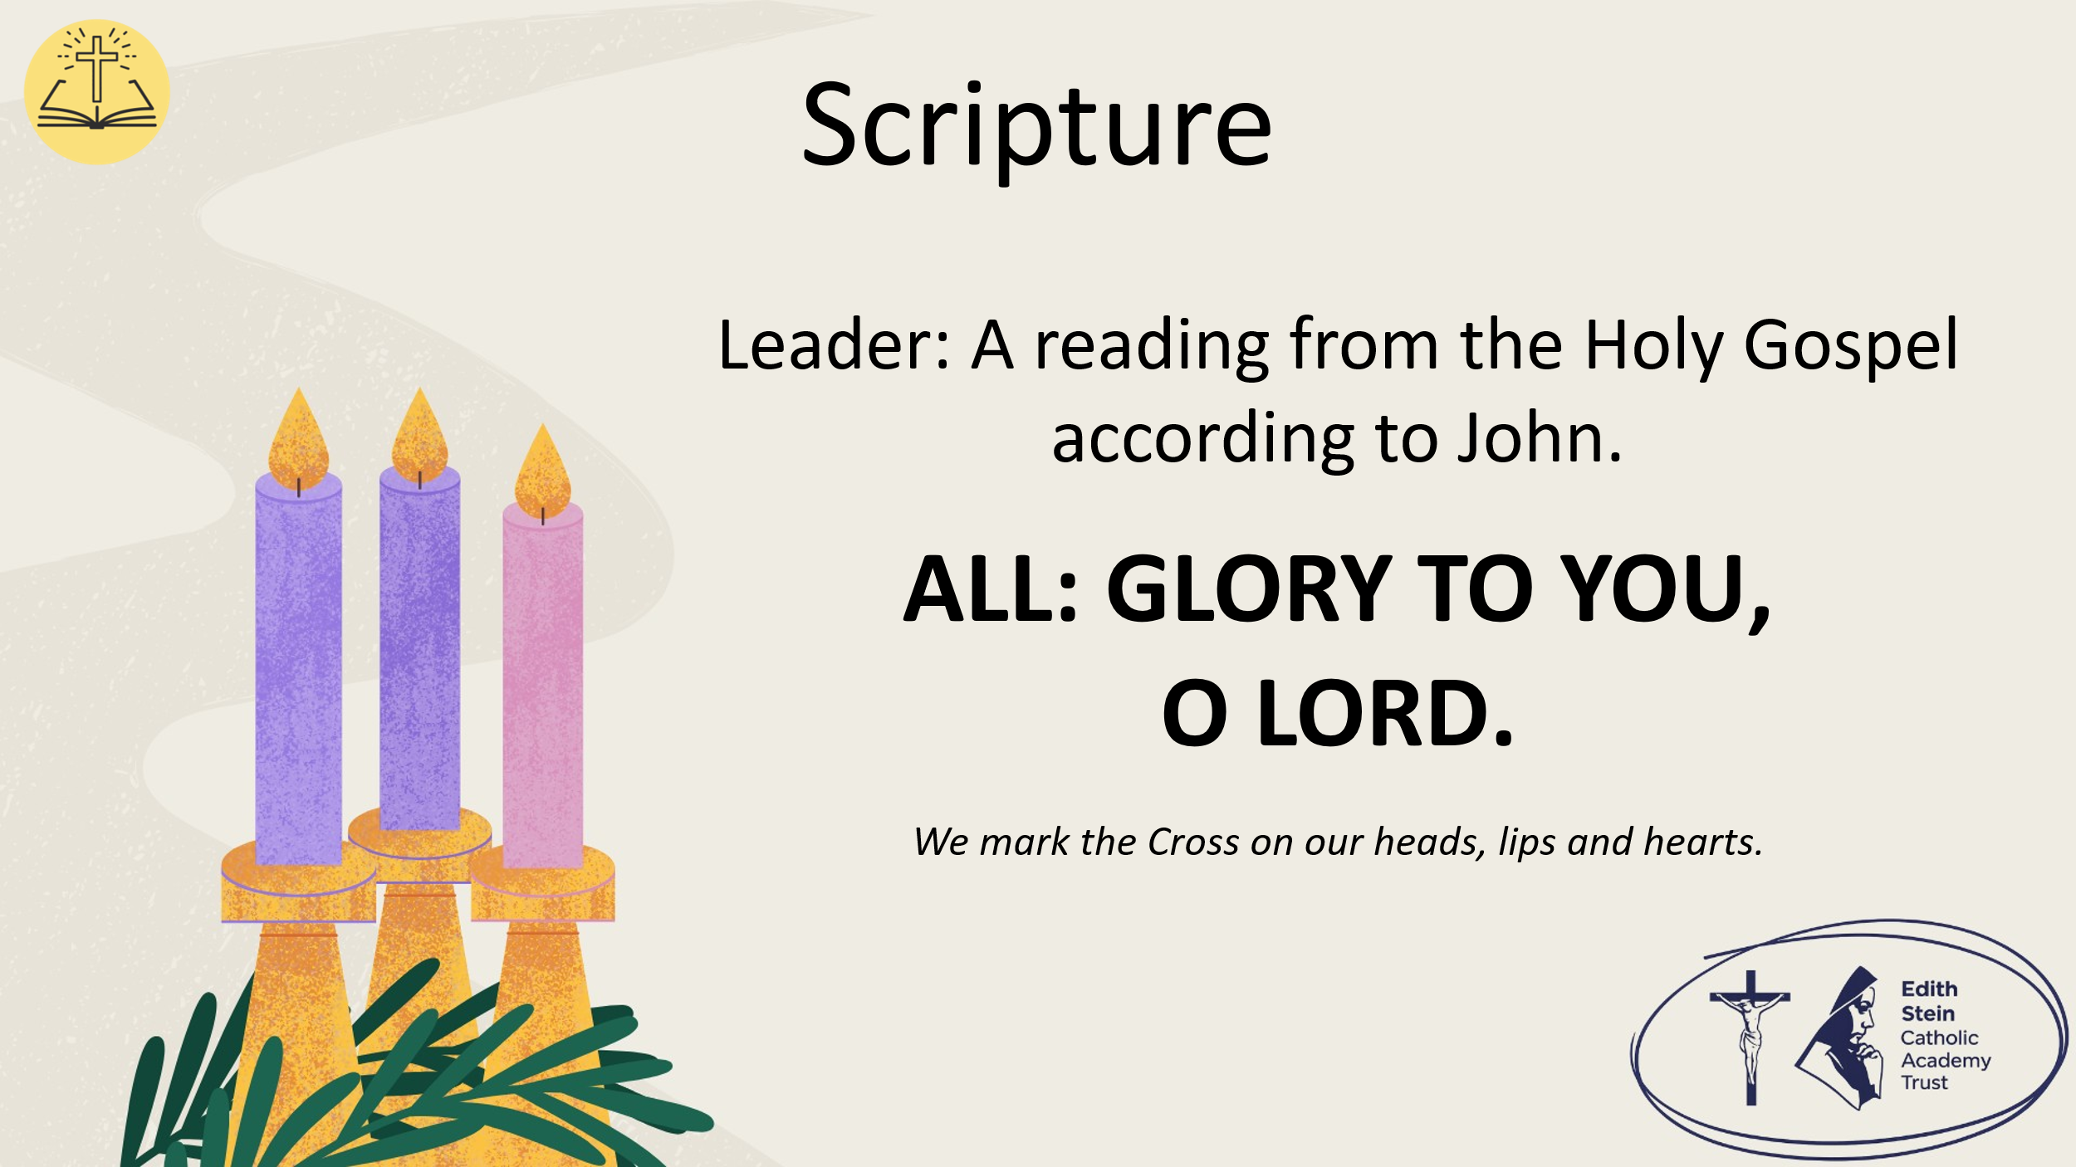 | See below or separate page for Gospel reading.  John 1:6-8, 19-28  A reading from the Holy Gospel according to John.  ALL: GLORY TO YOU, O LORD. | You may invite everyone to stand to listen to the Word proclaimed.  If you are not already doing so, please ensure that everyone crosses their foreheads, lips and hearts.
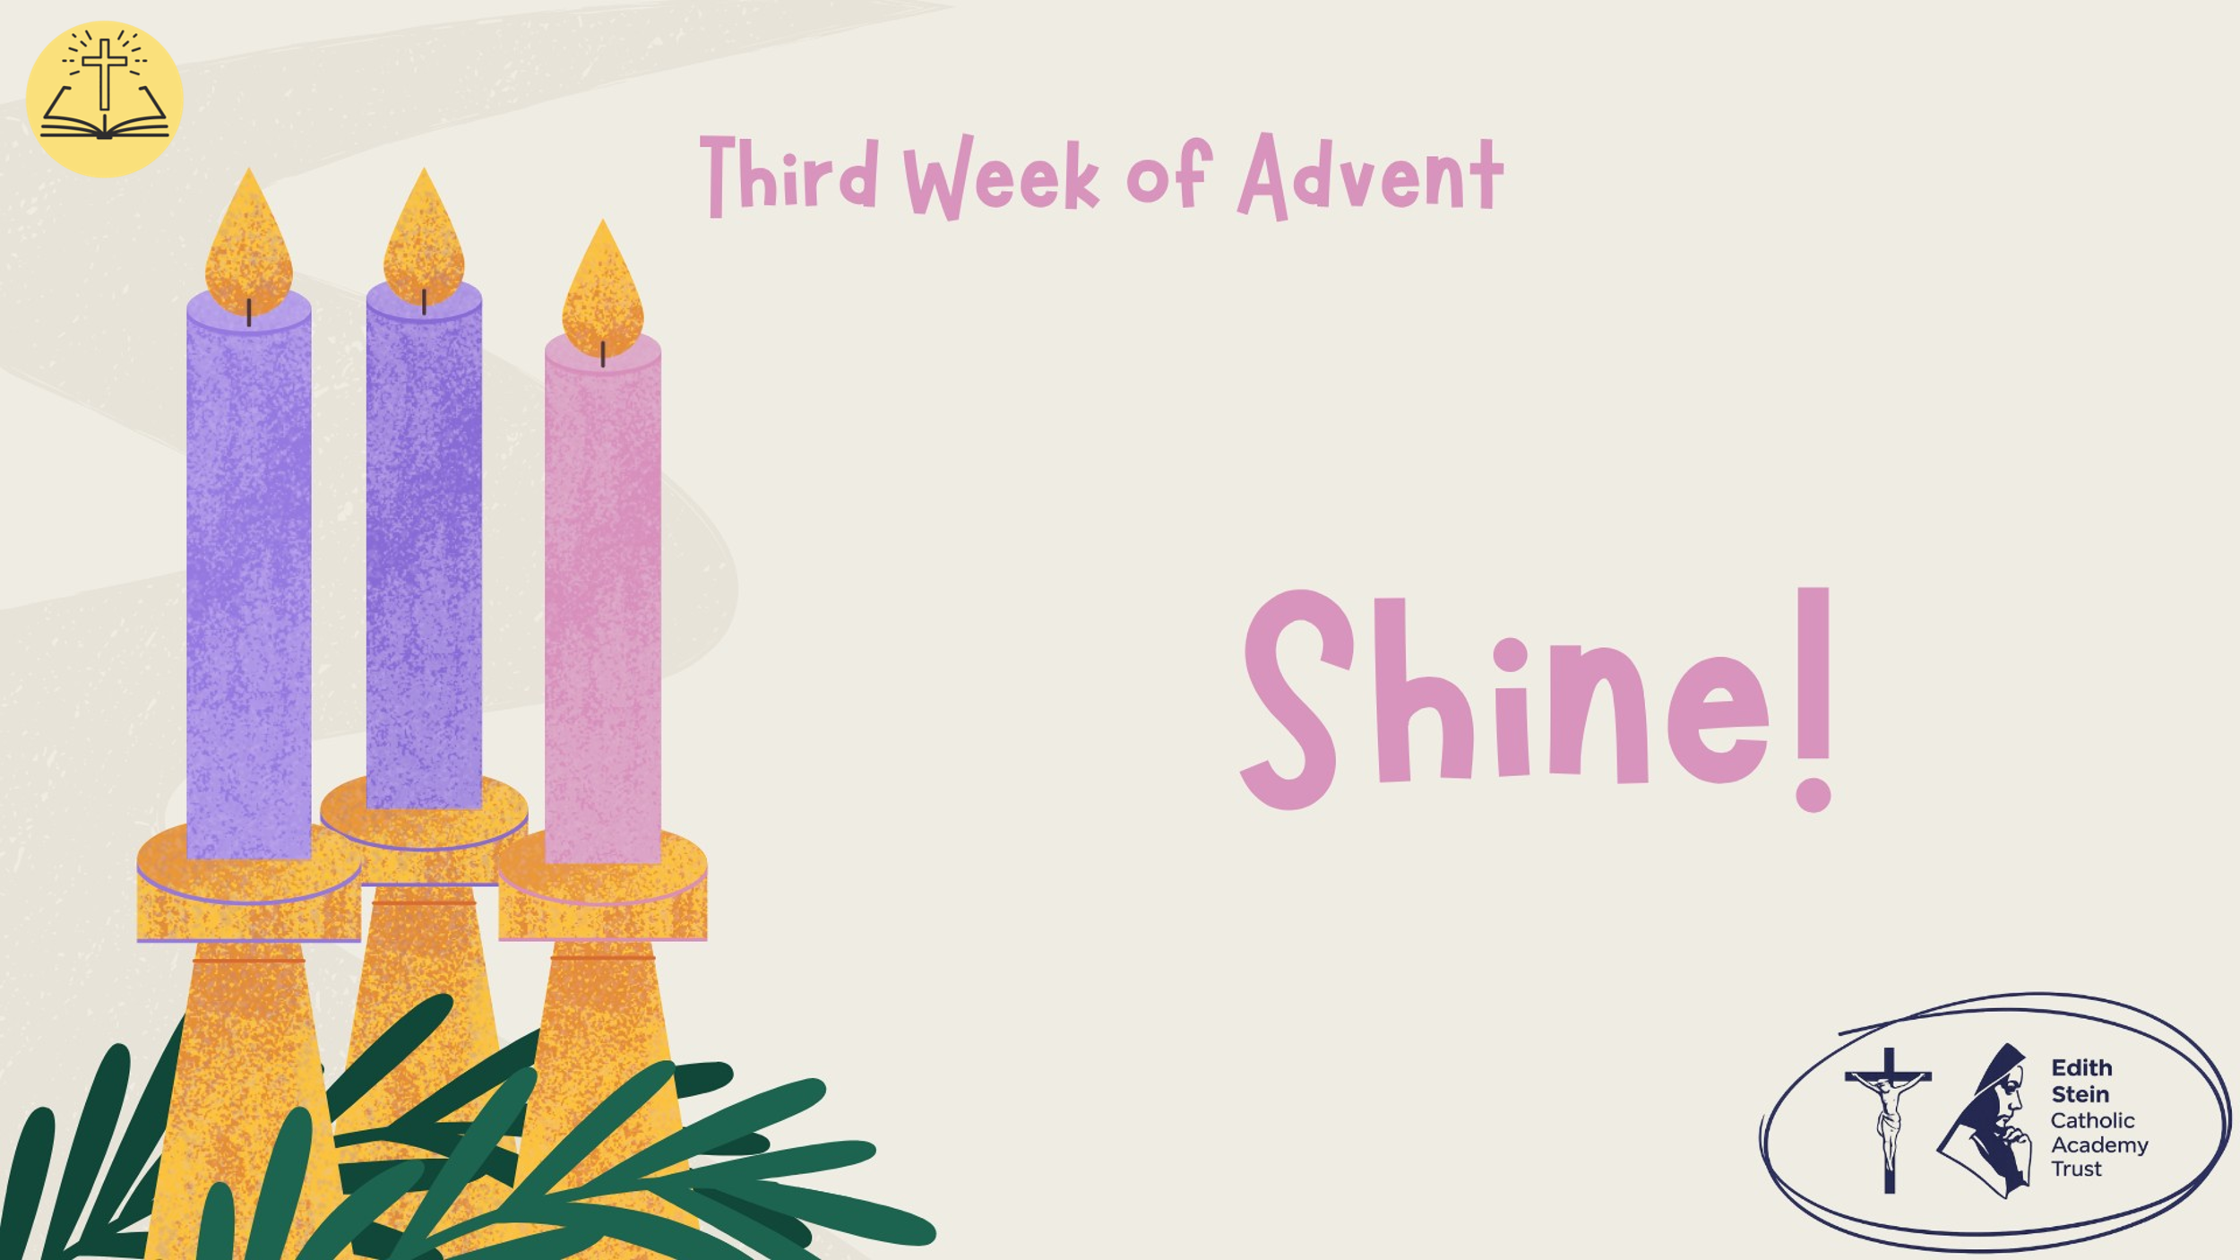 |  | This could be read by staff or student. Please ensure whoever is proclaiming the Gospel has had appropriate preparation and will proclaim worthily and well.
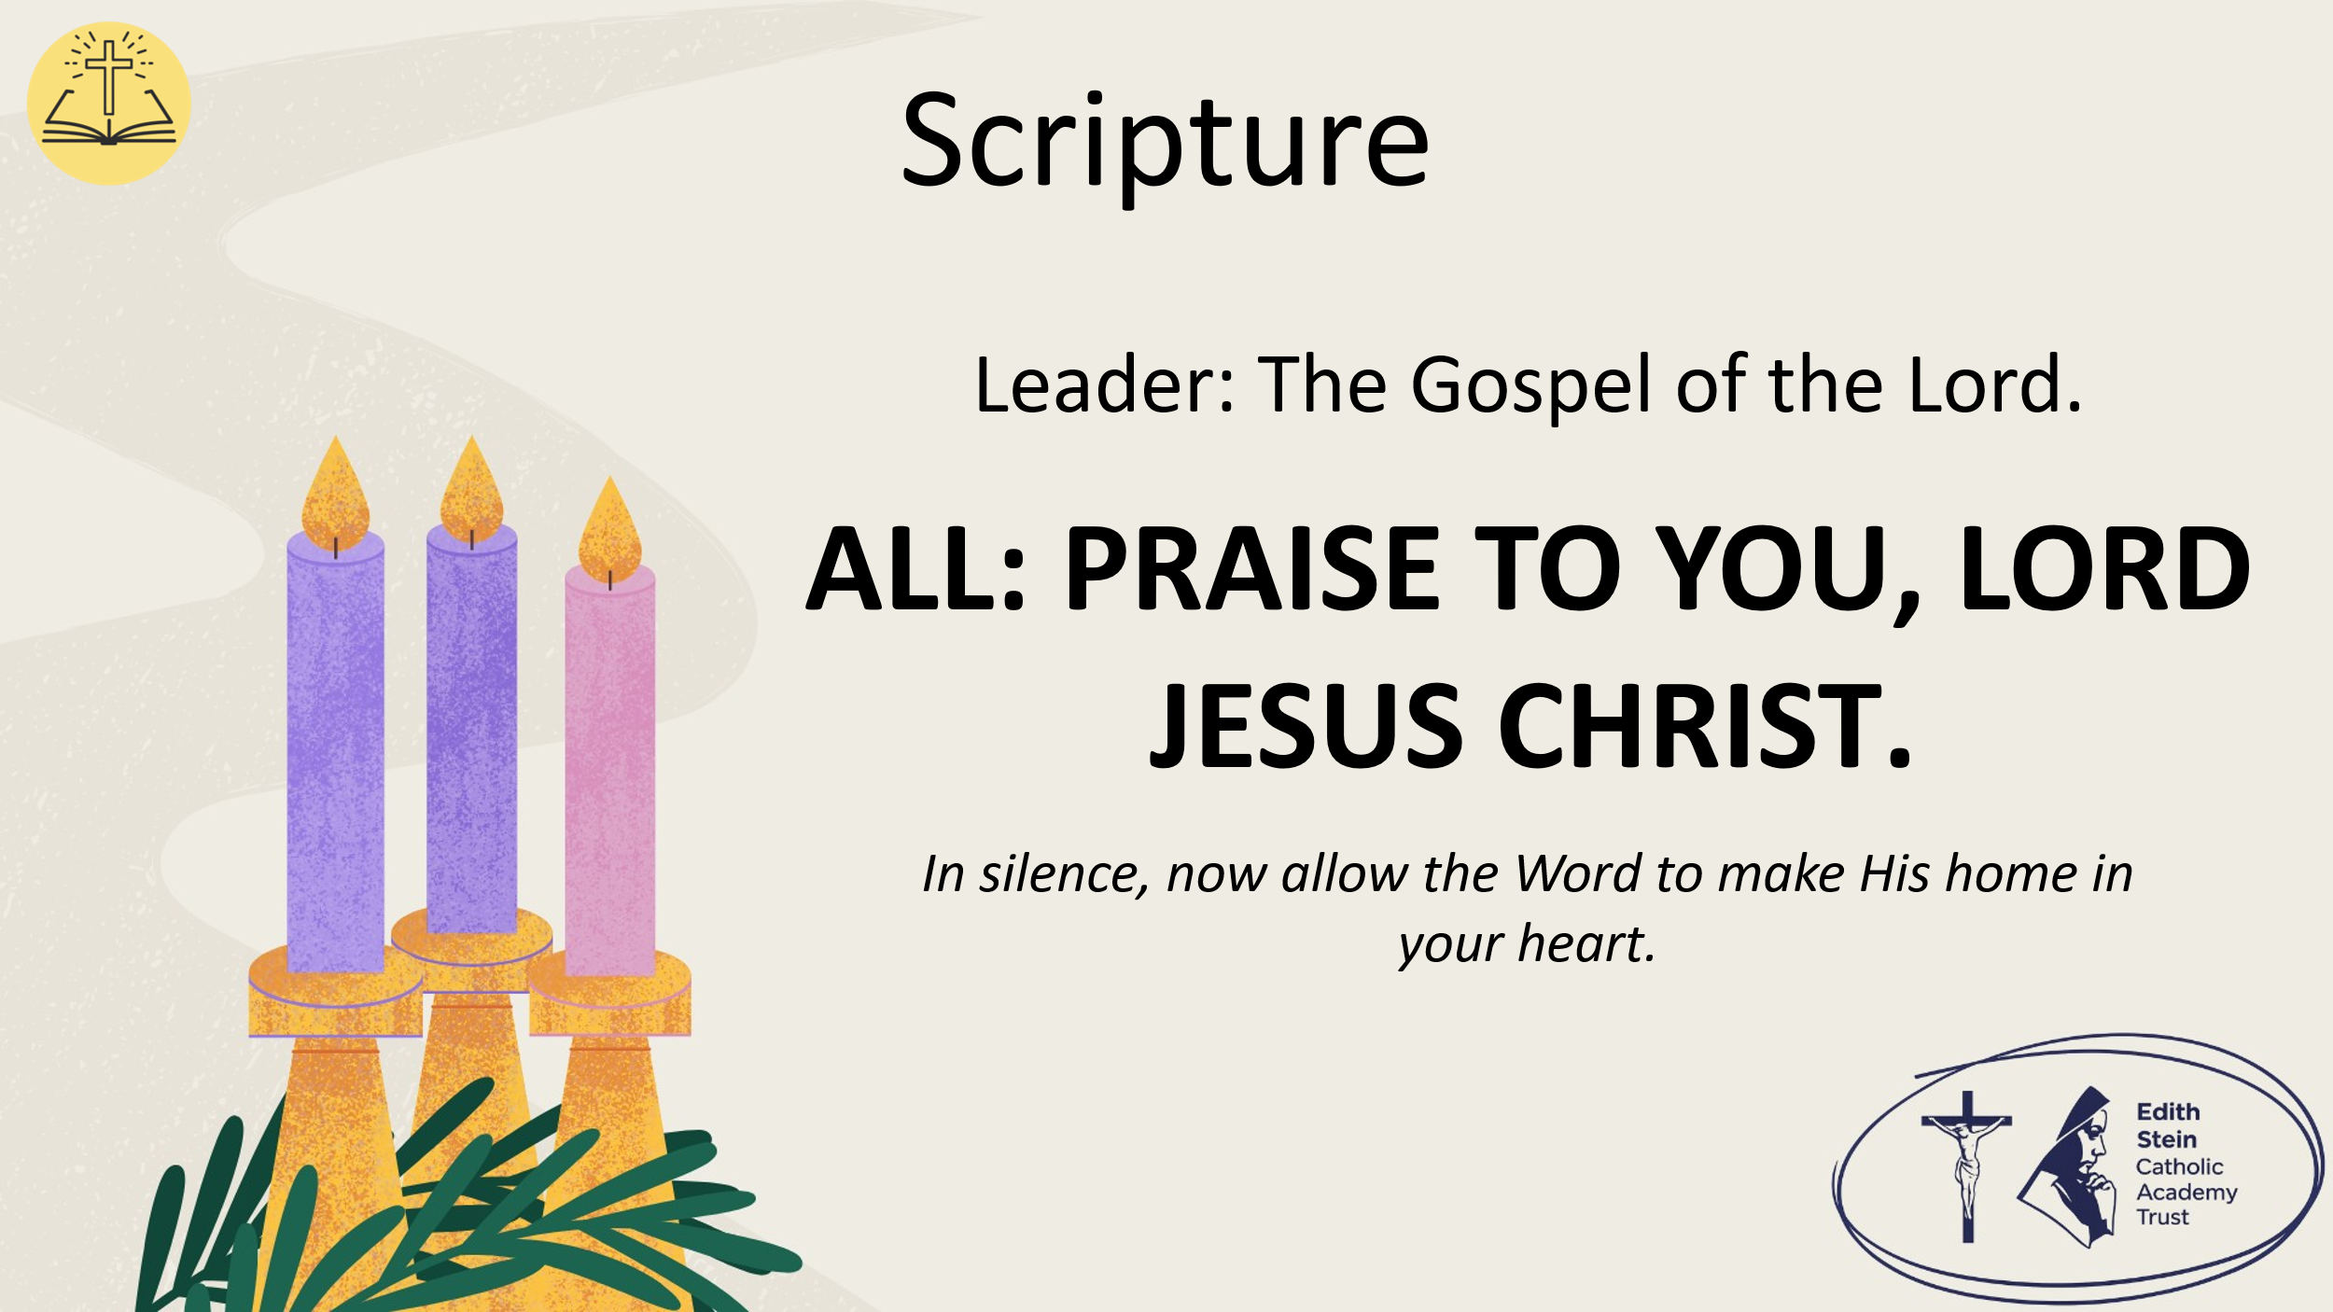 | The Gospel of the Lord.  ALL: PRAISE TO YOU, LORD JESUS CHRIST. | Allow a moment of silence at the end of the Gospel to allow the Word to make His home in everyone’s hearts.  Invite everyone to be seated if they have been standing for the Gospel.
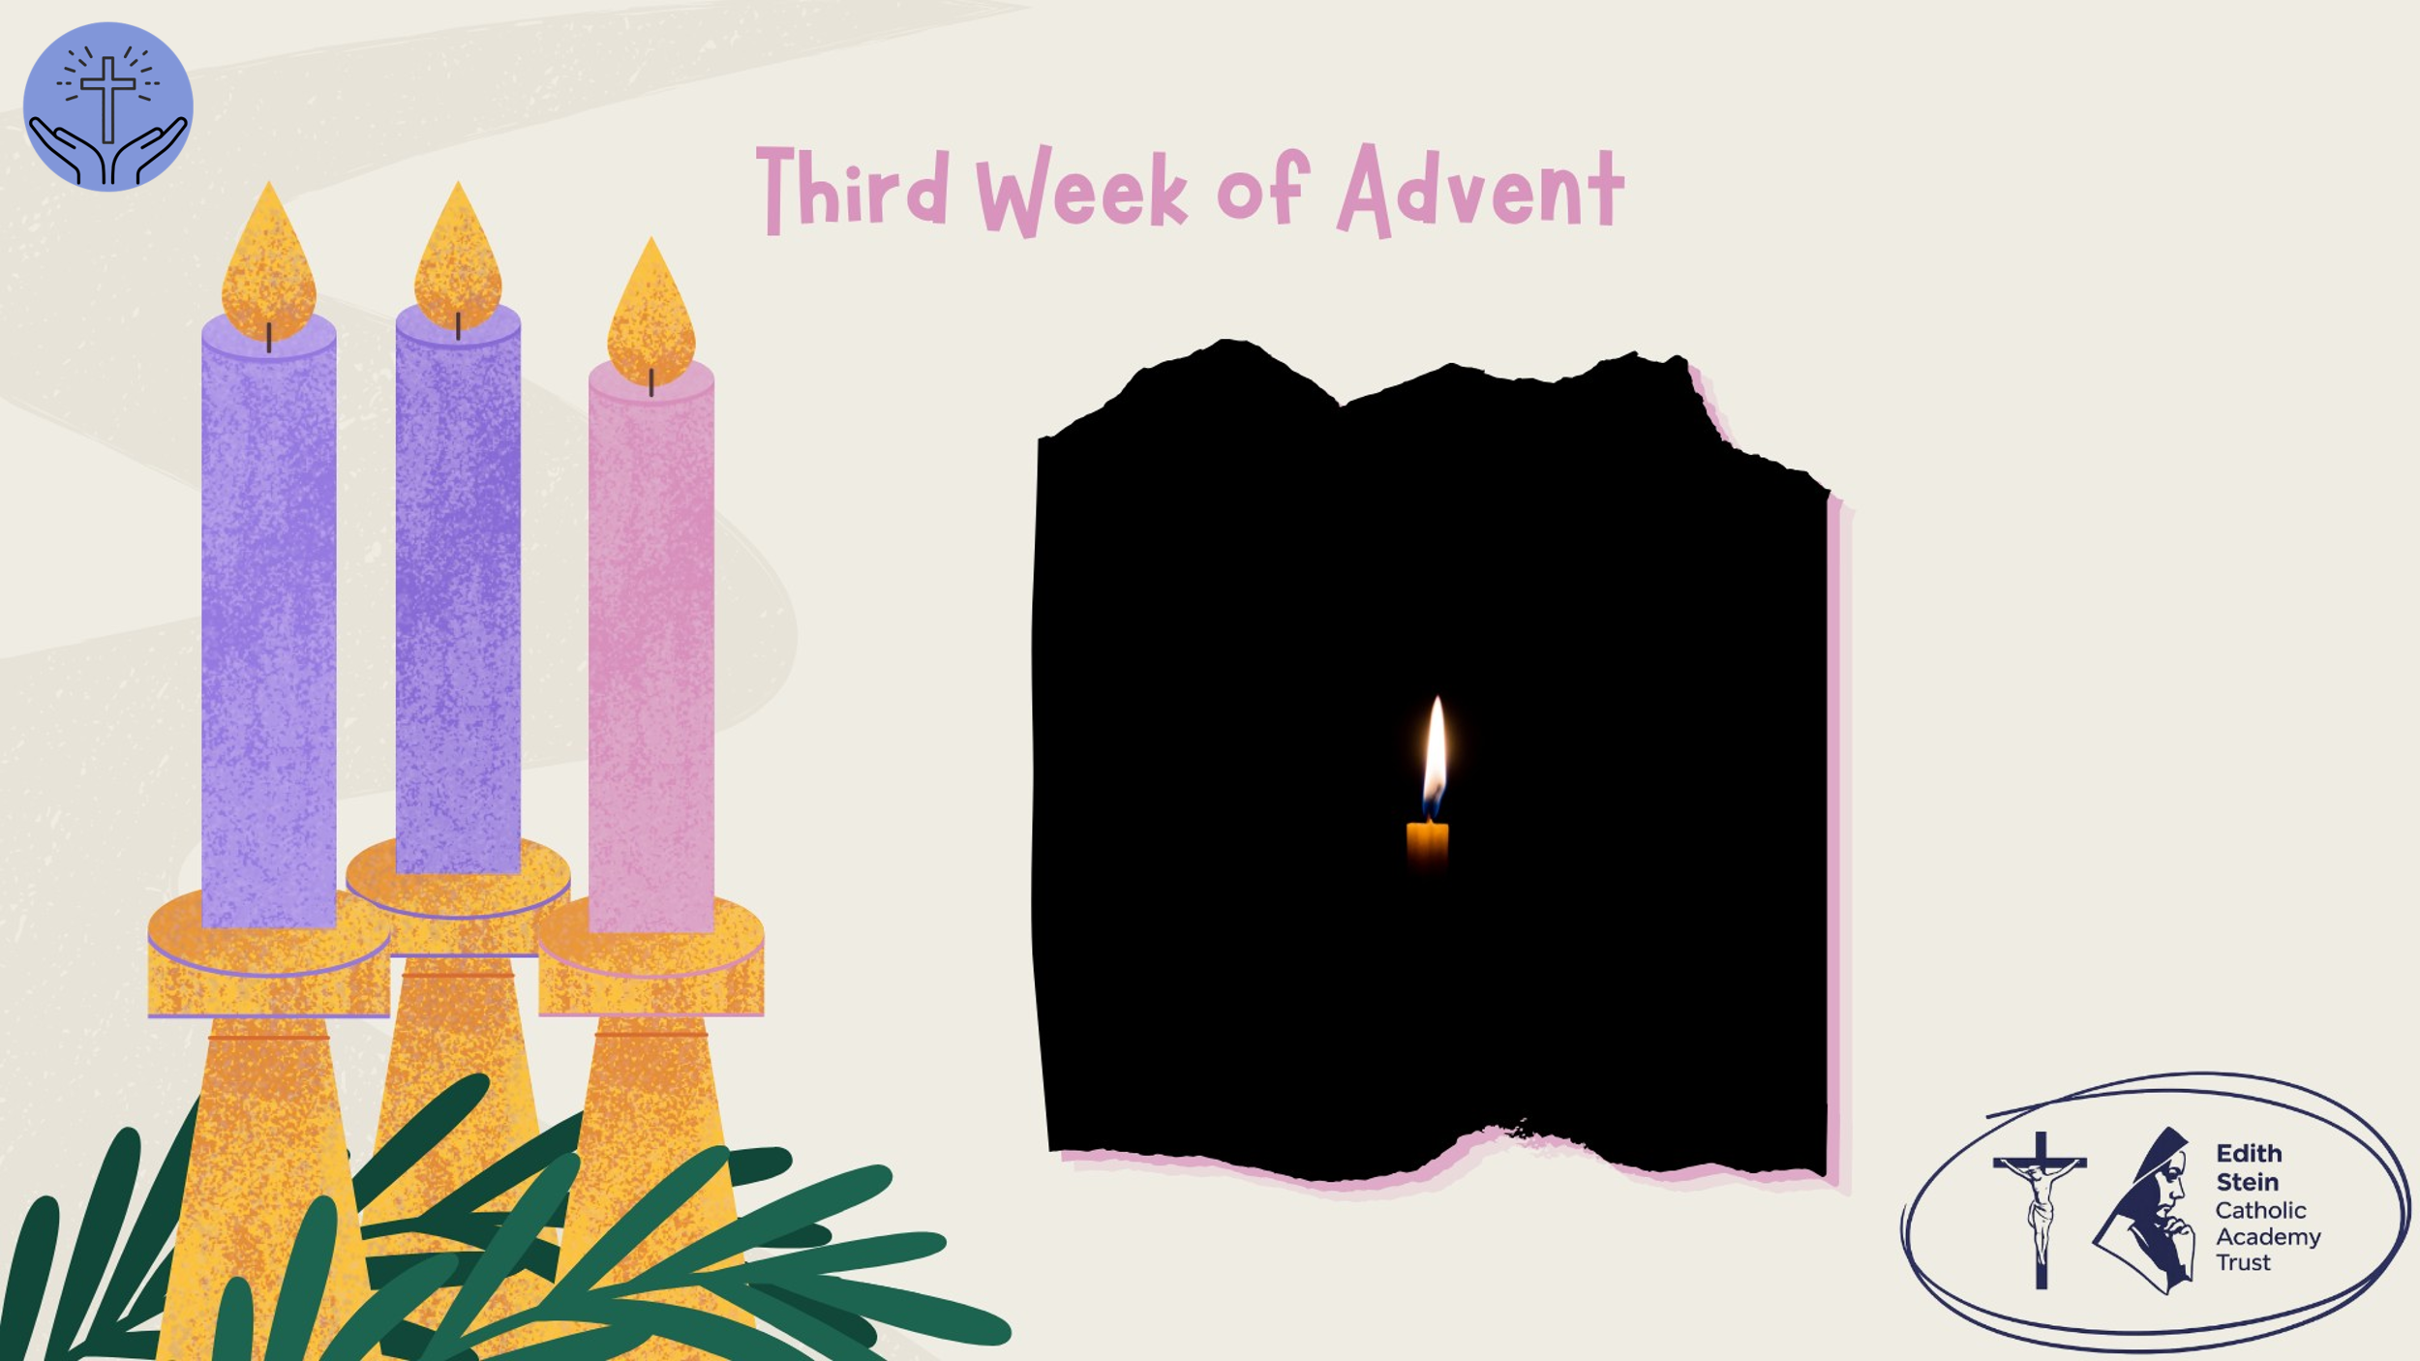 | Reflection  He was not the light. He came to testify to the light.  What does it mean to point beyond yourself?  Take a moment. Is there a word or phrase from the Gospel that stays with you?  Have a moment of silence.  John the Baptist had an important role. People came to him, listened to him and wanted to know who he was. But John was clear about one thing:  he was not the light. His purpose was to point people towards Jesus.  That challenges us to think about the influence we have on others.  We live in a world where attention can feel like everything. Social media encourages us to present ourselves in a certain way, to seek approval and to measure ourselves against other people.  But there is a difference between being noticed and making a difference.  You don't have to be the loudest person in the room to influence someone. You don't need thousands of followers to have an impact. Sometimes the people who make the greatest difference are those who quietly encourage others, stand up for someone who is being treated unfairly, or help someone recognise their own worth.  For Christians, being a light isn't about drawing attention to ourselves. It's about reflecting the light of Christ through the way we live.  Advent reminds us that joy is more than feeling happy when everything goes well. Christian joy is rooted in the hope we find in Jesus, and it can still be present when life is difficult.  So, consider these questions: pause after each one.  What kind of influence do I have on the people around me?  Do my words and actions build people up, or do they sometimes diminish others?  How could I help someone experience hope or joy this week?  Hold the answers in your heart as we pray together…
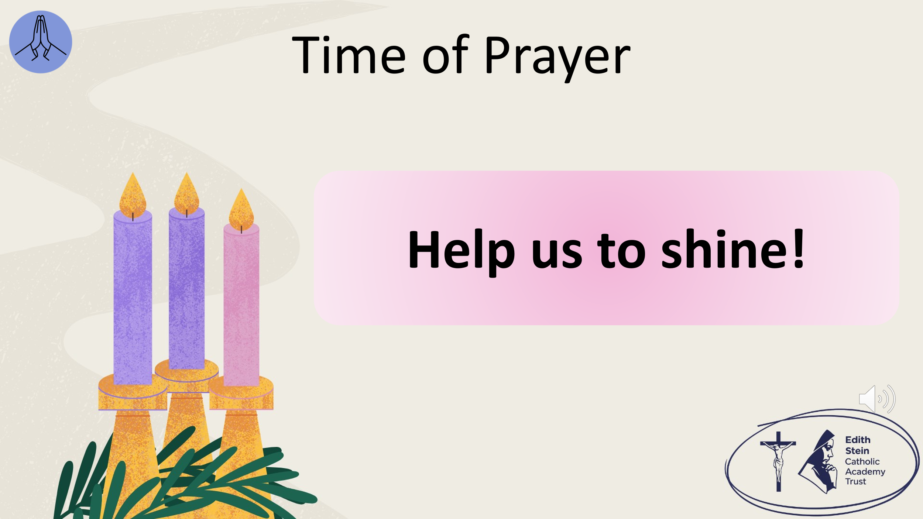 | The response to each line of the litany is,  Help us to shine!  When we have the opportunity to encourage someone but remain silent…  help us to shine.  When we see injustice and need the courage to speak up…help us to shine.  When we use our influence to bring people together rather than divide them… help us to shine.  When we struggle to find joy in difficult circumstances… help us to shine.  Through our words and actions… help us to shine.  When we celebrate each other’s gifts… help us to shine.  When we bring happiness to our homes and school… help us to shine.  When we remember that Jesus is our light… help us to shine.  When we choose love, even when it is hard… help us to shine.  When we want to make a difference in the world… help us to shine.
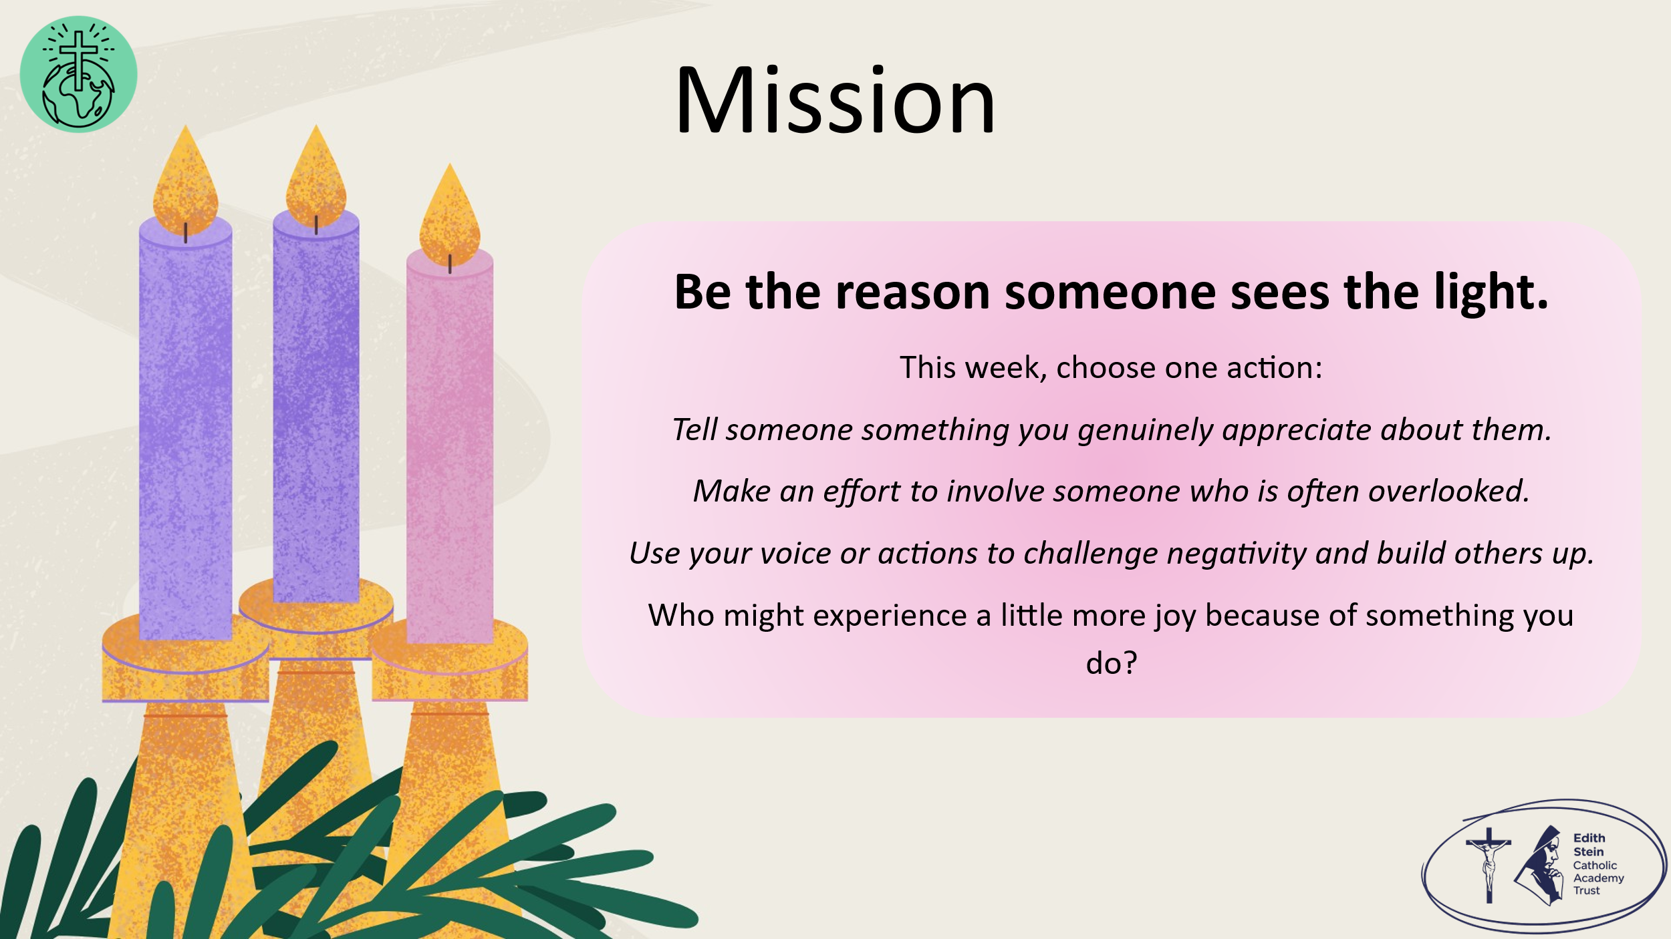 | Before we ask for God’s blessing, let us take up our mission:  John the Baptist didn't need to be the light himself. He simply needed to point people towards it.  This week, think about the way you influence the people around you. You may never know how much a kind word, a moment of encouragement or a decision to include someone can mean.  You don't have to do something extraordinary. Start with one small action.  Let the way you live point others towards the light of Christ.
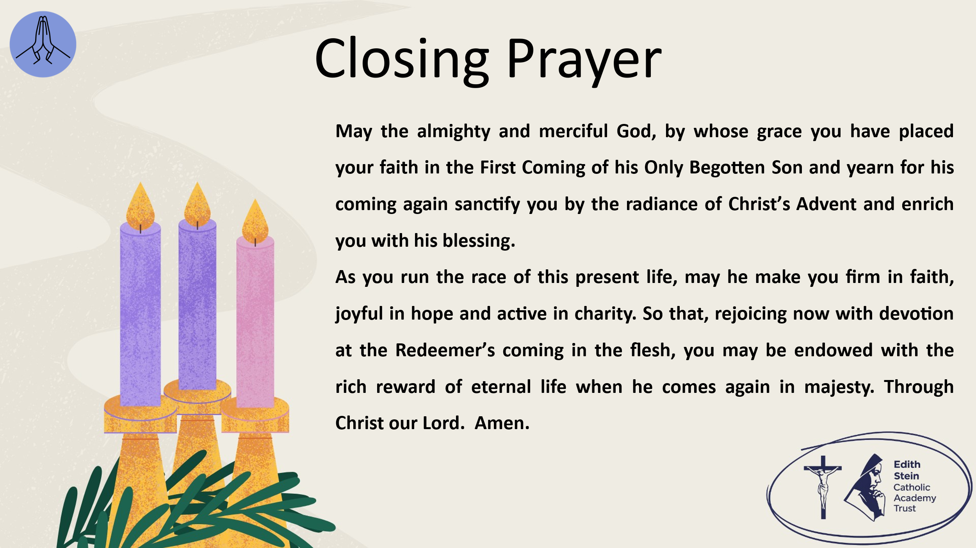 | Solemn Blessing  May the almighty and merciful God, by whose grace you have placed your faith in the First Coming of his Only Begotten Son and yearn for his coming again sanctify you by the radiance of Christ’s Advent and enrich you with his blessing.  As you run the race of this present life, may he make you firm in faith, joyful in hope and active in charity.  So that, rejoicing now with devotion at the Redeemer’s coming in the flesh, you may be endowed with the rich reward of eternal life when he comes again in majesty. Through Christ our Lord.  Amen.  SIGN OF THE CROSS

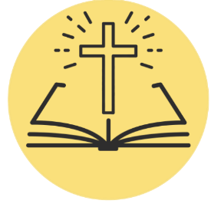
*Can be read by a student or staff.

A reading from the Holy Gospel according to John.
ALL: Glory to You, O Lord.

There was a man sent from God, whose name was John. He came as a witness, to bear witness about the light, that all might believe through him. He was not the light, but came to bear witness about the light.
John said, “I am the voice of one crying out in the wilderness, ‘Make straight the way of the Lord,’ as the prophet Isaiah said.”
“I baptise with water, but among you stands one you do not know, even he who comes after me, the strap of whose sandal I am not worthy to untie.” These things took place in Bethany across the Jordan, where John was baptising.

The Gospel of the Lord.
ALL: Praise to You Lord, Jesus Christ.

