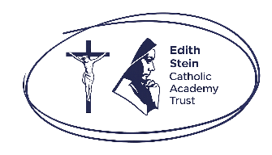
Secondary Celebration of the Word Assembly Script
Second Week of Advent, Year B

Slides | Script | Additional Notes
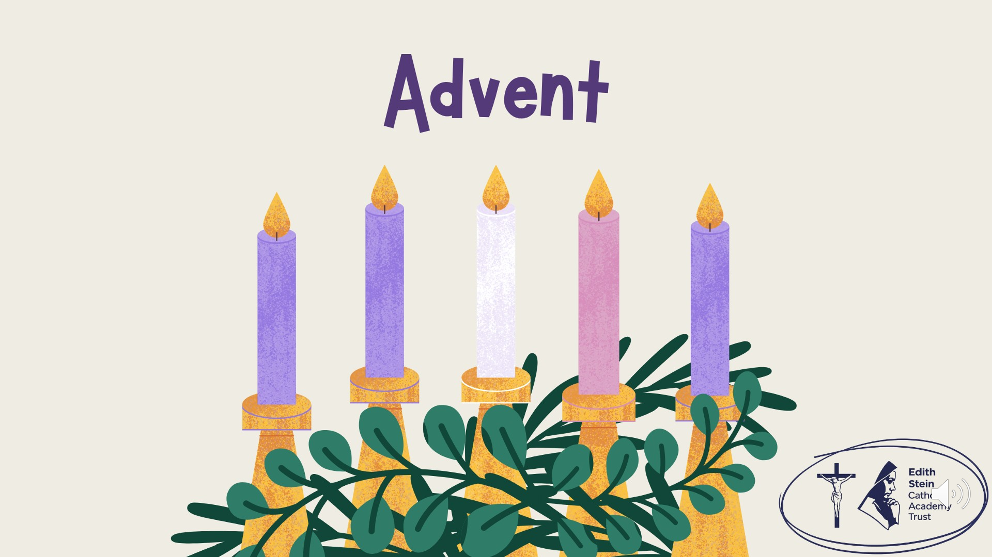 | SIGN OF THE CROSS  Good morning! | There is some background music on this first slide that you might like to use while staff and studentsf enter the assembly space.  Please check volume levels prior to the start of the assembly.
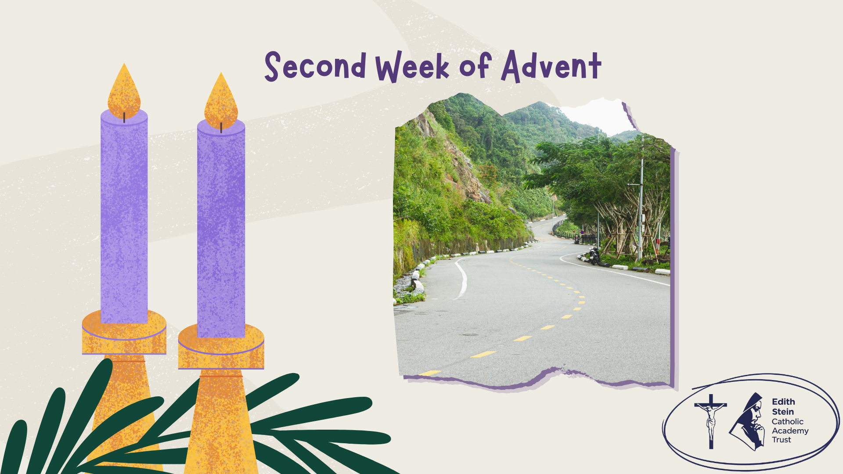 | Think about a journey. Sometimes the route is clear. Sometimes there are obstacles, diversions or things that make it harder to reach your destination.  In today's Gospel, John the Baptist calls people to prepare the way for the Lord.  Of course, he isn't asking us to build a physical road. He's calling people to prepare themselves for the coming of Jesus: to turn away from what is wrong and make space for God.  As we continue our Advent journey, let's consider this question: What might need to change in us for there to be more room for Christ?  Before we hear the Word of God proclaimed, let us continue our Advent journey together by lighting the second candle on our Advent Wreath. | Purple cloth, advent wreath.
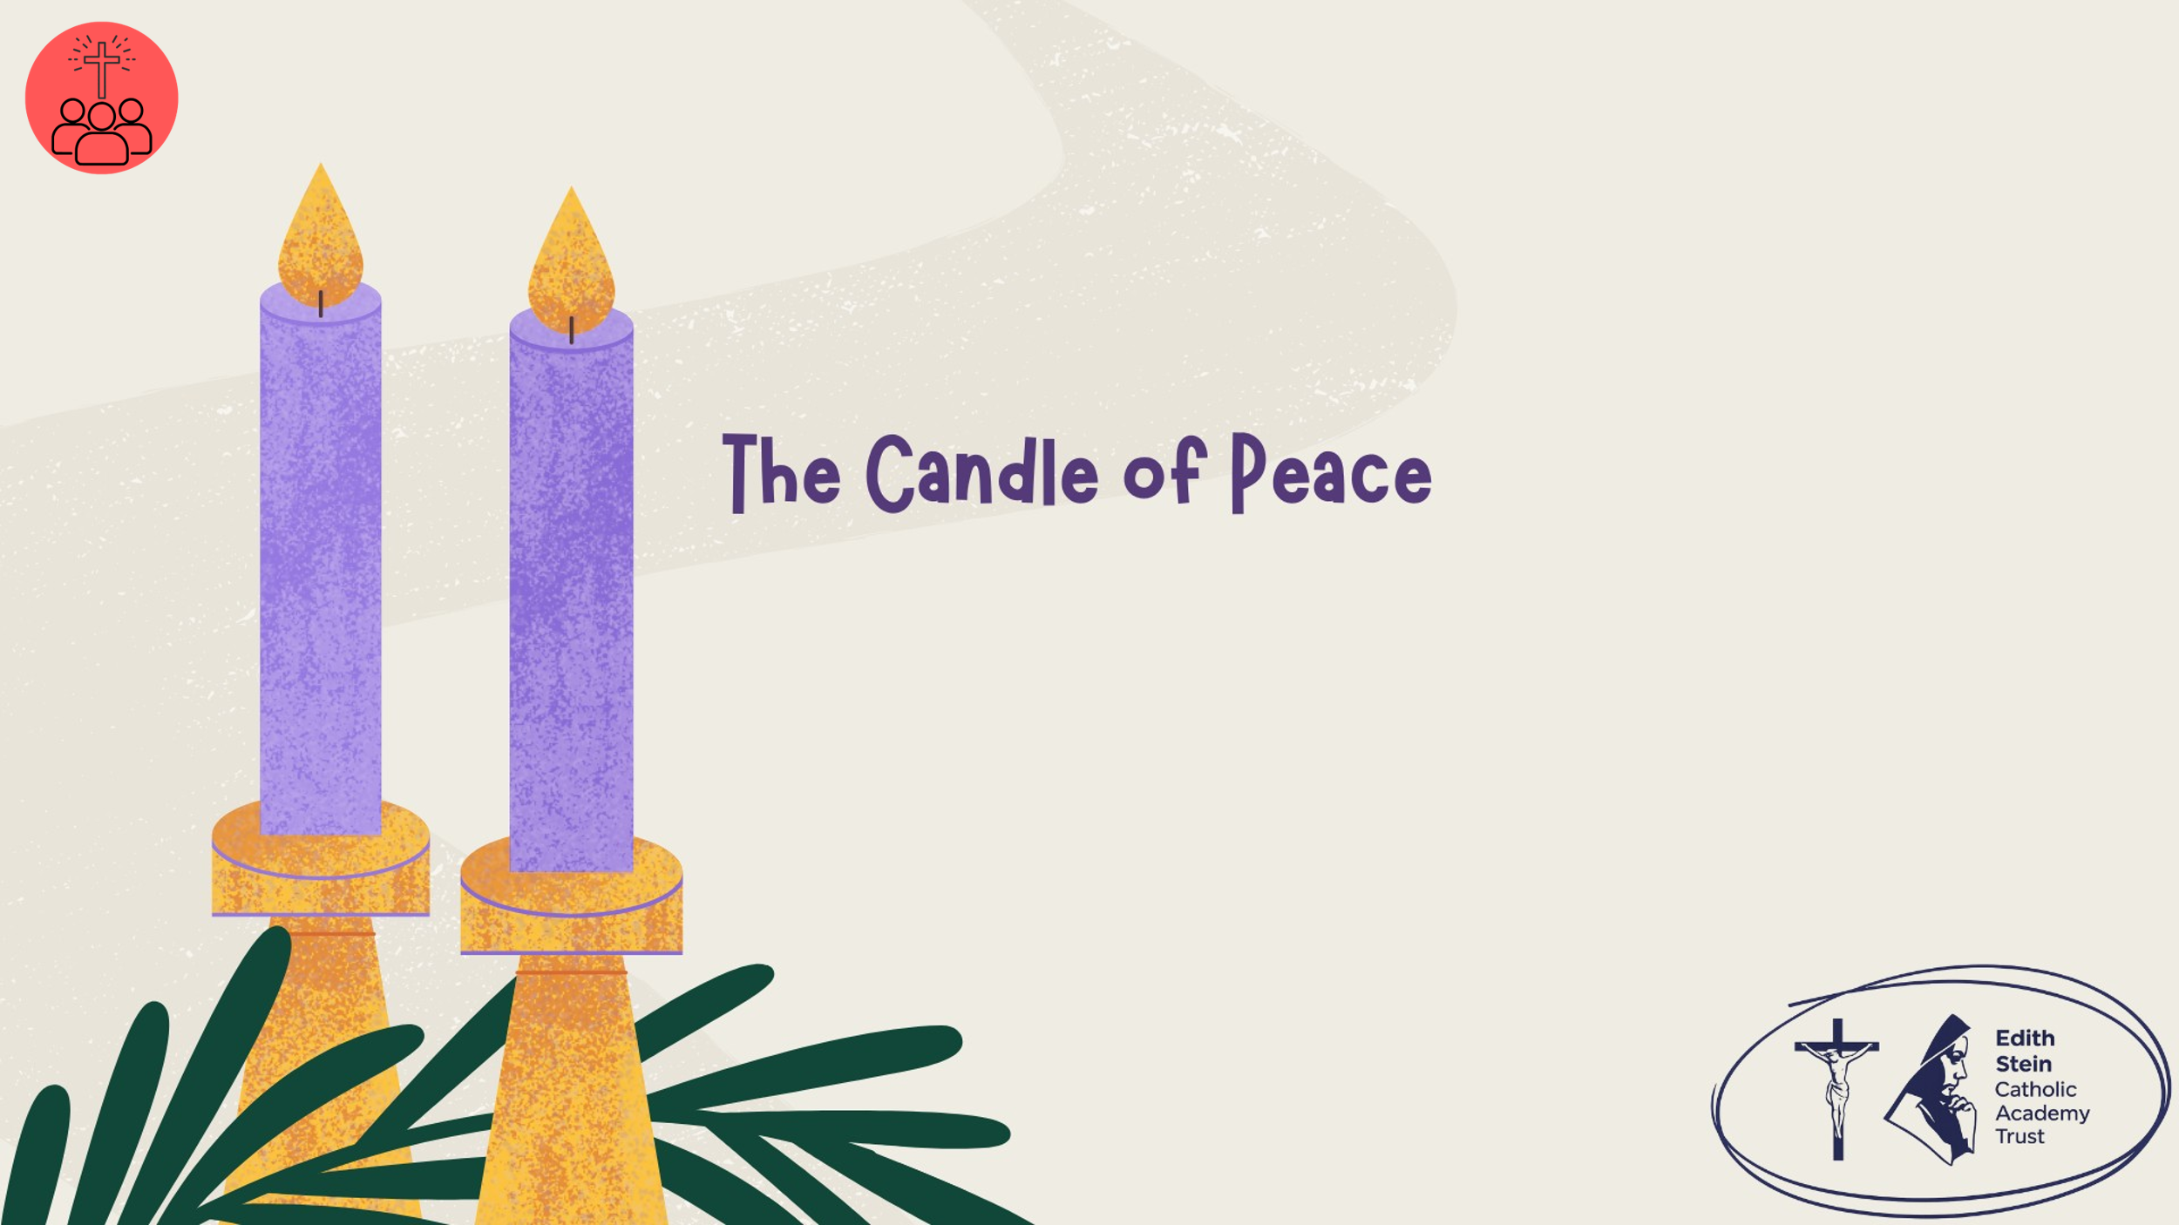 | Lighting the Advent Wreath  Lord our God, we praise you for your Son, Jesus Christ:  he is Emmanuel, the hope of the peoples,  he is the wisdom that teaches and guides us,  he is the Saviour of every nation.  Lord God, let your blessing come upon us as we light the candles of this wreath.  May the wreath and its light be a sign of Christ’s promise to bring us salvation.  May he come quickly and not delay. We ask this through Christ our Lord. Amen  Second Candle – Peace  Today we light the second candle, the Candle of Peace.  John the Baptist calls us to prepare the way for the Lord. We prepare not by decorating our homes, but by making room for Jesus in our hearts. When we choose forgiveness, kindness and peace, we help make a straight path for Christ.  Let us pray… | Light the first and second purple candles on the wreath.
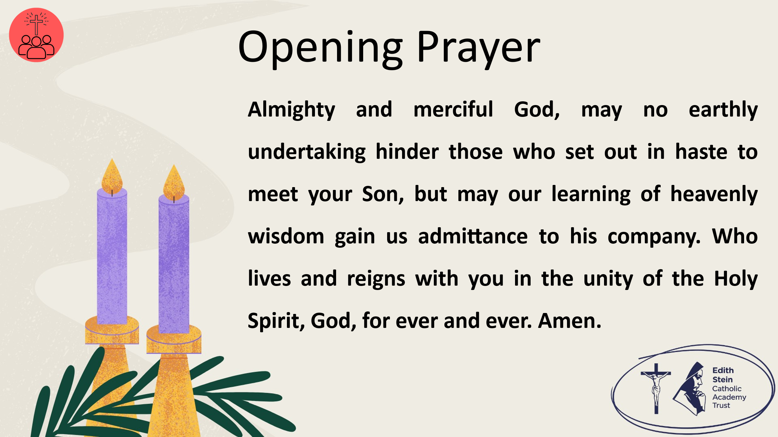 | Almighty and merciful God, may no earthly undertaking hinder those who set out in haste to meet your Son, but may our learning of heavenly wisdom gain us admittance to his company. Who lives and reigns with you in the unity of the Holy Spirit, God, for ever and ever. Amen.  Collect from Mass for the Second Sunday of Advent, Year B  Now let us prepare our hearts and minds to hear the Word of God.
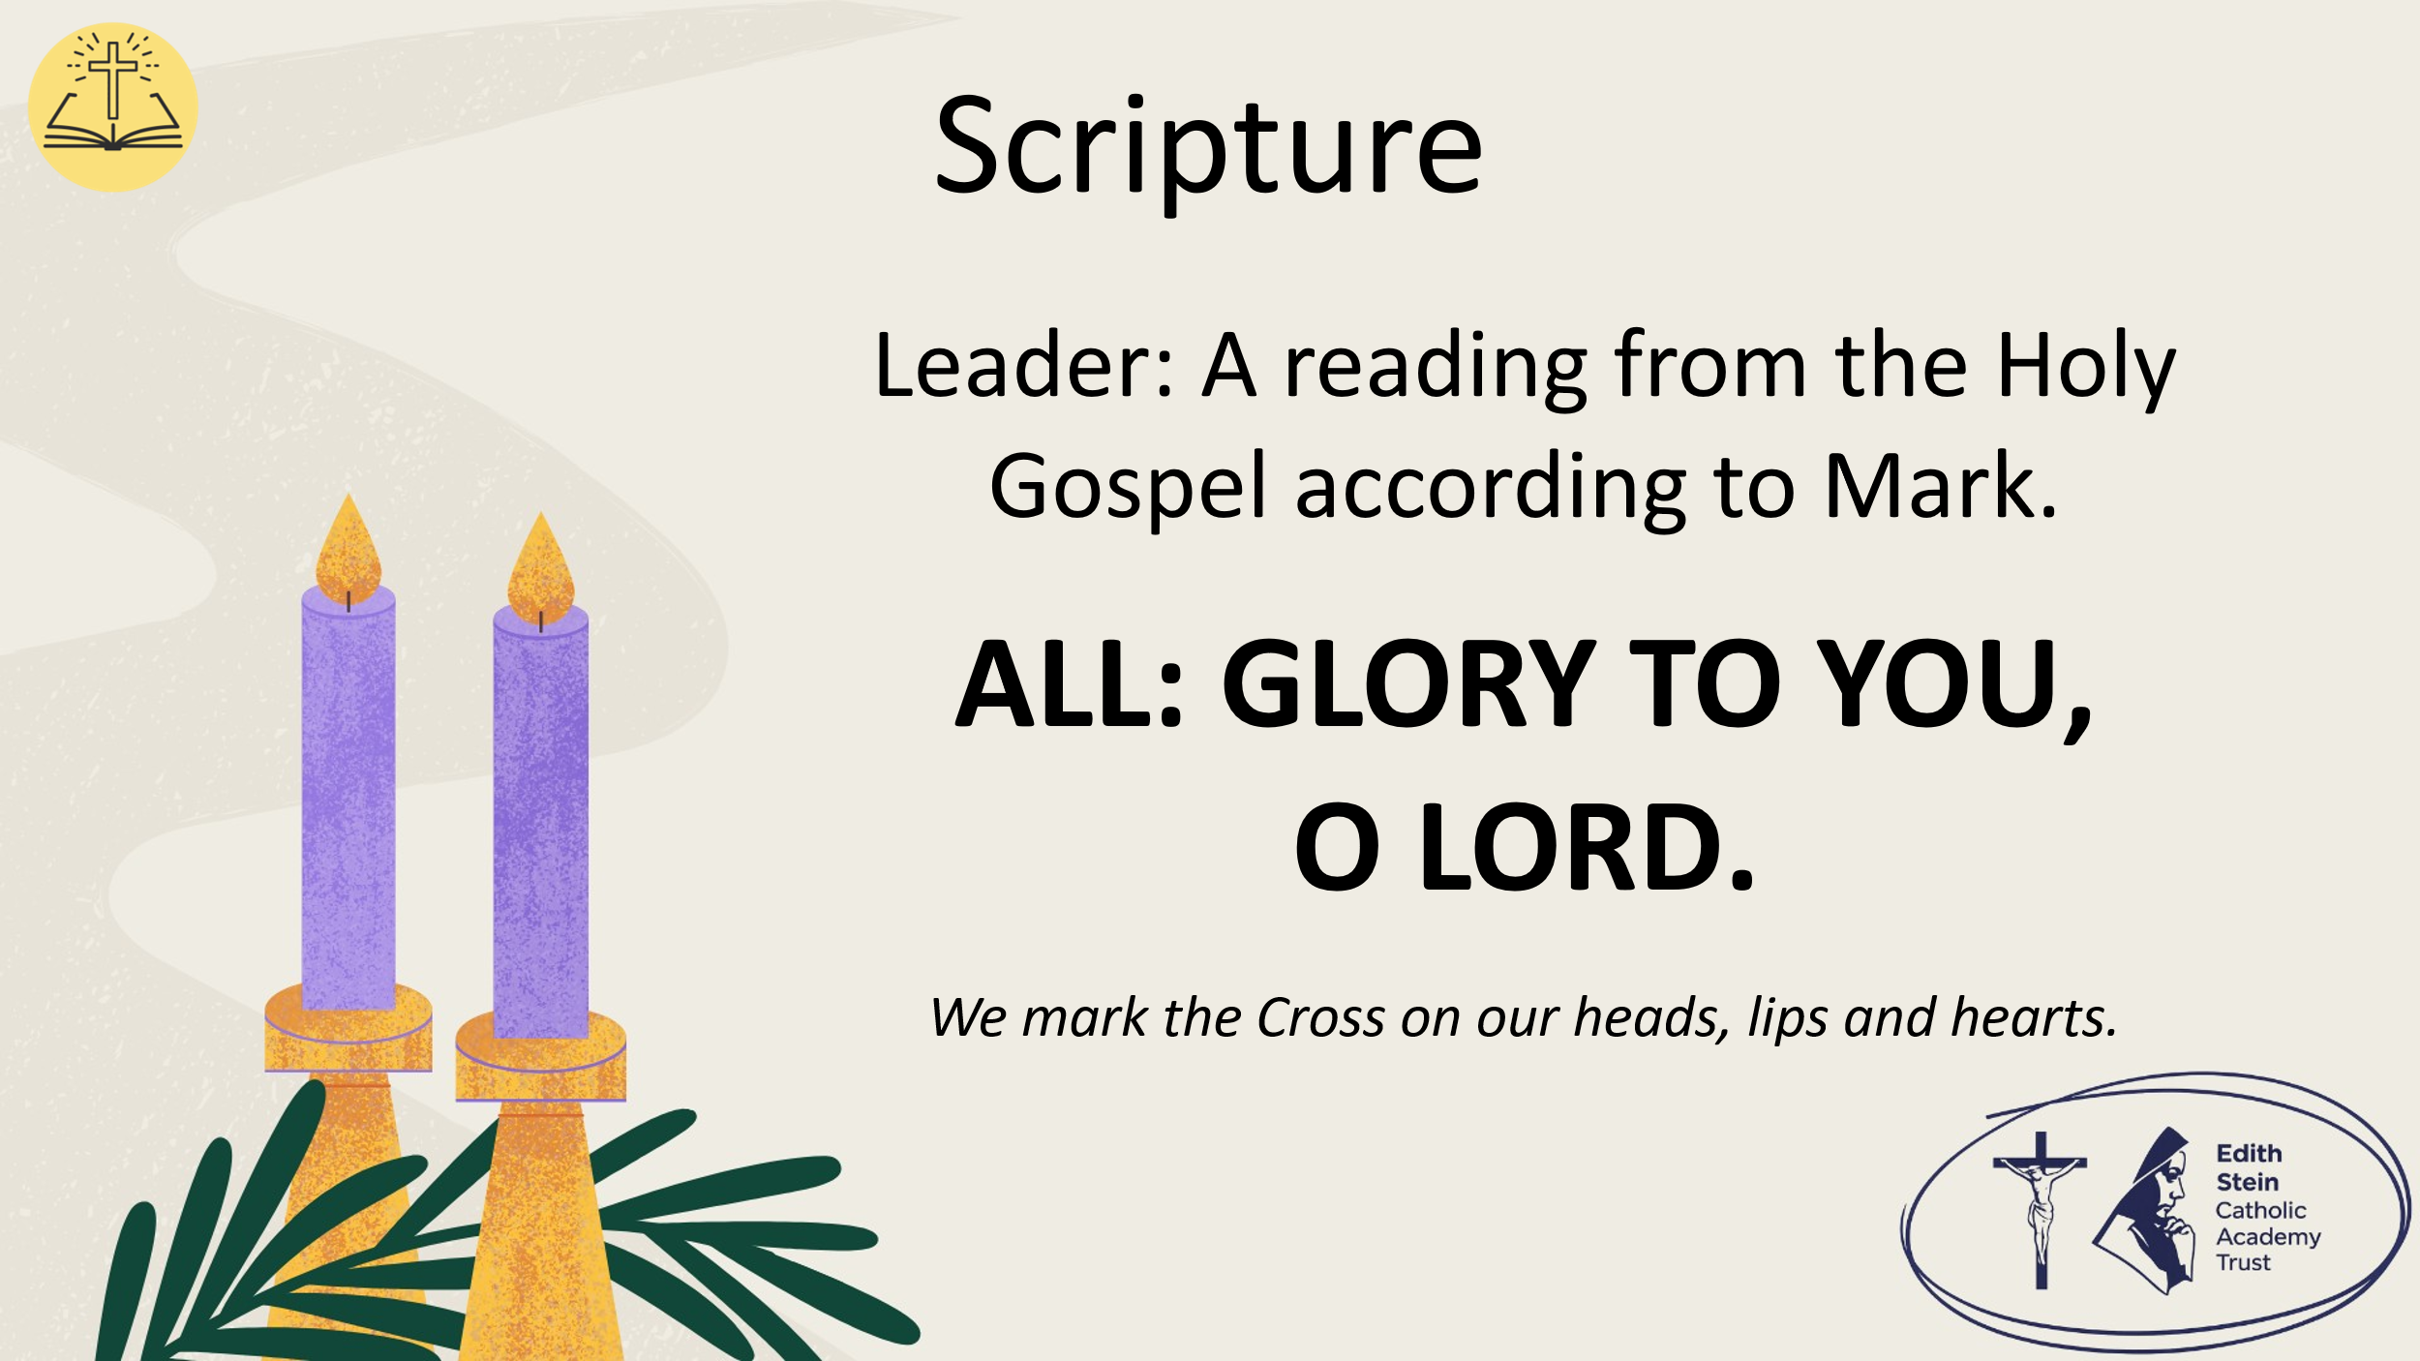 | See below or separate page for Gospel reading.  Mark 1:1-8  A reading from the Holy Gospel according to Mark.  ALL: GLORY TO YOU, O LORD. | You may invite everyone to stand to listen to the Word proclaimed.  If you are not already doing so, please ensure that everyone crosses their foreheads, lips and hearts.
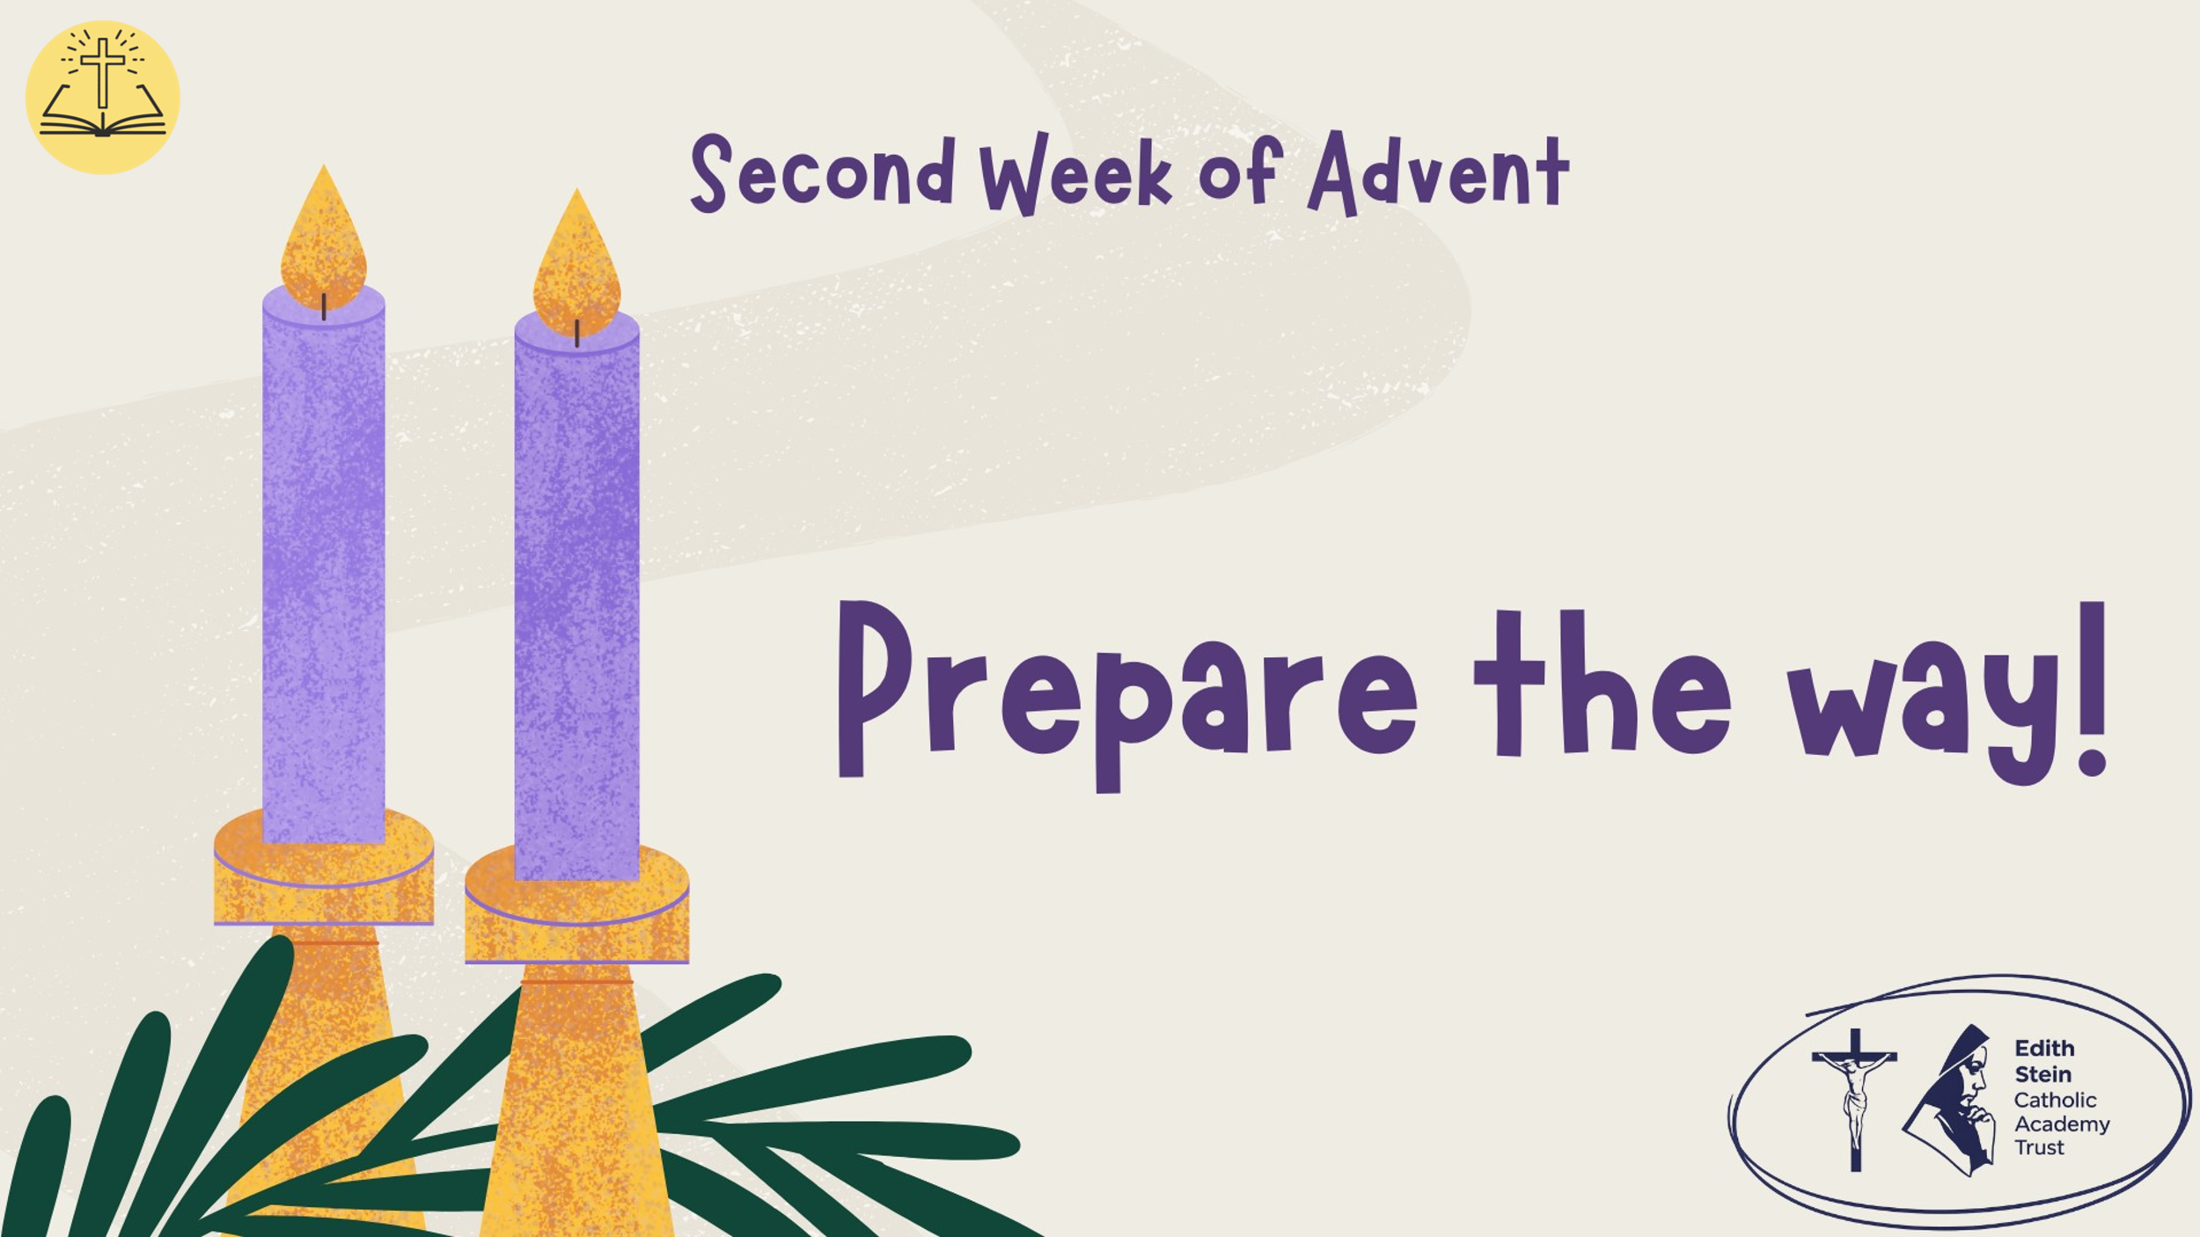 |  | This could be read by staff or student. Please ensure whoever is proclaiming the Gospel has had appropriate preparation and will proclaim worthily and well.
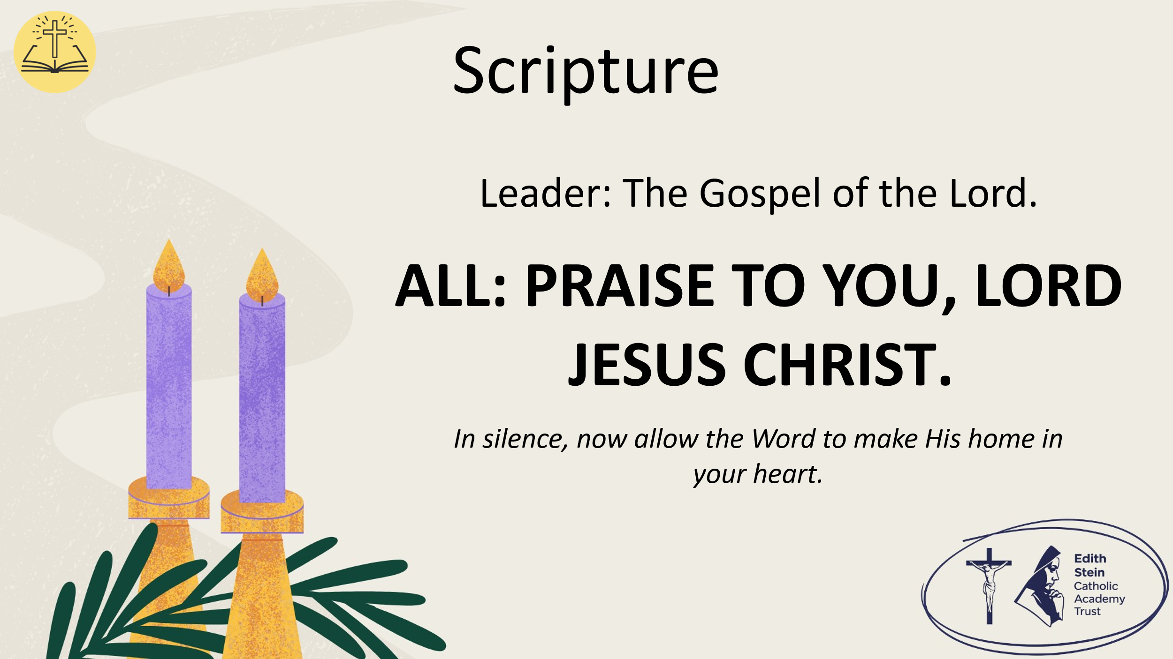 | The Gospel of the Lord.  ALL: PRAISE TO YOU, LORD JESUS CHRIST. | Allow a moment of silence at the end of the Gospel to allow the Word to make His home in everyone’s hearts.  Invite everyone to be seated if they have been standing for the Gospel.
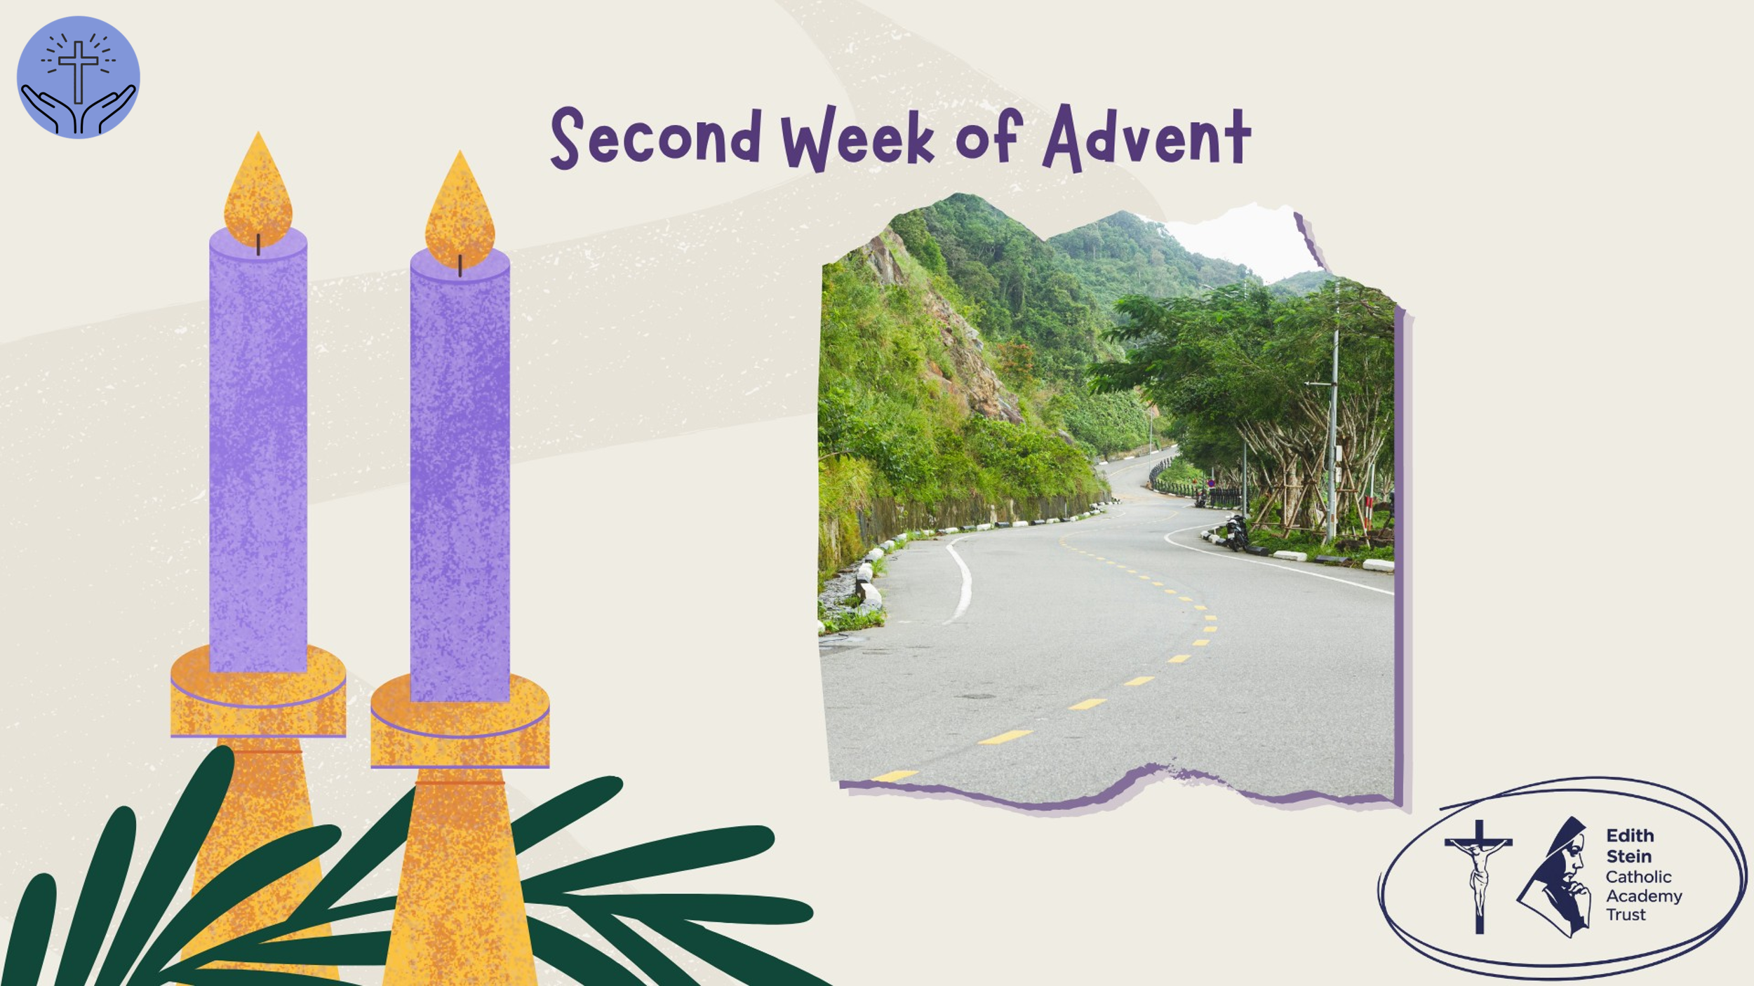 | What does it mean to prepare the way?  Take a moment. Is there a word or phrase from the Gospel that stays with you?  Have a moment of silence.  John the Baptist comes with a clear message: prepare the way for the Lord.  His message is challenging because preparation involves more than getting things ready on the outside. It means being willing to change on the inside.  We can all say that we want peace. We want peace in our friendships, in our families, in our school and in the world. But peace doesn't just happen.  Sometimes we hold on to resentment because we don't want to be the first to apologise. Sometimes we make assumptions about people without understanding their story. Sometimes we contribute to conflict through our words, our messages or our silence when someone is being treated unfairly.  Preparing the way for Jesus means being honest about these things. It means recognising where we might need to change, choosing forgiveness when it is difficult, and taking responsibility for the part we play in our relationships.  This doesn't mean ignoring injustice or pretending that hurtful behaviour doesn't matter. Real peace requires honesty, justice and the courage to put things right.  Advent invites us to clear a path for Christ.  So, take a moment to consider: pause after each question.  Where in my life is peace missing?  Is there a relationship in which I could take a positive step towards peace?  What might I need to change in myself, rather than simply expecting others to change?  Hold the answers to these questions in your heart as we pray…
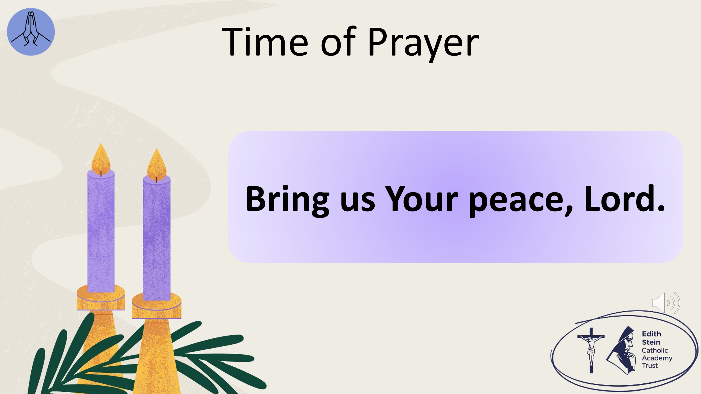 | The response to each line of the litany is,  Bring us Your peace, Lord.  When our minds are overwhelmed by pressure and uncertainty… bring us Your peace, Lord.  When conflict and misunderstanding damage our relationships… bring us Your peace, Lord.  When pride makes it difficult to apologise or forgive… bring us Your peace, Lord.  When our words or actions cause hurt… bring us Your peace, Lord.  When we struggle to be patient… bring us Your peace, Lord.  When the suffering and conflict in our world leave us feeling helpless…… bring us Your peace, Lord.  When we need calm in our hearts and minds… bring us Your peace, Lord.  Give us the courage to challenge injustice, repair relationships and become people who build peace… bring us Your peace, Lord. | There is background music on the slide that will play automatically.
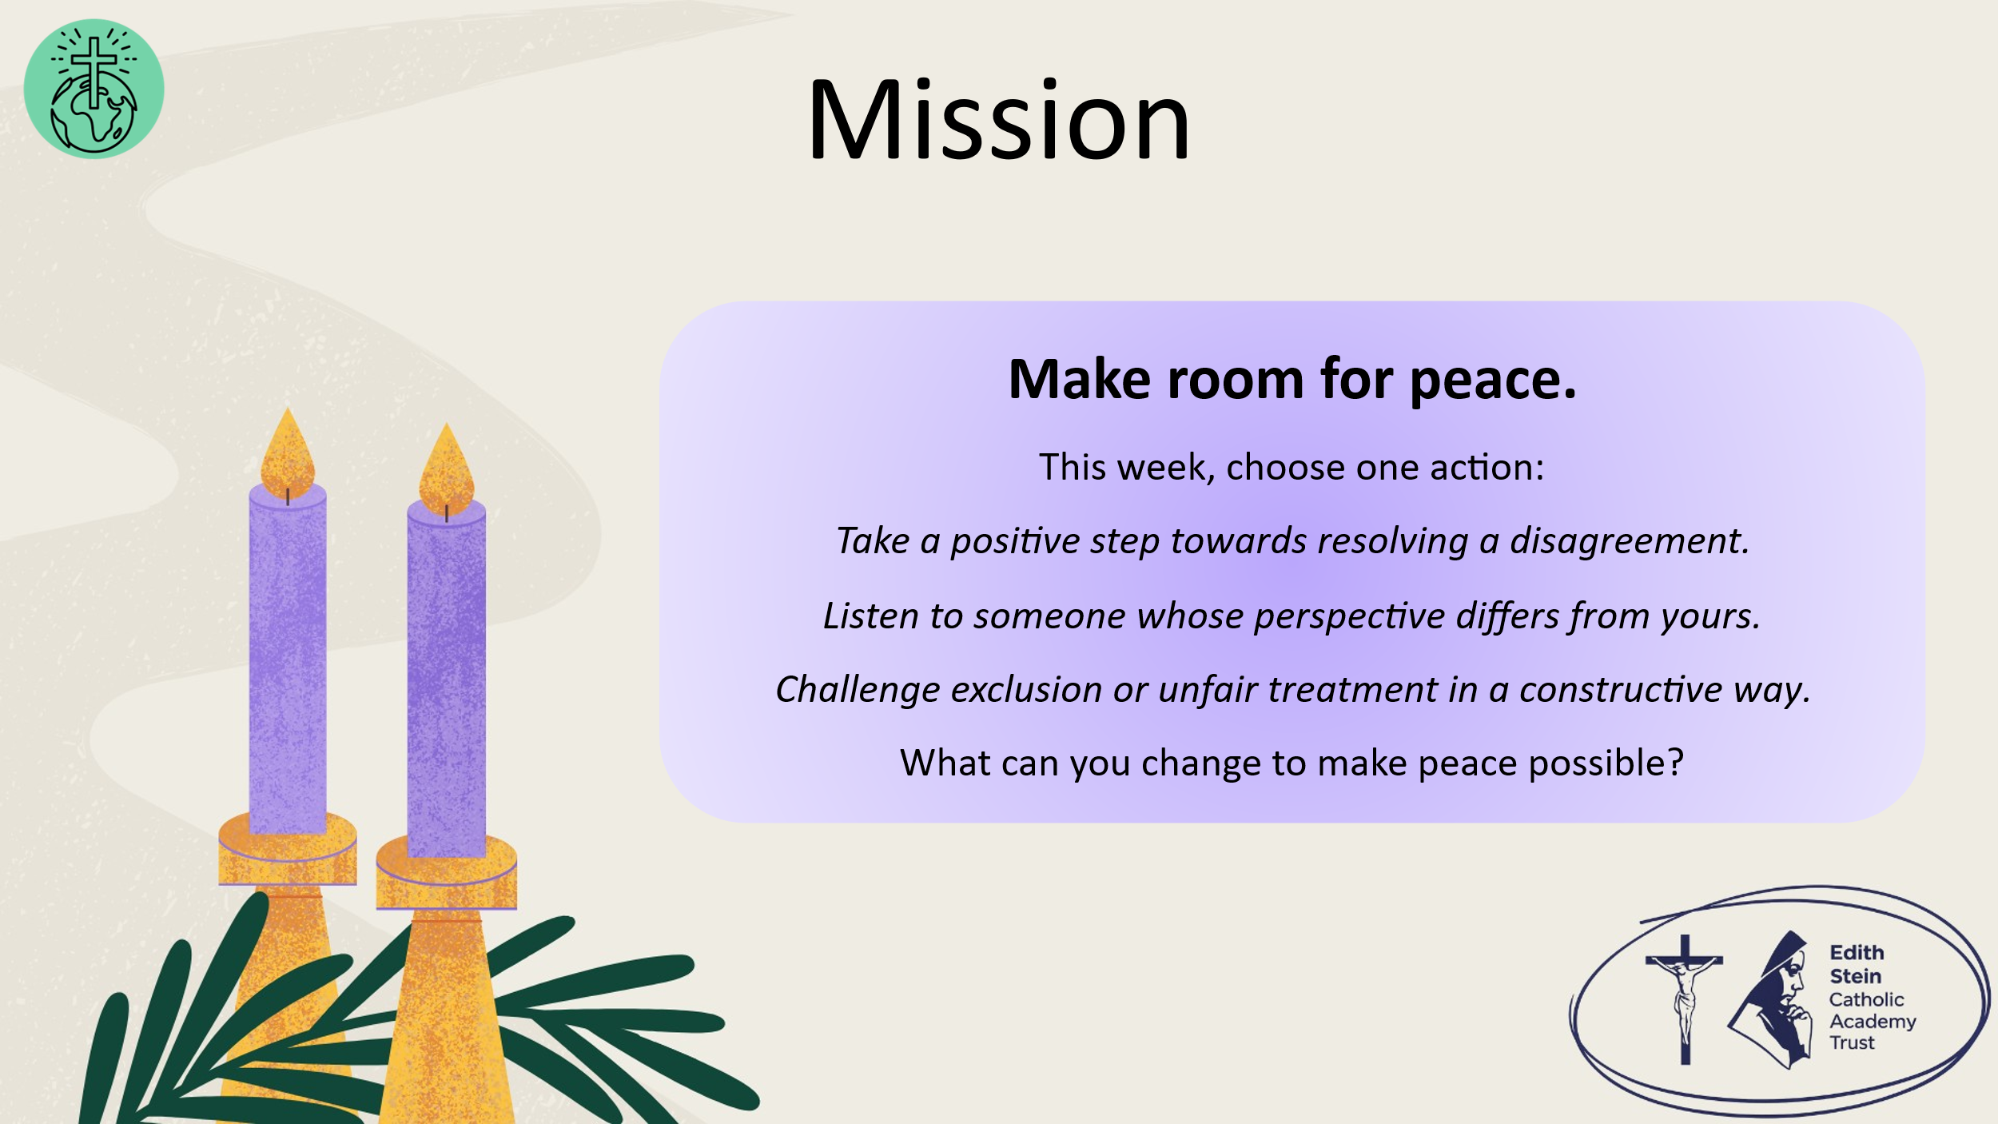 | So, before we go forth from this place, let us take up our mission.  Remember that preparing the way for Jesus is not just something we do during Advent. It is a choice we make in how we live.  You may not be able to resolve every conflict or change every situation. But you can choose how you respond, how you treat others and whether you help to build peace.  This week, choose one action:  Take a positive step towards resolving a disagreement.  Listen to someone whose perspective differs from yours.  Challenge exclusion or unfair treatment in a constructive way.  What can you change to make peace possible?
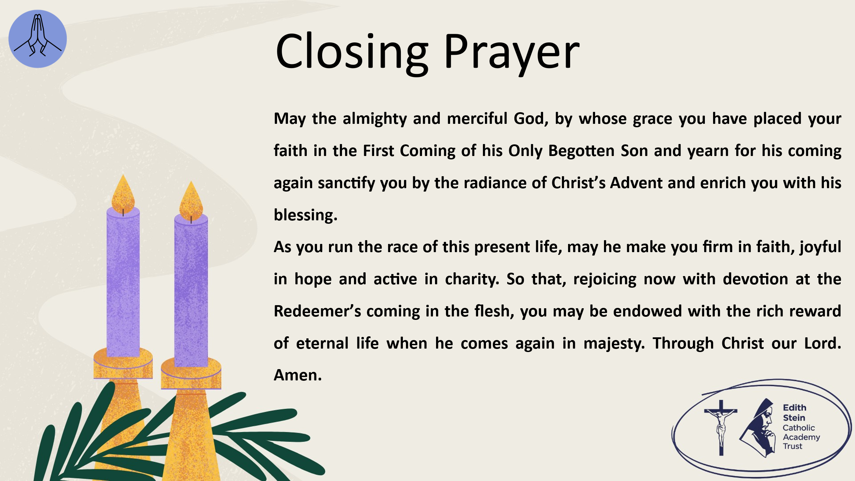 | Solemn Blessing  May the almighty and merciful God, by whose grace you have placed your faith in the First Coming of his Only Begotten Son and yearn for his coming again sanctify you by the radiance of Christ’s Advent and enrich you with his blessing.  As you run the race of this present life, may he make you firm in faith, joyful in hope and active in charity.  So that, rejoicing now with devotion at the Redeemer’s coming in the flesh, you may be endowed with the rich reward of eternal life when he comes again in majesty. Through Christ our Lord.  Amen.  SIGN OF THE CROSS

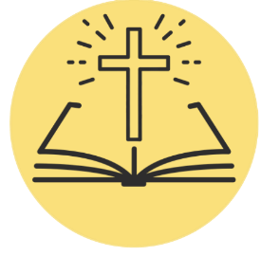
*Can be read by student or staff.

A reading from the Holy Gospel according to Mark.
ALL: Glory to You, O Lord.

The beginning of the gospel of Jesus Christ, the Son of God.
As it is written in Isaiah the prophet,

“Behold, I send my messenger before your face,
who will prepare your way,
the voice of one crying in the wilderness:
‘Prepare the way of the Lord,
make his paths straight,’”

John appeared, baptising in the wilderness and proclaiming a baptism of repentance for the forgiveness of sins. And all the country of Judea and all Jerusalem were going out to him and were being baptized by him in the river Jordan, confessing their sins. Now John was clothed with camel's hair and wore a leather belt round his waist and ate locusts and wild honey. And he preached, saying, “After me comes he who is mightier than I, the strap of whose sandals I am not worthy to stoop down and untie. I have baptized you with water, but he will baptize you with the Holy Spirit.”

The Gospel of the Lord.
ALL: Praise to You Lord, Jesus Christ.

