
Secondary Celebration of the Word Assembly Script
Frist Week of Advent, Year B

Slides | Script | Additional Notes
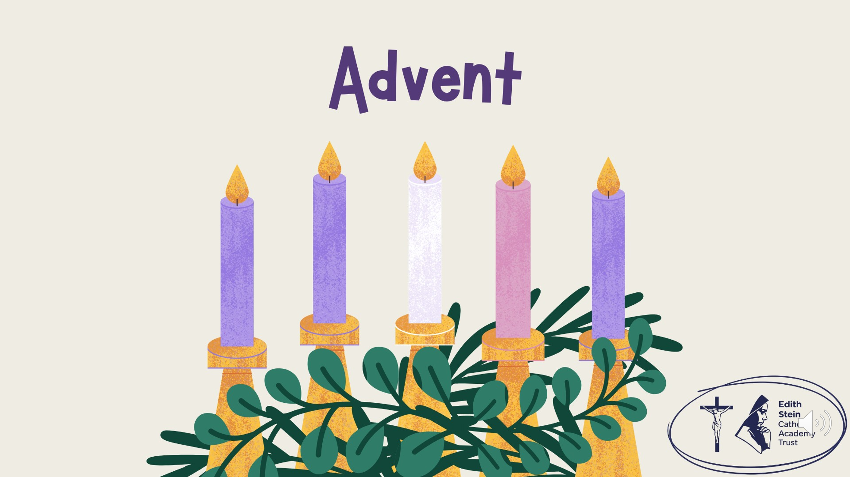 | SIGN OF THE CROSS  Good morning! | There is some background music on this first slide that you might like to use while staff and students enter the assembly space.  Please check volume levels prior to the start of the assembly.
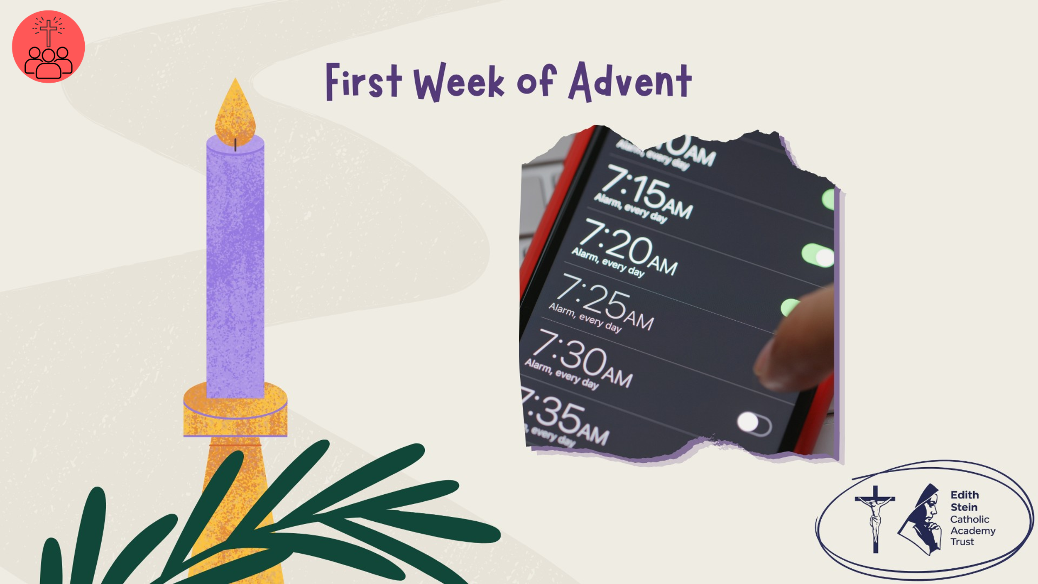 | Think about how many times your alarm went off this morning. Did you press snooze a few times? How many of you jumped straight out of bed? And how many of you just wanted to stay in bed?  In the Gospel this week, Jesus tells his disciples to stay awake and be ready. He isn't simply talking about sleep. He's asking them to pay attention: to God, to the people around them, and to the choices they make.  As we begin Advent, let's consider what it means to be truly awake, and whether we are pressing snooze on what God’s asking of us?  But before we hear the Word of God proclaimed, let us start our Advent journey together by lighting the first candle on our Advent Wreath. | Altar or prayer table set up: purple cloth (if available) and advent wreath.
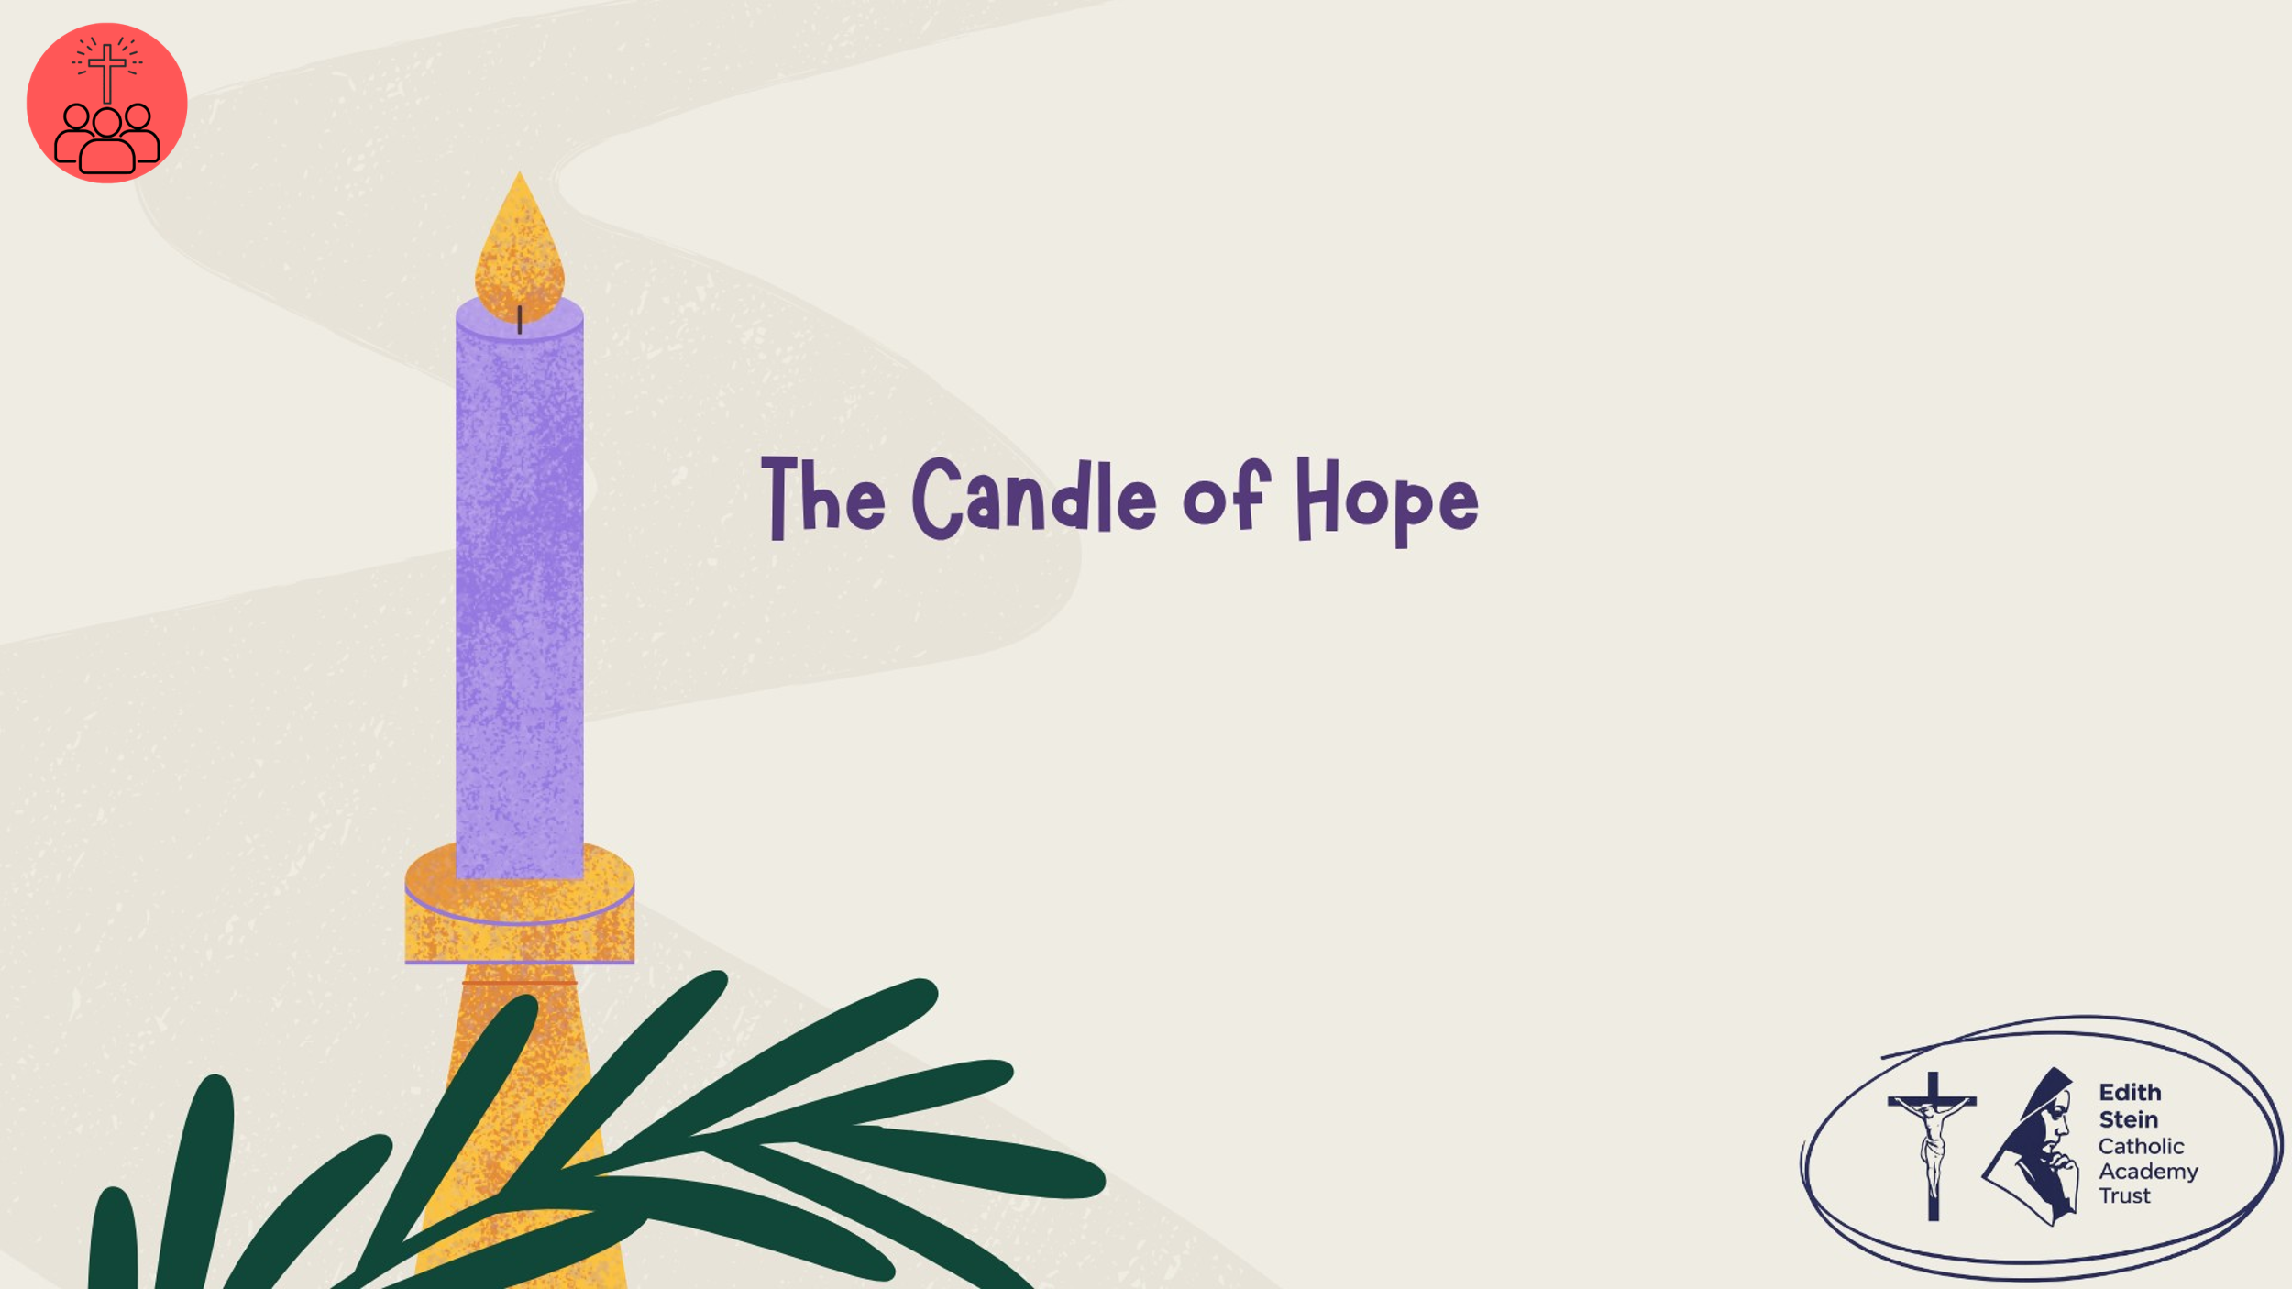 | Lighting the Advent Wreath  Lord our God, we praise you for your Son, Jesus Christ:  he is Emmanuel, the hope of the peoples,  he is the wisdom that teaches and guides us,  he is the Saviour of every nation.  Lord God, let your blessing come upon us as we light the candles of this wreath.  May the wreath and its light be a sign of Christ’s promise to bring us salvation.  May he come quickly and not delay. We ask this through Christ our Lord. Amen  First Candle – Hope  Today we light the first candle of Advent: the Candle of Hope.  Hope isn't the same as pretending everything is fine. It is the belief that darkness, disappointment and uncertainty do not have the final word.  For Christians, our hope is rooted in Jesus Christ. As we begin Advent, we prepare to celebrate his coming among us and to recognise his presence in our lives today.  Let us ask God to renew our hope and help us become people who bring hope to others.  Let us pray… | Light the first purple candle on the wreath.
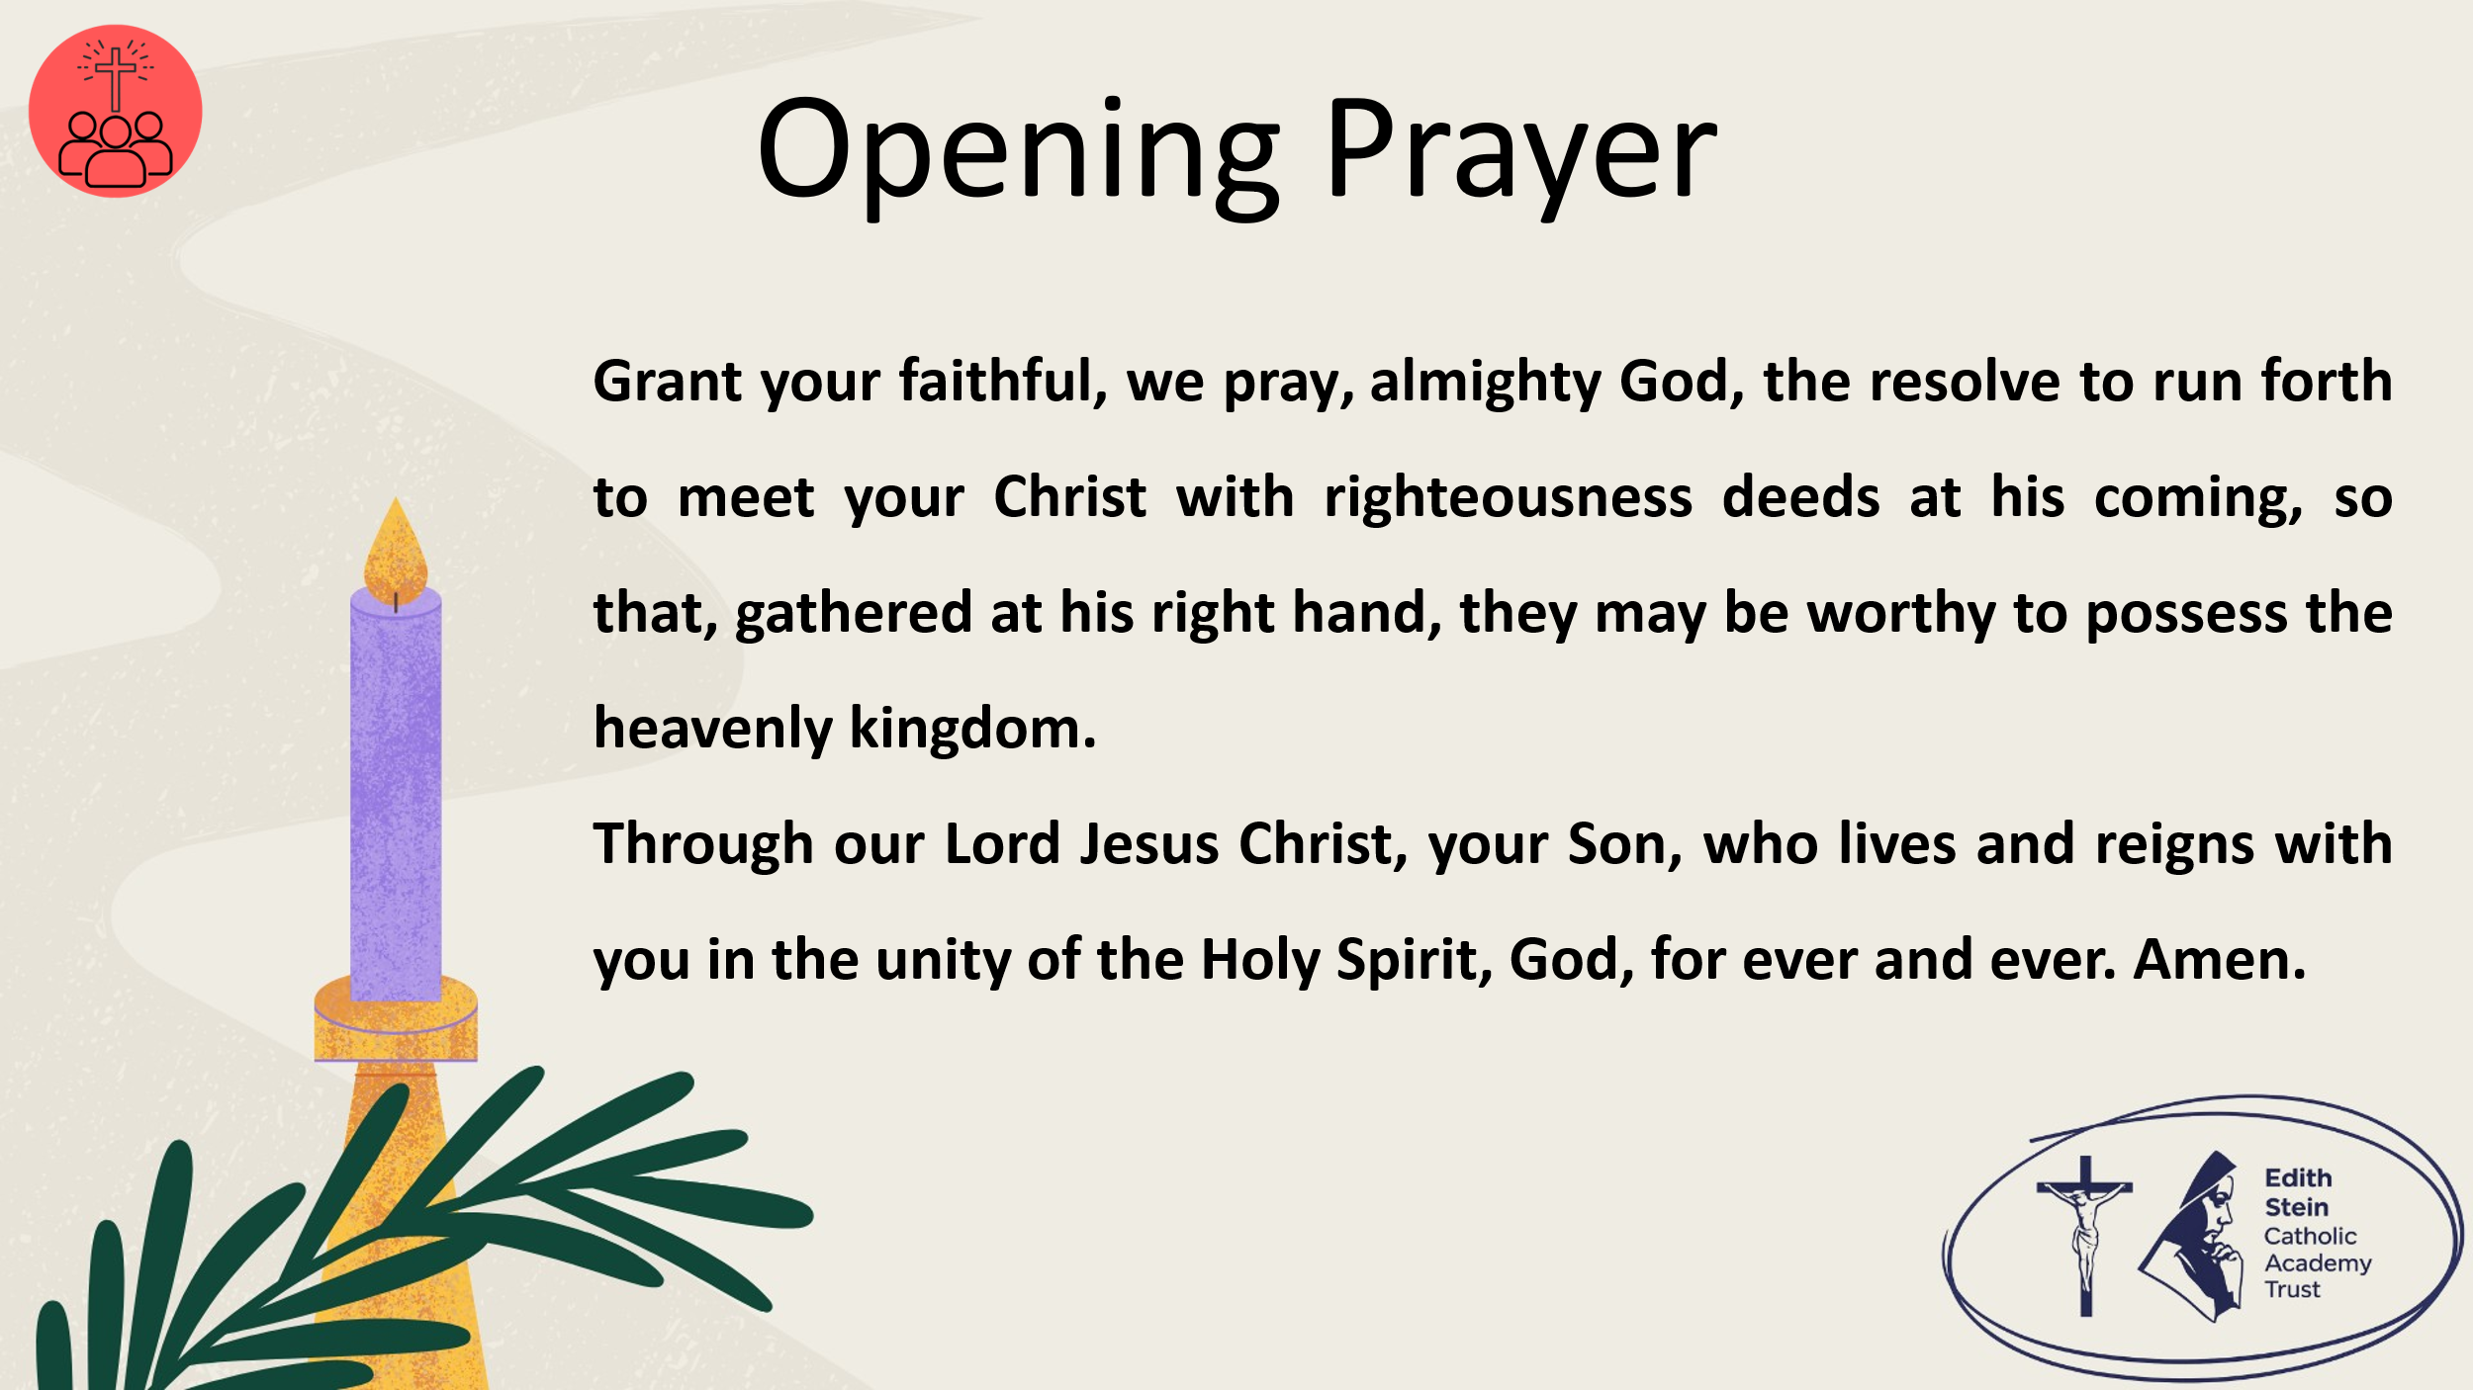 | Grant your faithful, we pray, almighty God, the resolve to run forth to meet your Christ with righteousness deeds at his coming, so that, gathered at his right hand, they may be worthy to possess the heavenly kingdom. Through our Lord Jesus Christ, your Son, who lives and reigns with you in the unity of the Holy Spirit, God, for ever and ever. Amen.  Collect from Mass for the First Sunday of Advent, Year B  Now let us prepare our hearts and minds to hear the Word of God.
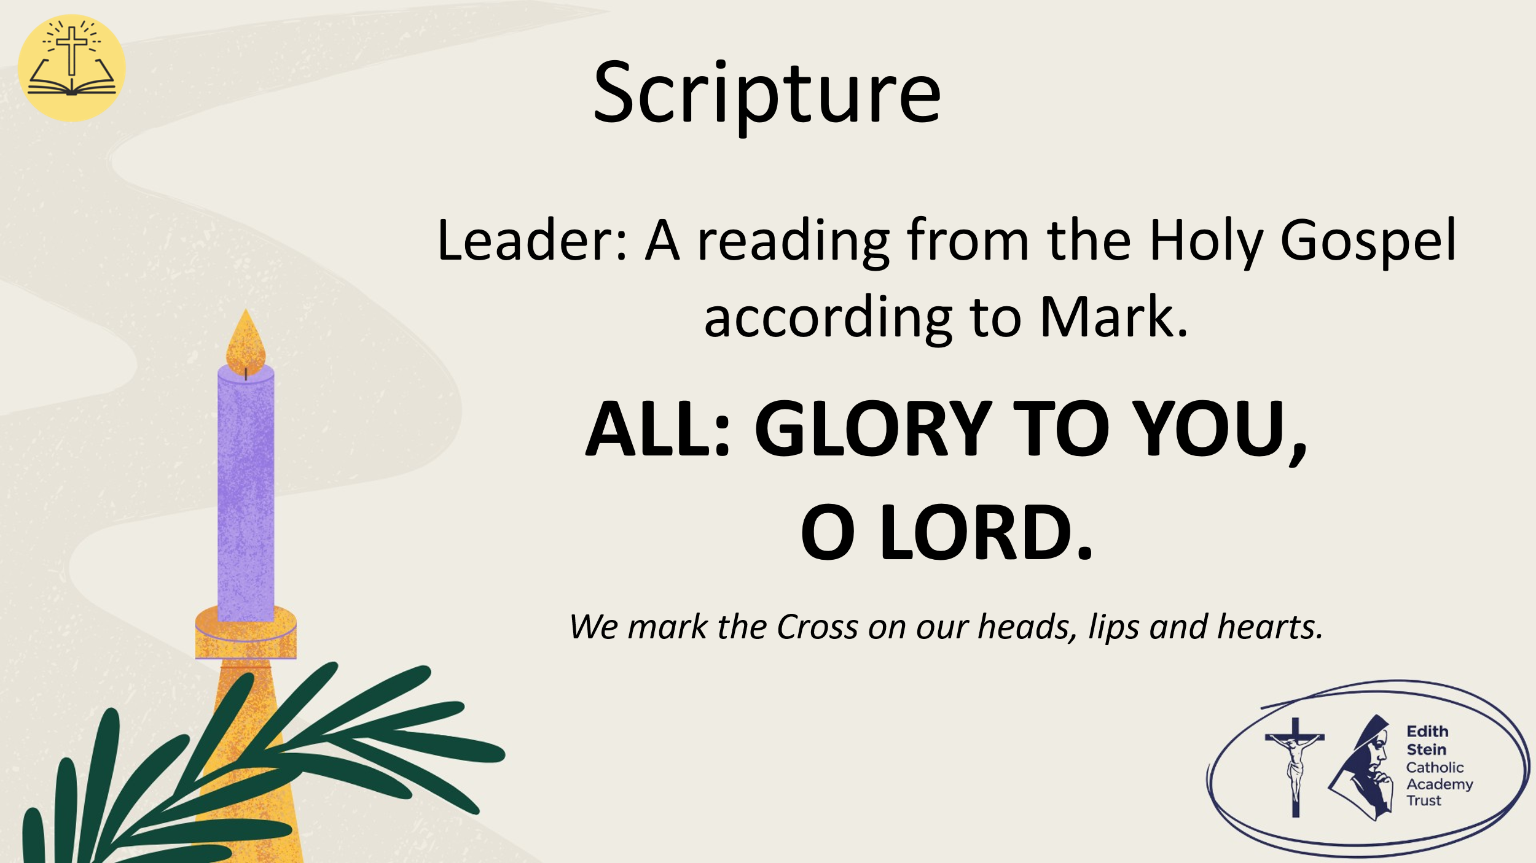 | See below or separate page for Gospel reading, but where possible, proclaim the Word from a Bible or lectionary.  Mark 13:33-37  A reading from the Holy Gospel according to Mark.  ALL: GLORY TO YOU, O LORD. | You may invite everyone to stand to listen to the Word proclaimed.  If you are not already doing so, please ensure that everyone crosses their foreheads, lips and hearts.
 |  | This could be read by staff or student.  Please ensure whoever is proclaiming the Gospel has had appropriate preparation and will proclaim worthily and well.
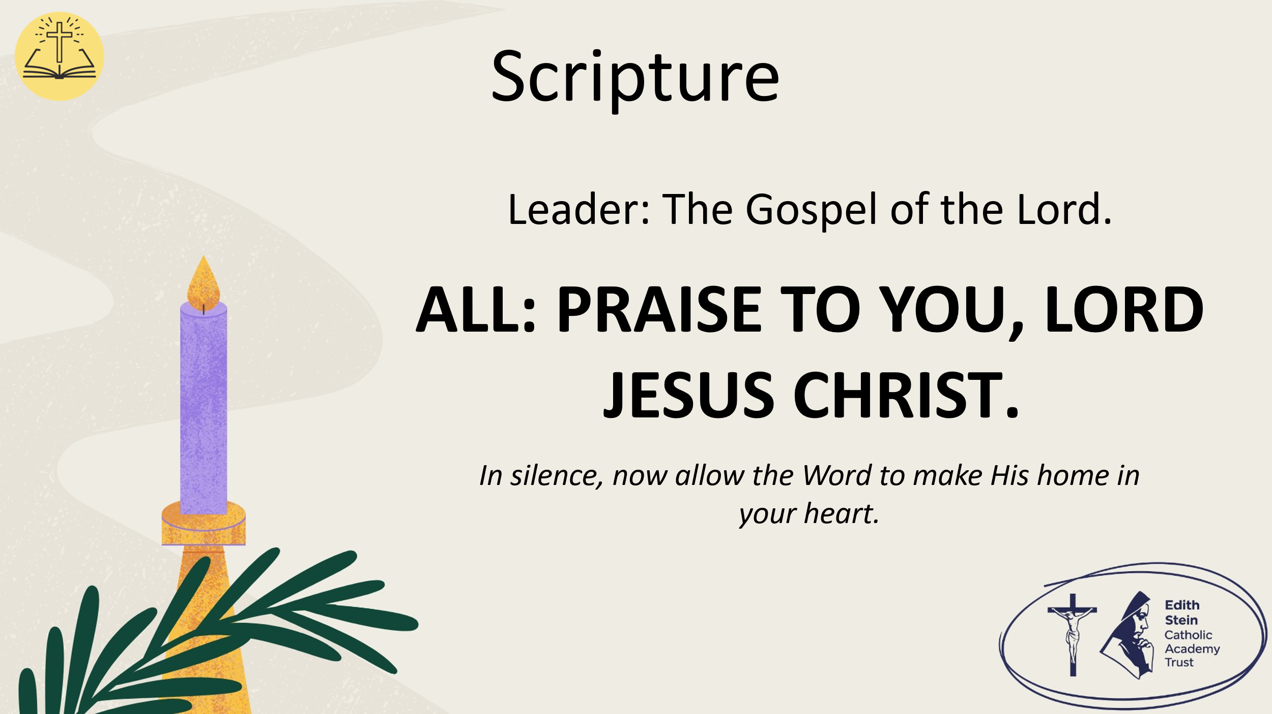 | The Gospel of the Lord.  ALL: PRAISE TO YOU, LORD JESUS CHRIST. | Allow a moment of silence at the end of the Gospel to allow the Word to make His home in everyone’s hearts.  Invite everyone to be seated if they have been standing for the Gospel.
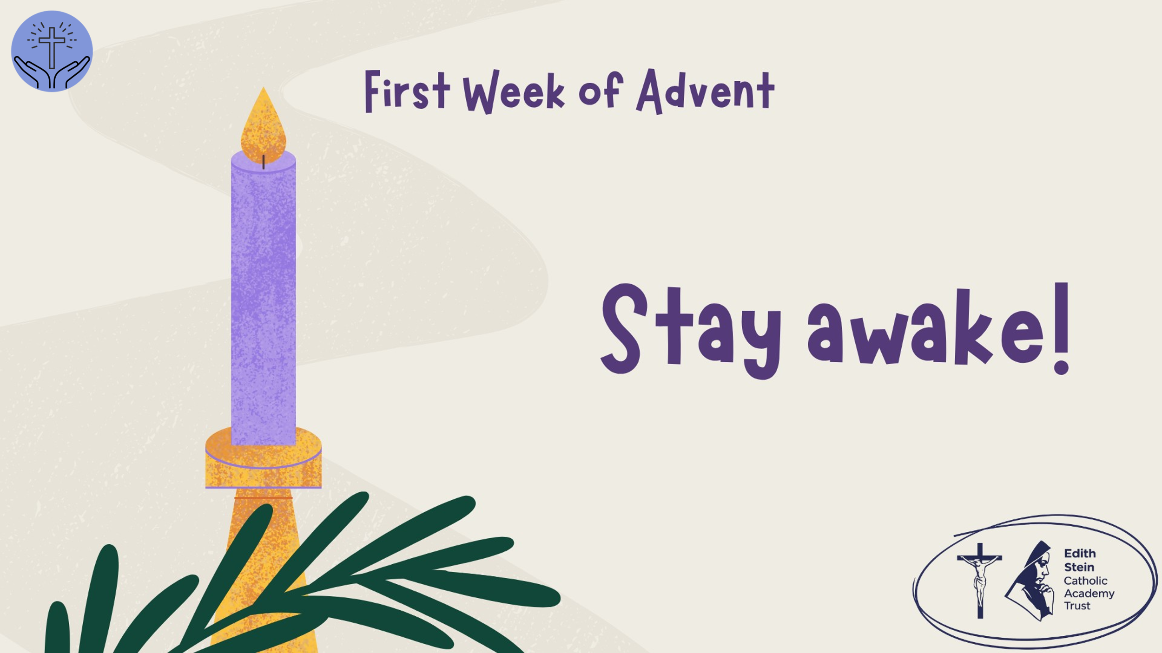 | Reflection  Stay awake.  What does it mean to be ready for God?  Take a moment. Is there a word or phrase from the Gospel that stays with you?  Have a moment of silence
 | Jesus tells his disciples to stay awake. But what does that really mean for us?  We live in a world that rarely switches off. There are deadlines, expectations, notifications, friendships, pressures and constant demands for our attention.  It is possible to be busy all the time and still miss what matters.  We can fail to notice when someone is struggling. We can become so concerned about our own lives that we overlook injustice. We can become distracted by what other people think of us and lose sight of the person God is calling us to be.  Advent invites us to pay attention.  To notice the person who is being left out. To recognise when we need to change. To see goodness where others see none. And to remain open to God, even when life feels uncertain.  So, as we begin this season of preparation, consider these questions: pause after each one.  What has been taking up most of your attention recently?  Is there something important you have been overlooking?  Where might God be inviting you to become more attentive, more compassionate or more hopeful?  Now hold your answers in your heart as we pray…
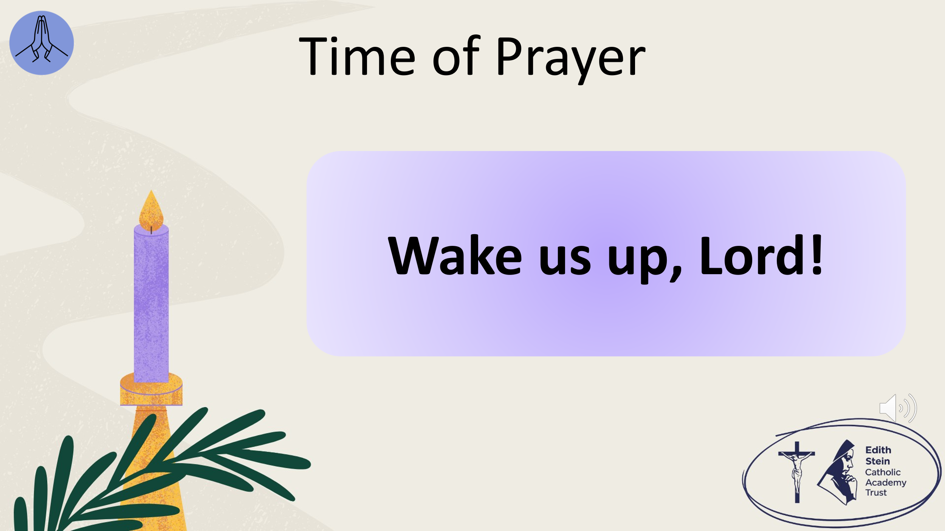 | Invite everyone present to close their eyes.  The response to each line of the litany is,  WAKE US UP, LORD!  When we feel lazy or distracted… wake us up, Lord!  When we feel ungrateful or greedy… wake us up, Lord!  When we forget to notice what is good around us… wake us up, Lord!  When we fail to see your goodness… wake us up, Lord!  When we fail to see or speak up for injustice… wake us up, Lord!  When we rush and don’t notice others… wake us up, Lord!  When we overlook someone in need… wake us up, Lord!  When we choose not to listen… wake us up, Lord!  When we miss opportunities to be kind… wake us up, Lord!  When we forget that you are always close to us… wake us up, Lord!  When we feel tired of trying to do what is right or we want to give up… wake us up, Lord!  When we need hope in our hearts… wake us up, Lord! | There is music on this slide to accompany the time of prayer.
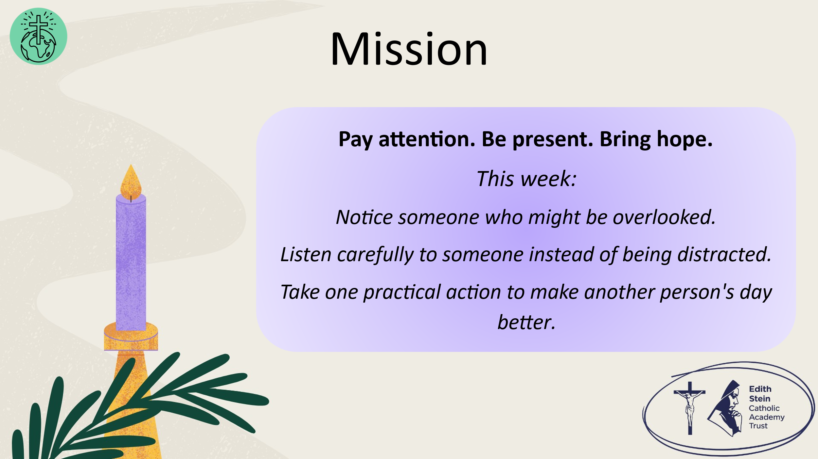 | Before we end in prayer, let us go forth from this time of worship with our mission:  Pay attention. Be present. Bring hope.  This week:  Notice someone who might be overlooked.  Listen carefully to someone instead of being distracted.  Take one practical action to make another person's day better.
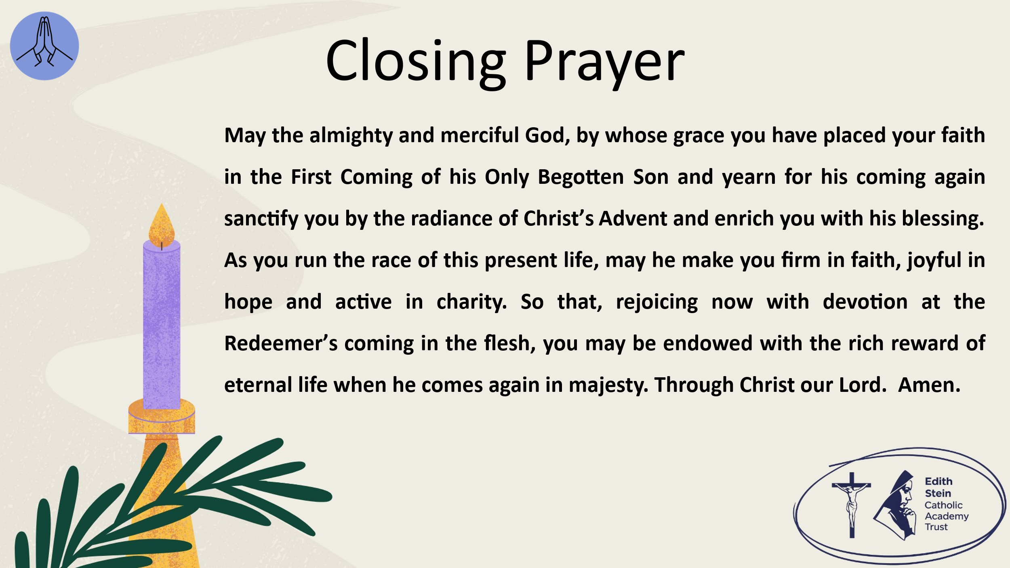 | Solemn Blessing  May the almighty and merciful God, by whose grace you have placed your faith in the First Coming of his Only Begotten Son and yearn for his coming again sanctify you by the radiance of Christ’s Advent and enrich you with his blessing.  As you run the race of this present life, may he make you firm in faith, joyful in hope and active in charity.  So that, rejoicing now with devotion at the Redeemer’s coming in the flesh, you may be endowed with the rich reward of eternal life when he comes again in majesty.  Through Christ our Lord. Amen.  Solemn Blessing for Advent from The Roman Missal  SIGN OF THE CROSS


*Can be read by student or staff.

A reading from the Holy Gospel according to Mark.
ALL: Glory to You, O Lord.

Be on guard! Be alert! You do not know when that time will come. It’s like a man going away: He leaves his house and puts his servants in charge, each with their assigned task, and tells the one at the door to keep watch.

“Therefore keep watch because you do not know when the owner of the house will come back—whether in the evening, or at midnight, or when the rooster crows, or at dawn. If he comes suddenly, do not let him find you sleeping. What I say to you, I say to everyone: ‘Watch!’”

The Gospel of the Lord.
ALL: Praise to You Lord, Jesus Christ.

