
Primary Celebration of the Word Assembly Script
All Saints and All Souls

Slides | Script | Additional Notes
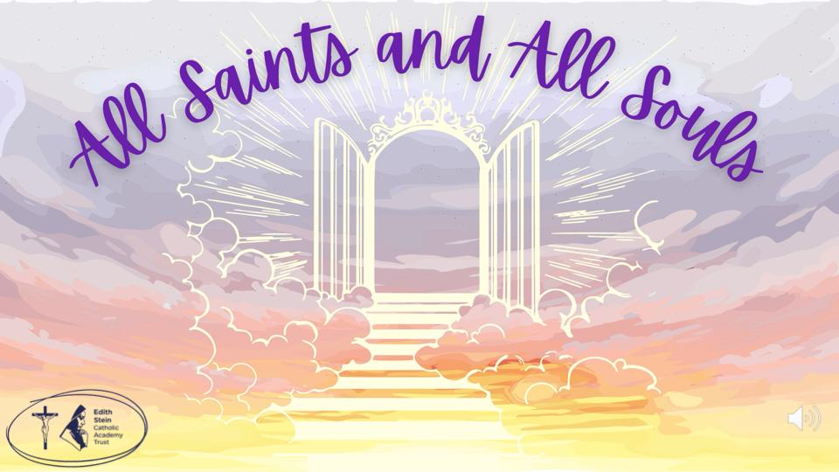 | Sign of the Cross  Good morning/afternoon!  We are going to begin our celebration of the Word assembly today with a little game of ‘Guess the Saint’.  I am going to give you 3 clues about a saint; once I’ve given you the 3 clues I shall ask you to give me the name of the saint you think the clues are about.  Let’s begin. | There is some background music on this first slide that you might like to use while staff and children enter the assembly space.  Please check volume levels prior to the start of the assembly.
 |  | This is a short video with music.
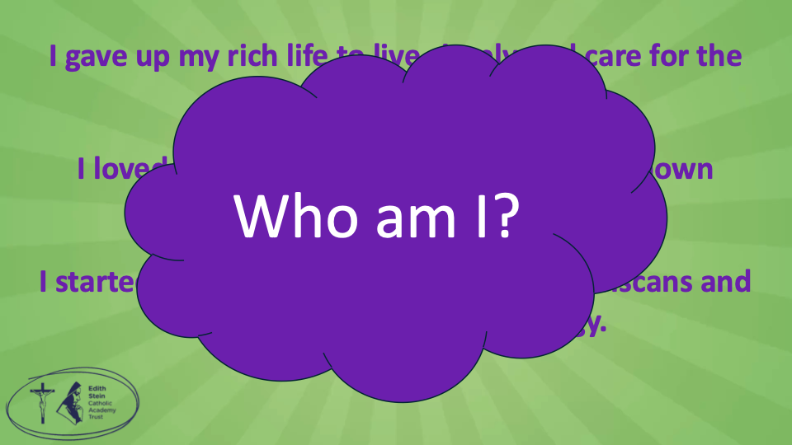 | - I gave up my rich life to live simply and care for the poor.  - I loved animals so much that I am often shown speaking to birds and blessing them.  - I started a religious group called the Franciscans and am the patron saint of ecology.  Who am I?
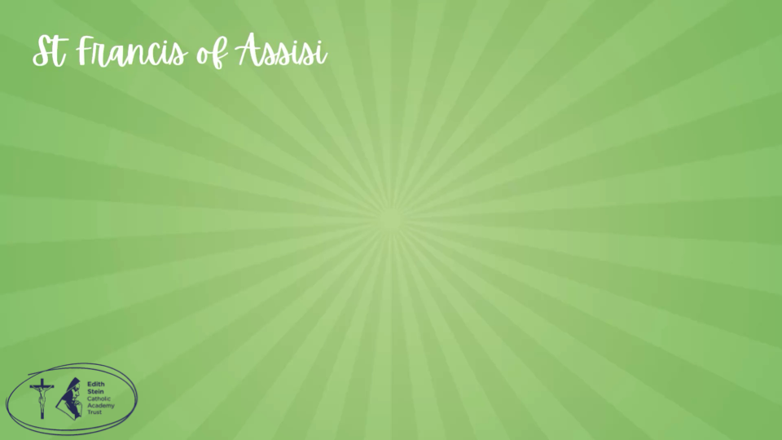 | St Francis of Assisi! | On each of these slides, the saint will appear with a sound effect.
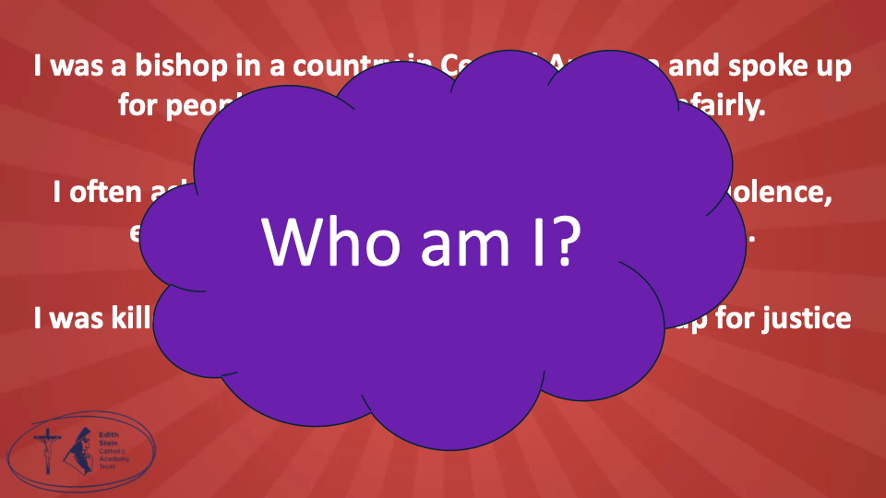 | - I was a bishop in a country in Central America and spoke up for people who were poor and treated unfairly.  - I often asked people to live peacefully and stop violence, even when it was dangerous for me to say so.  - I was killed while saying Mass because I stood up for justice and truth.  Who am I?
 | St Oscar Romero
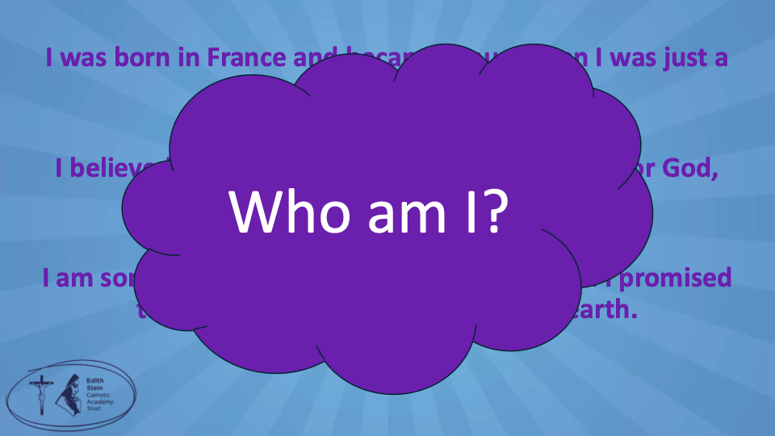 | - I was born in France and became a nun when I was just a teenager.  - I believed in doing small, everyday acts of love for God, even if no one else noticed.  - I am sometimes called ‘The Little Flower’ and I promised to spend my Heaven doing good on earth.  Who am I?
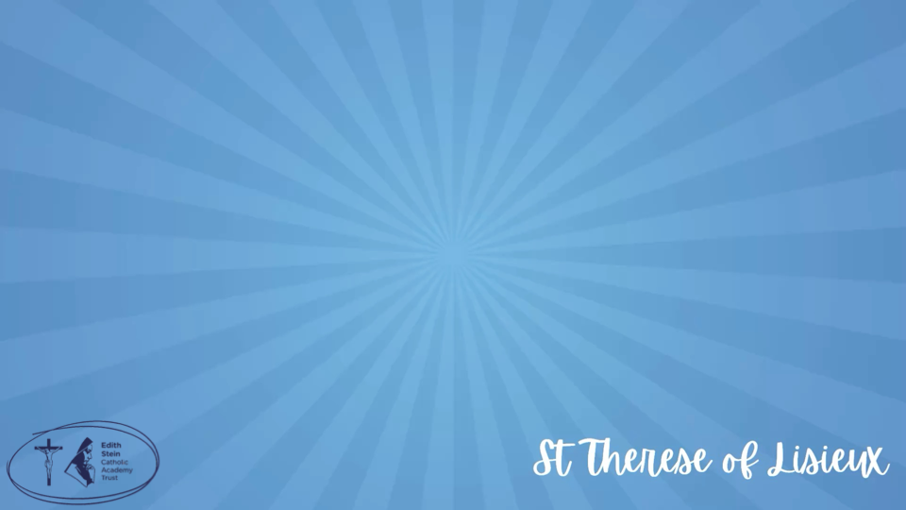 | St Therese of Lisieux
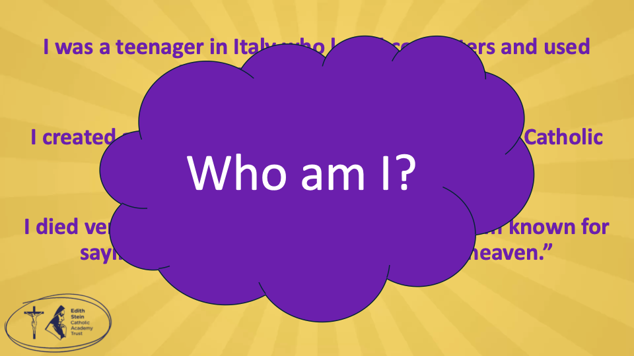 | - I was a teenager in Italy who loved computers and used technology in creative ways.  - I created a website to show miracles linked to the Catholic faith from around the world.  - I died very young from a serious illness, and I am known for saying, ‘The Eucharist is my highway to heaven’.  Who am I?
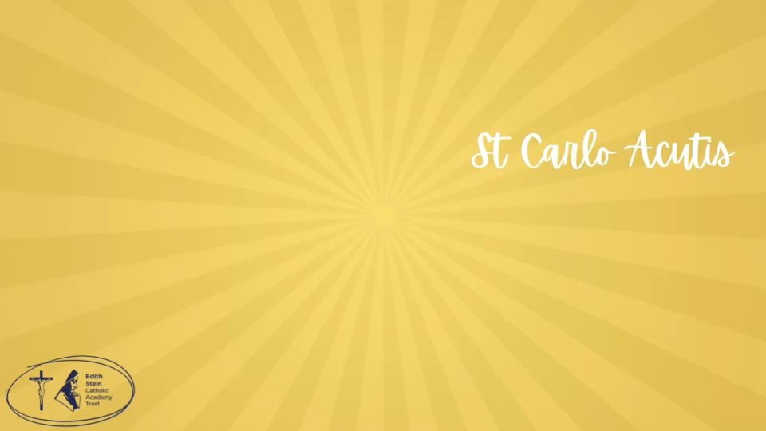 | St Carlo Acutis
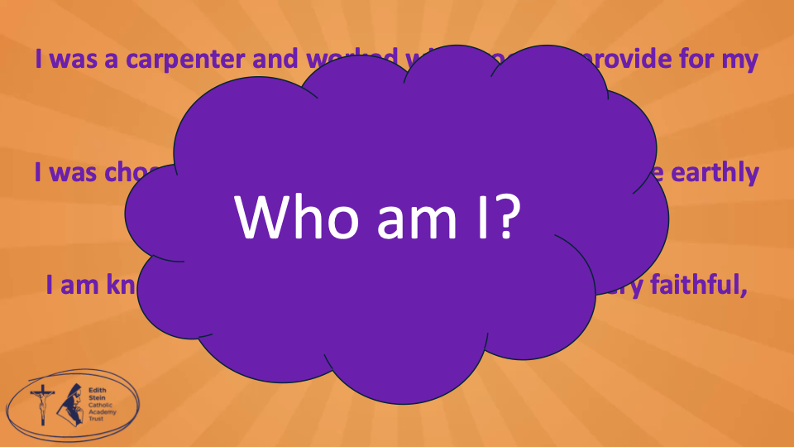 | - I was a carpenter and worked with wood to provide for my family.  - I was chosen by God to care for Mary and to be the earthly guardian of Jesus.  - I am known for being quiet in the Bible, but very faithful, brave, and obedient to God.  Who am I?
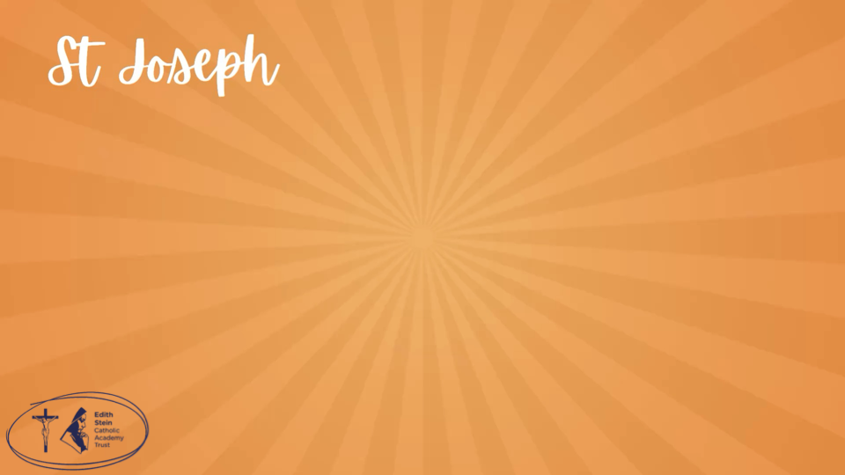 | St Joseph
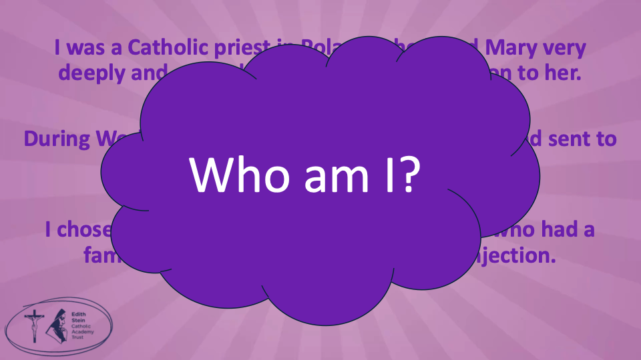 | - I was a Catholic priest in Poland who loved Mary very deeply and started groups to spread devotion to her.  - During World War II, I was arrested by the Nazis and sent to a concentration camp called Auschwitz.  - I chose to take the place of another prisoner who had a family, and I died after being given an injection.  Who am I?
 | St Maximilian Kolbe
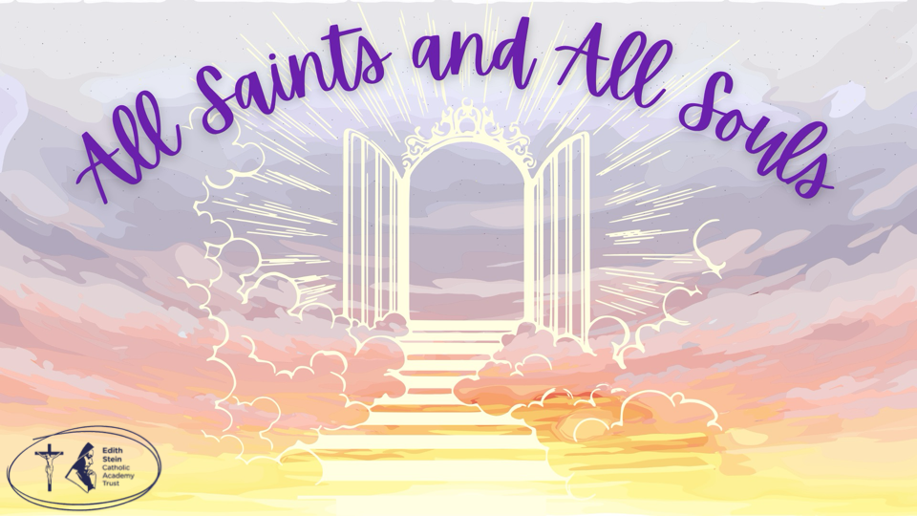 | So why are we talking about the Saints?  We are now in the month of November, which is a special month in the Catholic Church; a special month when we remember especially and pray for those who have gone before us and passed from this life to the next.
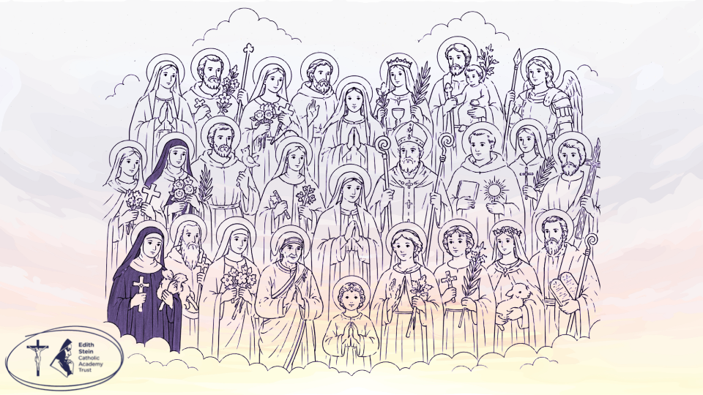 | We begin by celebrating the great solemnity of All Saints on 1st November. On this day, we celebrate all the saints — both the famous ones and the many ordinary people who loved God and lived good, kind lives. Saints are people who are now in heaven with God. On this day, we remember that we are all called to be saints, by loving others, helping those in need, and following Jesus in our everyday lives.  Saints are ordinary souls who answered an extraordinary call. Through lives of faith, sacrifice, and unwavering devotion, they allowed God's grace to transform them completely. Now they dwell in eternal light, their earthly struggles transformed into heavenly glory, interceding for us still.  On the 2nd of November, the Church celebrates All Souls’ Day, when we remember and pray for people who have died, especially those who are still on their journey to heaven. We think of our loved ones and ask God to take care of them. It is a day of hope, because we believe that God loves everyone and wants them to be with Him forever.  Let us pray…
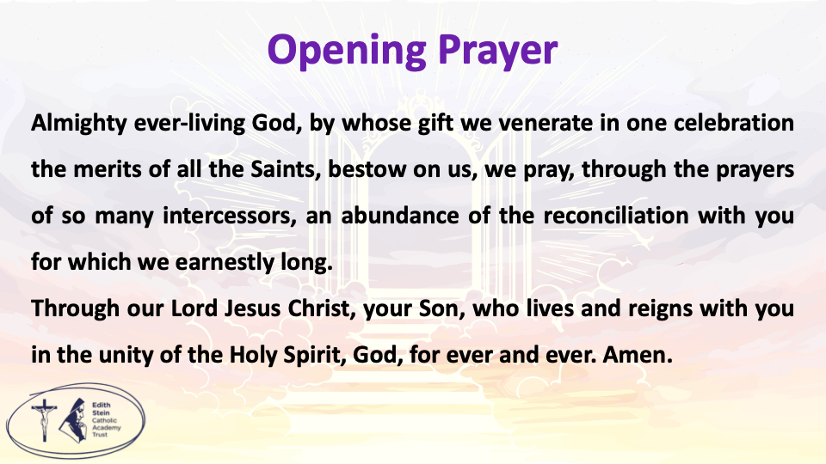 | Let us all rejoice in the Lord, as we celebrate the feast day of all the Saints, at whose festival the Angels rejoice and praise the Son of God.  Almighty ever-living God, by whose gift we venerate in one celebration the merits of all the Saints, bestow on us, we pray, through the prayers of so many intercessors, an abundance of the reconciliation with you for which we earnestly long.  Through our Lord Jesus Christ, your Son, who lives and reigns with you in the unity of the Holy Spirit, God, for ever and ever.  Amen.
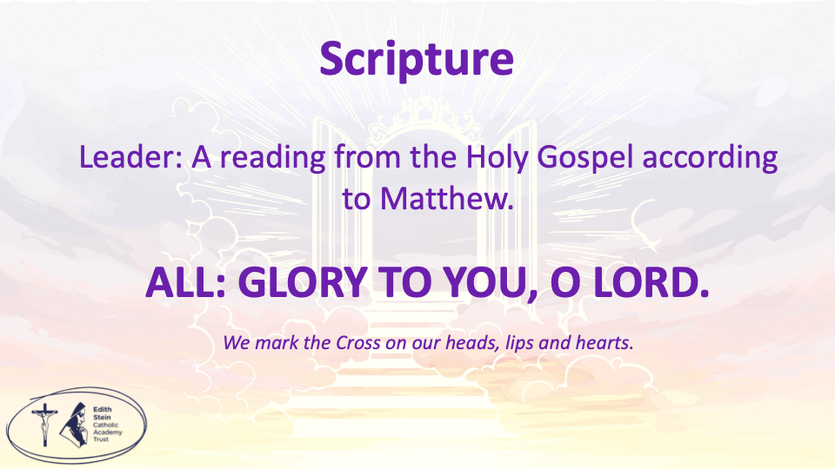 | Let us prepare our hearts and minds to listen to the Word of the Lord.  A reading from the Holy Gospel according to Matthew.  ALL: Glory to You, O Lord. | You may invite everyone to stand to listen to the Word proclaimed.  If you are not already doing so, please ensure that everyone crosses their foreheads, lips and hearts.
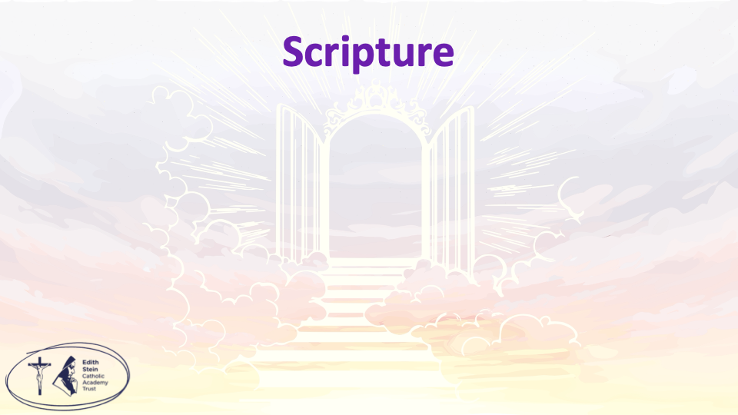 | See separate page for Gospel reading. | This could be read by staff or student. Please ensure whoever is proclaiming the Gospel has had appropriate preparation and will proclaim worthily and well.
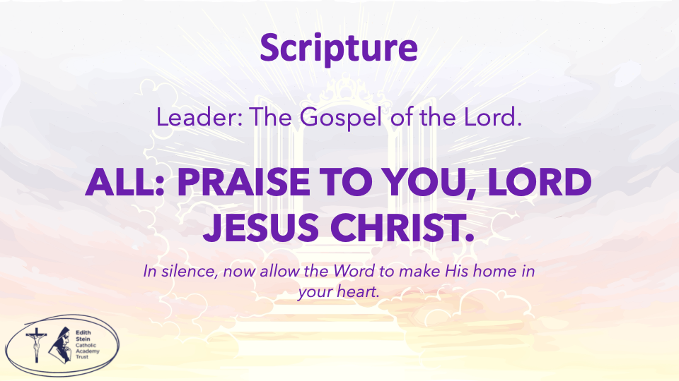 | The Gospel of the Lord.  ALL: Praise to You Lord, Jesus Christ. | Allow a moment of silence at the end of the Gospel to allow the Word to make His home in everyone’s hearts.  Invite everyone to be seated if they have been standing for the Gospel.
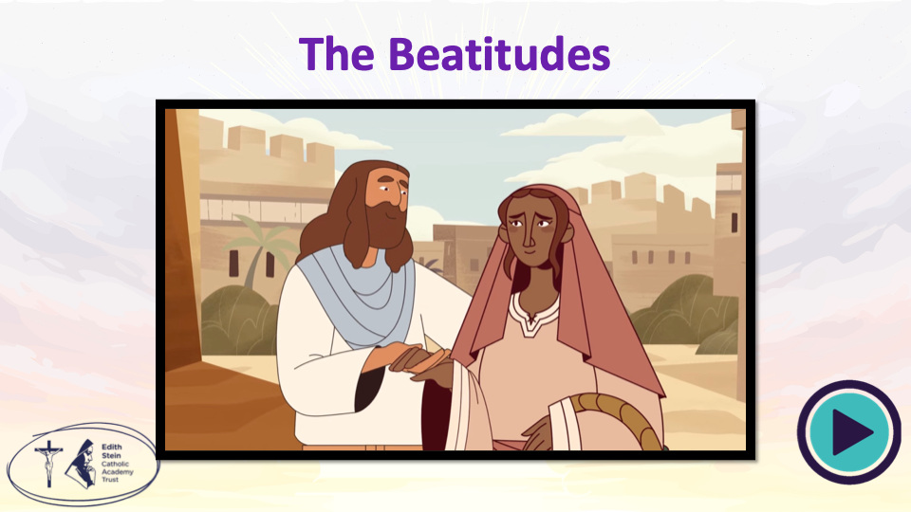 | Full video link available here: https://www.youtube.com/watch?v=tKmK9bMZfOk  Title: God's Story: Sermon on the Mount: The Beatitudes  By: Crossroads Kid’s Club  Time dependent – leave it out if not suitable. | You just need to click the play button and it will take you directly to the clip on YouTube. Please have this open and ready so no adverts play at the beginning. Check volume level.
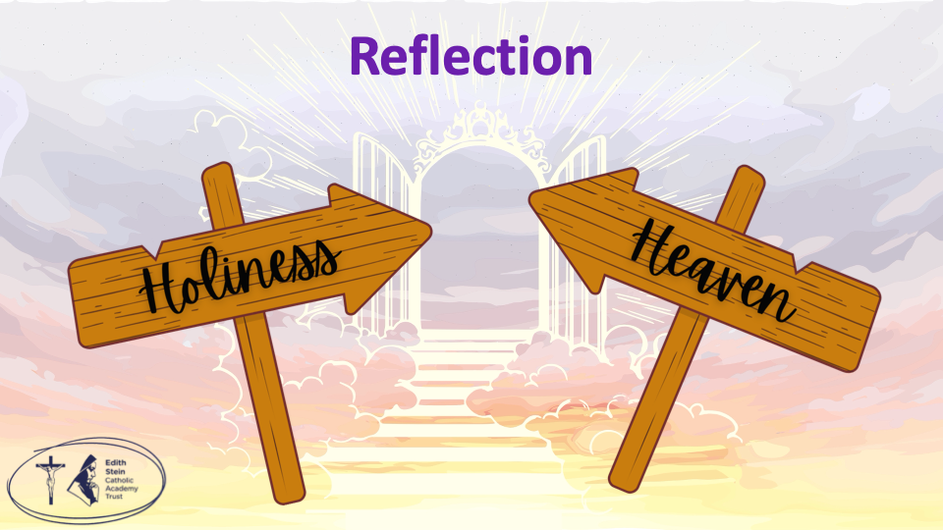 | This Gospel we have just heard proclaimed is called, ‘The Beatitudes’. The Church uses the Beatitudes on All Saints’ Day because they describe what a “saintly life” actually looks like in practice.  The Beatitudes are Jesus’ guide for holiness. They don’t describe people who are powerful, successful, or impressive in worldly terms. Instead, they describe people who are: humble and kind, gentle and merciful, peacemakers who rely on the goodness and grace of God. Those who stand for justice and endure suffering for doing what is right.
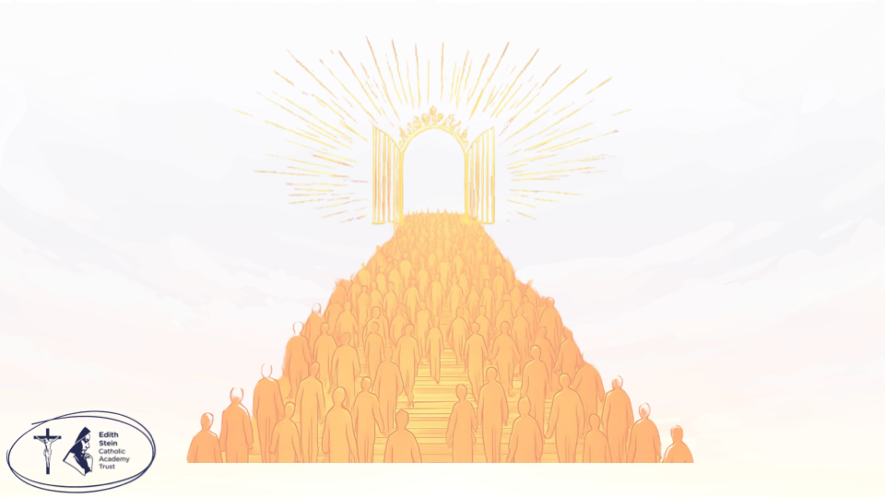 | That is exactly what saints are understood to be: ordinary people who lived in an “extraordinary way” by following Jesus’ way of love. Not perfect people, normal people who relied on a perfect God.  So, on All Saints’ Day, the Church proclaims the Beatitudes to teach us that the saints are not distant heroes, but people who lived out the Beatitudes in real life.  It also gently teaches all of us that holiness is not out of reach. The Beatitudes are like a roadmap showing that anyone can become a saint by living as Jesus teaches, day by day.  Let’s now pray that we too will grow in holiness and strive, each and every day, to be saints.
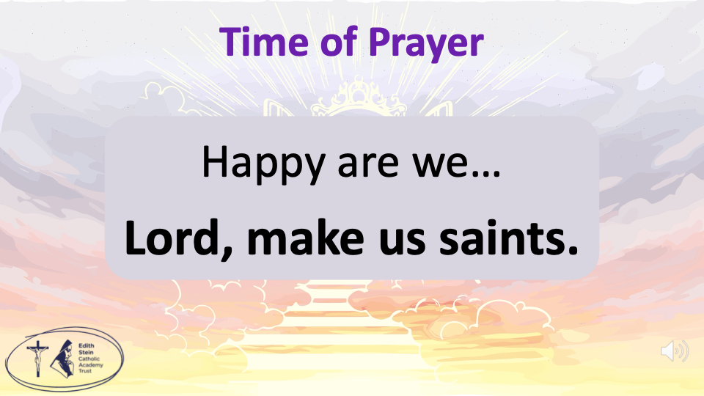 | I invite you all to close your eyes.  The response to each prayer is… Lord, make us saints. Everyone to repeat.  Happy are we… Lord, make us saints.  Those people who know they have great spiritual needs are happy… Lord we pray that we will always turn to you in prayer, that we will find our happiness in our trust in You. Happy are we… Lord, make us saints.  Those who are sad now are happy… we pray for those who are suffering sadness, especially those who are grieving loved ones. Happy are we… Lord, make us saints.  Those who are humble are happy… we pray that we will always be humble of heart, thinking always of others before ourselves. Happy are we… Lord, make us saints.  Those who want to do right more than anything else are happy… we pray for those in positions of power, that they will be led by God to always do the right thing. Happy are we… Lord, make us saints.  Those who give mercy to others are happy… we ask the Lord for forgiveness for our failings, and for the courage to show mercy to others when they hurt us. Happy are we… Lord, make us saints.  Those who are pure in their thinking are happy… we pray that we will always love and respect everyone as children of God. Happy are we… Lord, make us saints.  Those who work to bring peace are happy… we pray for peace around the world, and for those who work to end war and keep people safe in places conflict. Happy are we… Lord, make us saints.  Those who are treated badly for doing good are happy… we pray for Christians around the world who are persecuted for their faith in God, may they know God’s presence with them. Happy are we… Lord, make us saints.  Rejoice and be glad. You have a great reward waiting for you in heaven… we pray that we will all become saints in this world and in Heaven. Happy are we… Lord, make us saints. | Get the children to repeat the response after you and then after each prayer.  Invite everyone to close their eyes.  There is background music on the slide.
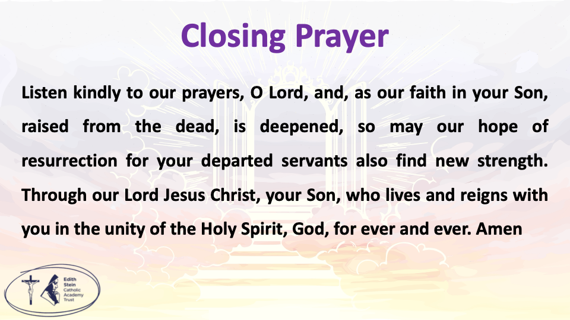 | Listen kindly to our prayers, O Lord, and, as our faith in your Son, raised from the dead, is deepened, so may our hope of resurrection for your departed servants also find new strength. Through our Lord Jesus Christ, your Son, who lives and reigns with you in the unity of the Holy Spirit, God, for ever and ever.  Amen.  SIGN OF THE CROSS

Opening Prayer
Let us all rejoice in the Lord, as we celebrate the feast day of all the Saints, at whose festival the Angels rejoice and praise the Son of God.
Almighty ever-living God, by whose gift we venerate in one celebration the merits of all the Saints, bestow on us, we pray, through the prayers of so many intercessors, an abundance of the reconciliation with you for which we earnestly long.
Through our Lord Jesus Christ, your Son, who lives and reigns with you in the unity of the Holy Spirit, God, for ever and ever.
Amen.

Closing Prayer
Listen kindly to our prayers, O Lord, and, as our faith in your Son, raised from the dead, is deepened, so may our hope of resurrection for your departed servants also find new strength. Through our Lord Jesus Christ, your Son, who lives and reigns with you in the unity of the Holy Spirit, God, for ever and ever.
Amen.

*Can be read by pupil or staff. You could even get two pupils to read it as a call and response…
A reading from the Holy Gospel according to Matthew.
ALL: Glory to You, O Lord.
Jesus saw the crowds who were there. He went up on a hill and sat down. His followers came to him. Jesus taught the people and said:
“Those people who know they have great spiritual needs are happy.
The kingdom of heaven belongs to them.
Those who are sad now are happy.
God will comfort them.
Those who are humble are happy.
The earth will belong to them.
Those who want to do right more than anything else are happy.
God will fully satisfy them.
Those who give mercy to others are happy.
Mercy will be given to them.
Those who are pure in their thinking are happy.
They will be with God.
Those who work to bring peace are happy.
God will call them his sons.
Those who are treated badly for doing good are happy.
The kingdom of heaven belongs to them.
“People will say bad things about you and hurt you. They will lie and say all kinds of evil things about you because you follow me. But when they do these things to you, you are happy. Rejoice and be glad. You have a great reward waiting for you in heaven. People did the same evil things to the prophets who lived before you.
The Gospel of the Lord.
ALL: Praise to You Lord, Jesus Christ.

