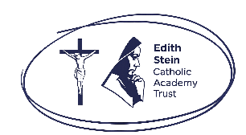
Primary Celebration of the Word Assembly Script
Second Week of Advent, Year B

Slides | Script | Additional Notes
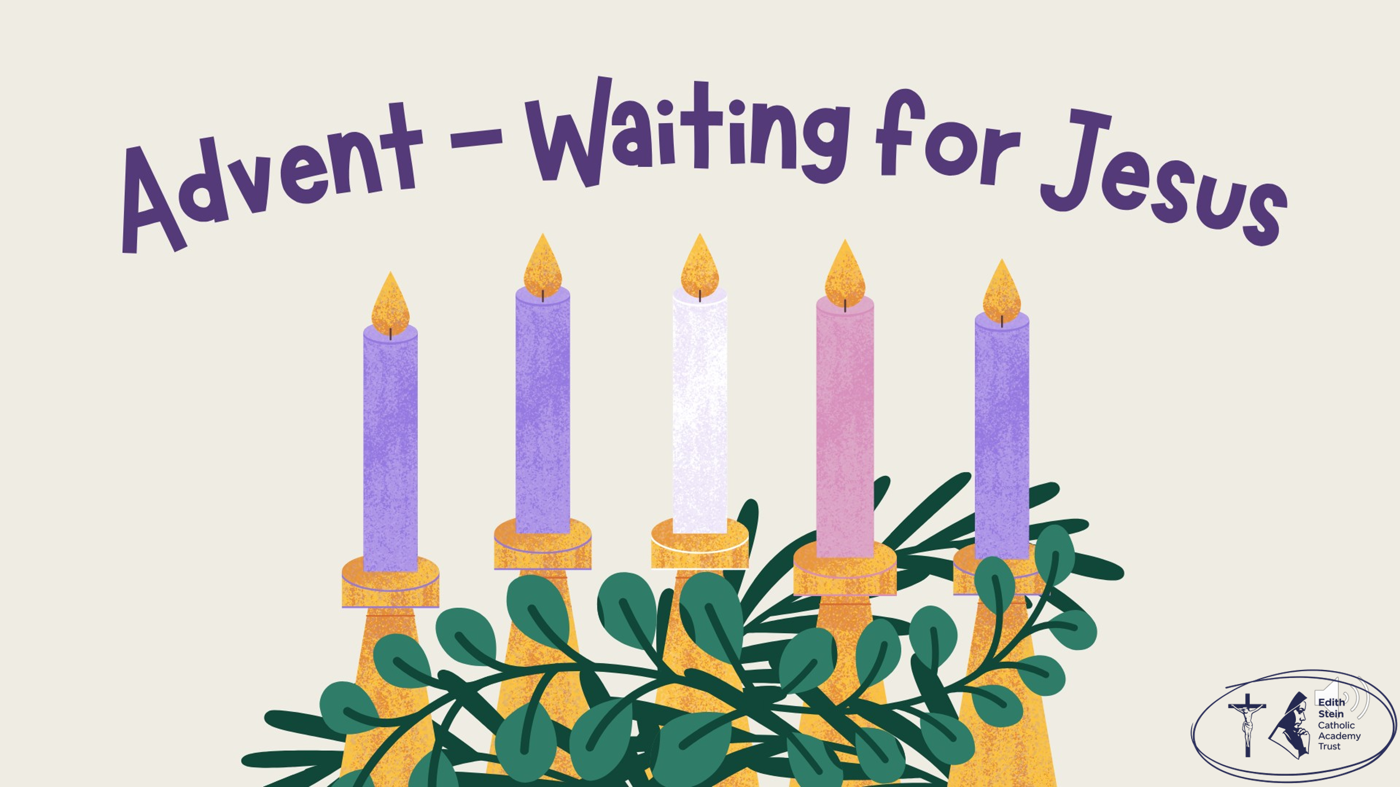 | SIGN OF THE CROSS  Good Morning/Afternoon! | There is some background music on this first slide that you might like to use while staff and children enter the assembly space.  Please check volume levels prior to the start of the assembly.
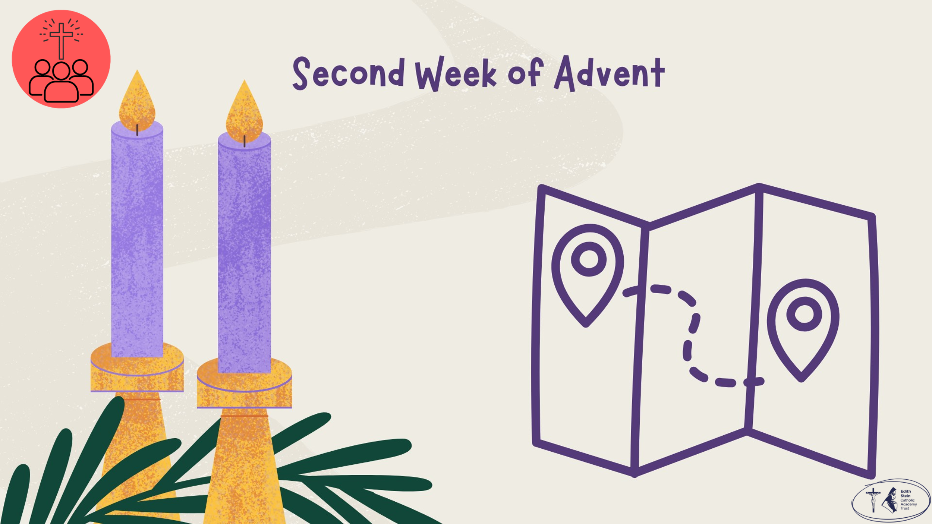 | Begin the assembly by having a good look at the map and asking the children why they think you are looking at the map.  Because we need to prepare the way for Jesus.  Before we hear the Word of God proclaimed, let us continue our Advent journey together by lighting the second candle on our Advent Wreath. | Purple cloth, advent wreath, the alarm clock from last week and a large map.  (Printables of alarm clock and map available from ESCAT Space).
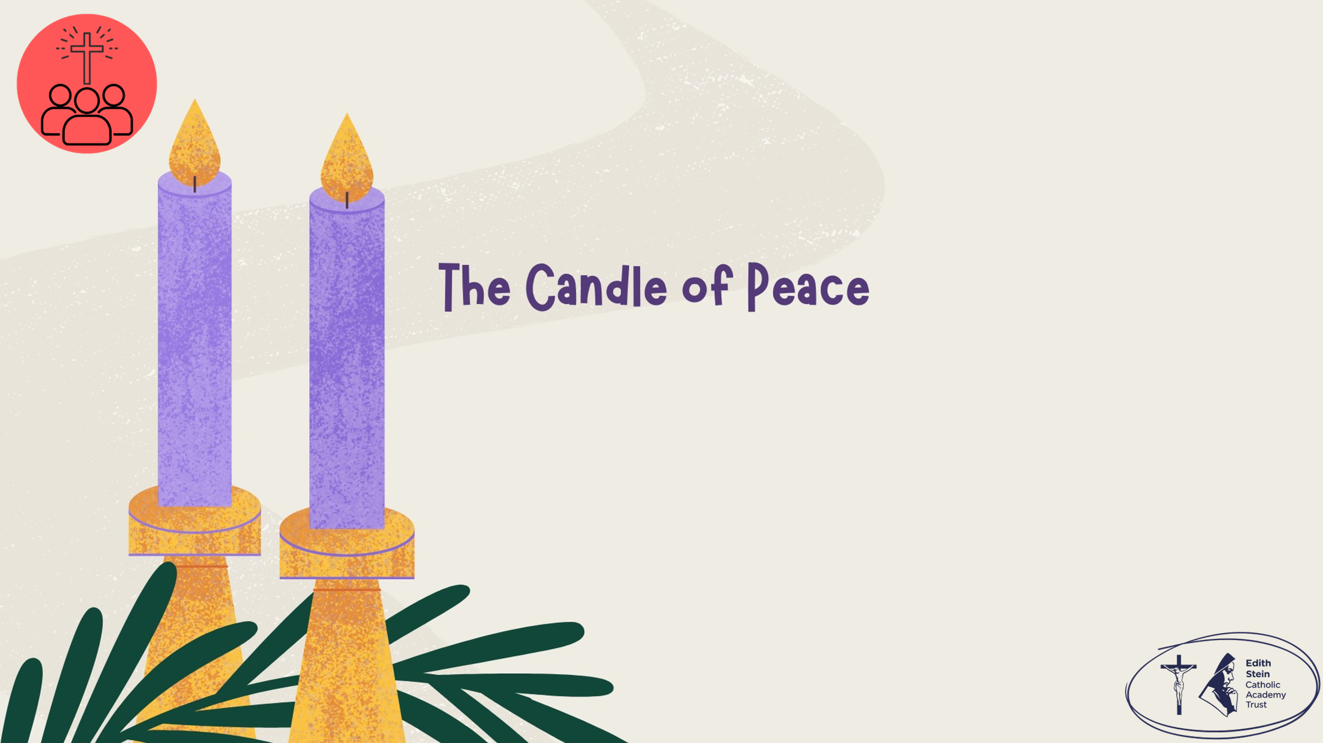 | Lighting the Advent Wreath  Lord our God, we praise you for your Son, Jesus Christ:  he is Emmanuel, the hope of the peoples,  he is the wisdom that teaches and guides us,  he is the Saviour of every nation.  Lord God, let your blessing come upon us as we light the candles of this wreath.  May the wreath and its light be a sign of Christ’s promise to bring us salvation.  May he come quickly and not delay. We ask this through Christ our Lord. Amen  Second Candle – Peace  Today we light the second candle, the Candle of Peace.  John the Baptist calls us to prepare the way for the Lord. We prepare not by decorating our homes, but by making room for Jesus in our hearts. When we choose forgiveness, kindness and peace, we help make a straight path for Christ.  Let us pray… | Light the first and second purple candles on the wreath.
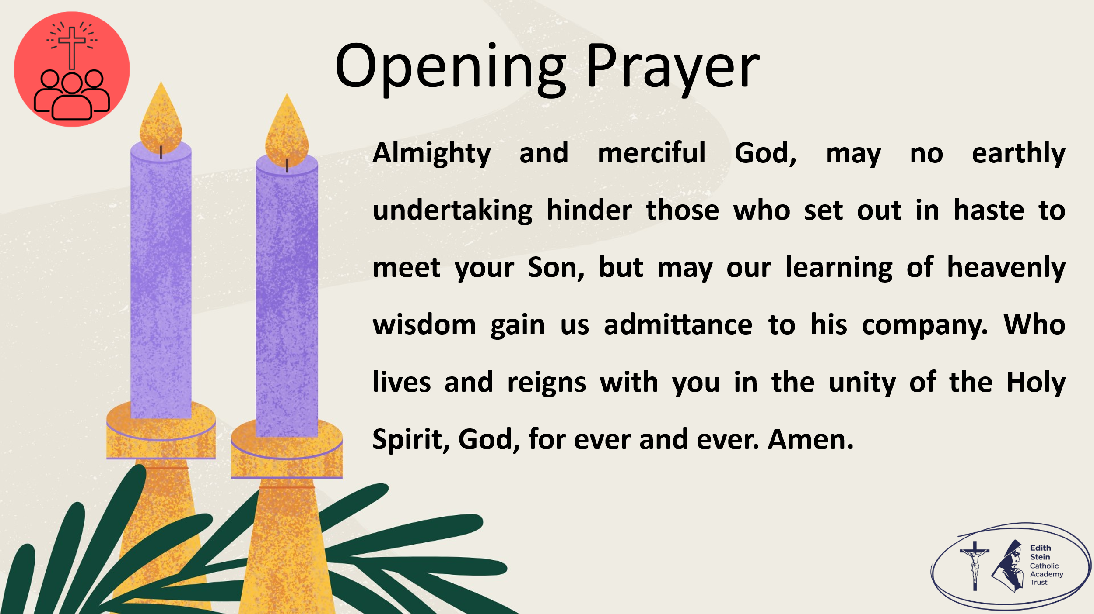 | Almighty and merciful God, may no earthly undertaking hinder those who set out in haste to meet your Son, but may our learning of heavenly wisdom gain us admittance to his company. Who lives and reigns with you in the unity of the Holy Spirit, God, for ever and ever. Amen.  Collect from Mass for the Second Sunday of Advent, Year B  Now let us prepare our hearts and minds to hear the Word of God.
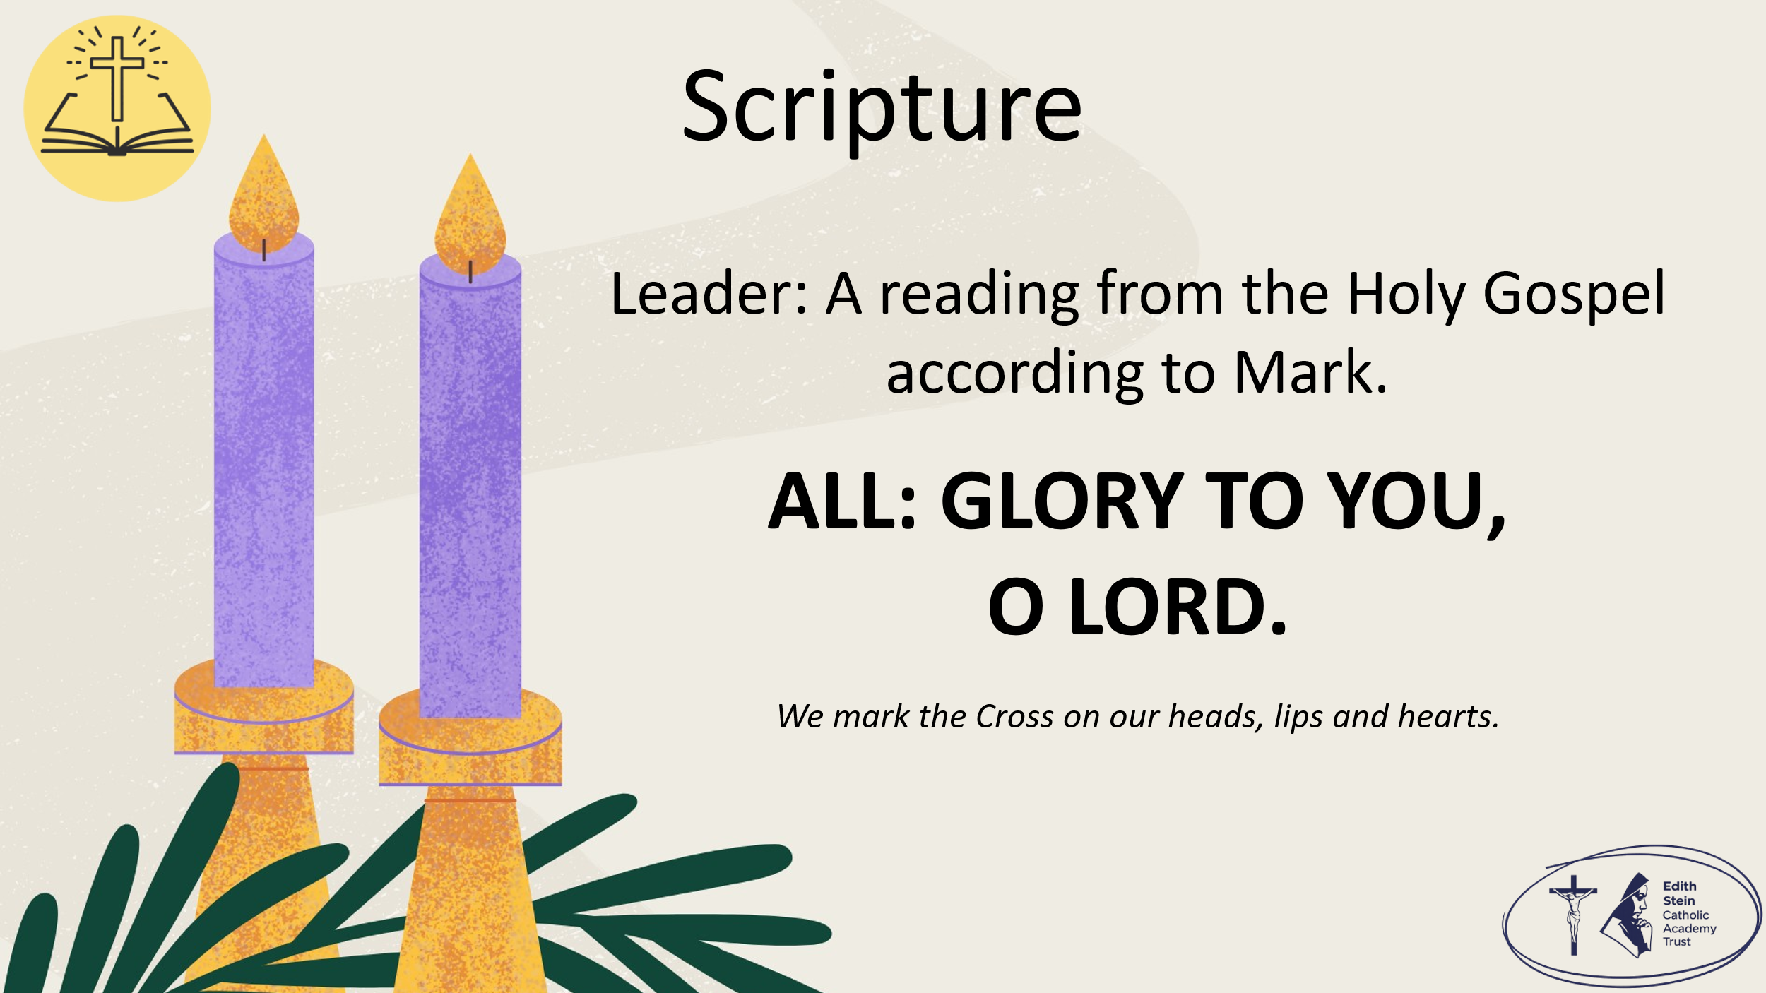 | See below or separate page for Gospel reading.  Mark 1:1-8  A reading from the Holy Gospel according to Mark.  ALL: GLORY TO YOU, O LORD. | You may invite everyone to stand to listen to the Word proclaimed.  If you are not already doing so, please ensure that everyone crosses their foreheads, lips and hearts.
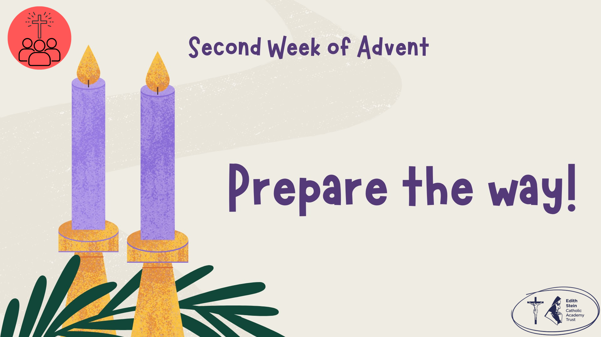 |  | This could be read by staff or student. Please ensure whoever is proclaiming the Gospel has had appropriate preparation and will proclaim worthily and well.
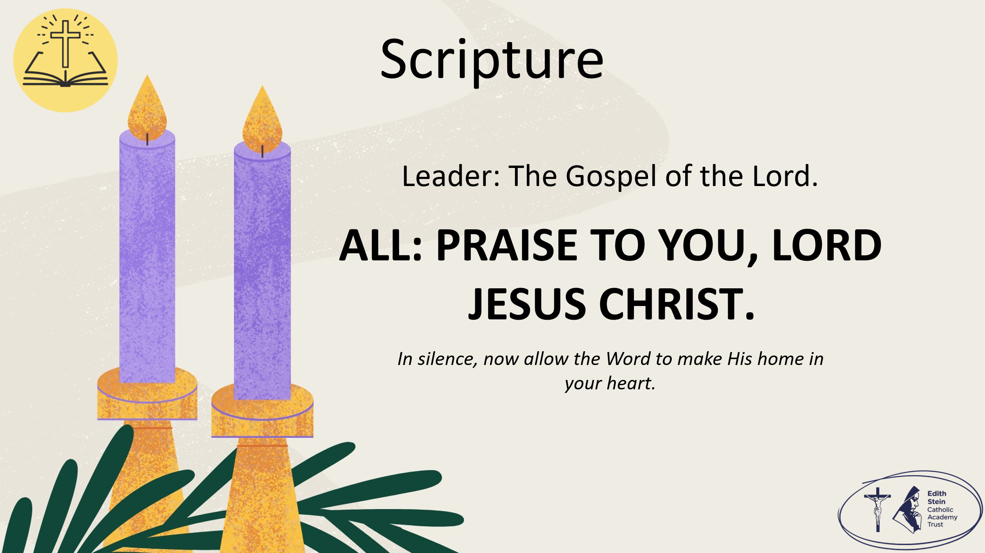 | The Gospel of the Lord.  ALL: PRAISE TO YOU, LORD JESUS CHRIST. | Allow a moment of silence at the end of the Gospel to allow the Word to make His home in everyone’s hearts.  Invite everyone to be seated if they have been standing for the Gospel.
Reflection
John the Baptist had an important job. He helped people get ready to welcome Jesus. He didn't build roads or bridges; instead, he helped people prepare their hearts.
We spend lots of time getting ready for Christmas. We decorate our homes, wrap presents and make plans with our families. But Advent reminds us that the most important preparation happens inside us. Every time we forgive someone, choose kindness instead of anger, share with others or spend time in prayer, we make more room for Jesus in our hearts.
As we continue our journey to Bethlehem, let us ask ourselves: What can I do this week to prepare my heart for Jesus?

Allow for a moment of prayerful silence.

Let us pray…

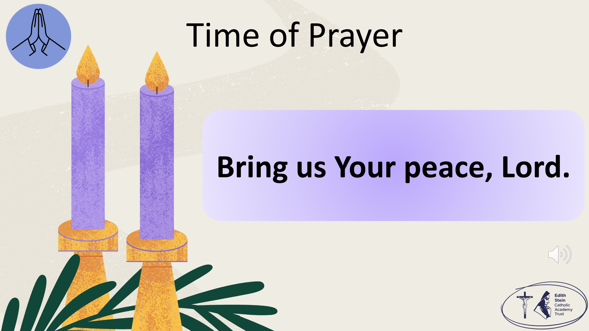 | The response to each line of the litany is,  Bring us Your peace, Lord.  When our hearts feel busy or worried… bring us Your peace, Lord.  When we argue or fall out with people… bring us Your peace, Lord.  When it is hard to say sorry… bring us Your peace, Lord.  When we struggle to be patient… bring us Your peace, Lord.  When someone needs a kind word or a gentle action… bring us Your peace, Lord.  When we are overwhelmed by the world… bring us Your peace, Lord.  When we want to make the world a better place… bring us Your peace, Lord.  When we need calm in our hearts and minds… bring us Your peace, Lord.
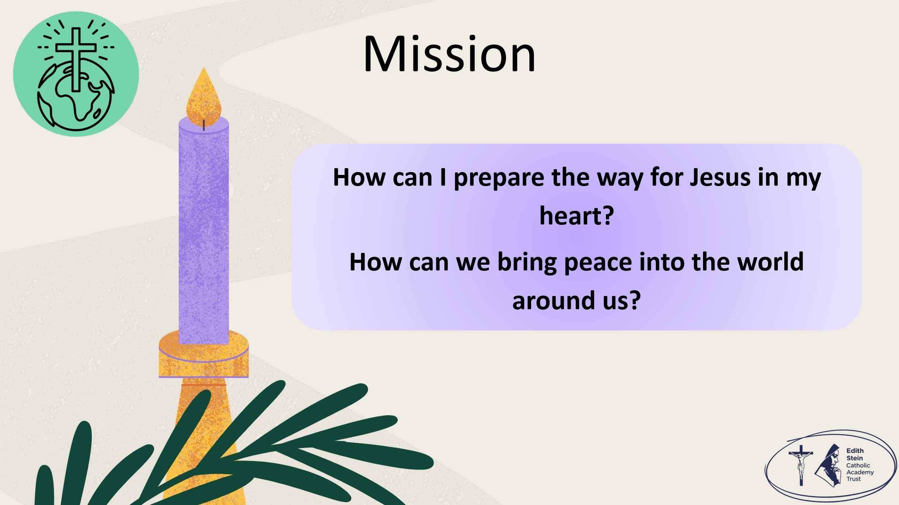 | So before we go forth from this place, let us take up our mission.  How can we be like John the Baptist and prepare the way for Jesus?  How can we prepare our hearts for Him?  How can we bring peace?  Remind the students that they will have a chance to make a personal response in their Advent Passport in class.
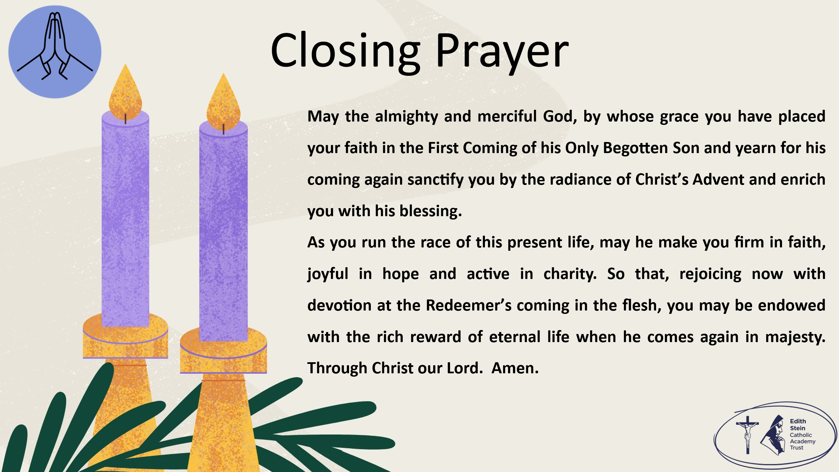 | Solemn Blessing  May the almighty and merciful God, by whose grace you have placed your faith in the First Coming of his Only Begotten Son and yearn for his coming again sanctify you by the radiance of Christ’s Advent and enrich you with his blessing.  As you run the race of this present life, may he make you firm in faith, joyful in hope and active in charity.  So that, rejoicing now with devotion at the Redeemer’s coming in the flesh, you may be endowed with the rich reward of eternal life when he comes again in majesty. Through Christ our Lord.  Amen.  SIGN OF THE CROSS

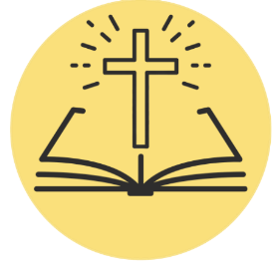
*Can be read by pupil or staff.

A reading from the Holy Gospel according to Mark.
ALL: Glory to You, O Lord.

This is the beginning of the Good News about Jesus Christ, the Son of God, as the prophet Isaiah wrote:
“I will send my messenger ahead of you.
He will prepare your way.”
“There is a voice of a man who
calls out in the desert:
‘Prepare the way for the Lord.
Make the road straight for him.’”
John was baptising people in the desert. He preached a baptism of changed hearts and lives for the forgiveness of sins. All the people from Judea and Jerusalem were going out to John. They told about the sins they had done. Then they were baptised by him in the Jordan River. John wore clothes made from camel’s hair and had a leather belt around his waist. He ate locusts and wild honey. This is what John preached to the people: “There is one coming later who is greater than I. I am not good enough even to kneel down and untie his sandals. I baptise you with water. But the one who is coming will baptise you with the Holy Spirit.”

The Gospel of the Lord.
ALL: Praise to You Lord, Jesus Christ.

