Procedure: Internal Auditing QAOP001
- SUMMARY
  - This procedure defines the process and methods for conducting internal quality management system (QMS) audits.
  - The QAM is responsible for implementation and management of all internal audits.
- REVISION AND APPROVAL
Rev. | Date | Nature of Changes | Approved By
01 | 9/15/2017 | Original issue. | Kevin Brumley
02 | 9/17/2017 | Added Hyper Links | Kevin Brumley

- TERMS AND DEFINITIONS
- Audit – systematic and formal comparison of documentation and practice against requirements, performed for the purpose of finding areas of nonconformity or opportunities for improvement.
- Evidence – data or examples which can be proven true and verified for the purposes of proving an audit finding.
- Finding – any summary of audit evidence; findings may be positive (reports of compliance) or negative (reports of nonconformity)
- Major Nonconformity – a nonconformity that shows an AS9100 clause or other requirement has not been implemented at all, or has been implemented in such a way that the requirements are not met at all.
- Minor Nonconformity – A single instance or small set of single instances that show a requirement has not been met. At the Lead Auditor’s discretion, a large number of related Minor Nonconformities may instead be filed as a single Major Nonconformity.
- Nonconformity / noncompliance – any instance where practice or evidence does not comply with requirements.
  - ERP System -Reliable Manufacturing Control System and Network
  - Quality Plan Document stating the committed and planned quality requirements
  - OER Objective Evidence Records

- PROCEDURE: CONDUCTING INTERNAL QMS AUDITS
How To Develop a Audit Schedule and Reporting
- 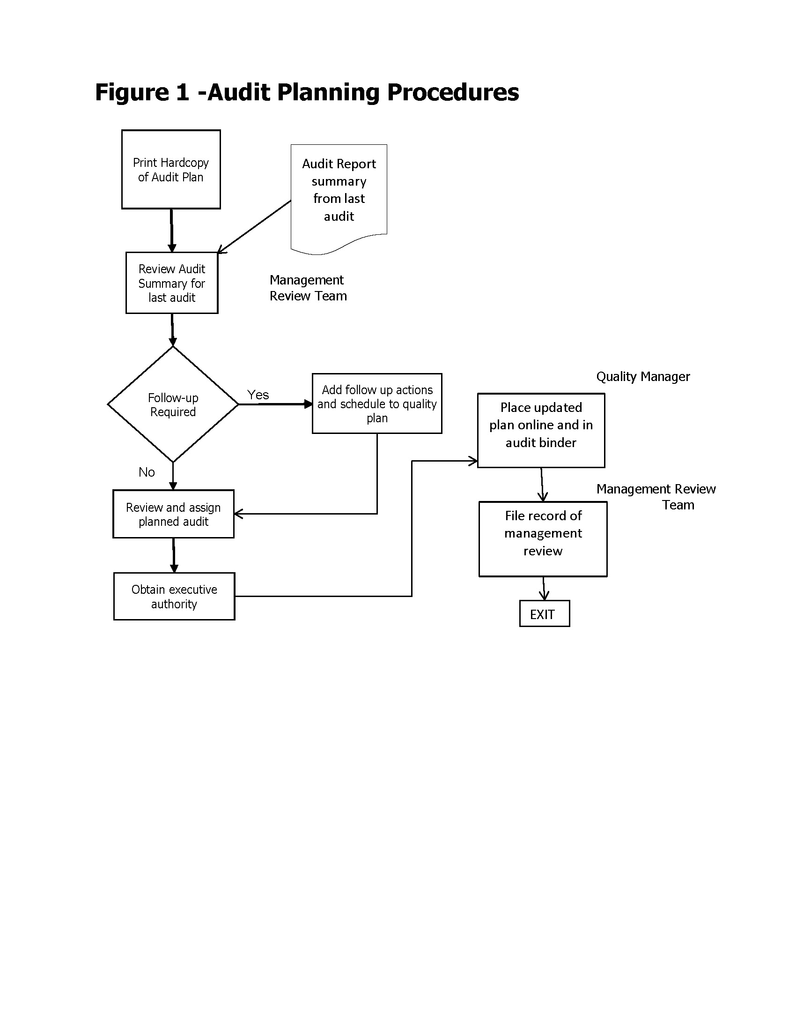
  - Internal quality audits are conducted to ensure ongoing compliance with requirements of the QMS standards, company’s policies and procedures. This is accomplished by auditing against all important processes and areas, and by applying all applicable sections of the standard. Audit requirements include those of ISO 9001, AS9100 Rev D, the company’s quality system documentation, as well as requirements of customers or regulatory authorities, as applicable.
  - List of Approved Auditors. Kevin Brumley, Donald Hudson.
  - Audits are conducted by process, and each process must be audited at least once annually. Documentation will be noted in the ERP Audit Module
  - The applicable ISO 9001/AS9100 standard clauses pertaining to each process are defined in Hyper Link below. These are the minimum clauses which must be audited for each process; an auditor may audit any clause of the applicable standard, and writing findings against them, depending on how the audit unfolds. QAEX028 Internal Audit Checklist. and the Process Effectiveness Assessment Report QAEX045 Additional processes of other activities or facilities, outside of the process model, may also be scheduled. For example, this may include safety audits, configuration management audits, etc. In such cases, unique audit forms may be developed for such non-process related audits.
  - The QAM plans audits according to need, management decision, or customer requirements, and assigns a Lead Auditor for each, as well as any supporting auditor team members. Scheduling is recorded in the Internal Audit Schedule portion of the Internal Audit Log.
  - Auditors are independent of the area being audited; RMC may therefore use approved third-party contract auditors for its internal audit program; the requirements for third party auditors are defined in the Reliable Mfg AS9100D QMS Manual. Employees selected as internal auditors will have attended at a minimum a 4 hour internal auditor training program and at least 8 hours of shadow auditing with a previously qualified internal auditor, or third party auditor.
  - Using the QAEX028 Internal Audit Checklist and or Process Effectiveness Assessment Report QAEX045 as a basic checklist, the Lead Auditor will plan the scheduled audit with the appropriate departments and with any other audit team members. The audit team will determine additional checklist items or requirements to verify, and add these to the checklist portion of the Internal Audit Report.
  - Auditors will then conduct the audit by following the steps defined on the Internal Audit Report. These are:
    - Step One: Audit Planning – definition of the scope of the audit, dates of audit, auditors, applicable clauses of affected standards, and documents to review.
    - Step Two: Document Review – a comparison of the quality system documentation against the requirements of the applicable standard.
    - Step Three: Auditing – comparison of actual practice vs. the requirements of both the company QMS documentation and the applicable standards.
    - Step Four: Verifying Effectiveness of the Process – general questions aimed at verifying that the process being audited is effective and not prone to generating nonconformities.
    - Step Five: Summarize Findings – a detailed list of the negative findings to be entered into the [CAR Form Name] system.
    - Step Six: Review of Report – a review by the Lead Auditor of all findings and evidence to ensure the audit report is complete, clear, objective, and provides traceable objective evidence.
  - Auditing shall be performed by obtaining objective evidence to support each requirement, or indicate where nonconformances are found. All findings are recorded on the Internal Audit Report within the ERPQMS Software. QAEX019 Audit Report. The internal auditor submits Corrective Action Report as necessary to address the non conformances recorded on the report.
  - When recording nonconformities, each negative finding must include three elements:
    - Indication of the Requirement – the document or clause of the applicable standard which is thought to have been violated.
    - Objective Evidence – traceable indication of the evidence found which supports the claim of a nonconformity (e.g.: documents, products examined, interview results). In all cases, objective evidence must be recorded in sufficient detail to ensure a third party can find the exact evidence at a later date.
    - Details of the Disconnect – a brief statement on why the objective evidence shows a nonconformity against the requirement.
  - The nonconformities shall be rated as either “Major” or “Minor” per the requirements of customers and some regulatory bodies. See definitions of Major and Minor Nonconformities Findings shall be rated by Type, whether Corrective, Preventive or Opportunity for Improvement (OFI) or for when a Corrective Action is filed.
  - Once Corrective Action are filed, the responsible managers or parties shall ensure timely corrective action is taken to remedy any non conformances found. During the Corrective Action effectiveness review, the results of actions taken to address audit findings are evaluated.
  - The QAM or his designee shall update the audit schedule within the ERPQMS Audit Module to reflect to closure of the audit, and enter a summary of audit findings. Based on the results of the audits, and previous audits, the QAM will then schedule the next audit of the particular process. Processes for which internal audits discover a high number of findings, or critical findings of any number, should be audited more frequently until the process is proven effective again.
  - The completed Internal QAEX019 Audit Report is then published on the company’s server and/or sent to the appropriate managers of the areas audited, in order to report the findings and results. In this way, and in conjunction with the submission of Corrective Action, all necessary managers are notified of the audit results and may make informed decisions for their departments based on those results.
  - The results of internal audits are also gathered and summarized on the Audit Trend Analysis Chart, generated by the Audit Report, for review by top management during management review and by all employees, through a general posting of the chart.
  - In all cases, all personnel are expected to cooperate fully with the audit team.

Table 1: Processes vs. ISO 9001:2015 Clauses

Process | Applicable ISO 9001:2015 Clause(s)
Processes

