Final(?) Version.2
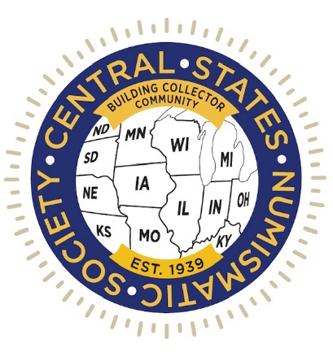
CSNS Partners With Newman Numismatic Portal For Symposium And Suspends Exhibits For 2023 Convention

Central States Numismatic Society looks to revamp
rules to attract more exhibitors and convention visitors

(Schaumburg, Illinois) November X, 2022 – As part of an ongoing expansion and modernization program for its annual convention, leaders of the Central States Numismatic Society (CSNS.org) are partnering with Washington University’s Newman Numismatic Portal (NNP) for a three-day symposium at the 2023 CSNS convention. The NNP Symposium sessions will be live-streamed and archived for free access at the NNP website, nnp.wustl.edu.
CSNS leaders have also suspended competitive exhibits for the 2023 convention to pause while examining possible changes to exhibit rules.
“In my discussions with collectors and show managers, I hear a strong desire to modernize exhibiting. However, there is disagreement in the numismatic community about competitive awards with some calling for changes in the exhibition rules and others who want to continue with rules that have been in place for decades,” said CSNS President Mitch Ernst.
“We have the opportunity now to do something different and do it right,” he stated.
“This reassessment of our exhibit area is part of the ongoing decisions, changes, and evaluations we are making to keep CSNS on an upward trajectory. We are committed to do the best we can in everything we do. It is important to know that every decision we make at CSNS will always be in what we believe is the best long-term interest of Central States and all its members; not necessarily what is best for a particular member, dealer, or club, but what is in the best long-term interest of the Central States Numismatic Society,” emphasized Ernst.
"What worked in the 1970s doesn’t work today and hasn’t for decades,” stated CSNS Convention Manager Larry Shepherd.
“We must consider the changing behaviors and desires of collectors and the abundant amount of available numismatic education on the internet that wasn’t an option 50 years ago. Our one-year sabbatical on competitive exhibits will give us time to explore changes or alternatives that might deliver a greater return," said Shepherd.
“The motto of the Central States Numismatic Society is ‘Building Collector Community,’ and evaluation of our exhibit area to determine what changes need to be made to align with those goals, and the NNP Symposium, are examples of innovative planning to bring numismatic education to a wider audience,” explained Ernst.
Len Augsburger, NNP Project Coordinator, and Lianna Spurrier, who produces the NNP Symposium on behalf of the NNP, plan to host and livestream six presentations per day during the 2023 CSNS convention. Some sessions may feature material previously shared in an exhibit format, and Newman Portal invites all potential speakers or exhibitors to contact NNPCurator@wustl.edu for further information.
“On behalf of the CSNS Board, we appreciate your understanding as we try to align our convention education programming with our overall convention goals of being bigger, better, safer and friendlier,” said Ernst.
“The NNP Symposium is one way for the hobby to do innovative planning to bring numismatic education to a wider audience,” he added.
The Newman Numismatic Portal (nnp.wustl.edu) is located at Washington University in St. Louis, Missouri and funded by the Eric P. Newman Numismatic Education Society. The NNP is dedicated to becoming the most comprehensive online resource for numismatic research and reference material, with a particular focus on American coinage and currency. Launched in 2016, the site now includes over 50,000 documents, representing 5 million pages of scanned and electronically acquired content.
The NNP Symposium hosted its inaugural event in 2020, followed by four additional events in 2021 and 2022. While all previous events have been entirely virtual, the partnership with CSNS will enable them to reach a new audience and expand the outreach of the NNP Symposium, and the NNP as a whole. More information about past Symposia can be found at nnpsymposium.org, and further information about the CSNS partnership will be added in December.
The CSNS 2023 convention will be conducted April 27-29 at the Schaumburg Renaissance Hotel and Convention Center, 1551 North Thoreau Drive, in the Chicago suburb of Schaumburg, Illinois. The 2023 PNG Day will be held there on April 26.
Information about the convention, including information about discount rates for transportation and hotel accommodations, will be available on the CSNS convention website, CSNS.org.

