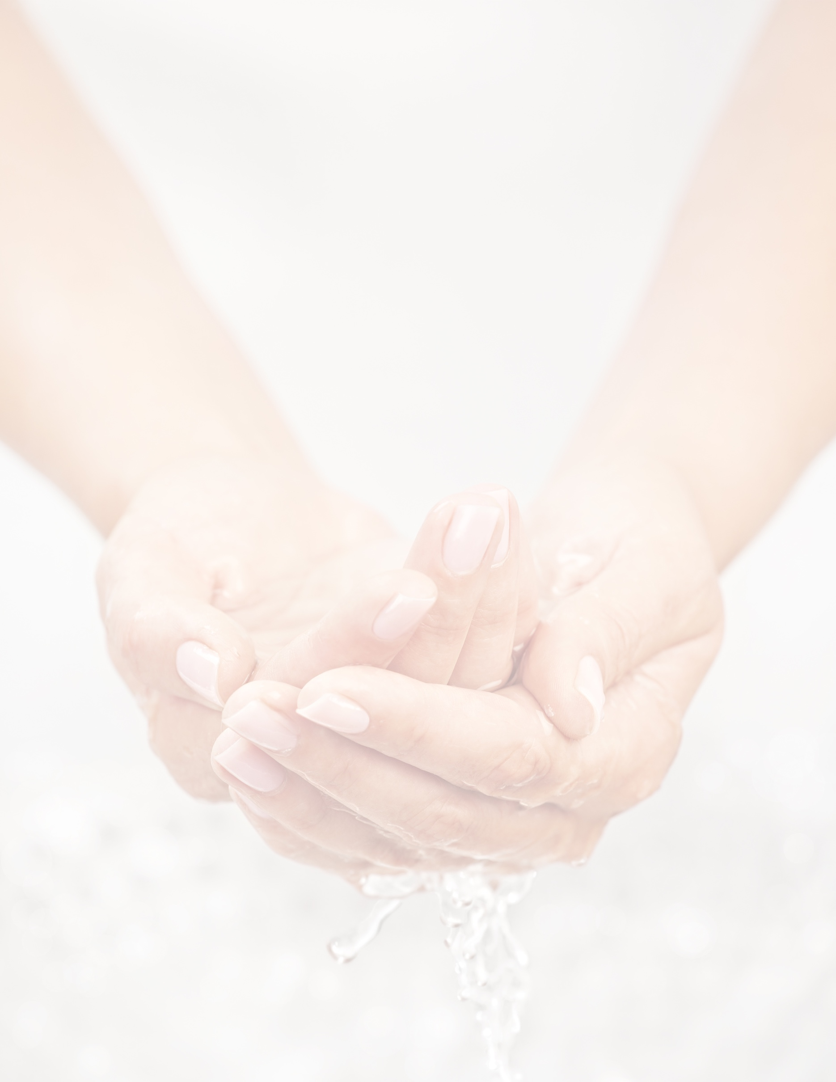

spa sanitation
& hygiene standards

{INSERT SPA NAME AND/OR LOGO}
A note from ISPA: This checklist provides general guidelines for reopening
a spa and does not supersede any laws under which your spa operates. Always follow the health and sanitation regulations established by your local, state or national governments. All ISPA guidelines, templates and resources should be reviewed by your legal counsel prior to use and distribution to ensure they are in compliance with the laws of your respective governing body. The checklist is meant to be customizable with applicable components being used as deemed appropriate by each individual spa location.

Introduction & Definitions
Maintaining a high standard of cleanliness and sanitation is essential to the successful operation of any spa. Not only are visibly clean spaces more inviting to guests, but thoroughly sanitizing and disinfecting all areas of a spa can be critical to the health and safety of every person who walks through its doors.
This document provides guidance on how to effectively sanitize and disinfect your spa after a shutdown period to reduce the spread of communicable diseases as much as possible.
A note about the terms used within this document: “cleaning,” “disinfecting” and “sanitizing” are sometimes used interchangeably, but their meanings are distinct. The definitions below are those used by the Centers for Disease Control and Prevention (CDC) and are consistent with the way these terms are used in this document.
Cleaning removes germs, dirt and impurities from surfaces or objects. Cleaning works by using soap (or detergent) and water to physically remove germs from surfaces. This process does not necessarily kill germs, but by removing them, it lowers their numbers and the risk of spreading infection.
Disinfecting kills germs on surfaces or objects. Disinfecting works by using chemicals to kill germs on surfaces or objects. This process does not necessarily clean dirty surfaces or remove germs, but by killing germs on a surface after cleaning, it can further lower the risk of spreading infection.
Sanitizing lowers the number of germs on surfaces or objects to a safe level, as judged by public health standards or requirements. This process works by either cleaning or disinfecting surfaces or objects to lower the risk of spreading infection.

Materials and Safety Precautions
Before sanitizing your spa, make sure you have appropriate cleaning materials and personal protective equipment (PPE) on hand. Such items may include:
- Soap
- EPA-registered disinfectants (find the list here)
- Disposable gloves
- Disposable gowns
- Face masks
- Household bleach
- Isopropyl Alcohol
- Barbacide
- Cavicide
Additional PPE (protective eyewear, facemasks, face shield) may be required based on the cleaning products or disinfectants being used and whether there is a risk of splash.
If an EPA-registered disinfectant is not available, diluted household bleach solutions may also be used if appropriate for the surface.
- Follow the manufacturer’s instructions for application and proper ventilation
- Wear protective inhalation masks and eyewear or full-face visors when using bleach and other hazardous chemicals
- Never mix household bleach with ammonia or any other cleanser
To make a bleach solution, mix:
- Five tablespoons (one-third cup) bleach per gallon of water, or
- Four teaspoons bleach per quart of water
Leave solution on surfaces for at least one minute.
Note: a bleach solution should only be used if absolutely necessary, as its smell and vapors can be unpleasant for guests and staff.
Alcohol based wipes, sprays or solutions containing at least 80 percent alcohol may also be used to disinfect surfaces. Dry surfaces thoroughly after application.

Prior to Reopening
Always follow the local, state and national regulations applicable to your spa regarding occupancy levels, social distancing protocols, etc.
Properly sanitizing your spa after an extended shutdown (especially due to a communicable disease) protects the health and safety of guests and staff. Observe the following guidelines to safely and effectively sanitize your spa prior to reopening.

Communal Areas (Lounges, Locker Rooms, etc.), Treatment Rooms and Service Areas

Hard Surfaces (not including electronics)
- Wear disposable gloves to clean and disinfect
- Collect cleaning materials and make sure the area you are disinfecting is well-ventilated
- Using an EPA-registered disinfectant (and following the instructions on the label) clean and disinfect high touch surfaces, including tables, doorknobs, light switches, lockers, countertops, retail shelves, handles, desks, phones, keyboards, faucets and sinks, chairs, stools, trolleys, vanities, storage containers, etc.

Soft Surfaces—Including Carpeted Floors, Rugs, Furniture and Drapes
- Clean the surface with soap and water or with cleaners appropriate for use on those surfaces
- Launder items (if possible) according to the manufacturer’s instructions, using the warmest appropriate water setting and drying items completely

Electronics
- For electronics such as tablets, touch screens, monitors and remote controls:
  - Consider a wipeable cover for applicable devices
  - Follow the manufacturer’s instructions for cleaning and disinfecting
- For digital locks:
  - Follow the manufacturer’s instructions for cleaning and disinfecting
  - No liquid cleaning solution should be applied directly to the lock
  - Apply disinfectant to a soft, lint free cloth and wipe down a single lock to test the solution; allow lock to dry completely
  - If no cosmetic change occurs after 10 minutes, disinfect remaining locks

Tools and Implements
- Always follow the laws and regulations governing service providers and their tools and implements
- Clean and disinfect tools and implements such as tweezers, microblading handles, reusable razor handles, comedone extractors, clippers, scissors, metal nail files, cuticle pushers, etc.
  - Clean tools using water and detergent
  - Rinse tools with clean water and dry them
  - Fully immerse tools in an approved disinfectant for at least eight minutes
  - Rinse tools with water and dry using a clean cloth
  - Store in a closed, disinfected container

Steam Rooms, Saunas and Wet Spaces
Proper ventilation is crucial for keeping airborne bacteria away from hydrothermal areas and to prevent the growth and spread of mold, fungus or bacteria. Prior to reopening your spa after a shutdown, consider reviewing the air quality and ventilation in these spaces.
For reference:
- Air in a sauna should be refreshed seven to 10 times an hour
- Air in a steam room should be refreshed six times an hour
For a deep clean of a hydrothermal area, avoid commercial steam cleaners or pressure washers, which can damage grout and remove protective layers from wood. Instead, use a domestic-quality, low pressure steam cleaner to remove excess residual dirt and body oils from surfaces prior to cleaning and disinfecting.

Steam Rooms
- Wear disposable gloves, inhalation masks and protective eyewear or full-face visors to clean and disinfect
- Use a small brush to clean corners, joints and other hard-to-reach places
- Use soap and water to clean all surfaces
- Use cleaning products or a solution with at least 80 percent isopropyl alcohol to disinfect all surfaces

Saunas
- Wear disposable gloves, inhalation masks and protective eyewear or full-face visors to clean and disinfect
- Use a small brush to clean corners, joints and other hard-to-reach places
- Use soap and water to clean all surfaces
- Use 3 percent hydrogen peroxide (undiluted) to disinfect all surfaces
Ozone gas (O³) has also been cited as an effective disinfectant for use in hydrothermal areas. Because ozone gas is toxic to humans, its use requires the installation of ozone gas generators that can be controlled remotely. These machines generate high concentrations of ozone gas which disinfect the area before the ozone turns back into oxygen (O²).

Fitness Areas
- Following manufacturer instructions, use the guidelines for hard surfaces to clean and disinfect fitness equipment
  - For disinfection, solutions containing at least 80% isopropyl alcohol or a diluted bleach solution with a chlorine concentration of 1000 PPM may be used
- If using a spray cleaner: spray into a soft, lint-free cloth and wipe frame and hard surfaces, reapplying cleaner as needed; do not spray equipment directly
- Dry surface completely
- Ensure excess cleaning fluid does not come into contact with electronic components
- Follow manufacturer instructions for cleaning equipment screens (if applicable)

Retail Spaces
- Use the guidelines for hard surfaces to clean and disinfect shelves and individual items (when possible), along with other surfaces
- Remove testers from retail area (consider making available by request only)

Laundry (Clothing, Towels, Linens and Other Items)
- Wear disposable gloves when handling laundry
- Wash your hands with soap and water as soon as you remove the gloves
- Do not shake dirty laundry
- Follow manufacturer’s instructions for laundering items
- Use the warmest appropriate water setting and dry items completely
- Clean and disinfect clothes hampers according to the above guidance for surfaces

After Reopening
Once your spa has reopened following an illness-related shutdown, maintaining high sanitation standards is critical for both reducing the spread of communicable diseases that may appear in the future and ensuring peace of mind for guests and staff.
- Always follow the local, state and national regulations and guidelines applicable to your spa, including those related to occupancy levels, social distancing and other measures intended to reduce the spread of viruses
- Encourage guests to reschedule appointments if they are sick or exhibiting symptoms of illness, especially a cough, fever, sore throat, or shortness of breath
- If a guest or staff member becomes ill while in the spa, follow the guidelines listed here
- Encourage employees to stay home if they are sick or exhibiting symptoms of illness
- Routinely sanitize communal areas, treatment rooms and restrooms according to the guidelines listed here
- Continue to sanitize hydrothermal areas according to the guidelines listed here

During Treatments and Services
For the safety of both guests and staff, service providers may adhere to some or all of the following guidelines before, during and after services to reduce exposure to germs and minimize the spread of communicable diseases.

All Service Providers
- Always follow the local, state and national regulations and guidelines applicable to your spa, including those related to occupancy levels, social distancing and other measures intended to reduce the spread of viruses
- Stay home if you are sick or are exhibiting symptoms of illness such as a fever or persistent cough
- Consider greeting guests with a no-touch welcome ritual or greeting instead of a handshake
- Wash hands for 30 seconds with soap and warm water prior to treatment, and verbally notify guest that hands have been washed; if washing hands is especially impractical, use hand sanitizer
- Encourage guests to wash hands prior to treatment; if washing hands is impractical or guest would prefer, provide hand sanitizer
- As much as possible, service providers should refrain from touching their own faces during services
- Consider the use of personal protective equipment during services, including disposable gloves or facemasks

In Case of Sickness
If a guest or staff member in the spa is sick or exhibiting symptoms consistent with COVID-19 , take the following steps to reduce the likelihood of transmission:
- Always follow the regulations and guidelines provided by local, state and national authorities
- If possible, close off all areas used by the sick person
- If possible, open outside doors and windows to increase air circulation and wait up to 24 hours before you clean or disinfect (if 24 hours is not feasible, wait as long as possible)
- Clean and disinfect all areas used by the sick person, following the guidelines found here
- Continue routine cleaning and disinfection

