2026 Eagle County Conservation District
50/50 Conservation Grant Application

Exhibit A: Project Scope and Deliverables
Contact Information

Name: Date:

Email: Phone:

Are you a:
- Landowner
- Land Manager

Physical Address:

Mailing Address:

Project Background Information

Project Title:

Project Location (Attach site map if applicable):

Is this project a continuation of a project funded by ECCD from the previous year?
- Yes
- No
If yes, list the project name:

Are these funds matching funds for a larger grant project?
- Yes
- No
If yes, list partners and total anticipated budget:

Is this project in response to an unforeseen emergency or natural hazard such as fire or flood?
- Yes
- No
If yes, explain:

What natural resource category(ies) do(es) your project address?
- Land
- Water
- Vegetation
- Wildlife
- Sustainability

Does this project include noxious weed treatment, as classified by the Colorado Department of Agriculture (List A, B or C)? *This grant will not award only noxious weed treatment. Please see our Noxious Weed Cost-Share Program*
- Yes
- No
If yes, what species will be treated and what control methods do you intend to use? Do you need technical assistance?

Engineering practices must be planned and installed in accordance with technical standards and specification provided by the Natural Resources Conservation Service (NRCS) or be authorized by a professional engineer. Will there be any engineering practices included in the scope of work?
- Yes
- No
If yes, who is the engineer?

Does this project require permitting?
- Yes
- No
If yes, what is the status of the permit?

Project Details

Brief Project Summary (limit 150 words) *Provide an overview of the proposed project that clearly explains what will be done, and the primary conservation goals.*

Background: (limit 150 words) *Explain the need for the project by describing the existing conditions, relevant research, and conservation issues the project aims to address. It should clearly articulate why the project is necessary and how it responds to identified natural resource concerns.*

Project Description: (limit 300 words) *Outline what specific actions will be implemented to carry out the project and identify the natural resources that will be impacted. It should clearly describe what will be done, and the expected conservation benefits.*

Project Method: (limit 300 words) *Describe how the project will be implemented, including the strategies, an outline or clear sequence of tasks/practices and an anticipated timeline for completing the work.*

Project Success and Deliverables (limit 250 words) *Define how project outcomes will be measured and evaluated, including specific metrics, monitoring methods, and reporting requirements. Explain how success will be demonstrated and documented.*

Deliverable Data: (Use metrics provided when reporting, i.e. feet, acres, quantity installed, percent, gallons, tons…)
Number of acres to be impacted
Number of acres to be revegetated
Feet of trees/windbreak to be planted
Feet of fence to be built
Number of wells to be installed
Number of ponds to be installed
Number of livestock tanks to be installed
Number of irrigation systems to be installed
Feet of irrigation pipe to be installed
Expected efficiency gains %
Gallons of water to be conserved
Tons of soil to be conserved
Number of gardens to be planted
Other quantifiable impacts to be made:

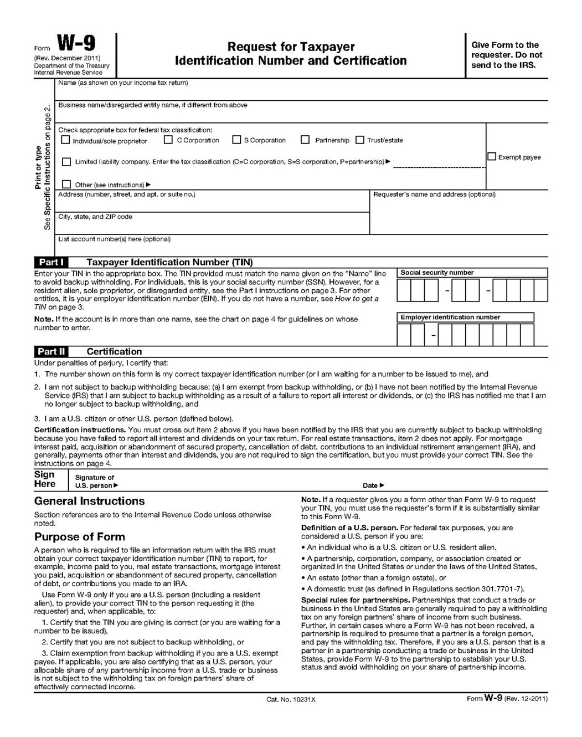

Release and Indemnity Agreement for 50/50 Conservation Grant
MUST BE SIGNED BY LANDOWNER OR MANAGER

1. The undersigned (the "applicant") wishes to participate in the 50/50 Conservation Grant, as described in the Exhibit A: Project Scope and Deliverables (“Exhibit A”) and Exhibit B: Proposed Budget and Budget Narrative (“Exhibit B”) attached to this Application, for the purpose of Exhibit A specified within the “Project Location”, which is for the protection of property within Eagle County. The undersigned agrees with the associated terms, conditions and parameters stated herein.
2. The applicant is either the land owner of record or the land manager. In the case that the applicant is the land manager, the land manager has authority to act on behalf of the land owner of record.
3. The undersigned voluntarily participates in this 50/50 Conservation Grant, is over 18 years of age, and owns or manages the land to which Exhibit A will be applied.
3. The undersigned agrees that all engineering practices will be planned, designed, and installed in accordance with NRCS technical standards and specifications, or as authorized by a licensed professional engineer. The Indemnitor shall indemnify and hold harmless the Indemnitee from any claims, damages, or losses arising from failure to comply with these standards or from errors or omissions in the planning, design, or installation of such practices.
4. The Applicant is responsible for obtaining all required permits prior to beginning the project. The Applicant shall indemnify and hold harmless the Indemnitee from any claims, damages, or losses arising from failure to obtain or comply with such permits.
5. The undersigned acknowledges that control of weeds through the use of herbicides and mechanical and other methods can be a dangerous or hazardous activity. The undersigned also acknowledges that there may be hazards not immediately apparent in the use of herbicide, mechanical and other methods of weed control. The undersigned, therefore, certifies that they will strictly adhere to herbicide label restrictions if they apply a herbicide, rather than obtaining application services, and will exercise caution in the use of all other methods of weed control.
6. By signing this agreement, the undersigned authorizes Eagle County Conservation District and authorized personnel to enter and access the Property for the purpose of evaluating the plan.
7. By signing this agreement, the undersigned understands that in order to be eligible for grant funding, Eagle County Conservation District and authorized personnel may require an initial and follow up site visit at the project site.
8. By signing this agreement, the applicant understands that Eagle County Conservation District will fund up to 50% of 50/50 Conservation Grant total project expenses with a maximum award amount of $15,000. Fund requests may be fully funded, partially funded, or fully denied. Nothing in this agreement shall obligate any party to expend funds or future payments of money in excess of the award amount provided by this agreement.
9. By signing this agreement, the Applicant acknowledges that this is a reimbursement program and they are responsible for full payment to their contractor and any natural resources professional, if applicable. The Applicant must obtain and provide receipts showing payment. Reimbursement of the award amount stated herein will occur only after the work has been completed in compliance with this agreement and all required documentation has been submitted.
10. By signing this agreement, the undersigned understands that they are not eligible for any award reimbursement payments for any incurred costs for work done prior to OR without signing an award statement that has been issued in their name.
11. If, prior to reimbursement or payment for completed projects, Eagle County Conservation District reasonably determines that the reimbursement or payment would be improper because the undersigned failed to complete the project in compliance with the approved Exhibit A as prescribed by the terms of this agreement or otherwise fulfill the applicant's obligations contained herein, Eagle County Conservation District shall have no obligation to make such payment. If, at any time after reimbursement or payment has been made, Eagle County Conservation District reasonably determines that the reimbursement or payment was improper because the approved Exhibit A for which the reimbursement or payment were not performed as prescribed by the provisions of this agreement, then upon written notice of such determination and request for reimbursement from Eagle County Conservation District, the applicant shall forfeit return such payment or reimbursement to Eagle County Conservation District.
12. THE UNDERSIGNED AGREES TO RELEASE AND DISCHARGE EAGLE COUNTY CONSERVATION DISTRICT, THEIR OFFICIALS, BOARDS, OFFICERS, PRINCIPLES, EMPLOYEES, CONTRACTORS AND AUTHORIZED PERSONNEL FROM ALL LIABILITY FOR DAMAGE TO PERSONS OR PROPERTY, CLAIMS, DEMANDS, LOSSES OR DAMAGES, AND TO DEFEND, INDEMNIFY AND HOLD HARMESS EAGLE COUNTY CONSERVATION DISTRICT, OFFICIALS, BOARDS, OFFICERS, PRINCIPLES, EMPLOYEES, CONTRACTORS AND AUTHORIZED PERSONNEL FROM ANY AND ALL CLAIMS, DAMAGES, LOSSES AND LIABILITIES ARISING OR ALLEGEDLY ARISING OR RELATED TO THE SUBJECT OF THIS AGREEMENT OR PARTICIPATION IN EAGLE COUNTY WEED COST SHARE PROGRAM (WHICH SHALL INCLUDE ATTORNEY FEES AND COSTS). THIS RELEASE APPLIES WHETHER DANGERS OR HAZARDS ARE, OR ARE NOT, APPARENT TO THE UNDERSIGNED.

___________________________________ ______________________
Landowner/Land Manager Signature Date

