By having this box checked within your Personnel Security record, on behalf of your Agency Administration with relevant “System Maintenance” access, you agree to opt-in to Transactional messages via automated SMS messaging regarding “SMS CAD Alerts”. Message and Data rates may apply.
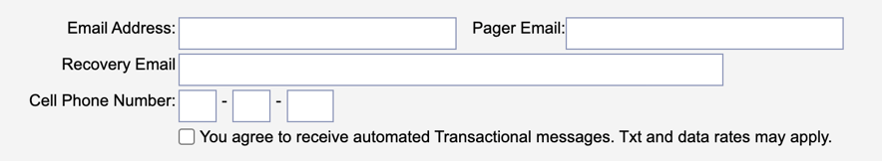

SMS message frequency will vary. To opt-out of the SMS messaging have your Agency Administrator with relevant “System Maintenance” access uncheck the box and remove your phone number from any groups or lists you are associated within “SMS CAD Alerts”.

