Sample Prospect Profile

Greg Russak, The Conscientious Capitalist

The purpose of this document is to help you to identify and qualify prospects for whatever goods and services you are selling. The key to success is to spend your time selling the right benefits to the right people and organizations that “fit the profile” of your best customers.

Step 1. The Target Audience
Instructions:
This is where you think about your target market in a top-down way, starting with data like revenue and industry, then moving to the types of people and their roles, and finishing up with measures like employee size.

Here’s an example for a tech company with an app that is used in business-to-business (B2B) customer service and technical support, but the principles can be applied to any business.

Example company
A typical buyer has the following profile:
(the following are for illustrative purposes only)
- Large, enterprise, “Fortune 2000” business, particularly in the following industries:
- High Tech
- Telecommunications
- Finance
- Retail
- Within those industries, the prospect should be responsible for and make or influence purchase decisions for:
- Customer service
- Product support
- IT help desk
- The above support operations should, at a minimum:
- Be staffed with 10 or more service representatives or call center agents per location
- Support 200 or more end users (employees, business partners, customers)

Step 2. Other General Characteristics of a Good Prospect
Instructions:
Think about and capture other characteristics that help to fill out what makes a good prospect. In this example, our tech company might also be using these as part of the Prospect Profile:
- Companies who do a significant portion of their business online
- Companies with self-service cloud-based information that is used for resolving problems
- Companies who serve commercial, educational, and government but not consumer markets

Step 3. Recognizing Prospect Types
Instructions:
Now that you’ve put some definition together about the prospective organizations, it’s time to think about how you recognize the kind of prospect as a person that you’re trying to reach them.

Table 1 lists the type of prospects for our example tech company. It’s based on the work by Geoffrey Moore in Crossing the Chasm (See Figure 1), but you can apply this kind of thinking about buyer type somewhat universally, especially if you have a new and different way of solving a business problem.

By simply applying this to your target markets, you’ll be forced into thinking about how to recognize different kinds of buyers. (A blank table is provided at the end of the document.)

Table 1. Prospect Type, Characteristics, and Market Category

Prospect Type | Prospect Characteristics  NOTE: THESE ARE FOR ILLUSTRATIVE PURPOSES ONLY AND NEED TO BE IN RELATION TO YOUR PROSPECTS | Market Category
Innovators | - Technology is a central interest  What is your Innovators’ central interest?  - Pursue new technology aggressively  This simply means they like to be first and they like others to know that they’re the “first kids on the block.” It doesn’t have to be about technology – it can be about your goods and services!  - Their endorsement reassures others  This applies UNIVERSALLY to all Innovators! They’re the ones people turn to to ask, “Have you heard of….?” | Early Market
Early Adopters (Visionaries) | - Are NOT technologists  In other words, they care more about the ENDS and less about the MEANS. They…..  - Are capable of seeing how the SOLTUON meets their needs  Again, a universal characteristic of Early Adopters, aka Visionaries! | Early Market
Early Majority (Pragmatists) | - Want to see well-established references  This is the market segment where the big money is. They look for proven solutions from providers who can assuage concerns with reference stories, case studies, and a track record. | Mainstream Market
Late Majority (Conservatives) | - Not comfortable with technology  - Wait for “established standards”  They’re only going to buy when it’s a no-brainer and a safe decision. | Mainstream Market
Laggards | - Only buy technology when buried deeply inside another product  In other words, they’re buying something else in which you are an embedded part. | Mainstream Market

Figure 1. Geoffrey Moore’s Technology Adoption Lifecycle Curve

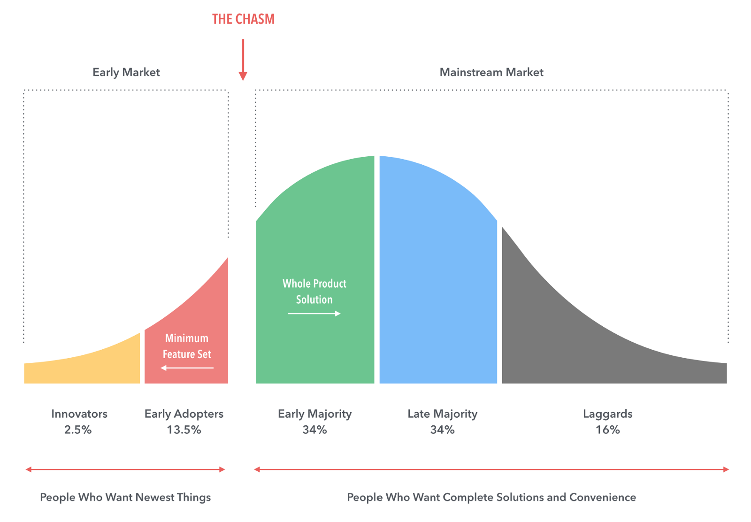
Image source: https://smithhousedesign.com/models-predicting-future-geoffrey-moores-crossing-chasm/

I like this version of the TALC. It captures more than just each market segment. It also describes the fundamental buyer characteristic that puts one buyer type on one side of the chasm versus the other; people who want the newest things versus people who want complete solutions and convenience.

A tell-tale signal that someone is “across the chasm” and in the Early Majority or Late Majority (forget Laggards) market is if they ask you for references. Innovators and Early Adopters don’t care who your other customers are unless in the context of whether they get to show their thought leadership and how visionary they are at being out in front of everyone.

There is one cautionary note to offer about this graph. It’s the perceived width of the chasm.

Don’t let the image fool you.

The chasm can be wide, and getting across is hard, but it’s not impossible if you have a solution that solves problems for large numbers of people and organizations, and you position it with the right types of prospects at the right time in the solution’s evolution in the eyes of the marketplace.
Step 4. Mapping Your BENEFITS to the Prospect Types
Instructions:
This takes some careful thought. You have to break down all – or at least, most of – the benefits your customers get from you, and then think about what kind of buyer type is going to find the greatest appeal from each of them.

You need to do this so that you keep the different types of buyers focused on those benefits that will resonate the most with them. How they react to the benefits is also a signal as to the type of buyer you have engaged. Yes, your benefits and the people you engage can have characteristics that spill into adjacent types, but they rarely span more than that.

Table 2 is the example for our sample tech company. A blank table is at the end of the document so that you can fill in YOUR Benefits to help you to focus on those benefits most appealing to each prospect type.

Table 2. Benefits Mapped to Prospect Type (for example purposes only)

Benefits | Should appeal to…
Tech-oriented differentiators and their key benefits | - Innovators
Anything patented or pending patent. Some technical advantage no one else has | - Innovators and  - Early Adopters
Customization capabilities  - What the customizations are and how they’re beneficial to the value to the customer | - Innovators and  - Early Adopters
Scalability  - What makes it scalable?  - How its accomplished differently from competition  - How it impacts user adoption and does it “protect” customer from runway cost increases | - Innovators and  - Early Adopters  - Early Majority
Strengthens relationships and develops loyalty with customers  - Helps your customer grow sales or service their customers better, faster, less expensively | - Early Adopters  - Early Majority
Integration  - Leverages/extends the useful life of your goods and services while extending the useful life of investments already made in other systems, processes, etc. | - Early Adopters  - Early Majority
“Whole Product” solution  - Does your solution “do it all”, or does it at least complement a best-of-breed integration through well-known and established partners and alliances | - Early Majority
Proven, standard deployment methodology / professional services  - Do you follow best practices based on industry standards?  - Advanced degrees/Experience/credentials of team | - Early Majority  - Late Majority
Proven solution and referenceable customers – probably the biggest consideration for Early and Late Majority Buyers  - Names prospects will recognize and which “transfer” credibility to you  - List strategic partnerships and alliances | - Early Majority  - Late Majority
Decreases costs  - Demonstrable operational improvements  - Quantifiable ROI projection | - Early Majority  - Late Majority
Improve workplace / employee happiness  - Employee productivity increases  - Enhancements to corporate culture that translates into advantages in recruitment, training, employee retention, job satisfaction, etc.; i.e. the Talent Edge | - Early Majority  - Late Majority
Technology is so deeply embedded they don’t even know it’s there | - Laggards

Table 1. Prospect Type, Characteristics, and Market Category

Prospect Type | Prospect Characteristics | Market Category
Innovators |  | Early Market
Early Adopters (Visionaries) |  | Early Market
Early Majority (Pragmatists) |  | Mainstream Market
Late Majority (Conservatives) |  | Mainstream Market
Laggards |  | Mainstream Market

Table 2. Benefits Mapped to Prospect Type

YOUR SOLUTION BENEFITS | Should appeal to whom?  - Innovators  - Early Adopters  - Early Majority  - Late Majority

