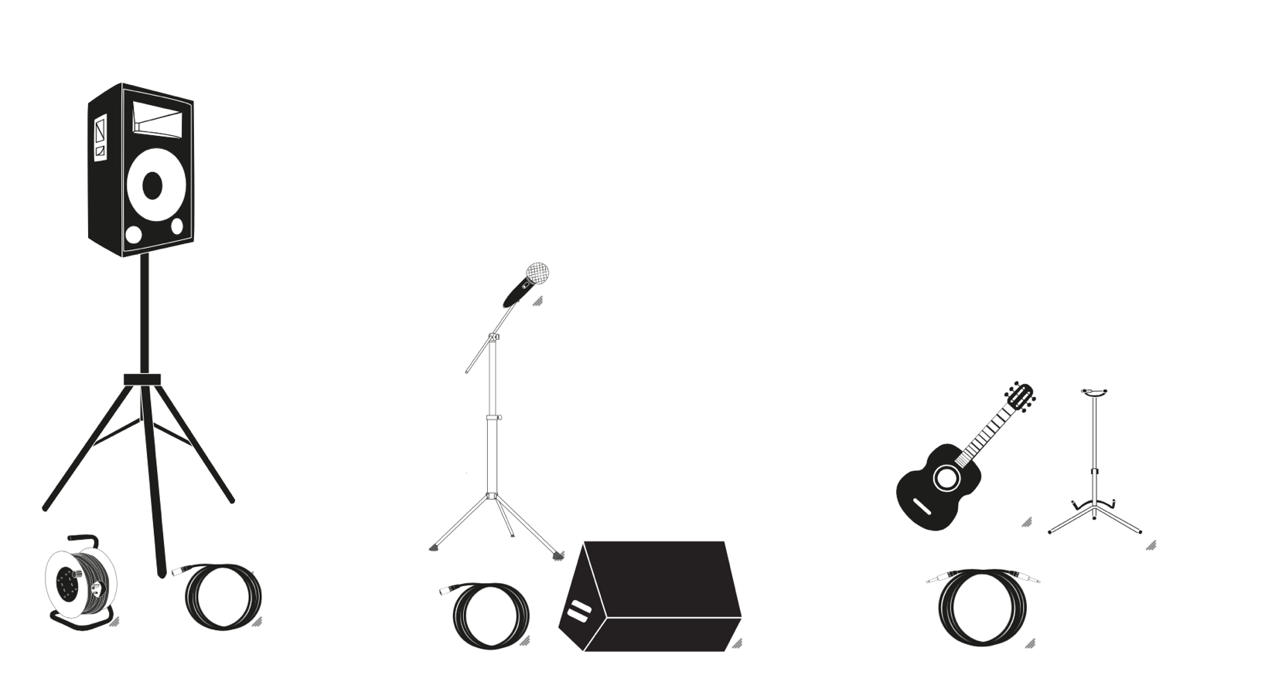

1 JBL Tower Speaker 1 boom mic stand/ microphone 1-2 Guitars

3 pin extension and power strip 1 Fishman amp (monitor/DI out) Guitar Stand

1 XLR 1 XLR ¼ inch Cable

Contact: [kelsibooking@gmail.com](mailto:kelsibooking@gmail.com)

Set List:

***Cover Songs***

1. Hurricane - Band of Heathens
2. Stand by me - Ben E. King
3. Aint no sunshine - Bill Withers
4. Neon Moon - Brooks & Dunn
5. Valerie - Amy Winehouse
6. Have you ever seen the rain - CCR
7. Dreams - Fleetwood Mac
8. As it was - Harry Styles
9. Smooth/ Havana (Mash-Up) - Rob Thomas/ Camila Cabello
10. Signed, Sealed, Delivered - Stevie Wonder
11. Flowers in your hair - The Lumineers
12. Water under the bridge - Adele
13. Here WIthout you - 3 Doors down
14. Riptide - Vance Joy
15. Country Roads – John Denver
16. Proud Mary - CCR
17. Forget you- Ceelo Green
18. Bags - Clairo
19. Aint no mountain high/ Dance with somebody (Mash-Up) - Marvin Gaye/Whitney Houston
20. Slow Hands - Niall Horan
21. Mary Jane’s Last Dance - Tom Petty
22. Drops of Jupiter - Train
23. 1000 miles/ Wonderwall (Mash-Up) - Vanessa Carlton/Oasis
24. The Sun - Maroon 5
25. Call it off - Tegan & Sara
26. Rolling in the deep - Adele
27. Make you feel my love - Adele
28. Back to Black - Amy Winehouse
29. Heaven - Bryan Adams
30. Thinking out loud - Ed Sheeran
31. Just the two of us - Grover Washington
32. Hallelujah - Jeff Buckley
33. Kiss me - Sixpence none the richer
34. I can’t make you love me - Bonnie Raitt
35. Landslide - Fleetwood Mac
36. I can’t help falling in love - Elvis
37. Stubborn Love - The Lumineers
38. Fast Car - Tracy Chapman
39. Jolene - Dolly Parton
40. Crazy - Ceelo Green
41. Come to my window – Melissa Etheridge

***Original Songs***

1. How Long
2. Get it
3. I’ve got me
4. The Greta Effect
5. Kerosene
6. Too Close
7. Melody
8. The Gambler
9. Ain’t no other