**Evening craft options**

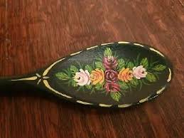

Barge painting

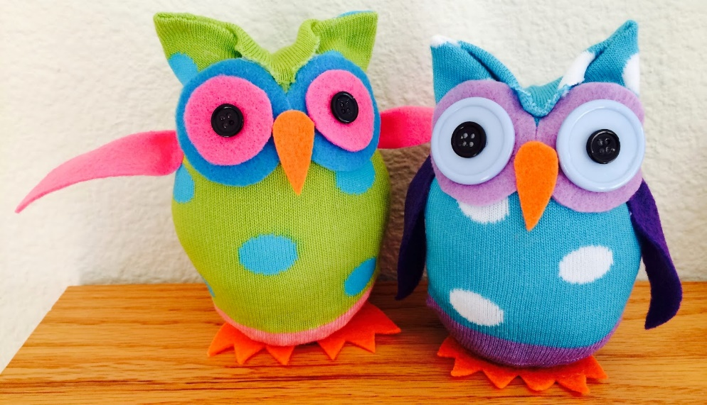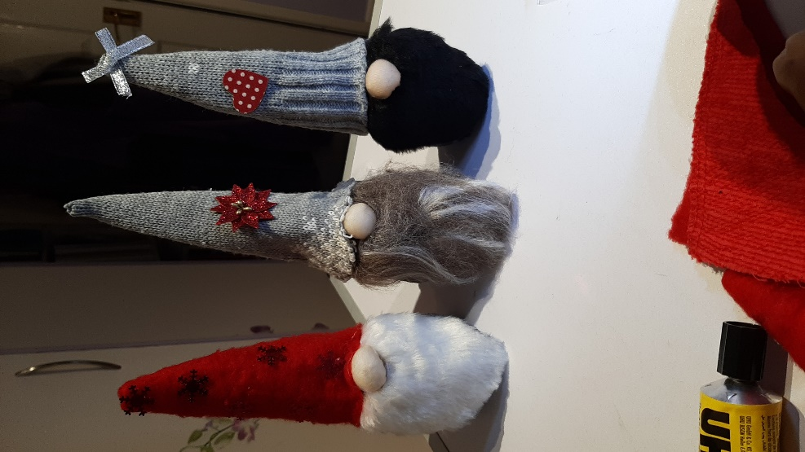

No sew sock owls or Nordic gnomes

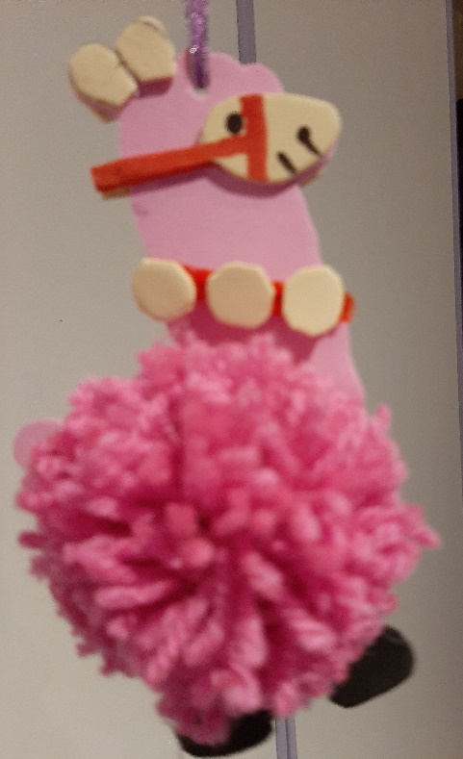 pom pom llamas

All available to pre book at £1 per person

Materials and tuition provided.