There is a shop onboard selling pocket money items

Badges available at £1 - £2 each - certificates at 50p each

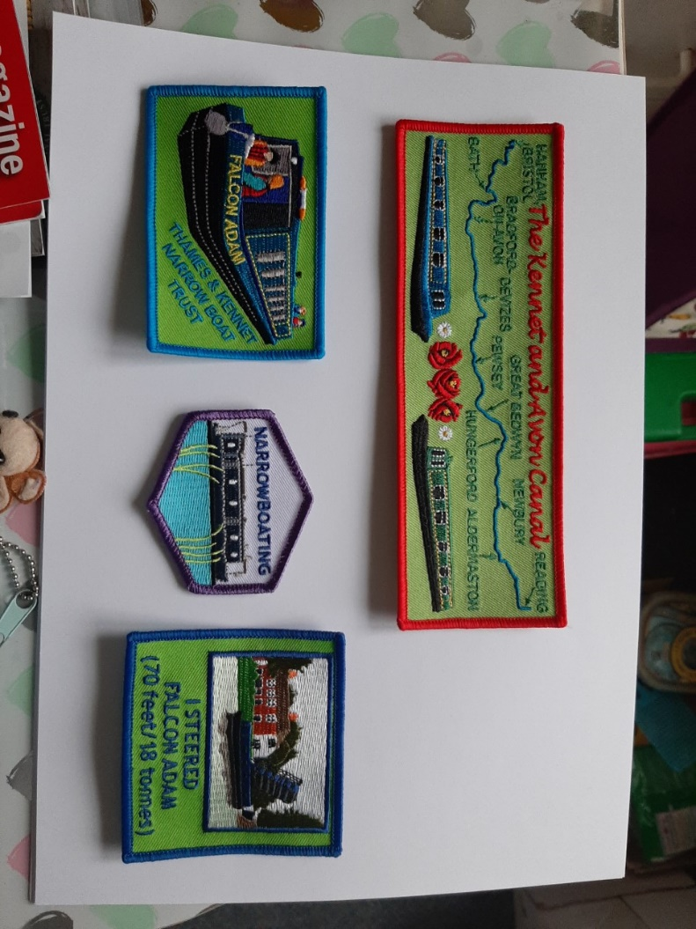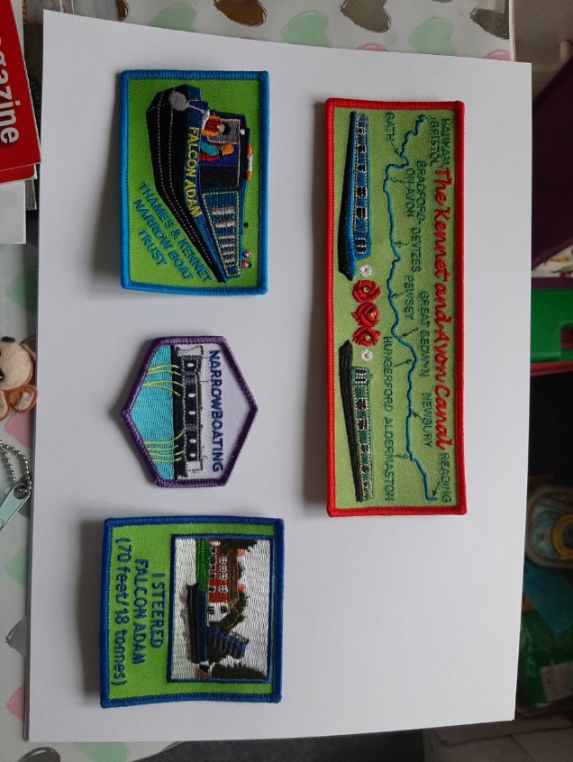

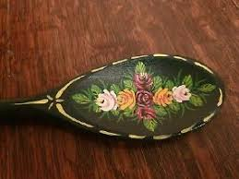We can also provide spoons and teach you how to do barge painting for £1 per person on overnight trips

For further information contact Julie on

[myersj@hotmail.co.uk](mailto:myersj@hotmail.co.uk) 0118 9618450 07798911978

[www.narrowboattrust.co.uk](http://www.narrowboattrust.co.uk)

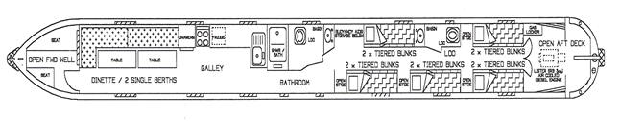

**Falcon Adam**

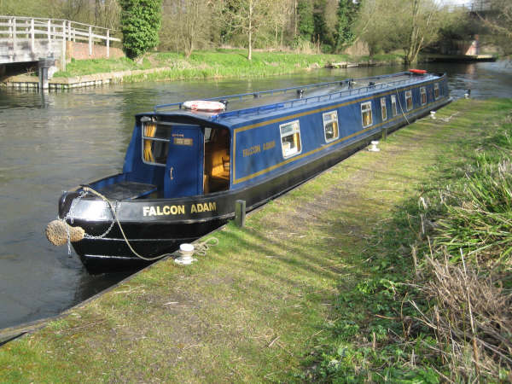

Falcon Adam is a 70’ narrowboat moored at Frouds Bridge Marina

on the Kennet and Avon canal. (RG7 4LH)

Just 13 minutes by train from Reading or Newbury.

It sleeps 12, ten in bunk beds and a further two in the sitting room.

It has a full kitchen with gas cooker and hob, sink, fridge, crockery for 12 and storage for food.

There are two bathrooms, both with toilet and wash basin and one containing a shower.

There are no electrical points or heating on board, although there is electric lighting.

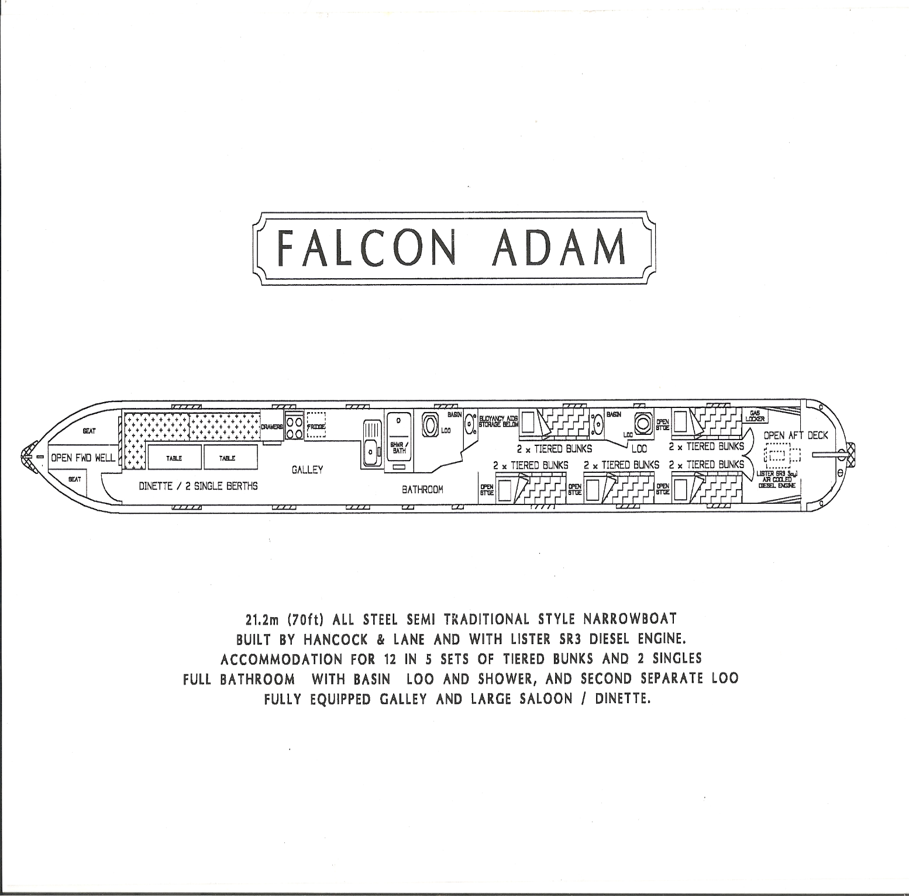**You do not need any experience as we will teach you and your youngsters all you need to know**.

Buoyancy aids/Life jackets are provided.

We can provide copies of letters and forms (consent, kit list, letter to parents, directions, risk assessment etc) for you to personalise and use.

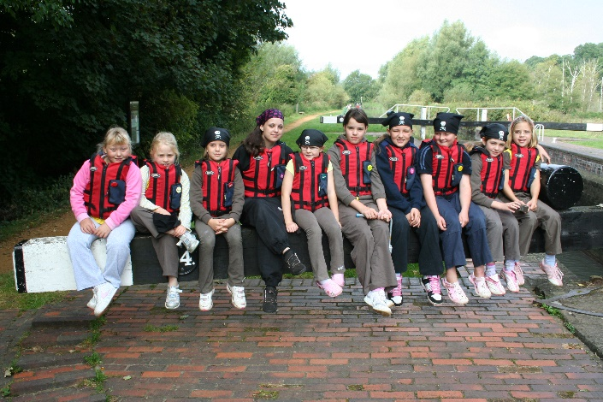**Trip Options**

**EVENING TRIP** – approx. 2 hours. £60.

Up to 20 young people aged 5+, at least 3 adults.

* Assemble at the marina to be welcomed by the skipper and crew member, half the group put on life jackets
* The life jacketed group boards the boat, the other half walks along the tow path (about a mile). This can include a scavenger hunt or spotter sheets.
* The boat group help operate the lock and take a turn at steering.
* The boat passes through one lock and turns.
* Groups swap over for the return journey.

**DAY TRIP** – approx. 6 hours. £180 weekday / £265 weekend.

10 young people aged 7+, 2 adults.

*This can include a sleepover on the boat before the trip, but is then limited to 8 young people. (no extra charge except your food)*

* Travel through three locks and 3 swing bridges to Midgham.
* Eat a packed lunch.
* Return home through same locks and swing bridges.
* Everyone on board learns how to work the locks safely and takes a turn at steering the boat.

**WEEKEND** – Friday night to Sunday night. £390 + food

8-16 young people aged 7+, 3 adults.

To involve 16 young people: one group of 8 does Friday evening to Saturday evening and then goes home, while the leaders stay on board to welcome the second group of 8 for Saturday evening to Sunday evening.

* Travel through nine locks and five swing bridges to Newbury.
* Saturday evening in Newbury where there are pubs, shops, a park and fish & chips should you wish to use these.
* Return trip through the locks back to the marina on Sunday.
* Everyone on board learns how to work the locks and takes a turn steering the boat with expert tuition and full supervision.

**LONGER RESIDENTIALS** - £720 per week.

--

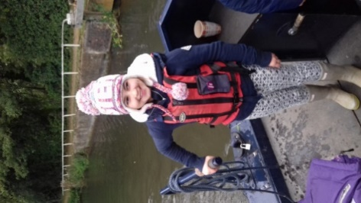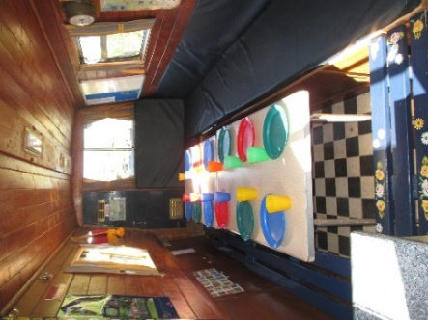We can usually provide a skipper to look after you all weekend and teach you what you need to know, they are volunteers and will need feeding and watering regularly!

Most of our skippers are Guiders, qualified in the Certificate of community boat management and/or the Guiding narrowboating qualification.

If you are interested in self-skippering, we can usually teach and qualify you over 2 weekends away with your group. (please note that 2 qualified skippers are needed to self-skipper Falcon Adam, this is not the case with all boats)