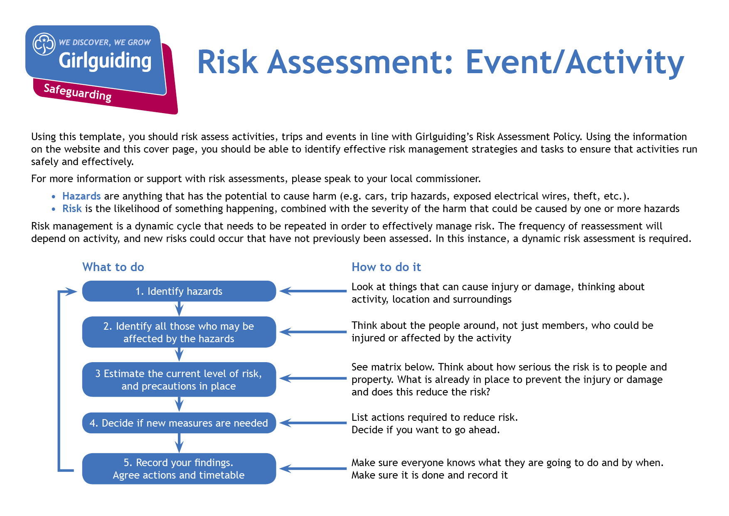

Event information and risk assessment

1 Adults refers to adult volunteers who are part of the event/ac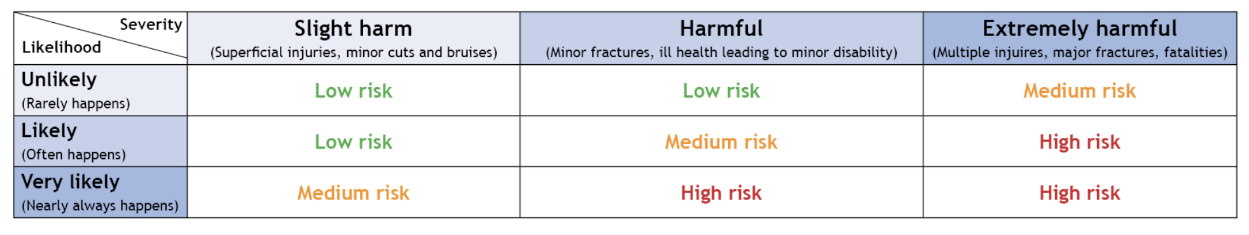tivity delivery team. * Refer to the Activity Finder for information about instructor qualifications.

|  |  |  |  |  |  |
| --- | --- | --- | --- | --- | --- |
| Name of Unit: | | | |  | |
| Event/activity (brief description) | | | | Date: | |
| Leader in charge: | Total attending: | Adults :1 | Girls/young women: | | General public: |
| Consent for activity/event forms completed please state: Yes No N/A | | | | Venue: | |
| Instructor qualification checked* please state: Yes No N/A | | | | | |
| **Decision**: once all the actions are carried out, can you eliminate or safely manage the risk of harm to ensure you can safely go ahead with this event/activity? If there is still some challenge or risk, are you still confident the control measures in place will keep girls safe? | | | | Yes No | |
| If you answered no to the above decision question, please explain why: | | | | | |
| Risk assessment completed by: | | | | Role: | |
| Has the risk assessment been shared with the leadership team? | | | | Yes No | |
| Risk assessment due for review (must be within 12 months) | | | | Date: | |

|  |  |  |  |  |  |  |
| --- | --- | --- | --- | --- | --- | --- |
| **Hazards**  What could cause harm or damage? | **Who or what is at risk of being affected and how?** | **What are you already doing?**  How have you reduced the risk already? | **Likelihoodof risk occurring (L/M/H)** | **Severity of risk**  **(L/M/H)** | **Are further controls necessary?**  What else needs to happen to reduce the risk to an acceptable level? | **Action by:**  name/date  You must complete this for every action |
| **Safeguarding & Inclusion** | | | | | | |
| Photos or videos being taken of the event without permission. |  |  |  |  |  |  |
| Volunteers posing a risk. |  |  |  |  |  |  |
| Personal information of volunteer or young members being given out. |  |  |  |  |  |  |
| Lack of communication |  |  |  |  |  |  |
| Parents briefed on activity and have given informed written consent to do activity |  |  |  |  |  |  |
| Clear procedures for referring safeguarding concerns and managing allegations against adults |  |  |  |  |  |  |
| Supervision/Ratios |  |  |  |  |  |  |
| Getting lost or separated from group |  |  |  |  |  |  |
| Behavioural Issues |  |  |  |  |  |  |
| Age Appropriate Content |  |  |  |  |  |  |
| Participant with additional needs, e.g. deaf, blind,  wheelchair accessibility,  learning disability, autism, ADHD, Impairment-specific,  Interpreters where English not spoken. |  |  |  |  |  |  |
| Possible stranger danger |  |  |  |  |  |  |
| **Spread of Infection including Covid** | | | | | | |
| Infection risks (see below).  These must be reduced to an acceptable level. |  |  |  |  |  |  |
| Close contact between people. |  |  |  |  |  |  |
| Infection risk from parents. |  |  |  |  |  |  |
| Sharing equipment. |  |  |  |  |  |  |
| Poor hand hygiene |  |  |  |  |  |  |
| Infection of vulnerable members. |  |  |  |  |  |  |
| Poor respiratory hygiene. |  |  |  |  |  |  |
| Poor level of cleanliness of hall and equipment, especially after other hirers. |  |  |  |  |  |  |
| Someone falling ill with Covid-19 symptoms during event. |  |  |  |  |  |  |
| Participant displays symptoms after event, raising concerns that others may have been infected. |  |  |  |  |  |  |
| **Health & Welfare** | | | | | | |
| Allergies |  |  |  |  |  |  |
| Accidents/Injuries/  Illnesses |  |  |  |  |  |  |
| Food provision for participants - knowledge of allergies |  |  |  |  |  |  |
| Parents briefed on activity and have given informed written consent to do activity |  |  |  |  |  |  |
| Exhaustion and dehydration |  |  |  |  |  |  |
| Carrying of heavy equipment |  |  |  |  |  |  |
| Sun burn/heat stroke/dehydration |  |  |  |  |  |  |
| **Activities** | | | | | | |
| Activities not complying with Girlguiding guidelines, therefore not covered by insurance |  |  |  |  |  |  |
| Food provision for participants - knowledge of allergies |  |  |  |  |  |  |
| Accidents, slips, trips or falls |  |  |  |  |  |  |
| Inclement weather |  |  |  |  |  |  |
| **Financial** | | | | | | |
| Financial Implications |  |  |  |  |  |  |
| Theft and mismanagement of funds |  |  |  |  |  |  |
| **Emergencies** | | | | | | |
| Accidents/Injuries/Illnesses |  |  |  |  |  |  |
| Illness of Leader in charge just before the event |  |  |  |  |  |  |
| Emergency evacuation procedures |  |  |  |  |  |  |
| Signed by commissioner: | | | | Date: | | |