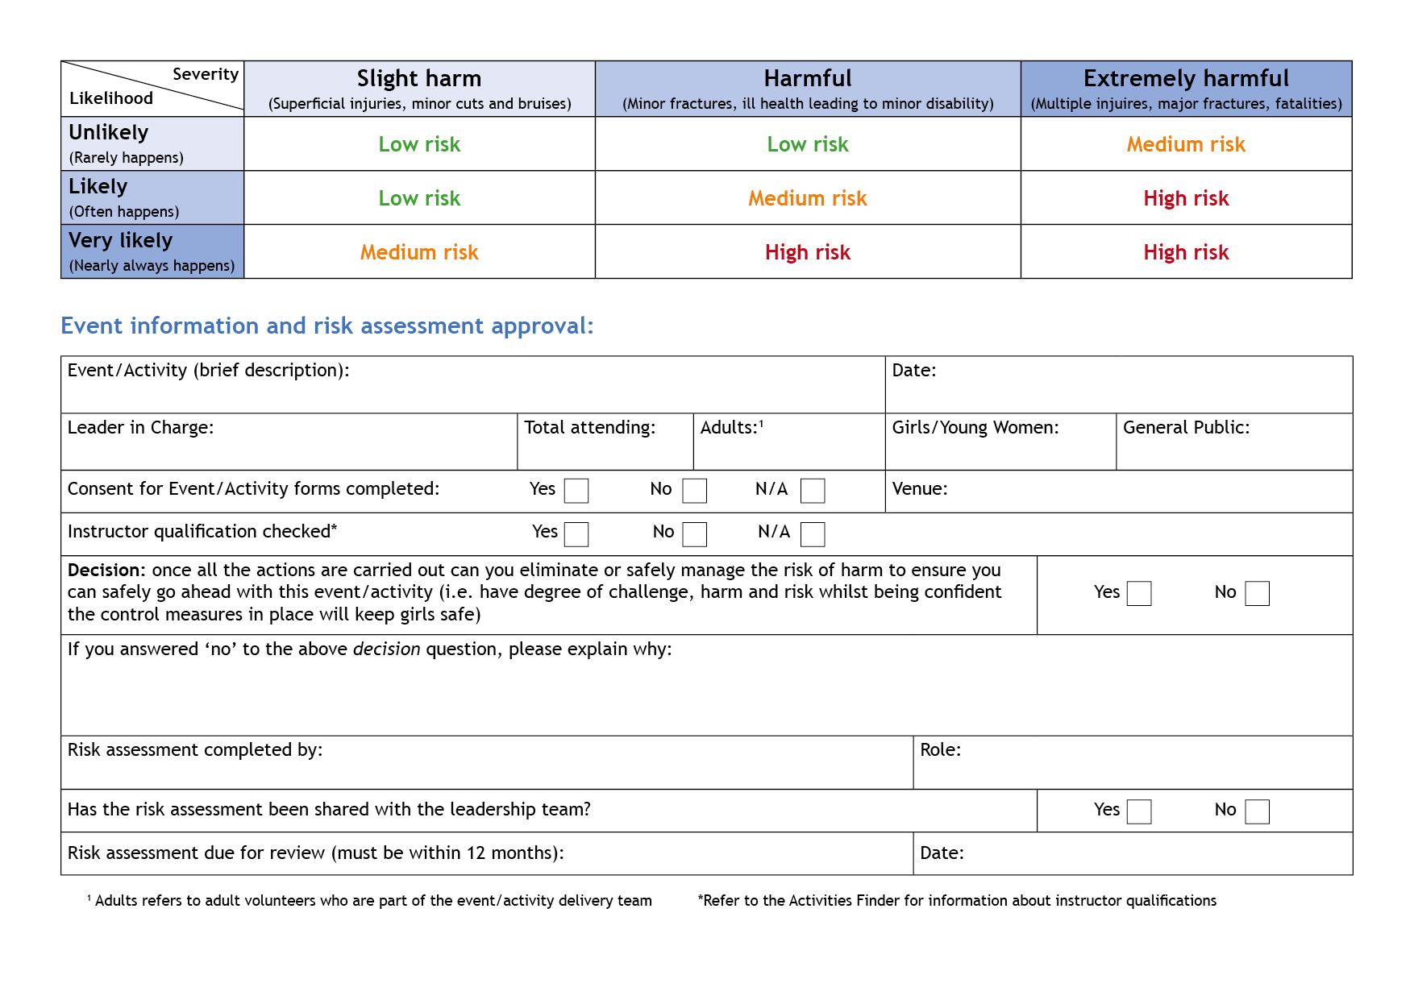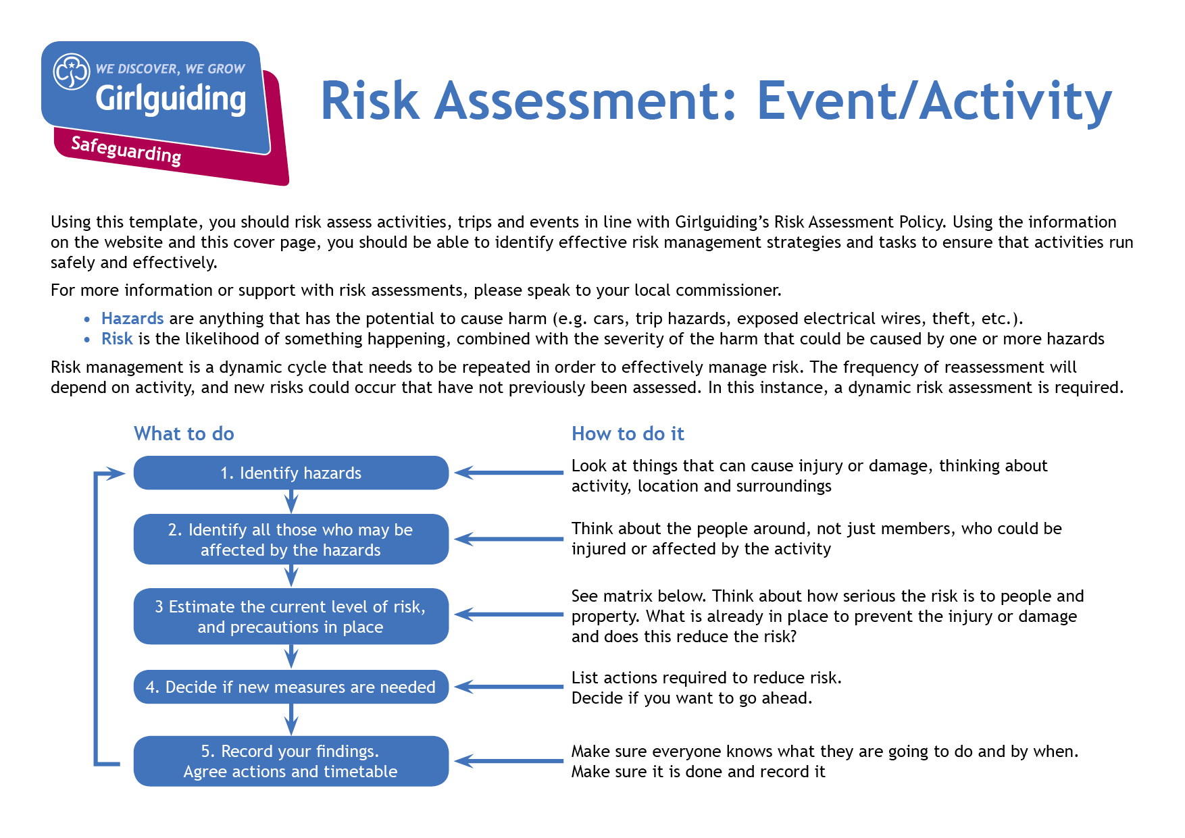

**Ferry Crossing**

| **Hazards**  What could cause harm or damage? | **Who or what is at risk of being affected and how?** | **What are you already doing?**  How have you reduced the risk already? | **Likelihood of risk occurring**  **(L/M/H)** | **Severity of risk**  **(L/M/H)** | **Are further controls necessary?**  What else needs to happen to reduce the risk to an acceptable level? | **Action by:**  name/date |
| --- | --- | --- | --- | --- | --- | --- |
| Ferry travel |  | * Only reputable ferry company will be used * Leaders will ensure that boarding and leaving the ferry is carefully supervised by leaders, and will carry out a head count before / after boarding and leaving * Leaders will explain arrangements for docking, and where / when to meet. * Leaders will be the first and last to enter when boarding and the first and last to exit when leaving * Leaders will closely supervise departure / arrival of girls from / to the coach * Girls will not be allowed onto vehicle deck during journey until time for disembarkation |  |  |  |  |
| Falls from moving ferry |  | * Leaders will brief girls not to go onto sections of the boat that prohibit access * Leaders will not permit girls to go onto open deck area if sea is rough * Emergency procedure in place and leaders will be aware of this |  |  |  |  |
| Safety |  | * Girls briefed before journey as to their responsibilities. * Ensure adequate supervision and ratios * Leaders will establish a specific seating area / meeting point and ensure that a leader is accessible there throughout the crossing * Leaders will ensure that girls read and / or listen to the ship’s official safety instructions and will help explain emergency procedures to the group * Leaders will give / establish clear rules for behaviour and conduct before journey begins and ensure that particular care must be taken on open deck * Leaders will patrol ship at regular intervals to maintain good order and sensible behaviour * Girls will remain in pairs, groups or buddy systems at all times, including visits to toilets / restaurant * If journey overnight, girls will be required to remain in cabins after a set time at night and leaders will patrol to check. * Leaders will have a clear pre-planned procedure for missing girls * If a major emergency occurs, leader will notify a senior member of the ship’s crew immediately * Girls will not be allowed to drink alcohol whilst onboard |  |  |  |  |
|  |  |  |  |  |  |  |

| **Hazards**  What could cause harm or damage? | **Who or what is at risk of being affected and how?** | **What are you already doing?**  How have you reduced the risk already? | **Likelihood of risk occurring**  **(L/M/H)** | **Severity of risk**  **(L/M/H)** | **Are further controls necessary?**  What else needs to happen to reduce the risk to an acceptable level? | **Action by:**  name/date |
| --- | --- | --- | --- | --- | --- | --- |
| Biological Agents |  | * Sick bags / buckets, paper towels and disinfectants should be available in case of sickness. * Members prone to travel sickness should make themselves known to leaders * If medication for travel sickness is taken prior to journey, ensure leaders are aware of this * PPE available for leaders to deal with this |  |  |  |  |
| Boarding and disembarking the ferry |  | • Remain in pairs or threes (buddy system - each responsible for named other)  • Plan arrangements for docking reminding group of numbered stairway  • Careful head count before boarding and disembarkation,  • Planned procedure for missing pupils |  |  |  |  |
| Slips and trips |  | * Remind girls to walk not run, especially on stairs * Trained first aider in leadership team * First aid kit carried by leaders |  |  |  |  |
|  |  |  |  |  |  |  |