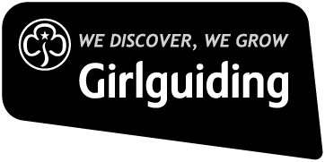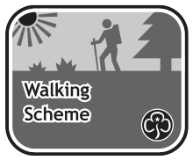

**Discover the great outdoors with Girlguiding’s 2021 Walking Courses**

**Ambleside, Lake District, Cumbria, 10-16 October 2021**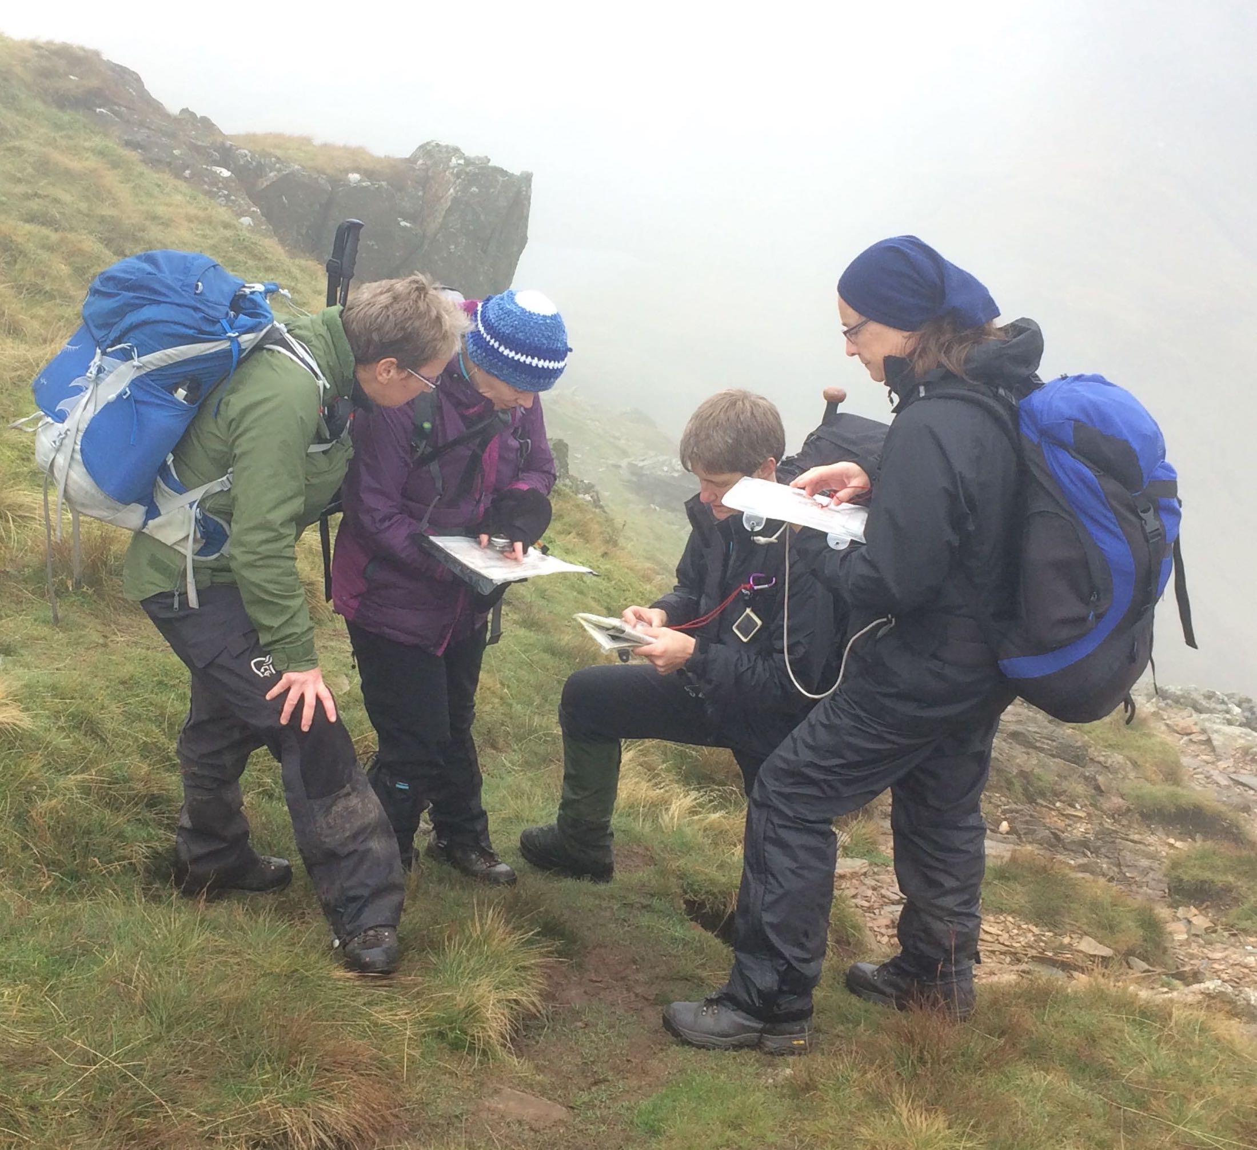

These courses will further develop your skills so that you can lead fun walking activities in more remote areas, that will build girls and young women’s confidence, as well as giving them time out in the open air to think and re-charge. Our courses are open to all Girlguiding members aged 18 and over, who have the relevant walking experience.

**Girlguiding Walking Scheme Level 3 Training Cost:** approx £325

If you are already qualified at Level 2 with further mountain walking experience, this course is a natural next step. However, you do not have to have completed Level 2 to do Level 3 if you already have enough relevant experience.

**Girlguiding Walking Scheme Level 3 Assessment Cost**: approx £350

You must have completed a Girlguiding Level 3 training course or Mountain Leader Award Training course or gained exemption from training. Your logbook must have 20 quality hill walking days in remote and extreme country.

**Mountain Training Hill and Moorland Leader (HML) Assessment Cost:** approx £250

is also open to those with 40 logged quality hill walking days, who have completed HML training or gained MT exemption. This course may be completed on its own (30 hours) or in addition to the Level 3 assessment included in the same overall fee.

**Mountain Training Mountain Leader Award (ML) Training Cost:** approx £450

This course is for those with experience in remote and extreme country who have logged at least 20 quality mountain days.

**Mountain Training Mountain Leader Award (ML) Assessment Cost:** approx £425

This course is for those who have completed Mountain Leader training or have had exemption from such training from MT, and who have logged at least 40 quality mountain days.

**How can I find out more?**

If you have any questions contact [leadership@girlguiding.org.uk](mailto:leadership@girlguiding.org.uk). If you’re unsure whether you have enough experience for any of these courses, please email us a copy of your log book and we will advise you.

**How can I book?**

If you are interested in attending one of the walking courses, please complete this form and send it by **Friday 11 June 2021,** with a copy of your logbook to: [leadership@girlguiding.org.uk](mailto:leadership@girlguiding.org.uk)

Or by post to*:* Sarah Webber, Learning and Development, Girlguiding, 17-19 Buckingham Palace Road, London SW1W 0PT.

Participants should arrive late afternoon **Sunday 10 October 2021** for a meal together and in time for an introduction session that evening. All meals and dormitory accommodation in bunks will be provided and is included in the costs, but you will need to bring your own towel, sleeping bag, pillow case, expedition food (for ML courses), outdoor clothing and equipment. You are expected to cover your own travel costs. Safety equipment will be provided if required.

|  |  |  |
| --- | --- | --- |
| **Courses** | **Cost** | **Course you would like to attend** |
| Girlguiding Level 3 Training course (10-16 Oct) | approx £325 |  |
| Both HML assessment and Girlguiding Level 3 Assessment course (10-16 Oct) | approx £350 |  |
| Girlguiding L3 Assessment course (10-16 Oct) | approx £350 |  |
| Hill and Moorland Leader Award Assessment course (10-13 Oct) | approx £250 |  |
| Mountain Leader Award Training course (10-16 Oct) | approx £450 |  |
| Mountain Leader Award Assessment course (10-15 Oct) | approx £425 |  |

*If you are booking on to the Mountain Leader (ML) training or assessment, or the Hill and Moorland Leader (HML) assessment courses you will also need to register, when requested, a CMS account, for that specific award, with Mountain Training, and also be a Mountaineering Council member .* More information about the Mountain Training courses, registration process and fees can be found here [Mountain Training and Girlguiding](https://www.mountain-training.org/help/girlguiding)

|  |  |
| --- | --- |
| Name: | |
| Girlguiding membership number: | |
| Current Appointment: | |
| Current walking qualification & date gained: | |
| Mobile no: | |
| Email: | |
| Please indicate here if your contact details may be shared with other applicants to assist in communication and lift sharing etc. | Yes / No*  (Please delete as appropriate) |
| Dietary requirements or any additional needs: | |

**Payment**

I enclose a non-refundable deposit of **£50** with this booking form and agree to pay the full amount by **Monday 5st July** (exact costs of the courses will be confirmed once bookings have closed).I understand that if there are not sufficient participants for the course to run my deposit will be refunded.

**If you choose to forfeit your place on any course after Mon 5 July 2020, your fees will be non-refundable unless you are able to find a replacement candidate.**

**Ways to pay**

1. **Cheque** made payable to “Girlguiding” or “The Guide Association”
2. **BACs:** please contact: [leadership@girlguiding.org.uk](mailto:leadership@girlguiding.org.uk) for payment details.

**Bursary**

We are offering a bursary for this year’s courses for those who will use the qualification to take young members into the hills. Applicants can apply for up to 50% of their course cost, and or up to 50% of travel costs. Please contact leadership@girlguiding.org.uk for more 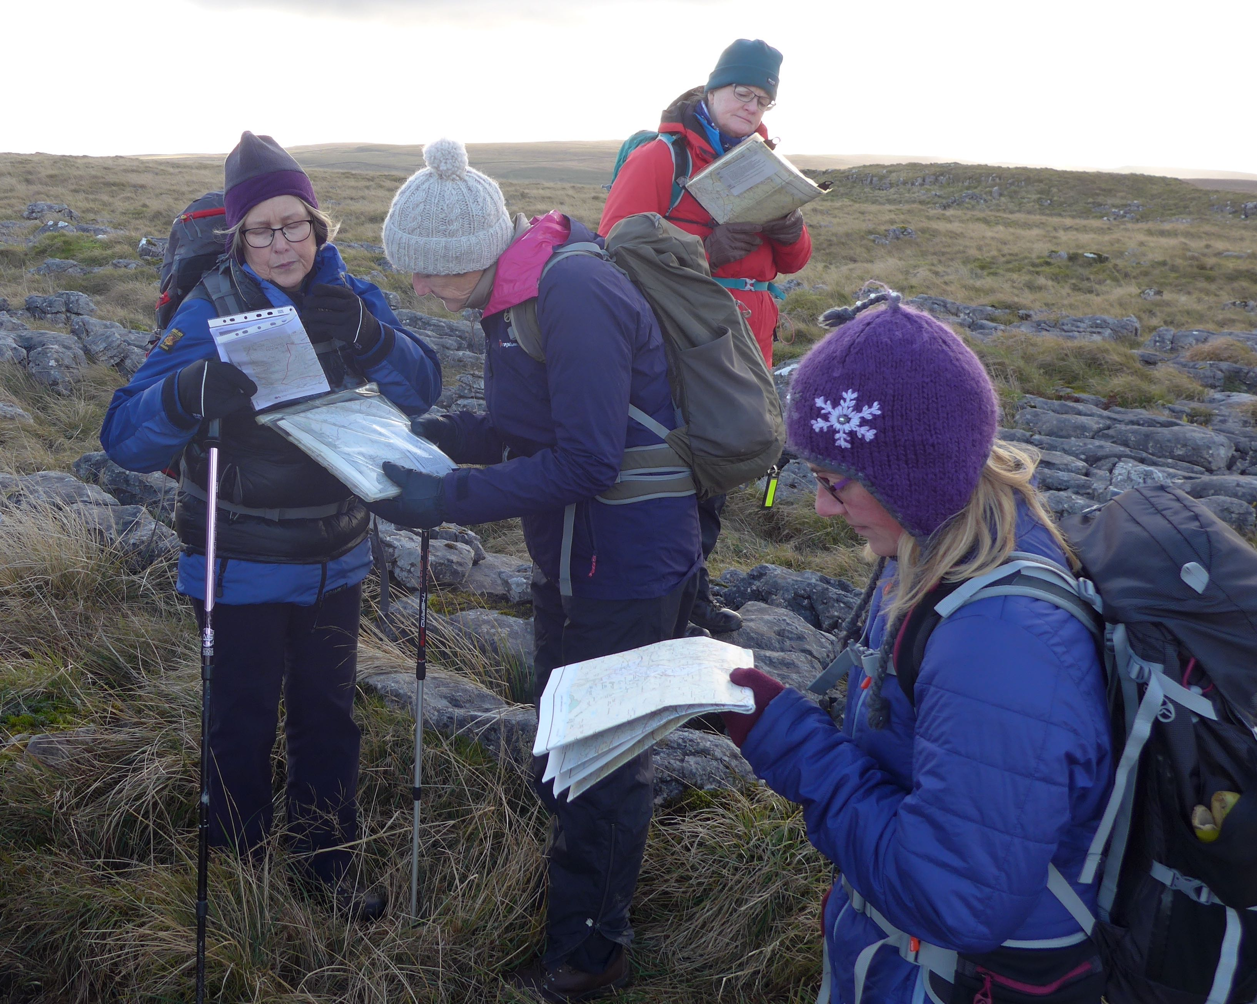information