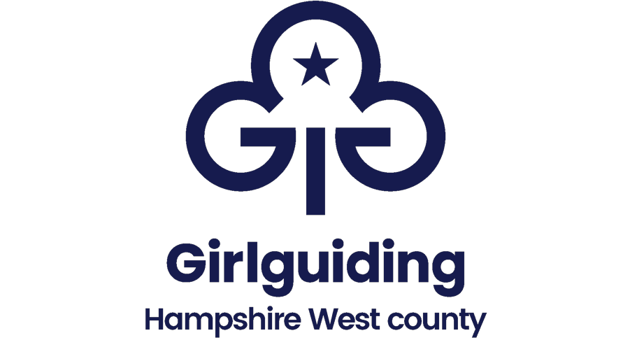
Girlguiding Hampshire West

Accounts Summary
Unit/Level
Unit Leader
Unit Trustees
Name the bank account is held in
Bank/Building Society
Sort Code
Account Number
Signatories and roles
How many signatories needed to sign cheques and online transactions
Who has access to online banking
Online transactions available by who
Debit card | Yes / No
Debit card used by
Financial Year (Month and Year)
End of Year Balance
Person responsible for keeping the accounts
Location of bank documents, cheque books, etc

I confirm that the:
i. Information given above is accurate
ii. Unit accounts have been independently reviewed

Signed by Unit Leader Dated

Upon completion, this form should be returned by the unit leader to the district/division commissioner, together with a copy the unit’s end of year accounts balance sheet, independent reviewer’s checklist and confirmation form, plus budget for the following year.

