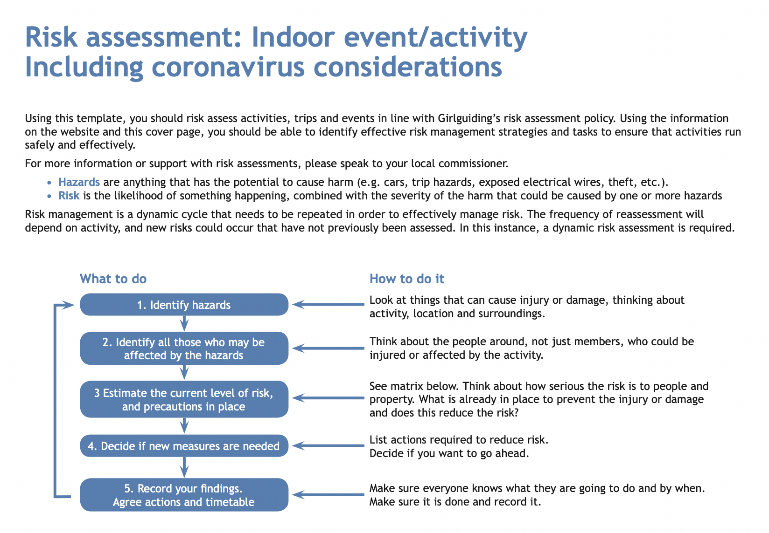
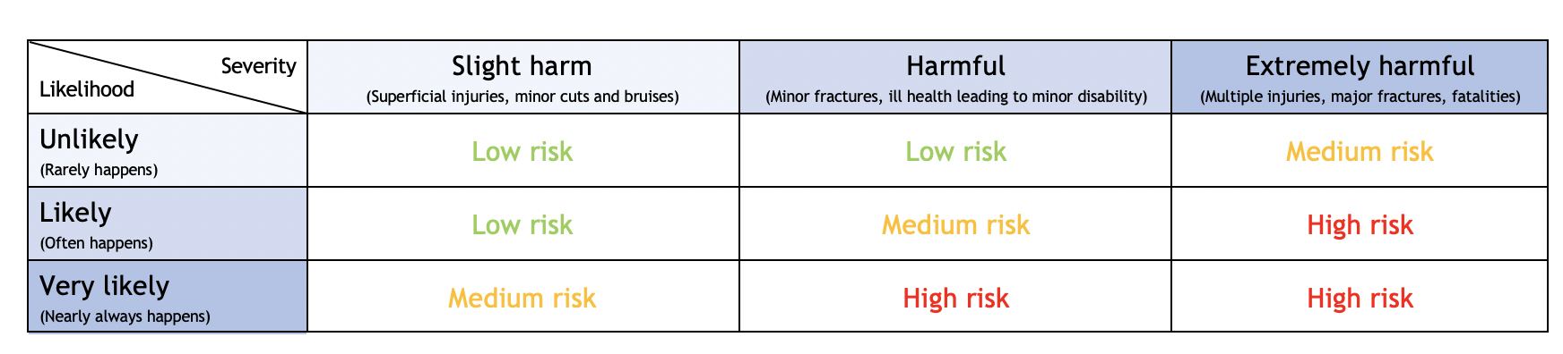
Event information and risk assessment approval:

Name of Unit:

Event/activity (brief description) |  |  |  | Date:
Leader in charge: | Total attending: | Adults :¹ | Girls/young women: |  |  | General public:
Consent for activity/event forms completed please state: Yes / No / N/A |  |  |  | Venue:
Instructor qualification checked* please state: Yes / No / N/A

Decision: once all the actions are carried out, can you eliminate or safely manage the risk of harm to ensure you can safely go ahead with this event/activity? If there is still some challenge or risk, are you still confident the control measures in place will keep girls safe? |  |  |  | Yes No
If you answered no to the above decision question, please explain why:

Risk assessment completed by: |  |  |  | Role:
Has the risk assessment been shared with the leadership team? |  |  |  |  | Yes No
Risk assessment must be reviewed weekly and ongoing with every change to either the meeting plans or government guidance on coronavirus safety measure. |  |  |  | Date: (insert an end date to correspond with the end of the summer term if there are no changes before then).
¹Adults refers to adult volunteers who are part of the event/activity delivery team. * Refer to the activity finder for information about instructor qualifications.
Note to leaders:
We recommend you agree with your approving commissioner/assessing team in advance how long they will need to review your risk assessment. We suggest allowing two weeks as a reasonable amount of time.

Hazards  What could cause harm or damage? | Who or what is at risk of being affected and how? | What are you already doing?  How have you reduced the risk already? | Likelihood of risk occurring (L/M/H) | Severity of risk  (L/M/H) | Are further controls necessary?  What else needs to happen to reduce the risk to an acceptable level? | Action by:  name/date  You must complete this for every action | Guidance notes  Be as specific as you can with the detail that you give in this document. What will you do to reduce the risk of a hazardous event happening?
You should use the examples below as a starting point for your risk assessment – delete those that are not appropriate and add those that are in order to take account of all the likely risks that might be present at your meeting.
Photos or videos being taken of the meeting without permission. | Risk to privacy of members. | Tell young members that this is not allowed, and they will be stopped from attending if they are found doing this.  Check who has given video and photo consent. |  |  |  |  | Remind yourself of digital safeguarding policy.  Make sure that others are also clear about the photography and video rules.
Volunteers posing a risk. | Risk to wellbeing of young members. | Always have at least two adults present.  At least one volunteer should have or be working towards their leadership qualification.  One volunteer must hold A Safe Space Level 3.  Volunteers who require a disclosure check should have one that is up to date. |  |  |  |  | Remind yourself of the recruitment and vetting policy and procedure.  Be clear about what arrangements you have in place to minimize this hazard. For example: Brown Owl and Snowy Owl will be at the meeting by x pm and girls have been told to arrive at y pm. The meeting will not open until both leaders are in place.  Will you have a spare volunteer on hand in case one of the leaders has a problem?
Personal information of volunteer or young members being given out. | Risk to privacy of members. | Do not allow anyone other than volunteers to set up the meeting.  Send emails to members, parents and carers with BCC function. |  |  |  |  | Remind yourself of the managing information policy and procedure.
Coronavirus infection risks (see below).  These must be reduced to an acceptable level. | All attendees are at risk from spread of virus through close contact. |  |  | High |  |  | Make a dynamic risk assessment at the start of every meeting to identify all hazards and move them or take them into account.  Make sure amendments are made to the activity if the hazard cannot be eliminated.
Infection risk from parents. | Crowding at the start and end of a meeting creates a risk of breaching social distancing. | Make sure there is a meeting point with easy access for parents and carers to drop off and collect members while maintaining social distance.  Also make sure there are clear procedures in place to meet and access the venue and for parents and carers to drop off and collect members while maintaining social distance.  Make sure that parents and carers are told in advance about the drop off and pick up plans.  Let the parents/carers know what all the guidelines are for the meetings, so they can explain everything to the girls beforehand. This may help prevent girls from feeling nervous or uncomfortable about a new meeting routine. |  | High | Make sure the information and consent form for the events and activities away from the usual meeting place has been completed and returned before the event.  Have a designated volunteer at the meeting point or door to receive or hand over young members, so that parents and carers don’t need to gather in a group.  Ask parents to check that all contact details on GO are correct.  In all communications to parents and carers clearly state that no girl must attend if she or anyone in the household is showing symptoms of Covid-19.  Write to parents/carers or make use of existing communication channels like WhatsApp group to make sure all parents/carers are familiar with new arrangements. |  | Give clear and precise plans to demonstrate that it is possible to carry out drop off and pick up safely and within social distancing rules.  Consider having additional paper copies of the consent form for members who have not completed it before the meeting, and extra pens in case parents don’t have one.  Put pens and paper in folder or bag and leave for 72 hours before touching or use gloves when handling paperwork.
Close contact between people. |  | Make sure all attendees are aware of social distancing requirements and are able to maintain them.  Choose activities that ensure social distance is easy to maintain, as appropriate.  Ensure ratios are maintained. There must be at least two adults at Rainbows, Brownies and Guides meetings during this time.  Do not exceed maximum numbers allowed in line with government guidance.  Ensure there is a space where anyone who starts to display symptoms of Covid-19 can wait away from the group, to be collected as soon as possible.  Make sure that you check local rules about members, adults and girls moving between tiers/nations if applicable. |  | High | Check government guidance on face coverings and mitigating actions from your activity. Make sure these are followed.  Find out in advance if there are any young members that have not been to school since social distancing has come in. They may be less familiar with guidance, so you will need to watch them more closely.  Avoid face to face or shouting activities. Check local guidance related to singing.  Lay out equipment to maintain social distancing, if applicable.  Share activity plans ahead of meeting so that young members and volunteers can be prepared for the activity.  Consider Covid-19 adjustments for any members with additional needs. Discuss with parents or carers ahead of the meeting and review any individual health or personal care plans. |  | Make sure you make particular reference to face covering requirements for your meeting. State who will be expected to wear them at meetings.  Also, check venue requirements as some indoor areas will expect everybody aged 5+ to wear a face covering whilst indoors or moving between rooms to entrance, exit or toilets.  Parent helpers may be needed to maintain ratios. Put this in the risk assessment and make sure they are fully aware of expectations during this time, including the rules around face covering, social distancing and the risk of self-isolating if someone tests positive.
Close contact between young members and leaders or adult volunteers. |  | Add masks and gloves to the first aid kit, to be worn when administering first aid. |  | High
Sharing equipment. |  | Keep the sharing of equipment to a minimum.  Clean all surfaces or equipment touched by multiple people before and after activity, and wash and sanitise hands after touching shared equipment. |  | High | Ask everyone to bring a small backpack with everything they need in it.  Ensure all personal items like coats and bags are stored in a designated area, and not touching.  Everyone should also bring their own water in a bottle. They should bring a snack if required.
Poor hand hygiene |  | Make sure everyone has clean hands when they arrive.  Have hand sanitizer available and encourage everyone to regularly reapply and always clean hands before and after any contact.  Encourage everyone to bring their own tissues and provide spare tissues. Ensure that all used tissues are thrown away into a bin or disposable rubbish bag, then hands are washed or sanitized. |  | High
Infection of vulnerable members. |  | Ensure you’re aware of any girls or volunteers who have a medical condition which makes them especially vulnerable at this time.  Take necessary precautions or explore alternative ways for them to remain involved without attending in person. |  | High |  |  | Detail management actions to mitigate any risks for vulnerable members and volunteers here.
Participant displays symptoms after meeting, raising concerns that others may have been infected. |  | Make sure parents have given the most up-to-date contact and health details, and that GO is updated accordingly.  Also make sure attendance records are kept for one month after any meeting, in case track and trace is required due to a later suspected case. |  | High |  |  | Are all volunteers aware of the potential impact of self-isolation, as well as the potential for testing positive themselves?
Poor respiratory hygiene. |  | Reinforce the ‘catch it, bin it, kill it’ message.  Encourage everyone to avoid touching their mouth, eyes and nose.  Encourage everyone to bring their own tissues and provide spare tissues. Make sure all used tissues are thrown away into a bin or disposable rubbish bag, then hands are washed or sanitized. |  | High | Bring spare tissues, sanitizer and rubbish bags with you in case the venue runs out or does not provide them
Poor level of cleanliness of hall and equipment, especially after other hirers. | Potential for cross-contamination and passing infection between users. | Check the agreed procedure on what cleaning is required and how it should be done. This should be agreed with the property owner if you hire the space.  Make sure that all members of the group understand their responsibilities to clean before and after use as required.  Report instances where cleaning has not been carried out in accordance with hire agreement to the property management. |  | High | Have your own equipment on hand, in case cleaning has not been completed correctly. This should include gloves and masks.  Bring your own tea towels and other equipment that might increase risk of cross-contamination. Wash these after use.  Disinfect toilets before and after use if required, in agreement with the property contract. |  | Include details of who is responsible for cleaning and when it will be done.  Check if time been left between other user groups before and after your meeting, to be able to clean.  Keep the number of girls using the toilet at any one time to a minimum.
Someone falling ill with Covid-19 symptoms during meeting. | Potential for cross-contamination and passing infection between users. | Follow venue instructions.  Move person to safe area. Call parent, carer or emergency contact to come and collect.  Ensure that all group contact information is accessible for track and trace.  Inform property management committee.  Follow cleaning procedure as set out by property management committee. |  | High | Make sure that first aid kit contains correct PPE equipment.  Ensure that a volunteer adult is present who has 1st response or equivalent training. |  | Detail the extra personal protective equipment that you have available here.
Someone falling ill with Covid-19 symptoms during meeting. | Potential for cross-contamination and passing infection between users. |  |  | High | Share guidance provided by property management ahead of meeting so that leaders and volunteers know what is expected of them. |  | If you are meeting a property that you own or manage have you reviewed the checklist and risk assessment? Visit the website for more information and guidance on managing property during coronavirus.  If you meet in a hired venue you need to review your unit meeting property risk assessment.
Please use the sections below to capture the other hazards and controls at your activity, as you normally would.
Signed by commissioner: |  |  |  | Date:

