[Want to add a local logo to your letter template? Our Online Print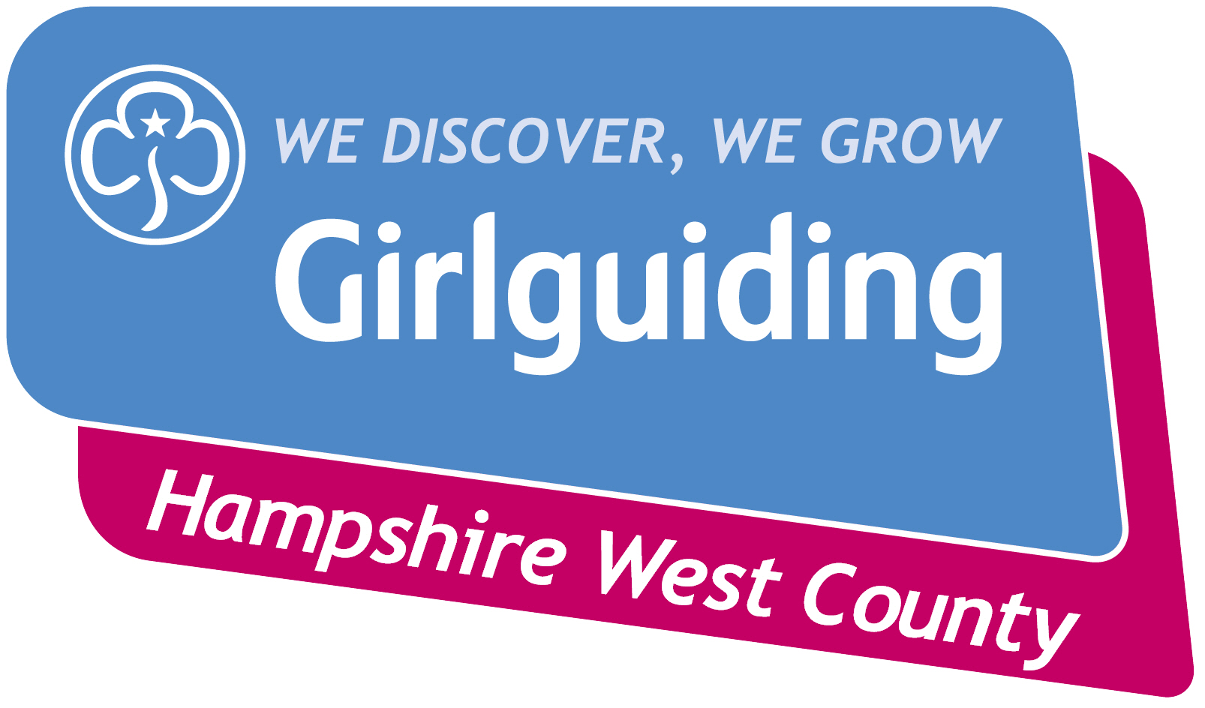 Centre allows you to create an on-brand logo in minutes. You can either create a general Girlguiding logo or a logo for a specific section. Visit the Girlguiding website and search for ‘Create a logo’ to find out more.]

Hi [girl’s name],
Your next adventure awaits
We’ve been so happy to have spent the last [length of time with section] with you and will very much miss you in [section name], but you’re about to start a wonderful new adventure!
[Insert new section Leader’s name] is very excited that you’re joining [insert section name], and is looking forward to meeting you next term and introducing you to all your new guiding friends.
You’ve achieved so much during your time with us – from [insert some of the things that the young member has achieved] to [badges/achievements/qualifications].
We’ve really enjoyed having you as part of our unit, but we know that you’re going to love the next step on your guiding adventure. [insert section] has so many exciting new activities and opportunities to offer you, and so many new friends to introduce you to.
If you want to add some more information you could work with the next section Leader and add: In [section] you will be [insert a few activities the next section up will be doing next term]. [Leader name] will be in touch to tell you more. The new term starts [add month/start date].
Good luck in your next adventure – we can’t wait to find out what you get up to and would love it if you’d come back to our unit to tell us all about your new group soon.
Have fun!
[Leader’s name]

