FFA Striped Bass Tournament RULES

Tournament Dates: 5/19/26 – 10/24/26
- There will be two winners: BOAT and SHORE categories.
- The Tournament “Trophy” Winner will be awarded to the angler with the highest total number of inches for his/her 3 largest fish submitted, and accepted, from SHORE OR BOAT. If from shore then that angler will win both categories.
- All Striped Bass will be CPR (Catch/Photograph/Release) and must be minimum 31inches long to be counted. No commercial catches.
- Fish must be measured from the tip of the lower jaw to the furthest tip of the fish.
- A photo of the fish being measured must be submitted. The pictures must be clear and display the entire fish, plus the legible tape measure lying flat next to the fish.
- A photo submission form must also be submitted for each fish.
- No more than 4 inches of any part of the ruler can be covered by fins.
- No girth measurement is required.
- Round up the overall length by adding an additional ½ inch to allow for lack of angler ability to pinch tail during photo taking. Examples: if ruler shows 36, submission form should be 36.5. If ruler shows 36.5, submission should be 37. If ruler shows 36.25, submission form should 36.75.
- In the event of a tie, the winner will be determined by earliest dates of submission.
- One submission form per fish. Submission forms may be mailed in once per week.

~ ATTENTION ANGLERS ~

Please be sure to fill out your submission forms COMPLETELY before sending them in.
If any information is missing it could change the final standings and may result in you not getting the full credit you deserve...

​*CPR (Catch, Photograph, Release) entries – check your Pictures, if you can’t read the length clearly, if the ruler is not flat next to fish, or if a given area of the ruler has more than 4-inches covered by fins: the entry will be disqualified.

And please get those fish back in the water quickly.

CHECK YOUR MEASUREMENT SLIPS & PICTURES BEFORE SUBMITTING THEM

​

Acceptable Image for Submission
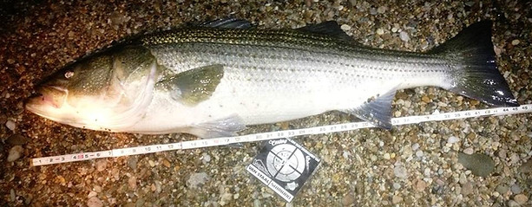

Unacceptable Image for Submission (this image/fish will not be considered)
