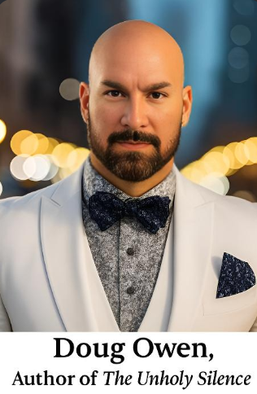

**Doug Owen – Author, Investigator, and Founder of Authentic Haunted**

**Doug Owen** is a renowned non-fiction author, independent paranormal investigator, and the founder of *Authentic Haunted*, a unique venture where he curates and trades rare haunted and allegedly cursed artifacts. Based in Idaho, Doug has spent decades researching and exploring some of America’s most enigmatic and haunted locations, including the infamous ***RMS Queen Mary*** and the ***Winchester Mystery House***. His investigations also reach deep into local Idaho landmarks, where he tirelessly uncovers the mysteries and folklore surrounding these often-overlooked sites.

His critically acclaimed memoir, ***The Unholy Silence*,** offers a **raw and gripping account** of the spiritual warfare that invaded his family’s life in a seemingly ordinary Idaho home. Through immersive storytelling and meticulous research, Doug reveals the chilling realities of **demonic voices, twisted apparitions, and psychological torment**. The book stands as a testament to his relentless pursuit of truth in the face of the supernatural—and the emotional toll such encounters can exact. His second book, ***Thinning the Herd: Americans Under Siege by America***, explores political injustice, media manipulation, and government overreach, expanding his writing into the realms of **civil liberties and constitutional preservation.**

Doug’s dedication to truth extends far beyond the paranormal. A passionate advocate for liberty, transparency, and the Constitution, he uses his voice to challenge propaganda, question unchecked power, and awaken readers to the **often-hidden forces shaping modern life**. He is an independent researcher with an unwavering commitment to justice, inspired by the sacrifices of generations before him and motivated by the desire to secure a freer, more honest future for his children and all Americans. Writing is in Doug’s blood. His grandfather was a reporter for ***The Times*** after World War II and helped edit and author several notable works, including ***Norjack: The Search for D.B. Cooper***. His grandmother was also a reporter, making journalism a cornerstone of his heritage. Doug carried that legacy forward by contributing regularly as the ***Pacific Northwest Reporter for Bank of America Properties***’ corporate newsletter, where he wrote recurring articles on regional developments. Today, he continues to publish his own monthly newsletter, keeping his readers engaged with fresh insights, bold commentary, and firsthand reports from his ongoing investigations.

**Doug Owen** is more than a writer and researcher—he is a multifaceted creator**. A skilled auto mechanic, martial artist, painter, sculptor, and prop maker,** Doug thrives at the intersection of creativity and practicality. His hands-on skills are both a necessity and an expression of his character: adaptive, resourceful, and deeply engaged with the world around him. He has a strong appreciation for craftsmanship, which carries through into his work with haunted artifacts, where history, emotion, and energy converge in the objects he uncovers and curates.

In his downtime, Doug enjoys **drag racing, golfing, and target practice**—activities that mirror his passion for precision, speed, and focus. He is also an **amateur chef** with a love for culinary experimentation and has even considered writing a **future cookbook** to blend his passion for food with his gift for storytelling. Whether he's under the hood of a car, experimenting in the kitchen, or deep in research,

Doug approaches every endeavor with intensity, creativity, and heart.

Above all, Doug is a father of four. His writing is often guided by a profound sense of duty to protect and inform the next generation. Through both his books and his life’s work, Doug Owen invites readers into a world where ***truth*** matters, ***mystery*** is respected and ***courage*** is found in confronting the unknown.

.