Deeded Lot & Coop Properties in Arizona

The following information that was prepared by Horizon in June 2016. Although somewhat dated, it is useful in assessing probable lot sales prices and annual rates of sale.

Summary

Horizon found 16 properties in Arizona that either sell deeded RV lots or sell cooperative memberships (4 properties) with a long-term proprietary lease. These are located throughout the state. Many are older, with only 5 built after 2000. Average listing prices range from a low of $7,250 to a high of $94,000. The overall average of all the properties is $41,200.

Average annual rates of sale on the newer properties range from a low of 3 per year at Arizona Legends in Benson (a troubled project with prices that are too high) to a high of 31.6 at Havasu RV Resort, a successful 398 site project in Lake Havasu City.

Havasu RV Resort and Palms RV Resort are both top rated properties. Desert Gardens is also well rated in spite of gravel roads and sites.

Havasu RV Resort Sales History

Havasu RV Resort, located in Lake Havasu City, consists of 398 sites, 2 clubhouses, is top rated by Good Sam and opened in 2004. There are 3 developer sites remaining for sale (these were subsequently sold as of the date of this report).

Although annual sales since inception have fluctuated, overall sales of developer lots are 31.6 sales per year (395 sales over 12.5 years).

The rate of sale for the last 3 and one half years has been brisk including resale lots, many of which have improvements such as casitas, outdoor kitchens and in some cases, park models.

The average sale price has been in excess of $80,000, but this is skewed by the lots with improvements. Bare lots have sold as low as $35,000. Lots that have sold for $60,000 and less have run from 22% of total sales to 37%.

Methodology:
1. Accessed the Mohave County Assessor site.
2. Went through all 398 lots and identified owner, sale price and date sold.
- Sales data includes both resales and developer lots (no way to distinguish). Developer lots unsold were 11 as of October 2015, currently 3 remaining as of June 1.
- Sale may be a bare lot (all come with 20 x 60 pad), or include casitas and/or park models
- No structure or prior/original sale information on resales is available from the assessor site.
Palms RV Resort

Palms RV Resort, located in Yuma, consists of 453 sites, 1 clubhouse, is top rated by Good Sam and opened in 2008. There are 294 developer sites remaining for sale (as of June 2016).

Although annual sales since inception have fluctuated, overall sales of developer lots are 18.7 sales per year (159 sales over 8.5 years).

The rate of sale slowed significantly after prices increases in 2009 and 2010 and has averaged 12.7 per year over 2013 – 2015.

This development allows stick-built homes which is unique among the comps. 67% of the sold sites have houses (some park models) on them, many of them very nice.

Example of stick-built homes at Palms RV Resort:

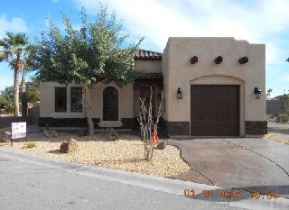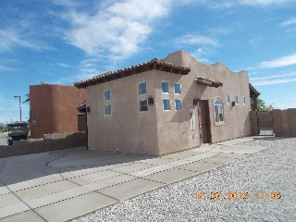
High End Lower End

- 5 pending sales as of June 6th not included in data
- 106 homes on 159 sold lots = 67% of total
- 4 Super Lots (1.5 lot) 291/293 310/312 282/284 317/319 None Sold
Methodology:
1. Identified all sold lots from the PDF map on web site - current as of June 6th 2016.
2. Went through all 159 sold lots on the Yuma County Assessor web site.
3. Identified sale date, sale price, what is on the lot (web site had pictures of each lot) and original sale date and price on resales.
4. A number of houses were included in the lot sales data which raised the average selling price.

Comparable Properties - Arizona
Property Name | Havasu RV Resort | Desert Gardens RV Resort | Caliente Casa Del Sol & Tierra Del Sol
Address | 1905 Victoria Farms Road | 9668 AZ-79 | 3502 N Pinal Pkwy Ave.
City | Lake Havasu City AZ | Florence, AZ | Florence
Web Site | www.havasurvresort.com | www.desertgardensrvpark.com | http://calientecasadesol.com/
Good Sam Rating | 10/10/9.5 | 10/9.5/10 | NA
55+ Age | No | 55+ | 55+
Comments | High end property. Strong amenities. | Gravel roads and sites, beautiful desert setting. | Old RV park property. Mostly park models.
Date Opened | 2004 | @2002 (started selling ’08) | 1971
Number of Sites | 398 | 266 | 857
Form of Ownership | Deeded Lot | Cooperative | Deeded Lot
# Developer Lots Sold | 395 | 186 | All
Average Sales Per Year | 31.6 | 21.9 | NA
Back In Lot Size | 35 x 70 (2450 SF) | 60 x 70 | 35 x 55 (1925 SF)
HOA Dues | $98 per month | $87.50 per month | $50 per month
# Listings | 1 Park Model lot  17 Bare Lots (3 developer)  17 Casita Lots | 80 developer | 8 bare lots (some with small sheds) - Resale
Average Listing Price | $67,116 (bare lots) | $25,300 | $20,548
High Listing Price | $99,900 | $34,000 | $31,500
Low Listing Price | $49,900 | $16,600 | $9,000
Average Price PSF | $24.45 | $8.16 | $10.67
Concrete Pad Size | 20 x 60 | None | Mix of gravel and concrete 10 x 45
Daily Rental Rates | NA | $43 - $64 Peak | NA
Weekly Rental Rates | $300 | $230 - $355 Peak | NA
Monthly Rental Rates | $600 - $850 | $450 - $682 | $350 - $400 by owner
Best 6 Month Rental Rate | $3,600 | $3,117 | $2,100
Annual Rental Rate | NA | NA | NA
# RV Parks 25 Miles  # RV Parks 50 Miles | 24  51 | 31  100 | 31  100
Primary Road | AZ 95 | AZ 79 | AZ 79
Interstate  Distance to Interstate | I-40  20 miles | I-10  28 Miles | I-10  28 Miles
Market Data:  Average Market Home Value - CLR  Average Market Home Rental - Trulia  Livability (Area Vibes)  Amenities (Area Vibes)  Cost of Living  Crime (Area Vibes)  Quality of Life Index  Population (CLR) | $234,752  $1,300  80  A+  103  B  192  52,696 | $133,723  $912  78  B+  86  A  197  17,524 | $133,723  $912  78  B+  86  A  197  17,524
Population 50 miles  Population 100 miles  Population 200 miles | 147,475  288,174  13,981,234 | 2,204,635  5,275,666  6,205,700 | 2,204,635  5,275,666  6,205,700
Key Amenities | Clubhouse (2)  Pool (2)  Outdoor Rec.  Laundry (2) | Clubhouse (1)  Pool (1)  Outdoor Rec.  Nature Trails  Laundry | Clubhouse  Rec Hall  4 swimming pools with hot tubs, showers, bathrooms  Outdoor rec. 7 laundry

Property Name | Arizona Legends RV Resort | Cochise Terrace RV Resort | Sunscape RV Resort
Address | 1915 Casa Del Rio | 1030 S. Barrel Cactus | 1083 E Sunscape Way
City | Benson, AZ | Benson, AZ | Casa Grande
Web Site | http://arizonalegendsrv.com/ | www.cochiseterrace.com | www.sunscapervresort.com
Good Sam Rating | NA | 9.5/9.5/9 | 10/9.0/9.0
55+ Age | 55+ | No | 55+
Comments | Nice view. Problems with delayed clubhouse. Over-priced lots have hurt sales. | Nice property. 2 RV deeded lot sections, 1 manufactured home section and a public RV rental section. | Mostly park models. Reasonably nice facility. Escapees Park.
Date Opened | 2007 | 1997 (Snowbird Hill 75 sites started selling Feb 2015) | @1996
Number of Sites | 200 | 308 (150 deeded RV lots) | 504
Form of Ownership | Deeded RV lots | Deeded RV lots | Cooperative
# Developer Lots Sold | 27 | 14 out of 75 Snowbird Hill | 479
Average Sales Per Year | 3 | 16 | 24
Back In Lot Size | 35 x 75 (3118 SF listed lots) | 40 x 50 | 35 x 65
HOA Dues | $675 annual | $250 annual plus $300 Facilities fee | NA
# Listings | 173 - developer | 52 – developer Snowbird Hill | 11 - resale
Average Listing Price | $52,455 | $26,383 | $23,045
High Listing Price | $75,000 | $32,500 | $35,500
Low Listing Price | $17,000 | $23,500 | $17,500
Average Price PSF | $17.10 | $10.71 | $9.93
Concrete Pad Size | NA | NA | Varies - 10 x 40 common
Daily Rental Rates | NA | $ 41 Winter | $35 Winter
Weekly Rental Rates | NA | $246 Winter | $185 Winter
Monthly Rental Rates | $400 lease to purchase | $458 Winter | $350 Winter
Best 6 Month Rental Rate | $2,400 | $2,982 (7 mo. plus 5 storage) | $2,100
Annual Rental Rate | NA | NA | NA
# RV Parks 25 Miles  # RV Parks 50 Miles | 16  54 | 16  54 | 19  92
Primary Road | I-10 | I-10 | I-10
Interstate  Distance to Interstate | I-10  Close | I-10  Close | I-10  Close
Market Data:  Average Market Home Value - CLR  Average Market Home Rental - Trulia  Livability (Area Vibes)  Amenities (Area Vibes)  Cost of Living (Area Vibes)  Crime (Area Vibes)  Quality of Life (CLR Search)  Population (CLR) | $97,442  $900  77  A  85  D+  196  4,622 | $97,442  $900  77  A  85  D+  196  4,622 | $154,819  $1,045  78  A  88  D+  197  50312
Population 50 miles  Population 100 miles  Population 200 miles | 934,336  1,297,076  5,632,961 | 934,336  1,297,076  5,632,961 | 2,551,461  5,240,118  6,168,915
Key Amenities | Clubhouse  Pool/Hot Tub | Rec Hall  Pool/Hot Tub  Outdoor Rec. | Rec Hall  Pool  Outdoor Rec.  Nature Trails

Property Name | Happy Trails RV Resort | Villages at Lynx Creek | Copper Ridge RV Development
Address | 17200 W Bell Rd | 12200 E State Route 69 | 10375 Sidewinder Trail
City | Surprise, AZ | Prescott Valley, AZ | Wellton, AZ
Web Site | www.htresort.com | http://www.villagesatlynxcreek.com/ | http://copperridgerv.com/
Good Sam Rating | NA | NA | NA
55+ Age | 55+ | 55+ | No
Comments | Mostly park models & other structures - built around a golf course. Huge development. | Mostly park models - Built along a golf course. | No amenities. 5,500 SF lots surrounded by a Mexican wall. RV’s, park models and stick built home allowed.
Date Opened | 1986 | 1980’s | 2007
Number of Sites | 2,373 | 454 | 101
Form of Ownership | Deeded lot | Deeded lot | Deed lot
# Developer Lots Sold | All | All | 50
Average Sales Per Year | NA | NA | 5.3
Back In Lot Size | 42 x 65 | 42 x 50 | 5,500 SF
HOA Dues | $134 mo. | $114 mo. | None
# Listings | 19 – resale | 1 - resale | 51 - developer
Average Listing Price | $58,539 | $42,000 | $31,461
High Listing Price | $68,950 | $42,000 | $38,500
Low Listing Price | $39,000 | $42,000 | $29,500
Average Price PSF | $20.18 | $20.00 | $5.42
Concrete Pad Size | Mixed - either patios or full pads | Concrete Pads 15 x 35 | Gravel sites with a Mexican wall
Daily Rental Rates | $55 | NA | None
Weekly Rental Rates | $325 | NA | None
Monthly Rental Rates | $800 | By owner | None
Best 6 Month Rental Rate | $3,600 | By Owner | None
Annual Rental Rate | NA | NA | None
# RV Parks 25 Miles  # RV Parks 50 Miles | 24  91 | 19  46 | 28  45
Primary Road | AZ 303 | AZ 69 | I-8
Interstate  Distance to Interstate | I-10  14 Miles | I-17  34 Miles | I-8  1 Mile
Market Data:  Average Market Home Value - CLR  Average Market Home Rental - Trulia  Livability (Area Vibes)  Amenities (Area Vibes)  Cost of Living (Area Vibes)  Crime (Area Vibes)  Quality of Life (CLR Search)  Population (CLR) | $243,266  $1,045  82  A  100  A  197  121,189 | $195,612  $1,300  78  B  95  B  197  32,742 | $101,198  $831  74  D+  88  A+  197  1,807
Population 50 miles  Population 100 miles  Population 200 miles | 3,876,096  4,439,147  6,467,247 | 225,244  4,141,013  8,093,665 | 200,544  412,191  10,682,208

Property Name | North Ranch RV Resort | Golden Vista RV Resort | Palms RV Resort
Address | 30625 Hwy 89 | 3710 S Goldfield Rd | 3400 S Ave 7th E
City | Congress, AZ | Apache Junction, AZ | Yuma
Web Site | https://www.escapees.com/parking/rainbow-parks/congress-arizona | http://www.gvrv.us/index.htm | www.yumapalmsrvresort.com
Good Sam Rating | 6.5/8.5/9.0 | NA | 10/10/10
55+ Age | 55+ | 55+ | 55+
Comments | Escapee Rainbow Park. Mixed RV and Park Models. Very basic property. | Mostly park models. A complete and nice property. | Newer development that allows RV’s. park models and stick built homes.
Date Opened | 1980’s | 1984 (started selling in 1995) | 2008
Number of Sites | 111 RV Sites for rent, @400 total | 1,075 | 453
Form of Ownership | Cooperative | Deeded RV Lots | Deeded RV Lots
# Developer Lots Sold | All | All | 159
Average Sales Per Year | NA | NA | 18.7
Back In Lot Size | 35 x 50 to 50 x 80 | 35 x 48 | 35 x 70 - 40 x 70
HOA Dues | NA | $145 mo. | $198 mo.
# Listings | 3 - Resale | 10 - Resale | 294 - developer
Average Listing Price | $48,500 | $32,450 | $94,000
High Listing Price | $50,000 | $58,000 | $139,900
Low Listing Price | $47,500 | $25,000 | $79,900
Average Price PSF | $15.16 | $19.32 | $35.64
Concrete Pad Size | Mostly Gravel | 20 x 40 | 12 x 55 Concrete patio
Daily Rental Rates | $26.50 | $35.00 | 29.95 - $44 (peak season)
Weekly Rental Rates | $159.00 | $240.00 | $105 - $280 (peak season)
Monthly Rental Rates | $395.00 | $500 - 550 (3 - 4-month min) | $681 - $999 (peak season)
Best 6 Month Rental Rate | $2,370 | $2,950 (annual) | $3,580
Annual Rental Rate | NA | $2,950 | NA
# RV Parks 25 Miles  # RV Parks 50 Miles | 4  34 | 66  107 | 39  43
Primary Road | AZ 89 | AZ60 | I-8
Interstate  Distance to Interstate | I-17  54 Miles | I-10  28 Miles | I-8  Close
Market Data:  Average Market Home Value - CLR  Average Market Home Rental - Trulia  Livability (Area Vibes)  Amenities (Area Vibes)  Cost of Living (Area Vibes)  Crime (Area Vibes)  Quality of Life (CLR Search)  Population (CLR) | $242,037  $1,850  74  F  84  B+  197  94 | $120,691  $1,050  78  A  84  C+  197  39,888 | $167,125  $1,000  74  A  101  D  197  93,677
Population 50 miles  Population 100 miles  Population 200 miles | 510,742  4,363,815  8,402,319 | 3,977,788  5,315,341  6,321,190 | 218,144  430,971  13,062,393
Key Amenities | Clubhouse  Some outdoor rec.  Nature Trails | Clubhouse/Ballroom  Pool  Outdoor Rec.  Activity buildings | Clubhouse  Pool/spas (2)  Outdoor rec.  Tennis/Pickleball Courts

Property Name | Country Roads RV Park | Wagons West RV Park | Greenfield Village Resort
Address | 5707 E. 32nd St. | 801 W Limberlost Dr. | 111 S Greenfield RD
City | Yuma, AZ | Tucson, AZ | Mesa, AZ
Web Site | http://www.countryroadsyuma.com/ | http://www.wagonswestrvpark.net/ | http://www.greenfieldvillage.com
Good Sam Rating | NA | NA | NA
55+ Age | 55+ | 55+ | 55+
Comments | Mostly park models. A very large and complete property. | Mostly park models. Old and dated property, very budget. | Mostly park models. Large, decent amenities, small sites.
Date Opened | 1985 | Over 30 years old | 1980’s
Number of Sites | 1,294 | 215 | 792
Form of Ownership | Deeded lot | Cooperative | Deeded lots
# Developer Lots Sold | All | All | All
Average Sales Per Year | NA | NA | NA
Back In Lot Size | 40 x 60 | 40 x 60 | 30 x 70
HOA Dues | $170 per month | $1,650 annual | $1,968 annual
# Listings | 18 - Resale | 10 – Resale | 10 - Resale
Average Listing Price | $46,661 | $7,250 | $45,580
High Listing Price | $55,000 | $12,500 | $60,000
Low Listing Price | $35,000 | $2,500 | $34,900
Average Price PSF | $19.20 | $3.02 | $21.70
Concrete Pad Size | 16 x 40 | 10 x 20 | 15 x 65
Daily Rental Rates | $55 | $30.88 | NA
Weekly Rental Rates | $320 | $186.22 | NA
Monthly Rental Rates | $785 | $525 | $500 – 3 mo. minimum
Best 6 Month Rental Rate | $3,510 | $3,150 | $3,000
Annual Rental Rate | $4,320 | NA | NA
# RV Parks 25 Miles  # RV Parks 50 Miles | 39  43 | 26  43 | 72  117
Primary Road | I-8 | I-10 | AZ60
Interstate  Distance to Interstate | I-8  Close | I-10  Close | I-10  17 Miles
Market Data:  Average Market Home Value - CLR  Average Market Home Rental - Trulia  Livability (Area Vibes)  Amenities (Area Vibes)  Cost of Living (Area Vibes)  Crime (Area Vibes)  Quality of Life (CLR Search)  Population (CLR) | $167,125  $1,000  74  A  101  D  197  93,677 | $177,035  $1,125  78  A+  97  D  196  523,642 | $210,247  $1,300  81  A+  93  D+  197  447,589
Population 50 miles  Population 100 miles  Population 200 miles | 218,144  430,971  13,062,393 | 1,017,607  2,746,895  5,811,756 | 4,133,215  5,055,543  6,338,358
Key Amenities | Clubhouse  Restaurant  Pool/Spa (5)  Outdoor Rec.  Activities Rooms | Rec. Hall  Covered Pool/Spa | Clubhouse  Pool  Outdoor Rec.  Activities Rooms

Property Name | Juniper Ridge RV Resort
Address | 1911 Juniper Ridge Dr
City | Show Low, AZ
Web Site | www.juniperridgeresort.com
Good Sam Rating | NA
55+ Age | 55+
Comments | Very nice clubhouse/recreational complex. Built along a golf course. Mostly park models.
Date Opened | Early 1990’s
Number of Sites | 528
Form of Ownership | Deeded Lot
# Developer Lots Sold | All
Average Sales Per Year | NA
Back In Lot Size | 40 x 65
HOA Dues | $458 Qtr.
# Listings | 18 - Resale
Average Listing Price | $38,261
High Listing Price | $66,000
Low Listing Price | $22,000
Average Price PSF | $14.72
Concrete Pad Size | 6 x 20
Daily Rental Rates | $32
Weekly Rental Rates | $125 - $192
Monthly Rental Rates | $450 - $650
Best 6 Month Rental Rate | $2,250
Annual Rental Rate | $2,400
# RV Parks 25 Miles  # RV Parks 50 Miles | 8  23
Primary Road | AZ60
Interstate  Distance to Interstate | I-40  48 Miles
Market Data:  Average Market Home Value - CLR  Average Market Home Rental - Trulia  Livability (Area Vibes)  Amenities (Area Vibes)  Cost of Living (Area Vibes)  Crime (Area Vibes)  Quality of Life (CLR Search)  Population (CLR) | $180,301  $1,200  76  A  92  D+  146  9,962
Population 50 miles  Population 100 miles  Population 200 miles | 81,384  228,763  6,488,404
Key Amenities | Clubhouse  Pool/Spa  Outdoor Rec.  Golf Course

Havasu RV Resort

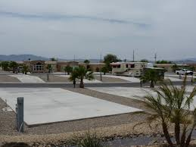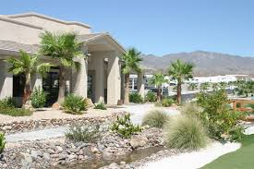

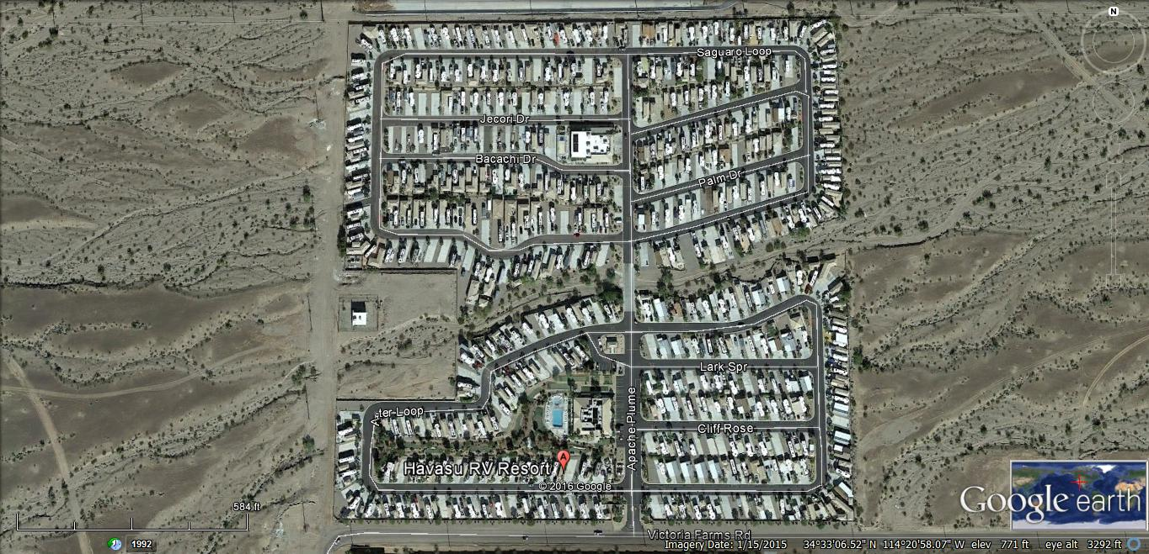

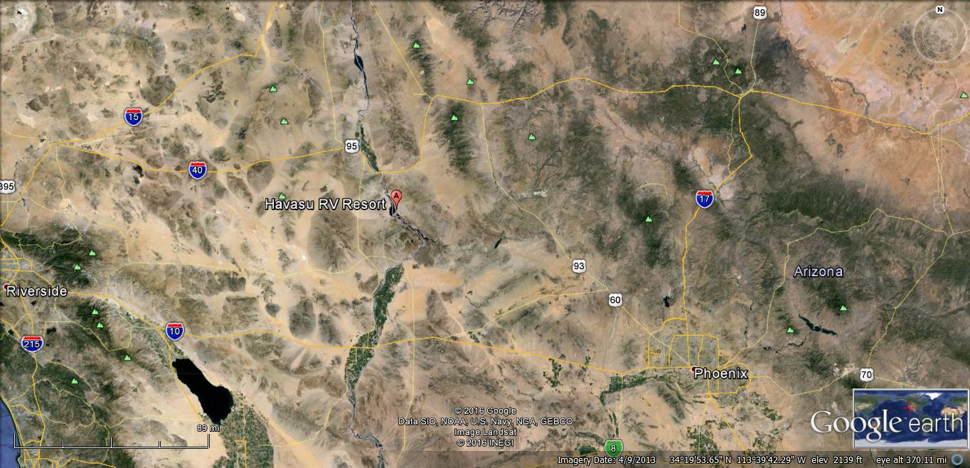

Desert Gardens RV Resort

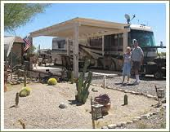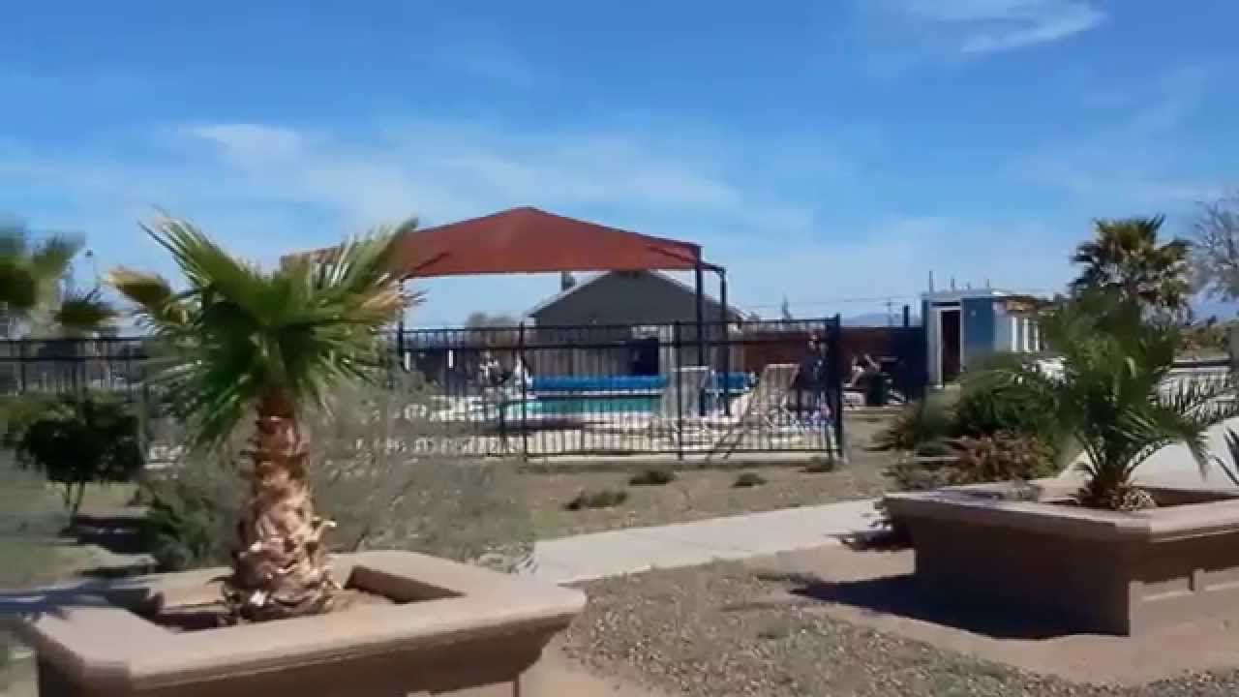

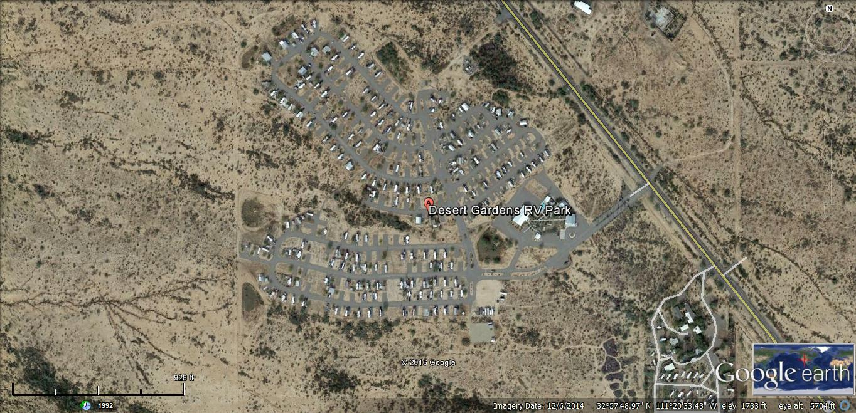

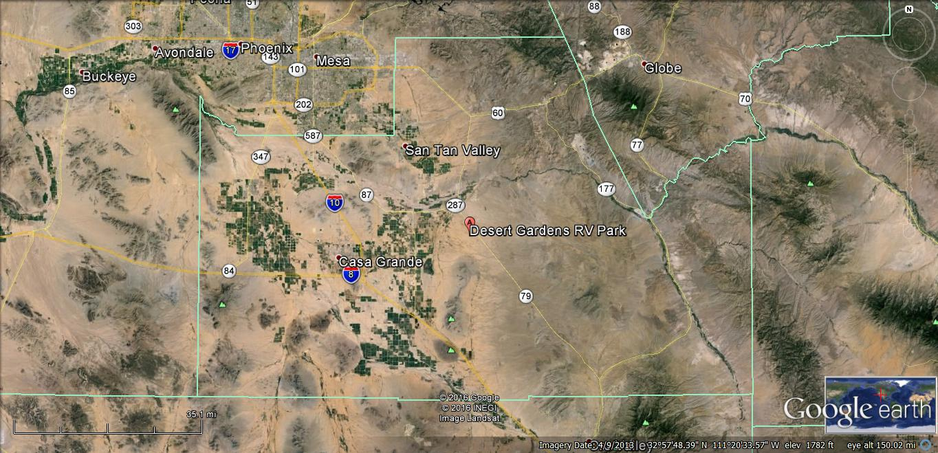

Caliente Casa Del Sol & Tierra Del Sol

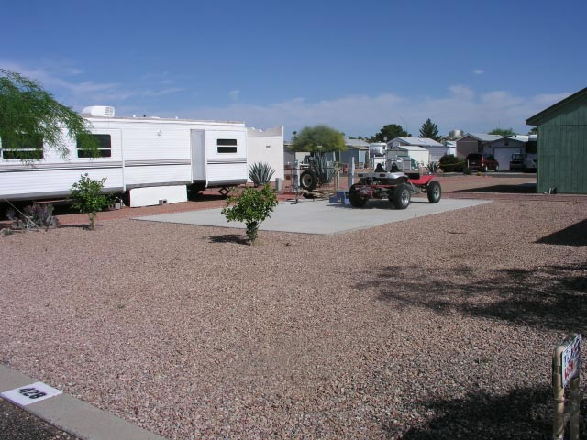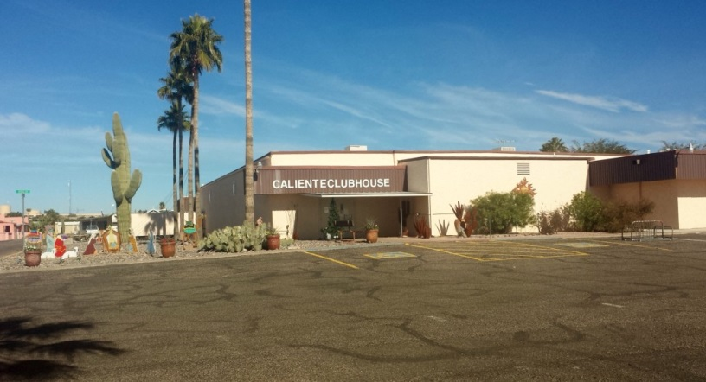

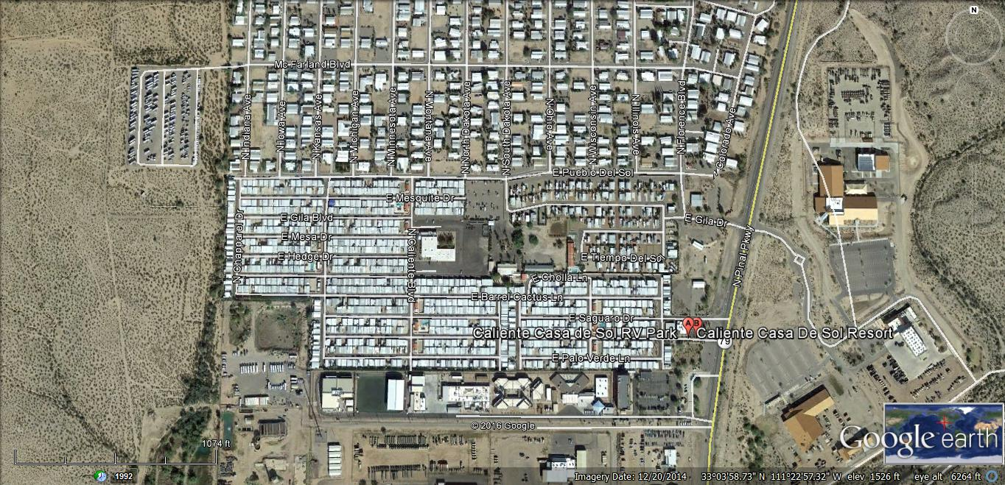

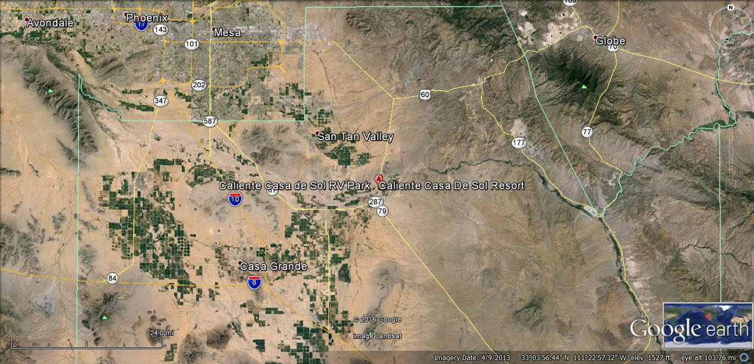

Arizona Legends RV Resort

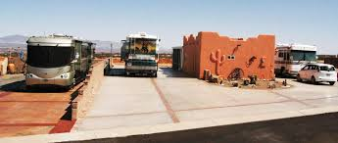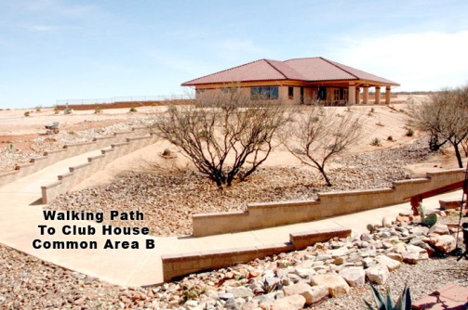

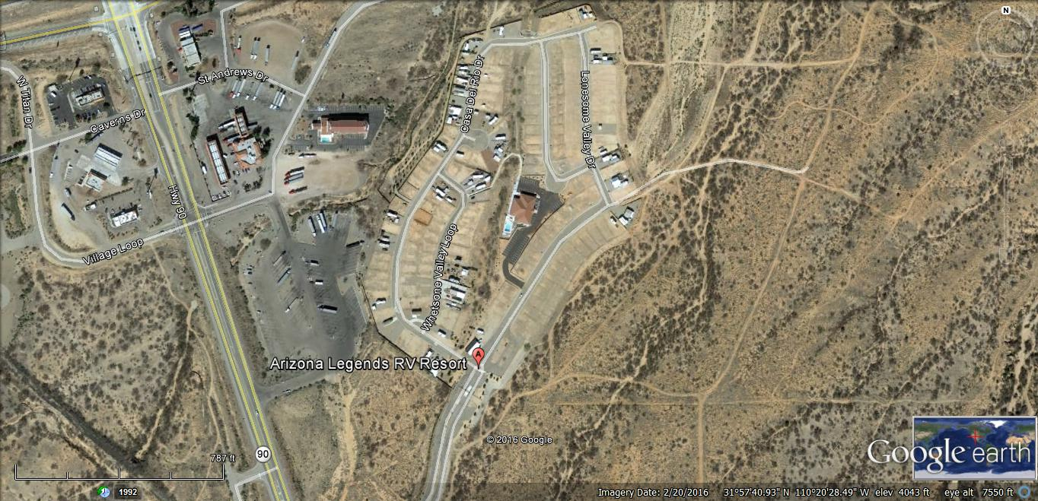

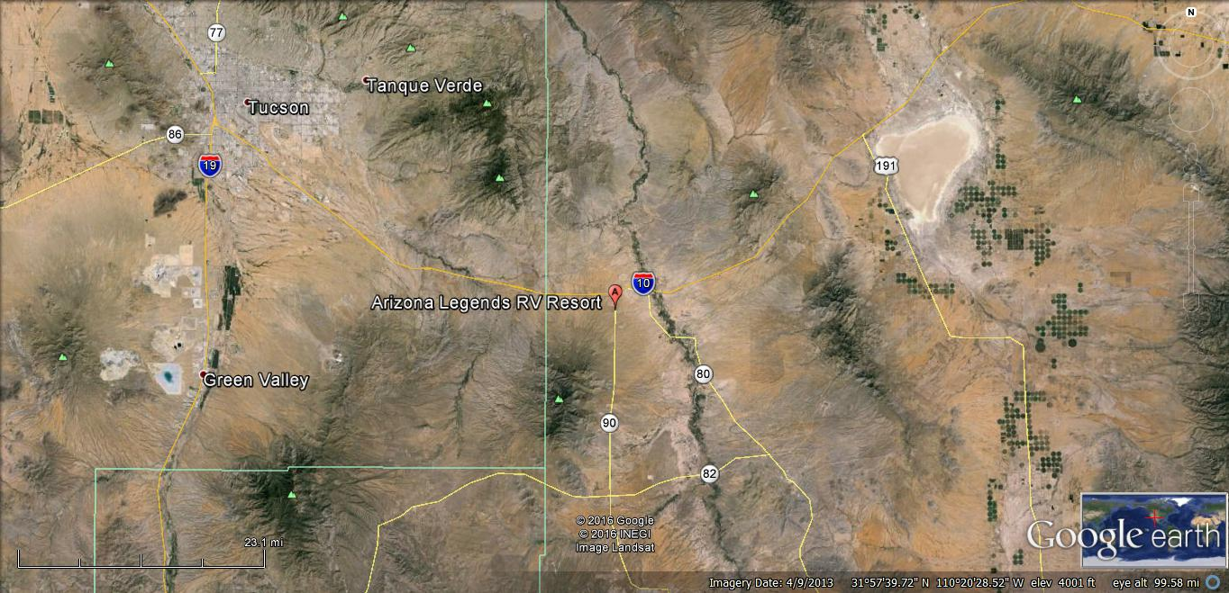

Cochise Terrace RV Resort

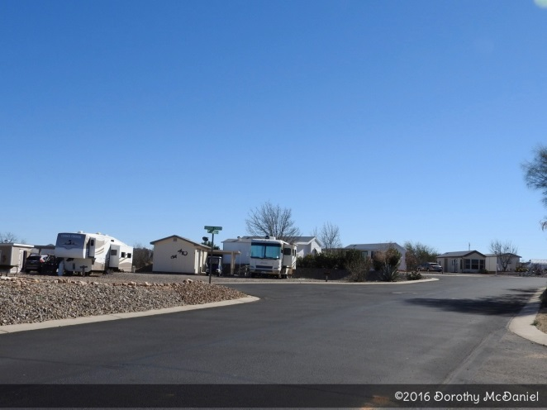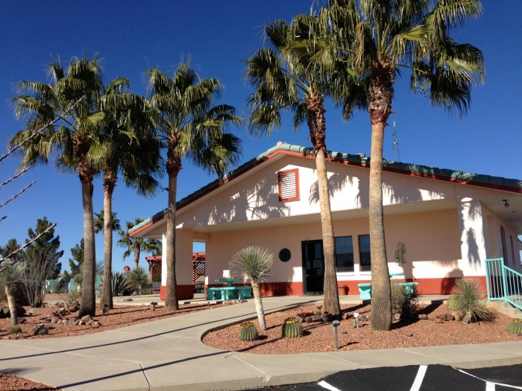

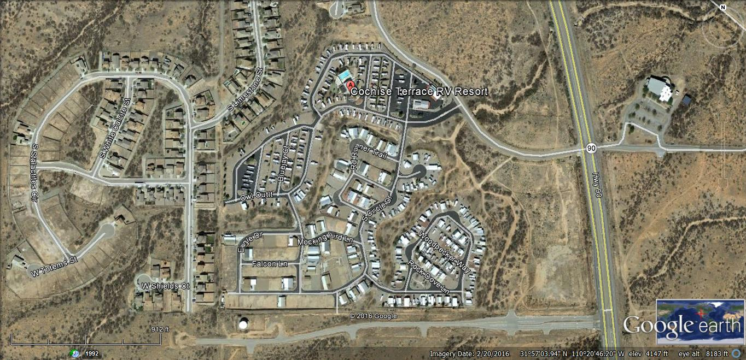

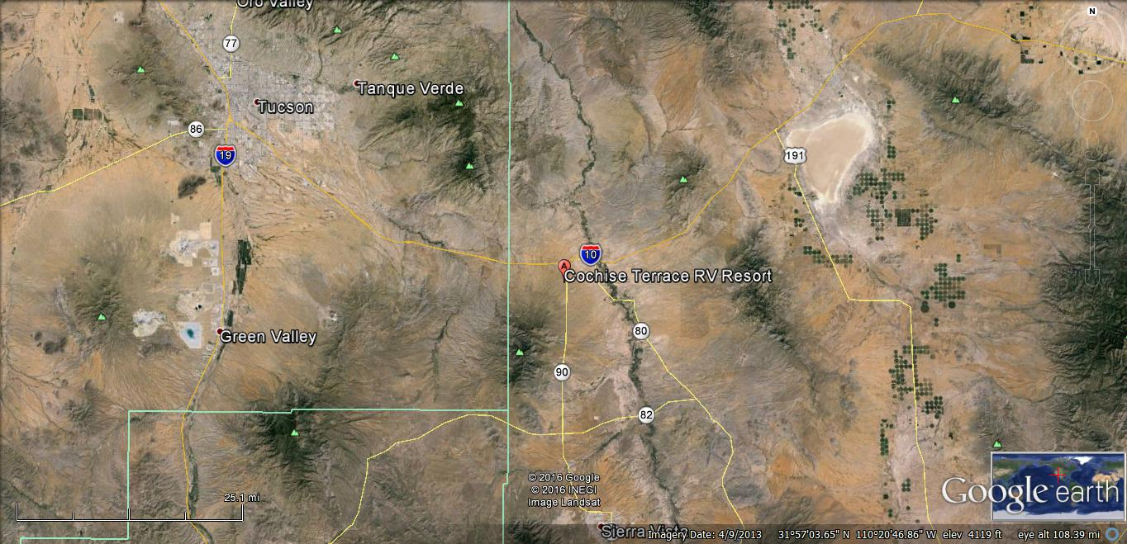
Sunscape RV Resort

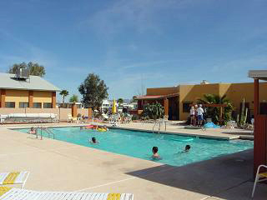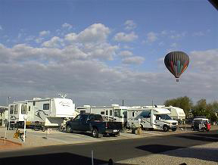

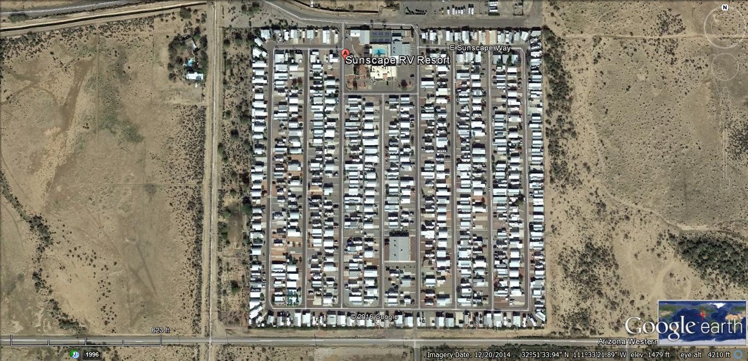

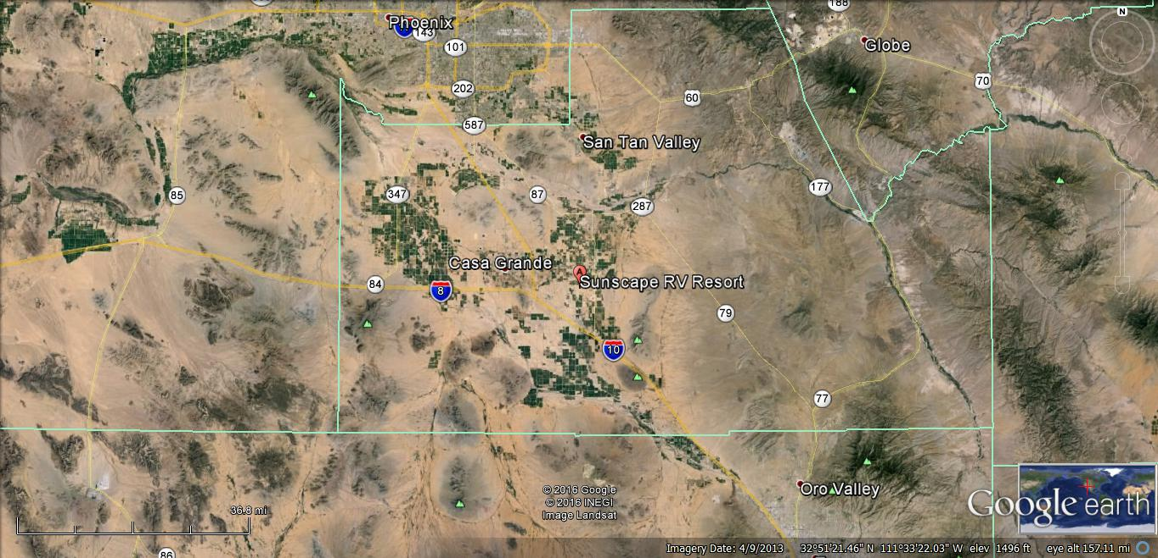
Happy Trails RV Resort

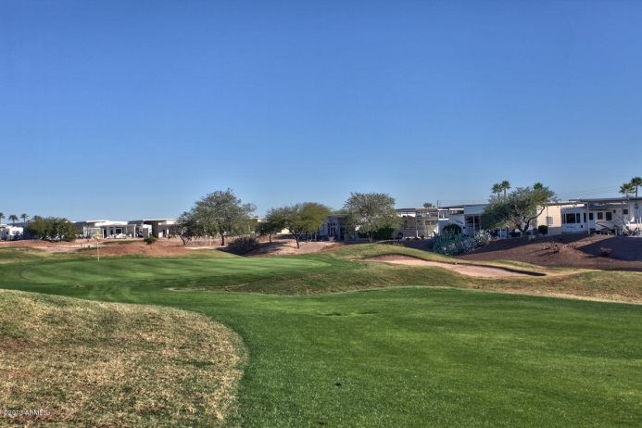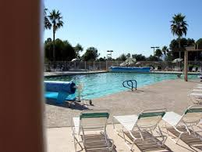

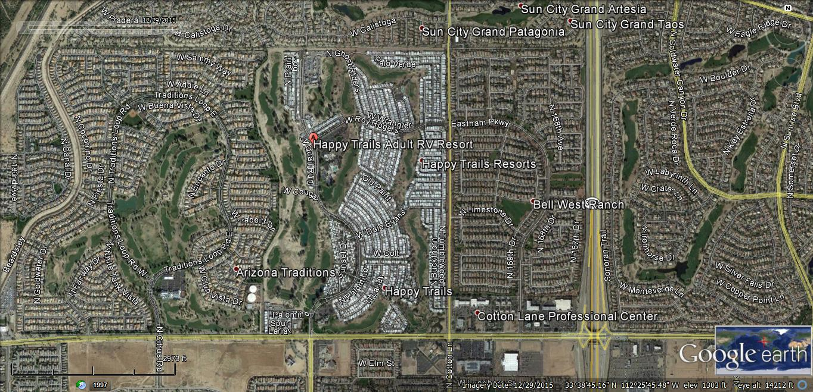

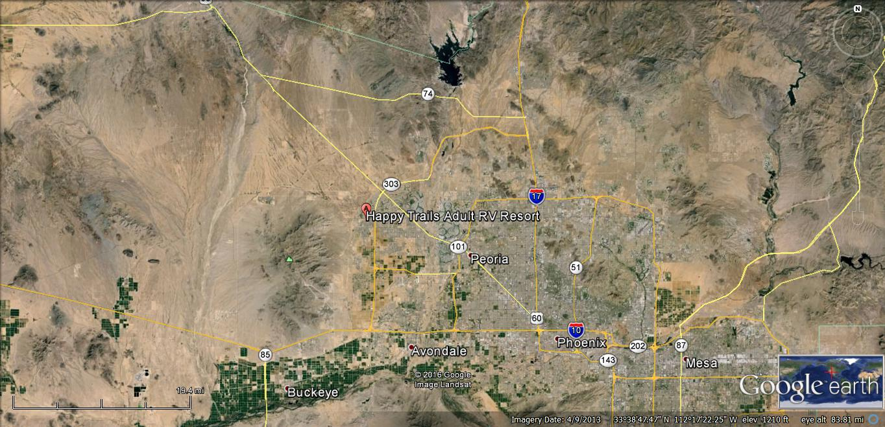
Villages at Lynx Creek

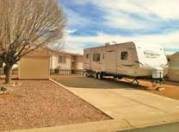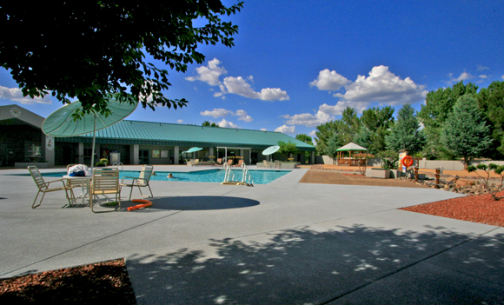

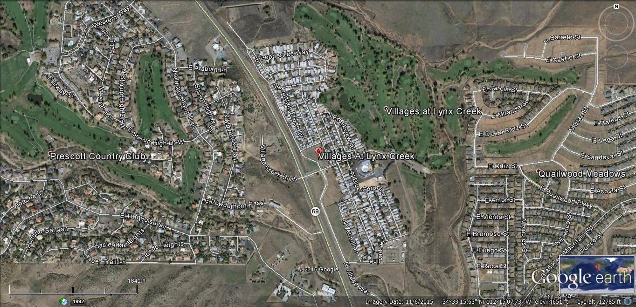

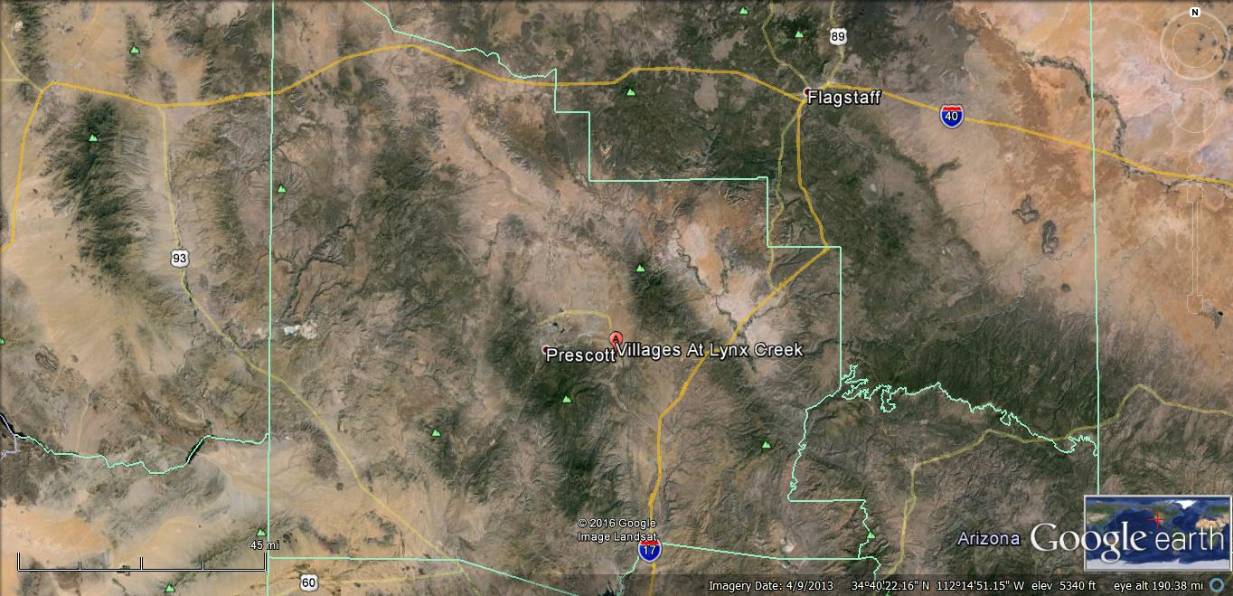
Copper Ridge

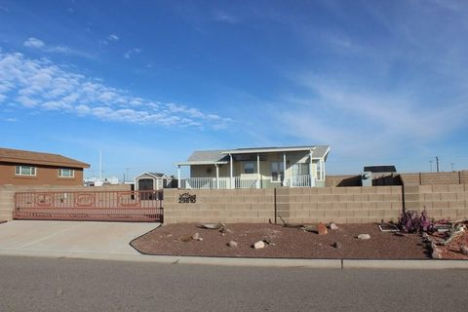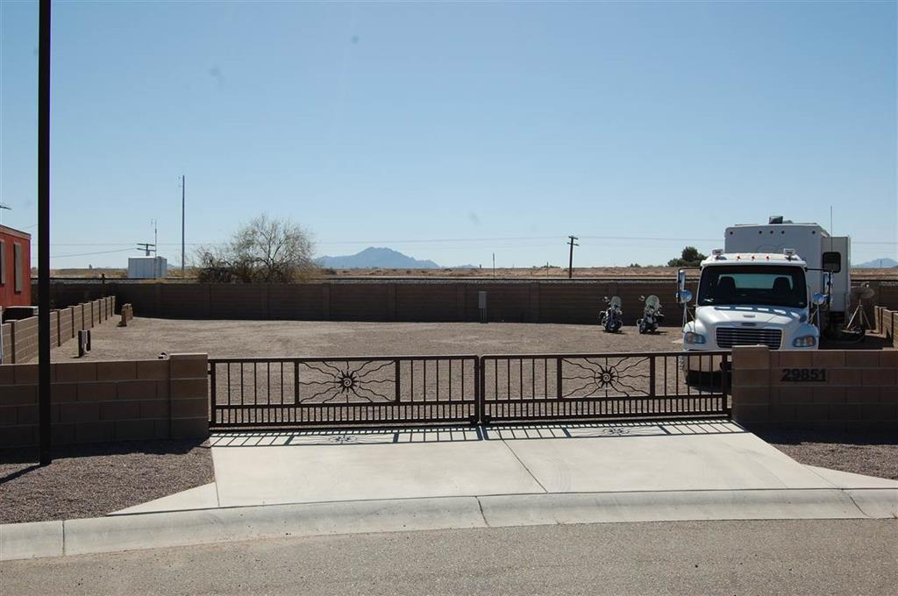

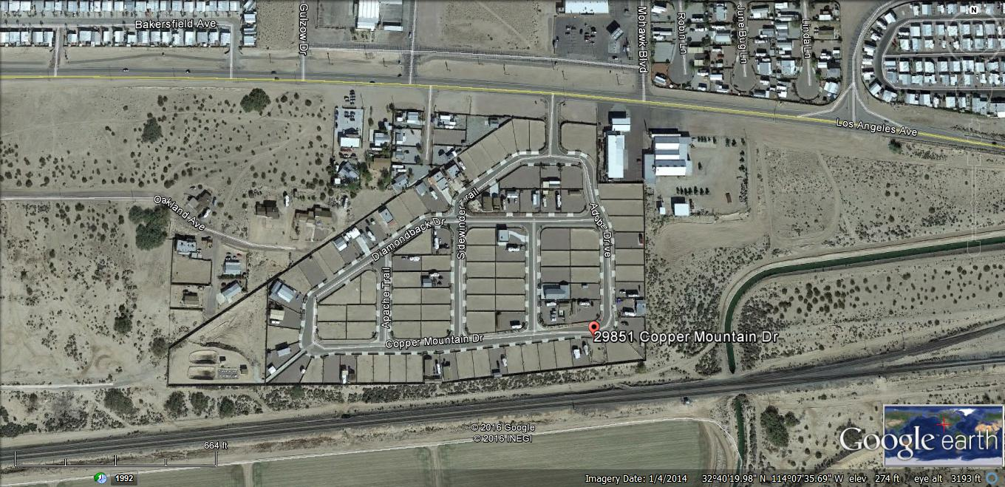

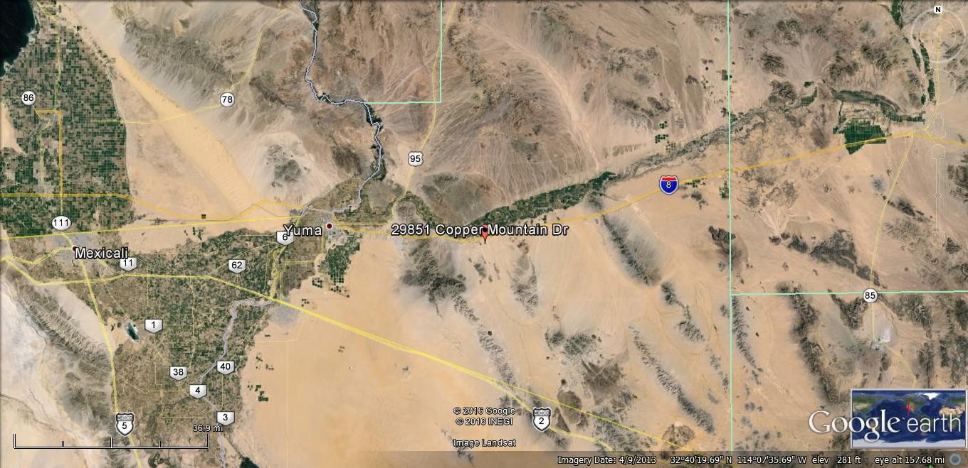
North Ranch RV Resort

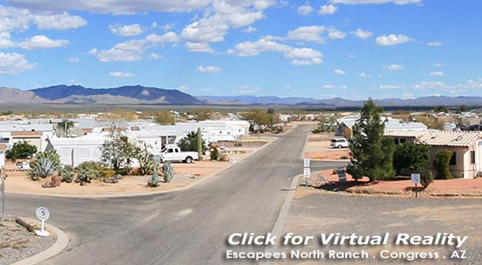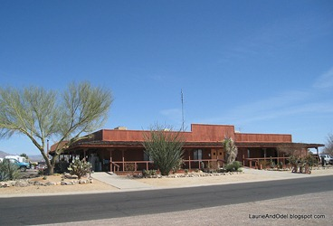

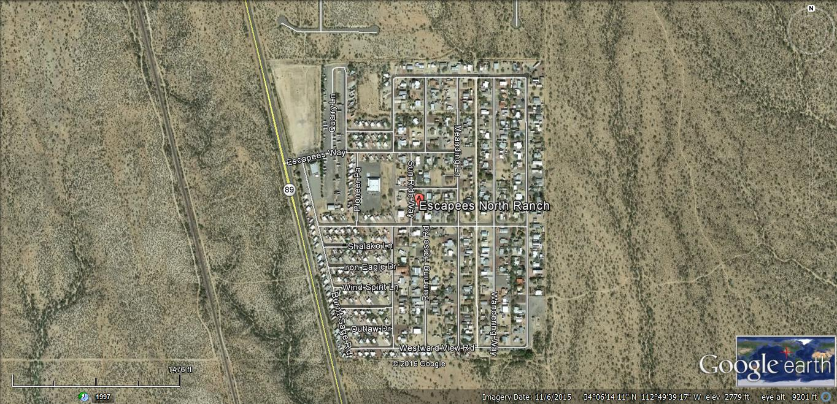

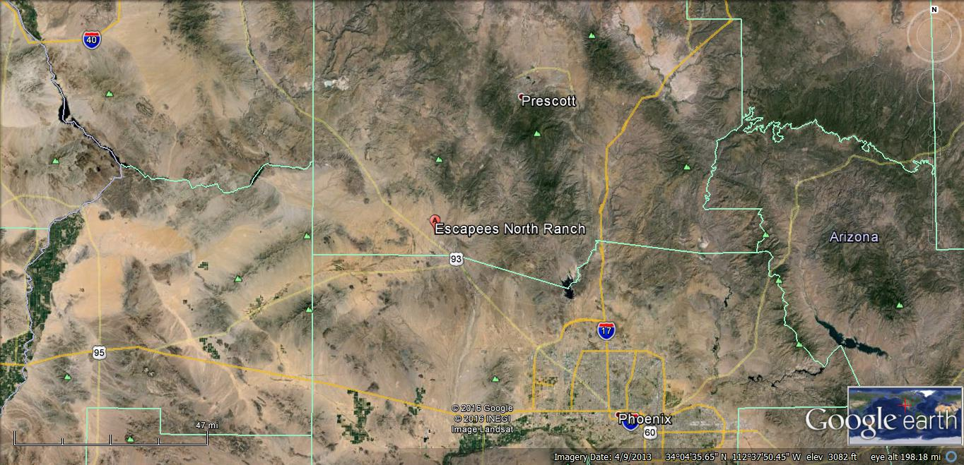

Golden Vista RV Resort

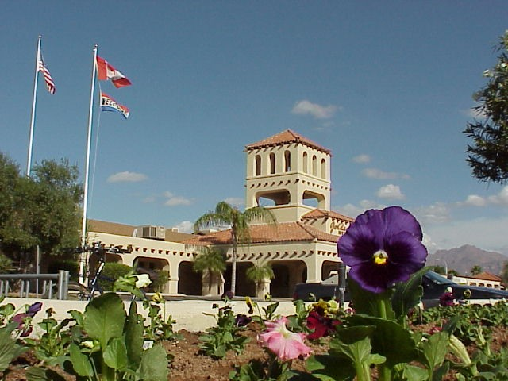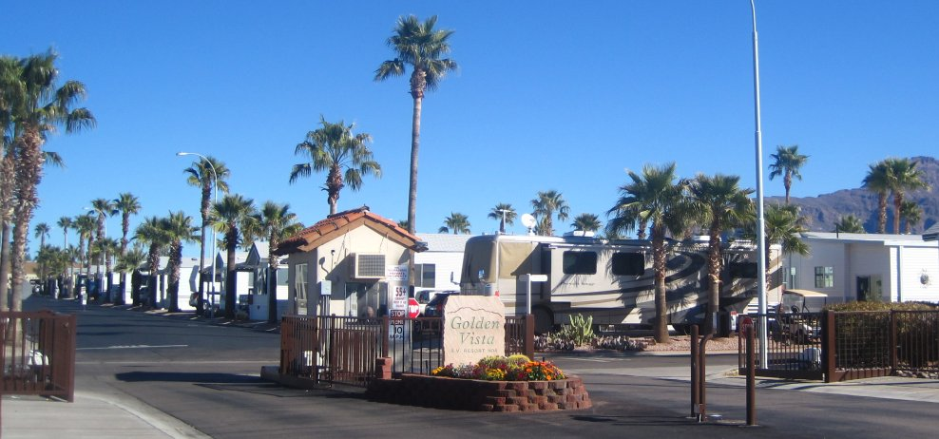

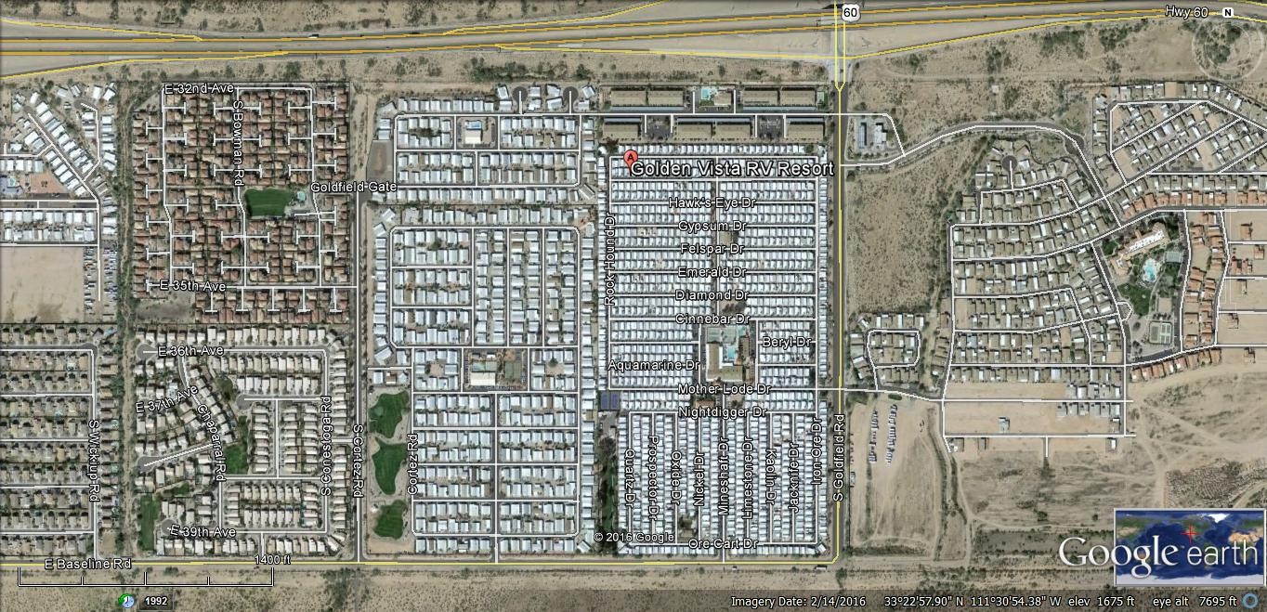

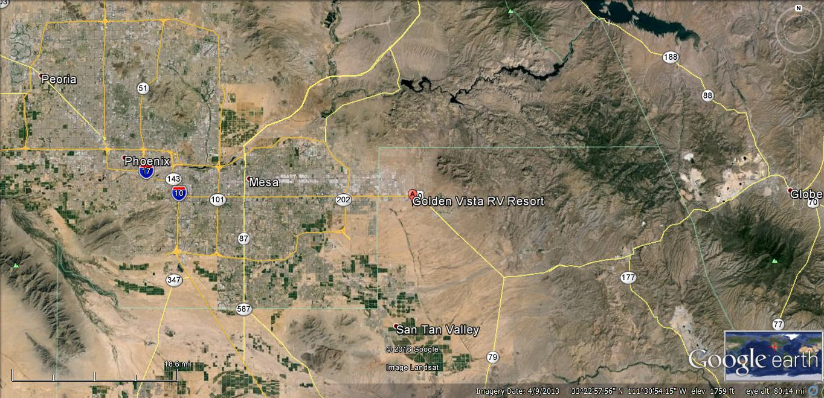

Palms RV Resort

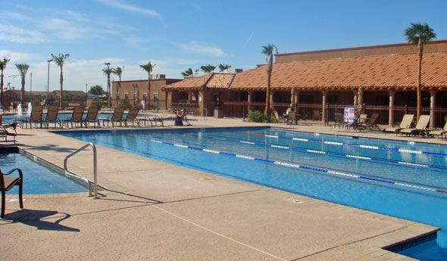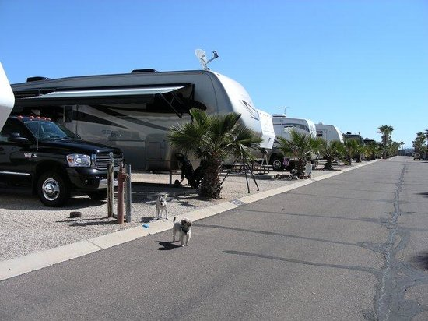

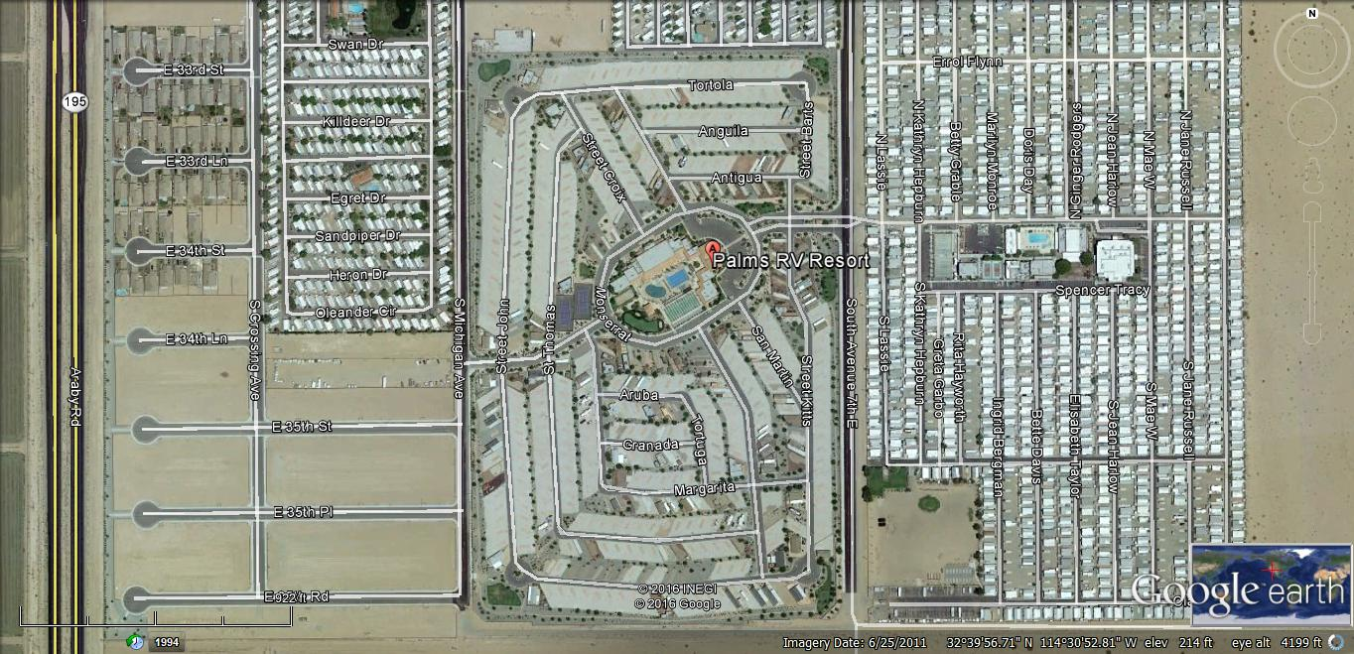

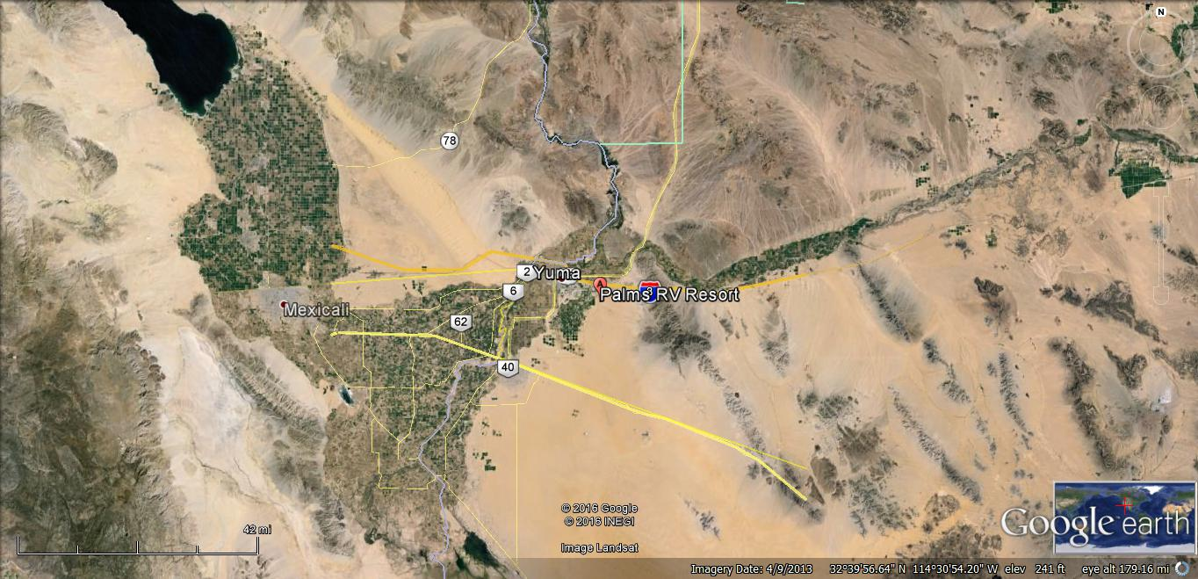

Country Roads RV Park

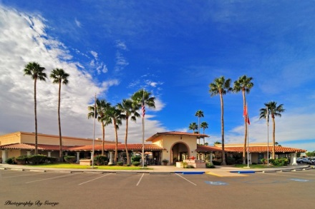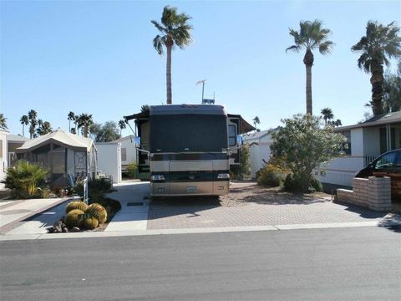

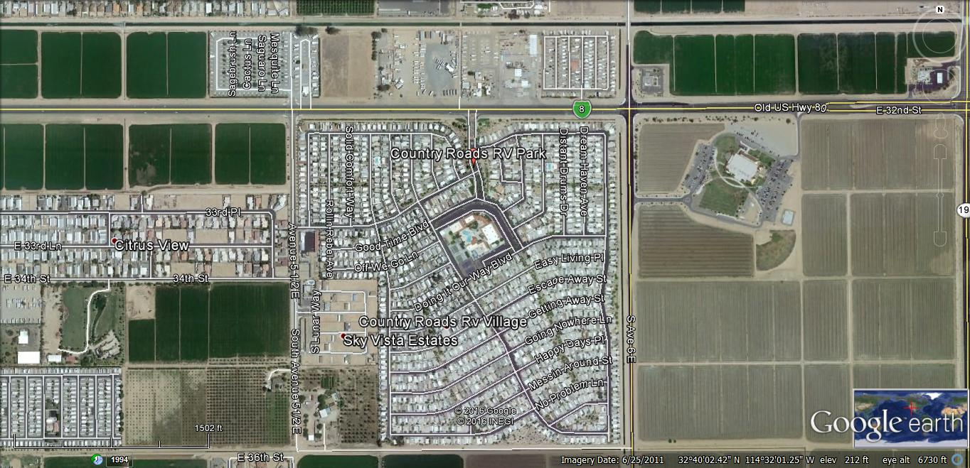

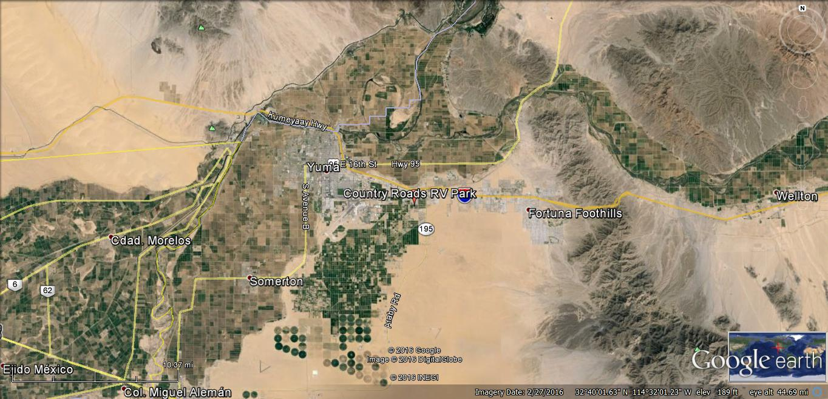
Wagons West RV Park

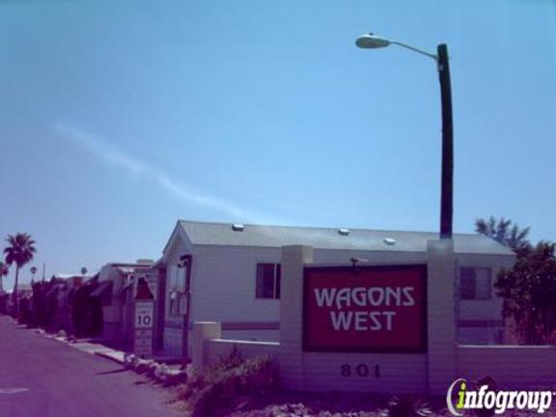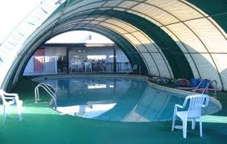

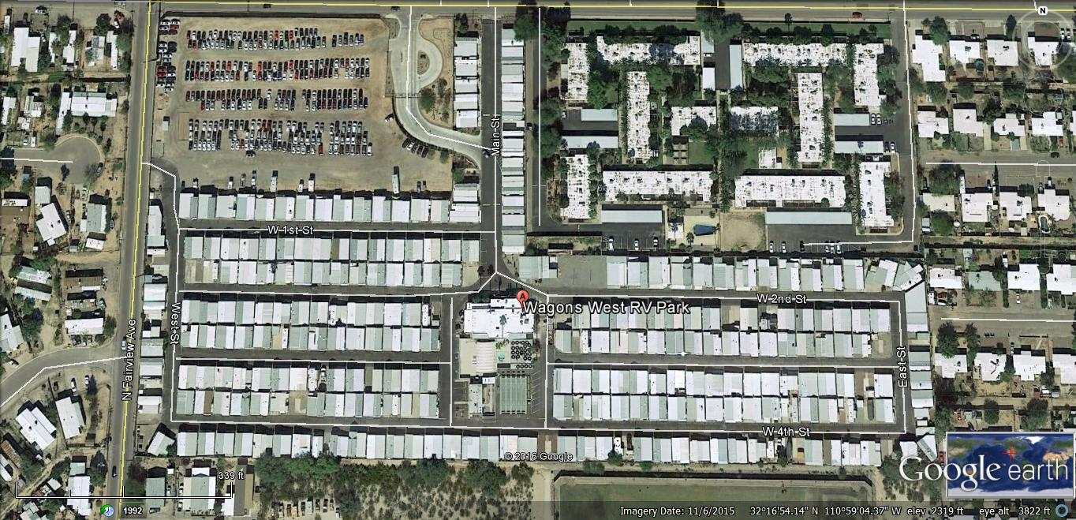

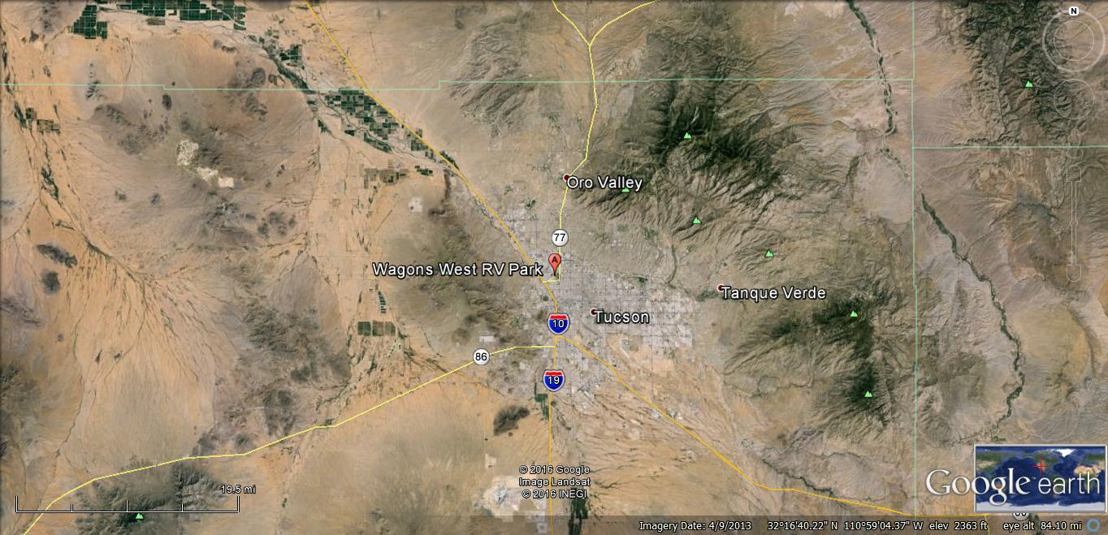

Greenfield Village Resort

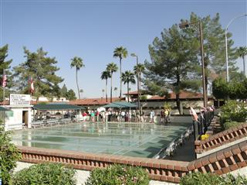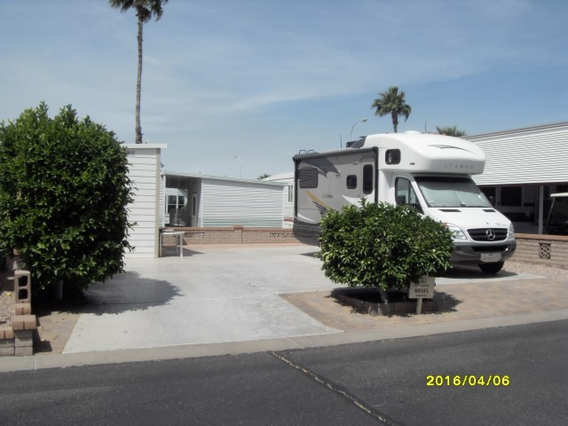

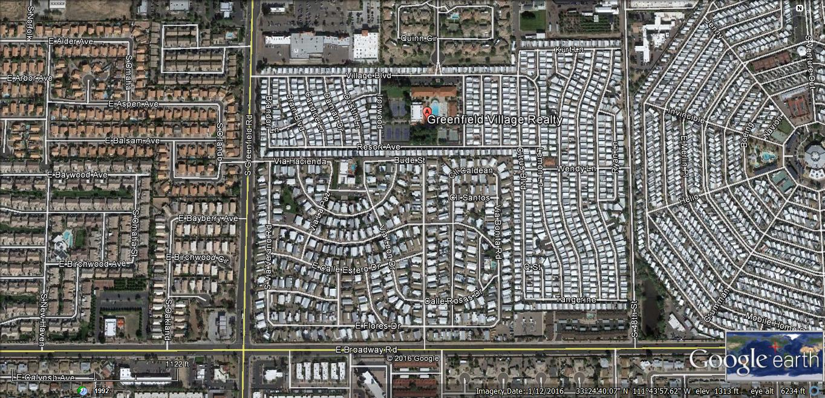

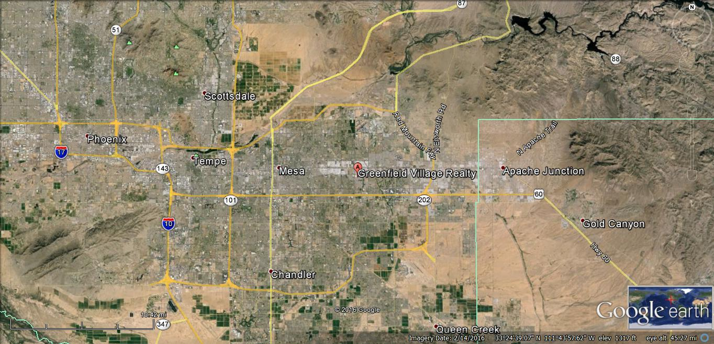
Juniper Ridge RV Resort

