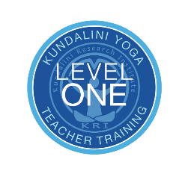
Registration Form
Kundalini Teacher Training - Level 1
As taught by Yogi Bhajan (KRI Approved)

November 2020 – June 2021

Legal Name (print)________________________________________________________

Spiritual Name (print)_____________________________Birth date_________________

Mailing Address___________________________________________________________

Best Phone ______________________Email ___________________________________

Emergency Contact_________________________Relationship _____________________

Emergency Contact Phone ________________________

Payment Options:
____ Deposit $500
____ EARLY BIRD ($3,095 minus deposit) by 2/18/20, after
____ ($3,295 minus deposit) until 8/18/20, after
____ ($3,495 minus deposit)

Payment Methods:
- Mail your check Payable to The InnerSanctuary and completed Registration Form to the address below.
- To process credit card charge call 315-345-8672. Mail your Registration Form to the address below. (I understand that all credit card payments will be assessed a 3% finance charge.)
- Visit www.innersanctuaryCNY.com to pay via Paypal. Mail Registration form to the address below.
Address: The Innersanctuary, 7271 State Fair Blvd, Baldwinsville, NY 13027

______________________________________________ Date _______________________
Student Signature

______________________________________________ Date _______________________
The InnerSanctuary of CNY, Inc.

For information call 315-345-8672 or email innersanctuarycny@gmail.com
(No refunds, returns or exchanges after 9/22/20; however, if the course is cancelled, money will be refunded)

