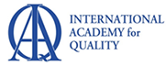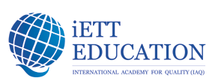

QiETT – Quality in Education Think Tank of the International Academy for Quality (IAQ)
QiETT Members for 2020

Chair: Pedro Saraiva (Portugal)
Co-Chair: Beth Cudney (USA)

Think Tank Members (alphabetical order)
Azat Abdrakhmanov (Kazakhstan)
Jiju Antony (UK)
Juhani Anttila (Finland)
Matthew Barsalou (Germany)
Bo Bergman (Sweden)
Kwai-Sang Chin (Hong Kong)
Joseph DeFeo (USA)
John Dew (USA)
Paul Harding (South Africa)
Zhen He (China)
David Hutchins (UK)
Kamran Moosa (Pakistan)
Vladimir Okrepilov (Russia)
Jorge Roman (Chile)
Gulshan (Shan) Ruprai (Australia)
Anil Sachdev (India)
Kazuyuki Suzuki (Japan)
Chalassathien Thavorn (Thailand)

