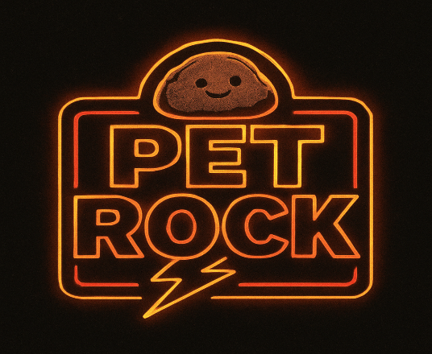

Website and Facebook Page
PetRockColorado.com
Pet Rock Facebook Page
Contact Info: JT Jones
303-378-1216
jtjonesmusic@gmail.com

PET ROCK SONG LIST
- MOVE IT ON OVER- GEORGE THOROGOOD
- TUSH- ZZ TOP
- FORTUNATE SON- CCR
- TAKE IT EASY- THE EAGLES
- PUMP IT UP- ELVIS COSTELLO
- I NEED TO KNOW- TOM PETTY
- CROSSROADS- CREAM
- HONKY TONK WOMEN- ROLLING STONES
- NIGHT MOVES- BOB SEGER
- ONE WAY OUT- ABB
- LONG TRAIN RUNNING- THE DOOBIE BROTHERS
- ROCKIN’ ME- STEVE MILLER BAND
- LAWYERS, GUNS, & MONEY- WARREN ZEVON
- MOVIN’ ON- BAD COMPANY
- TWIST & SHOUT- THE BEATLES
- BLITZKRIEG BOP- THE RAMONES
- I WANT YOU TO WANT ME- CHEAP TRICK
- STAY WITH ME (KEY OF G)- THE FACES
- JUST GOT PAID- ZZ TOP
- JEALOUS AGAIN- BLACK CROWS
- ARE YOU SURE HANK DONE IT THIS WAY- WAYLON
- I HEAR YOU KNOCKING- DAVE EDMUNDS
- WALK THIS WAY- AEROSMITH
- JUST WHAT I NEEDED- THE CARS
- DON’T DO ME LIKE THAT- TOM PETTY
- THE STAKE- STEVE MILLER BAND
- ROCKY MOUNTAIN WAY- JOE WALSH
- OLD TIME ROCK N ROLL- BOB SEGER
- CAN’T GET ENOUGH OF YOUR LOVE- BAD COMPANY
- MELISSA- ABB
- BITCH- ROLLING STONES
- PSYCHO KILLER- TALKING HEADS
- WOOLY BULLY- SAM THE SHAM & THE PHARAOHS
- STUCK IN THE MIDDLE WITH YOU- STEALERS WHEELS
- SAME OLD SONG AND DANCE- AEROSMITH
- BALLROOM BLITZ- SWEET
- CUSTARD PIE- LED ZEPPELIN
- BIG BALLS- AC/DC
- AMERICAN BAND- GRAND FUNK RAILROAD
- RADAR LOVE- GOLDEN EARRING
- DIRTY WHITE BOY- FOREIGNER
- WORKING MAN BLUES- MERLE HAGGARD
- SWEET LEAF- BLACK SABBATH
- CRIPPLE CREEK- THE BAND
- DEAD FLOWERS- THE ROLLING STONES
- I WAS MADE FOR LOVIN’ YOU- KISS

