Just Read

by Lori Degman
illustrated by Victoria Tentler-Krylof

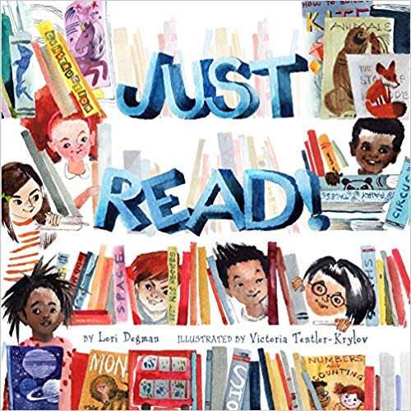

ABOUT THE BOOK:
Learning to read is a big accomplishment, and this exuberant picture book celebrates reading in its many forms. In lively rhyme, it follows a diverse group of word-loving children who grab the opportunity to read wherever and whenever they can. They read while waiting and while sliding or swinging; they read music and in Braille and the signs on the road. And, sometimes, they even read together, in a special fort they’ve built. The colorful, fanciful art and rollicking text will get every child more excited about reading!

ABOUT THE AUTHOR:
Lori Degman is the author of 1 Zany Zoo (Simon & Schuster), Cock-a-Doodle Oops! (Creston Books), Norbert's Big Dream (Sleeping Bear Press), and the upcoming Like a Girl (Sterling), and Travel Guide for Monsters (Sleeping Bear Press). Lori was a teacher of the deaf and hard-of-hearing and is now a full-time author. She lives in a northern suburb of Chicago, IL. Visit Lori online at loridegman.com.

ABOUT THE ILLUSTRATOR:
Victoria Tentler-Krylov grew up in Saint Petersburg, Russia, and studied architecture and urban design at Cooper Union and Columbia University. Victoria's artwork has been published by Pink Giraffe Books in Russia and by Spider magazine, The Wall Street Journal, The Boston Globe, and Flutter Magazine in the US. Her first book, a picture-book read-aloud of Peter Pan, was published by Quarto. She lives with her family just outside Boston, MA. Visit Victoria online at cargocollective.com/victoriakrylov.
.

ABOUT THE CREATOR OF THIS GUIDE:
Randi Sonenshine is a literacy specialist, instructional coach, and children’s author. Her debut picture, The Nest That Wren Built will be published by Candlewick Press in the spring of 2020. Visit Randi online at randisonenshine.com.

About this Guide: This guide is intended for use with grades k-2, but it can be easily adjusted for different grade levels. Literacy and math lessons are aligned to the Common Core State Standards. Science activities are aligned to the Next Generation Science Standards. Social studies activities are aligned to the National Council for the Social Studies C-3 Framework.

Table of Contents
Reading Literature
Guided Reading Activity 3
Mirrors and Windows Activity 4
Foundational Reading
Fluency Fun 5
Syllable Sort and Syllable Relay Race 6
Language
Silly Singulars and Peculiar Plurals...................................................................................................................7
Writing
My Everyday Reading Book................................................................................................................................8
Math
Problems on the Playground............................................................................................................................9
Science/STEM
Investigation Read...........................................................................................................................................10
Social Studies
Reading and Creating Maps.............................................................................................................................10
Armchair Traveler...........................................................................................................................................11
Art
Book Mobile.................................................................................................................................................... 12
Origami Shark Book Buddy............................................................................................................................12
Music
Reading the Notes............................................................................................................................................13
Physical Education/Movement
The Narrator Says............................................................................................................................................13
Miscellaneous........................................................................................................................................................14
Appendices............................................................................................................................................................15

Reading Literature

Guided Reading Activity
CCSS.ELA-LITERACY.RL.1.1
Ask and answer questions about key details in a text.
CCSS.ELA-LITERACY.RL.1.3
Describe characters, settings, and major events in a story, using key details.
CCSS.ELA-LITERACY.RL.1.5
Explain major differences between books that tell stories and books that give information, drawing on a wide reading of a range of text types.

Before Reading

1. Show students the cover of Just Read and read the title. Ask, “Based on the title and cover art, what do you think this book is about?” Ask for specific details that helped students make that inference.

2. Ask the class, “What are some of the reasons people read?” Brainstorm and list lots of examples. (Encourage creative responses and prompt students to think about people in different situations, such as a shopper comparing features of a product, a driver reading road signs or stopping to read a map, someone reading instructions for putting something together or following a recipe, a writer doing research for a new book.) Emphasize the importance of reading for fun, to build imagination, to explore new worlds, and to learn something new.

3. Point out and discuss the difference between the author and illustrator. Read the dedications by the author and illustrator. Ask, “Who did the author and illustrator mention? Why were those people important to them? Ask, "Who has been/is important in your reading life?" Encourage students to share who taught them to read, who reads with them on a regular basis, etc.

During Reading

1. Explain that the book is like a list, naming many characters, places, and kinds of reading. Ask students to pay attention to the details in order to remember as many as they can.

2. Read the story aloud, emphasizing the rhyme and rhythm of the text.

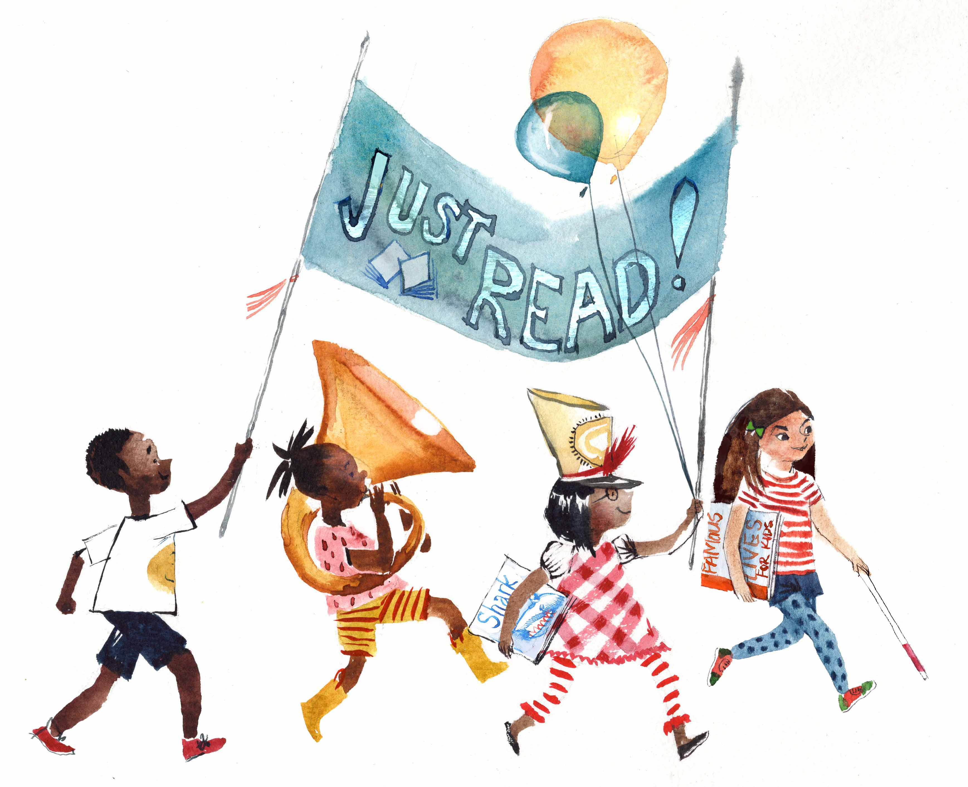
3. Before each page turn, encourage the students to predict what, where, or with whom the speaker will read next.

After Reading

1. Ask students to recall as many specific details as they can. Use prompting as necessary.

- Is there a story with a beginning, middle, and end? (more a list poem)
- How is the book like a poem? How is it like a list?
- Is there a main character? (lots of different characters) Who are some of the people/animals the reader "reads" with in the book?
- Is the speaker really reading with a pirate, moose, knight, etc? What does the speaker mean, then?
- What are some of the different kinds of reading mentioned? (sign language, braille, music, maps) Add these to the brainstorming list from the "Before Reading" activity. If possible, show examples of Braille, a sign language reading chart, maps, sheet music, and other "texts" mentioned in the book. Discuss the different approaches to reading these texts.

2. Discuss the setting. List all the places where the characters read in the book. Go back and use illustrations to find the ones that were missed. How does the illustrator create different settings with colors, shapes, lines, etc.

3. Ask questions that require students to make connections to the text (examples below).

- What characters have you read with lately?
- Where are some of the interesting places you read?
- What kinds of things, other than books, do you read on a daily basis?
- What, with whom, and where would you like to read that you haven't already?

4. Explore the theme/main idea of the text: Based on all the responses and the ideas in the book, what is the "big idea" you think the author makes in the text?

Mirrors and Windows Activity
CCSS.ELA-LITERACY.SL.1.4 Describe people, places, things, and events with relevant details, expressing ideas and feelings clearly.

1. Explain the concept of "mirrors and windows" to students: Books that are mirrors show or reflect characters, settings, situations, and families like our own. Books that are windows allow us to see through them, how others live. Show examples of books that are your own mirrors and those that are windows, explaining why they fit in those categories.

2. Go back through the book. Ask students to identify and describe one character, reading situation, and/or setting that is a mirror for them and one that is a window.

3. Mirrors and Windows book pass station/group activity.
In advance, you will need to choose a variety of texts for each station representing diverse cultures, religions, settings (city life, rural, and suburban settings, as well as other countries and geographic regions) family situations (multi-generational, single-parent, etc.) abilities, etc. There are many lists of diverse children's books on the Internet. Here are a few examples: http://hereweeread.com/2017/11/2018-ultimate-list-diverse-childrens-books.html

https://multiculturalchildrensbookday.com/multicultural-reading-resources/diversity-book-lists-for-kids/diversity-books-by-genre/diverse-picture-books/

- For more independent students, use the organizer in appendix A. Have students take turns passing books around. For more structure, set a timer for 2 minutes each. For each book, students will record whether it is mostly a mirror book or a window book and explain in the columns provided on the organizer.

- For less independent students, conduct a whole-group activity. Give students laminated or cardstock pictures of the mirror and window provided in appendix B. These can also be fixed to popsicle sticks for ease of use. Share books one at a time (Do booktalk or read flap copy, show a few pictures). Have students hold up the appropriate icon (mirror or window). Choose a few to explain the connection if a mirror book and what is new/different in window books. Be sure to model first.

- Ask students to reflect upon what they learned from the activity. Do they mostly read window books, mirror books, or a balance of both? Why are both important?

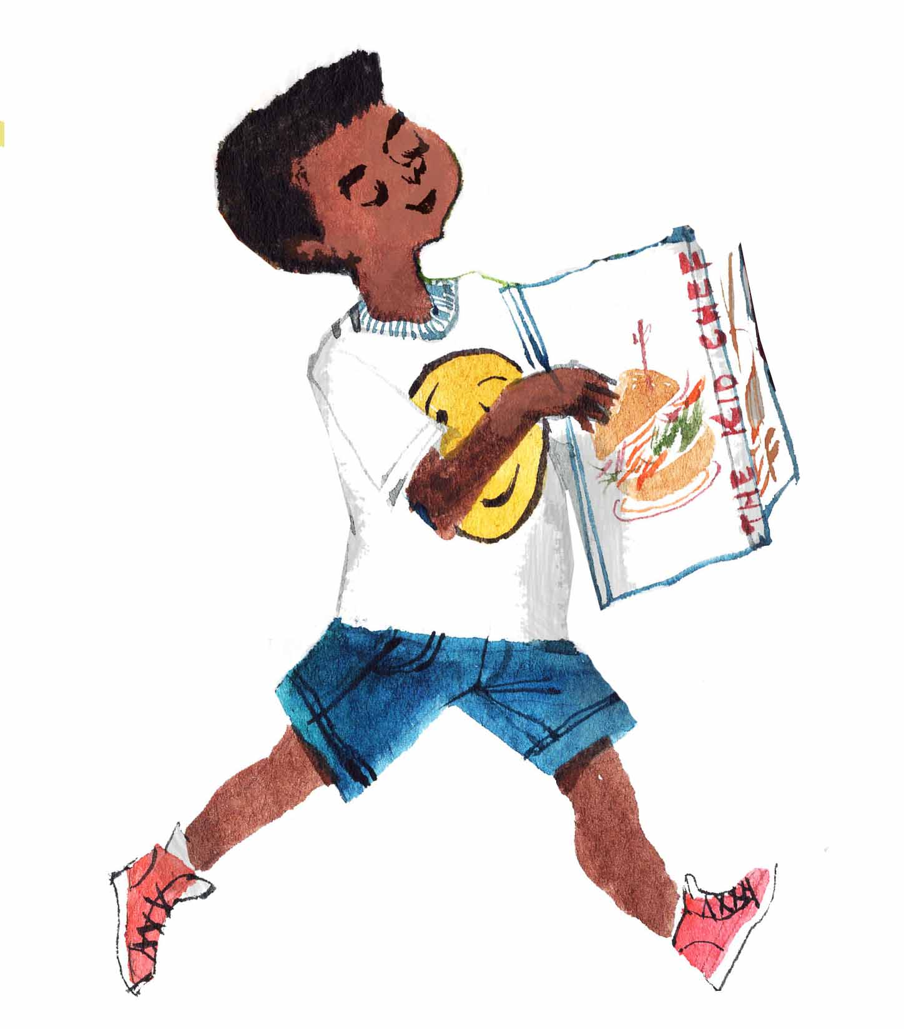
- As an extension, send home a letter to parents explaining the concept of mirror and window books and encourage them to do an "audit" with children of the books in their home. Is there a good balance? On trips to the library or book stores, recommend families find examples of both types of books.

Foundational Reading

Fluency Fun

CCSS.ELA-LITERACY.RF.1.4.B
Read grade-level text orally with accuracy, appropriate rate, and expression on successive readings.

Choose from the following fluency activities based on the readiness of your students. For each activity, you may project the text.

1. Echo Reading (for less independent students and struggling readers)- read each page, pointing to the words as you do so, and have students recite back. Encourage them to mimic your pacing, phrasing, enunciation, and expression. As a variation, divide the class into two groups and alternate which group is the "echo" for each page.

2. Two-Voice Poem (for more independent readers)- Divide students into pairs. Tell students to assign A and B based on random criteria, for example, the partner whose birthday falls first in the calendar year is Partner A. After students have a chance to practice their parts and get help and feedback from partners and the teacher if necessary, they should read the text, alternating parts according to their letters. Circulate and choose one or two pairs to perform for the class. As a variation do this as a whole group activity, with all "A" partners reading their parts and all "B" partners reading their parts in a chorus.

Syllable Sort
CCSS.ELA-LITERACY.RF.1.2 Demonstrate understanding of spoken words, syllables, and sounds (phonemes).
CCSS.ELA-LITERACY.RF.1.3.B Decode regularly spelled one-syllable words.
CCSS.ELA-LITERACY.RF.1.3.E Decode two-syllable words following basic patterns by breaking the words into syllables.

1. Preparation: Print Appendix C on cardstock and laminate. Make enough for pairs of students or small groups, depending on how you will structure the activity. Cut out the cards and put each set in an envelope or clip together. Gather enough containers (small buckets, jars, baskets, etc.) for each pair/group to have three. Label each basket with a sticky note or masking tape with a 1, 2, and 3. As an alternate, use index cards or cut out card stock with numbers 1, 2, and 3.

2. Remind students that syllables are word parts or chunks and that dividing words into syllables helps to decode new or difficult words. Demonstrate methods for counting syllables, such as clapping, tapping, robot-speak, or putting a hand under your chin to feel the jaw drop with each spoken syllable. For a kinesthetic component have students "hop" out each syllable. Use students' names for practice, as well as objects around the room, if necessary.

3. Distribute card sets and containers. Instruct students to sort the word cards into the appropriately labeled container based on the number of syllables. Go over the correct placement with the whole group. Use strategic grouping for best results with this activity. For a fun follow-up, do the syllable relay race below.

Syllable Relay Race

Preparation: Make two sets of word cards, with a variety of 1, 2, 3, and 4 syllable words. Place each set in a bucket or basket. Using painters tape or chalk if outside, mark the floor or sidewalk with two sets of the following: a starting line, 15 progress lines at 1-2 foot intervals, and a finish line. Put an additional bucket at each finish line.

1. Review how to recognize syllables if necessary. Divide the class into two teams. Explain the following rules: Each team will start with one player at the starting line, who will draw a card from that team's bucket. Players will take turns reading the word aloud (with teacher assistance if needed) and hop out the correct number of syllables to the appropriate line, while saying the syllables aloud. For example: Player 1 draws the word popcorn. That player reads the word aloud, and then hops up two lines, while saying "pop" for the first line and "corn" for the second line. The player on the opposite team repeats the

same process with his or her word card. The next player on each team will replace the previous player, wherever he or she landed, and repeat the process. As players are replaced, they will drop their word cards in the bucket at the finish line. The first team to get to the finish line twice wins the game.

2. For a more impromptu version of the game, simply designate start and finish lines, have students call out words of their choice, and then allow them to hop out the number of syllables in their chosen words.
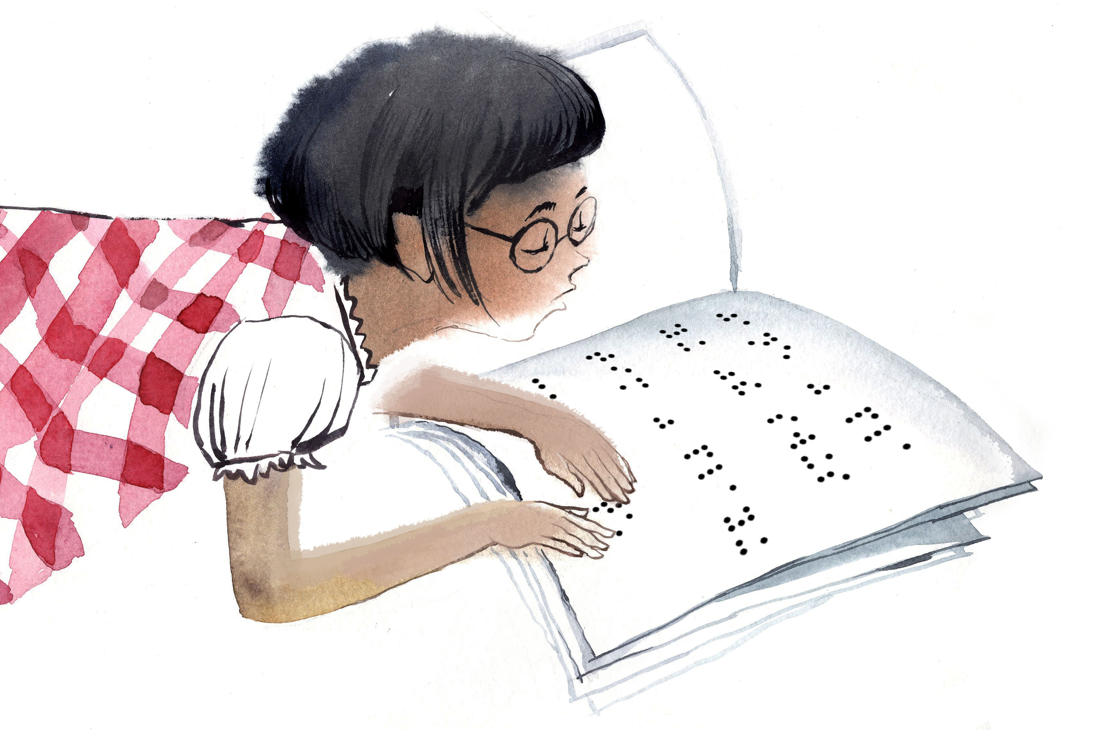

Language

Silly Singulars and Peculiar Plurals

CCSS.ELA-LITERACY.L.1.1.C
Use singular and plural nouns with matching verbs in basic sentences (e.g., He hops; We hop).

Preparation: Project or display on chart paper or the board two lists. One list will have nouns from the text and illustrations in the book: astronaut, pirate, farmer, clown, penguin, bear, tortoise, hare, moose, shark, tiger, bird, etc. (For more advanced students, go through the book with you and have them identify the nouns.) The second list will have verbs: rake, spin, slide, swing, drum, strum, sing, drive, read, march, stroll, etc.

1. Have students choose one noun and one verb. They then must create a sentence using the singular form of the noun with the correct verb form and then the plural form of the noun with the appropriate verb form. For example, a student chooses knight and spin. He or she must say, "The knight spins," and "The knights spin." For a kinesthetic component, have students demonstrate the action.

2. As a fun alternative, make several sets of cards using the two lists of words. Print or write them on one color for nouns and another for verbs. Have students work in pairs or groups. The dealer deals an equal number of noun and verb cards to each member. They then move around the group, taking turns with pairs of cards. The next dealer shuffles, and play begins again.
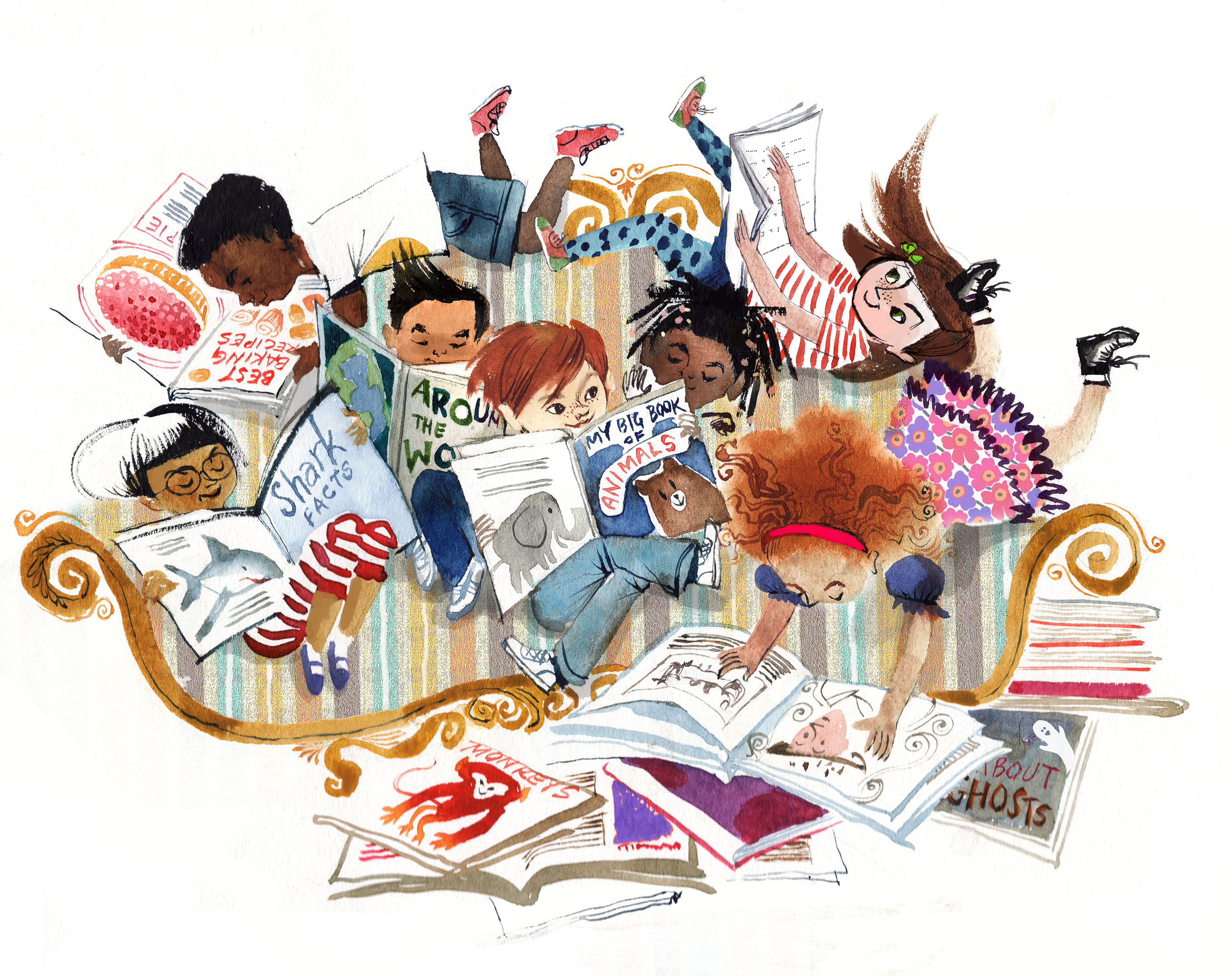

Writing

My Everyday Reading Book

CCSS.ELA-LITERACY.W.1.3
Write narratives in which they recount two or more appropriately sequenced events, include some details regarding what happened, use temporal words to signal event order, and provide some sense of closure.
CCSS.ELA-LITERACY.W.1.8
With guidance and support from adults, recall information from experiences or gather information from provided sources to answer a question.
Demonstrate understanding of the organization and basic features of print.
CCSS.ELA-LITERACY.L.1.2
Demonstrate command of the conventions of standard English capitalization, punctuation, and spelling when writing.

1. This activity will encourage family literacy and engagement. Prior to this activity, discuss with students the idea that like in the book, reading is all around us - at stores, on streets, in our homes, etc. Explain that they will be creating their own books, using words from their daily routines and travels. For one week, they will collect words and phrases they encounter on a daily basis. Using these words, they will then write and illustrate their own narrative picture books.

2. Give each student a copy of the Word Collection sheet (appendix D). Instruct them to use this sheet to record words and phrases from their daily routines and travels. Model this using your own daily routine and travels. For example, In the morning, I read the words "shampoo" and "toothpaste" in my bathroom. Then I read "cereal" and "bread" in the kitchen. On my drive to work, I read signs that say "stop," "speed limit, "Target," and "City Park". On Tuesdays, I read a script and music when I am at play rehearsal. Each Wednesday, when I go to exercise, I read the words "locker room" at the gym.

3. Send a letter home to parents/caregivers explaining the activity and asking for help with collecting and recording words and phrases, as well as writing the where and when. The "where" and "when" will help students use "time and place" words to show the sequence of events in their narratives.

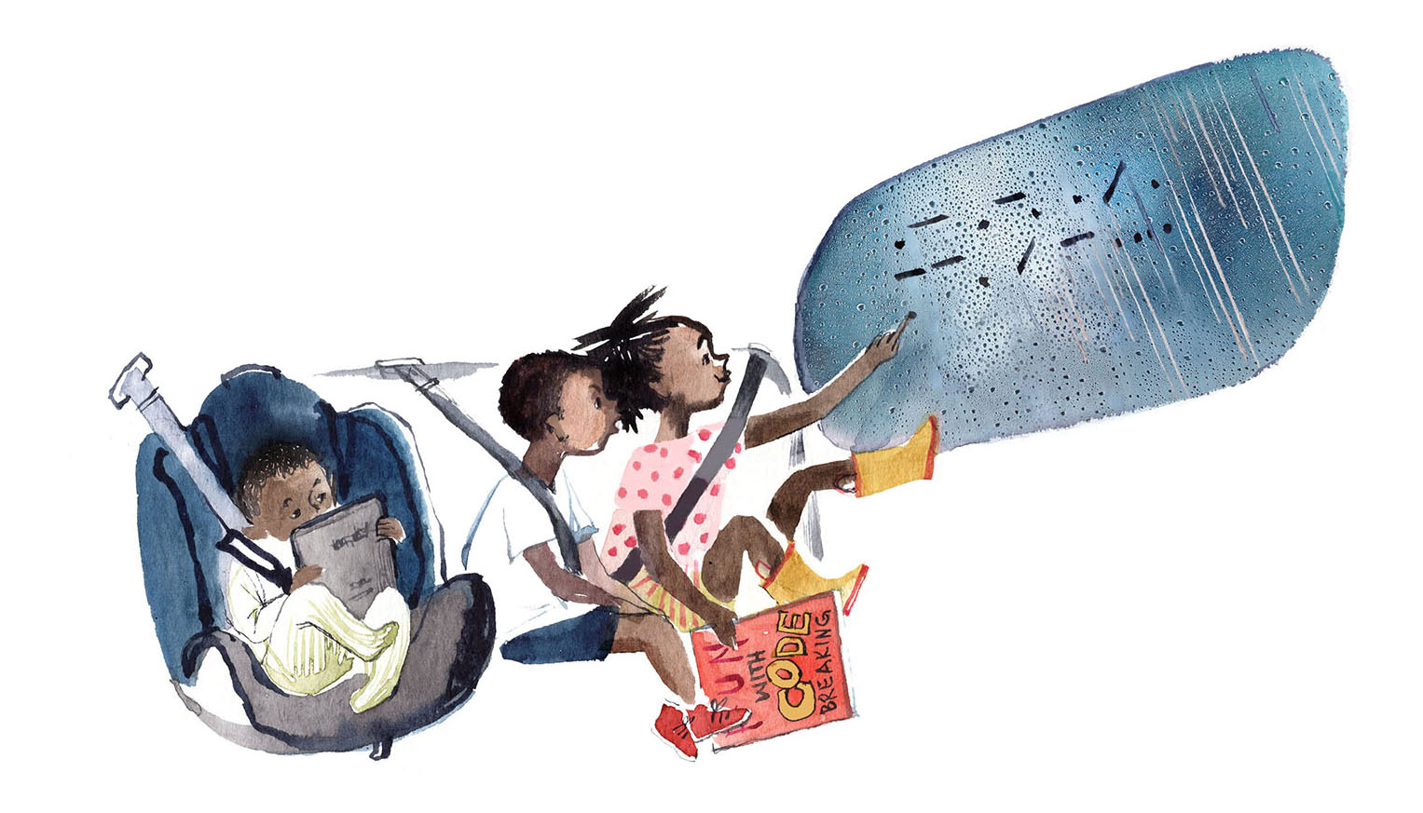
4. Check in on students' progress daily. After a week, guide students in writing and illustrating their narratives. Provide materials for book covers, illustrations, etc. When the project is finished, have students take turns reading their books to the class from an "authors chair," and/or invite families for a literacy night.

Math
Problems On The Playground

CCSS.MATH.CONTENT.1.OA.A.1
Use addition and subtraction within 20 to solve word problems involving situations of adding to, taking from, putting together, taking apart, and comparing, with unknowns in all positions, e.g., by using objects, drawings, and equations with a symbol for the unknown number to represent the problem.

CCSS.MATH.CONTENT.1.NBT.B.3
Compare two two-digit numbers based on meanings of the tens and ones digits, recording the results of comparisons with the symbols >, =, and <.

1. Use the playground illustration for this activity. First, have students count the number or adults in the illustration. Record this number (6) on the board or chart paper. Next, have students count the number of children (20). Record this number.

2. Introduce or review the symbols =, <, and >. Ask students, "Is the number of children less than, equal to, or greater than the number of adults. Write out the comparison using the symbols.

3. Next, ask and display the following word problem: "How many more adults need to come to the playground to equal the number of children?" Demonstrate how to find the solution using subtraction.

4. Next, ask and display the following word problem: "If fifteen children left the playground, would the number of children left be equal to, greater than, or less than the number of adults?" Work through the math with students, or for more advanced students, have them work out the math independently or with a partner.

5. For a challenge, have students create their own word problems using the playground scenario.

Science/STEM
Investigation Read

1. Talk about the role of reading in science, engineering, and technology. Give examples, such as reading blueprints, reading and interpreting data, reading the stars, reading code, etc.

2. Put together a text set of books about scientists, inventors, scientific discoveries, etc. For more independent students, have them choose a book and then report about the topic and how reading played a role in the life or process of the subject. Refer to the NSTA website or other lists of books for ideas, or seek out the expertise of your librarian. Pinterest is also a good resource. Here are a few sample lists:

http://static.nsta.org/pdfs/2018BestSTEMBooks.pdf
http://www.startwithabook.org/booklists/inventions-and-inventors
https://www.scholastic.com/teachers/lists/teaching-content/books-about-inventors-and-inventions/

Social Studies

Reading and Creating Maps
D2.Geo.1.K-2. Construct maps, graphs, and other representations of familiar places.

1. Teach/review the concept of location and distance. Use objects and students around the classroom to demonstrate the following: near/close to, far, between, beside/next to. Depending on readiness, introduce the concepts of right, left, and for more advanced students, introduce the cardinal directions.

2. Project a map of the world, or use a wall map to introduce the continents. Point out North America to orient students. Use the location and distance words to describe the position and location of each continent relative to each other. Ask students questions like the ones below to facilitate this (point out reference continent as you ask questions).

- Is South America near or far from North America?
- Which continent is farthest from North America?
- Which continent is next to Europe?
- Which continents are between North America and Asia
- Which continent is closest to Australia?

3. Make an interactive map of the classroom, library, lunchroom, or playground.
- Draw the shape of the room or area first on butcher paper. For a reference point for indoor spaces, include doors and windows. For the playground, provide any trees, fences, the school building, etc.
- Provide students with cut out shapes representing certain objects in the room or equipment and other structures on the playground. Have students take turns describing the location of their objects relative to one of the reference points, and then place the object in the appropriate place on the map. For a variation or extension, give each student a cutout figure of a person. One at a time, call out a position and have the student place the figure in the described location. For example, "Maria, you are in between the check-out desk and the rocking chair."
- For additional enrichment and family engagement, have students create a map of their home, bedroom, or some other familiar place such as the library or city park.

Armchair Traveler: An Inquiry-Based Journey
D1.2.K-2. INDIVIDUALLY AND WITH OTHERS, STUDENTS CONSTRUCT COMPELLING QUESTIONS, AND Identify disciplinary ideas associated with a compelling question.
D1.5.K-2. Determine the kinds of sources that will be helpful in answering compelling and supporting questions.
D2.Geo.3.K-2. Use maps, globes, and other simple geographic models to identify cultural and environmental characteristics of places.
D2.Geo.6.K-2. Identify some cultural and environmental characteristics of specific places.
CCSS.ELA-LITERACY.W.1.8
With guidance and support from adults, recall information from experiences or gather information from provided sources to answer a question.
CCSS.ELA-LITERACY.SL.1.4
Describe people, places, things, and events with relevant details, expressing ideas and feelings clearly.

1. Explain to students that asking questions, using tools, and gathering information are essential to exploring, understanding, and making connections to the world in which we live. These skills are also the means to initiate powerful and positive change. In social studies, we can put those skills to use by investigating people and places, especially those that are new to us. Point out the text that says, "I read about places I've never been." Tell students that for this activity, they will be investigating a place in the United States where they have never been and would like to visit.

2. Project or display a map of the United States. Ask students if they can point out the state in which you live. If not, assist them. Point out geographic features of your state, including mountains, deserts, plains, bodies of water, etc. Discuss some of the notable features, benefits, and landmarks that make your state unique. For example, do certain geographic features (beaches, mountains, canyons) bring tourists? Do the geography and climate provide optimal growing conditions for certain crops in your state? Are there institutions, history, and/or landmarks that make your state notable?

3. Using the words and map knowledge gained in the previous activity encourage students to make observations regarding other regions, states and geographic features in relation to your own state. Explain that they will be investigating a state they would like to visit.

4. Have students pick out a state they would like to visit. Next, work with students to develop a broad overarching compelling question to guide their discoveries, such as "What makes _________ a good place to
visit?" Next, have them work with a partner or in a small group to create 3-5 more specific supporting questions about the state. For example, "What landmarks or features are unique to the state? (For younger or less independent learners, do this as a guided activity.)

5. Brainstorm various tools and resources that will help students answer their questions, such as maps, reference books, the Internet, etc. Make available a wide variety of these in the classroom and provide time and scaffolded help as needed for students to answer their research questions.

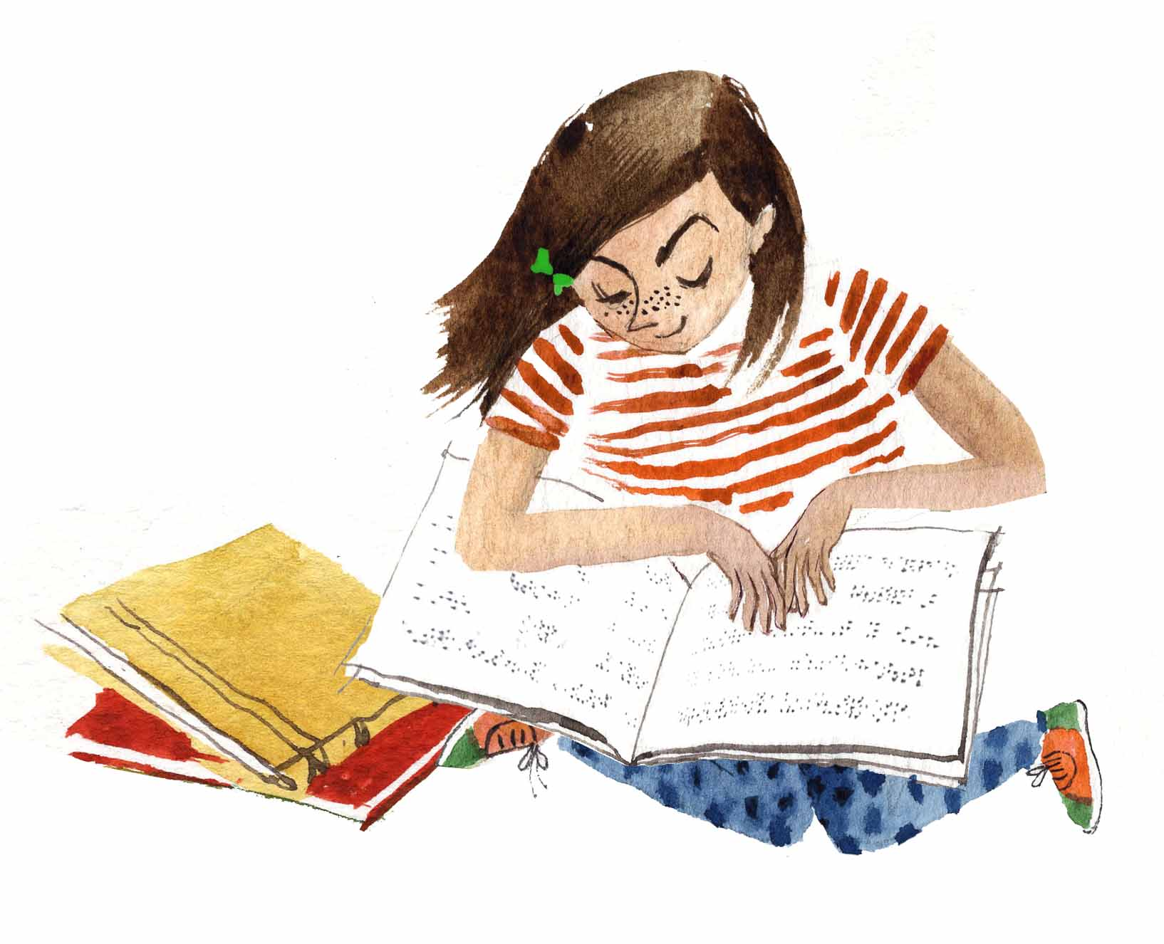
6. Have students create a poster or some other display with text and pictures based on the information they gathered. Do a gallery walk or have students present their findings to the class.

Art

Book Mobile

Materials Needed:

- Various decorative art supplies (markers, sequins, buttons, etc.), string (yarn, ribbon, twine), hole punchers, plastic hangers or small embroidery hoops
- Construction paper or card stock cut into book shapes or assorted shapes

Instructions:
1. Pre-cut the string into segments of three different lengths, enough for each student to have 3-5 pieces.
2. Have students write the titles of their favorite books (3-5) on the cutouts/assorted shapes and decorate with art/craft supplies. Punch a hole in each piece and tie a string to each.
3. Have students fix the "ornaments" to the hanger/embroidery hoop. As an alternate, for a classroom display, hang these from a clothesline or from the ceiling.

Origami Shark Book Buddy
Students will make this corner book buddy to "read with" and hold their places.

Materials Needed:

- Red, gray, white, and black paper (or blue, if you want a blue shark)
- Craft glue
- Scissors

Instructions:
Visit the website: https://heyletsmakestuff.com/shark-week-corner-book-mark/ for easy instructions and a video. If you have more prep time and would like to offer students different animals from the book, here are some more options:

Hare (rabbit) and Bear: https://www.itsalwaysautumn.com/diy-origami-bookmarks-print-fold.html
Penguin: https://www.redtedart.com/easy-penguin-bookmark-corner/
Tortoise (turtle): https://www.redtedart.com/easy-turtle-bookmark-corner/

Music

Reading the Notes
1. Project or draw on the board a quarter note, half note, and whole note. Explain that the quarter note gets one beat, a half note gets two, and a whole note gets four. Demonstrate how to clap out the number or beats for each note. Make up several short sequences of notes and have students clap out each note as you point to it. Use recorders, kazoos, or simply have students hum out the notes while you count the number of beats to hold.

2. As an extension, have students create their own rhythms using at least ten notes, then let them play or hum these for each other.

3. Invite the music teacher or a local musician to your classroom. Have him or her share several examples of musical scores and talk to students about how to read music.

Physical Education/Movement

The Narrator Says...
For this version of Simon Says, use prompts from the book. Here are some examples:

- hide like a tortoise
- circle like a shark
- growl like a bear
- walk on the moon like an astronaut
- hop like a hare
- waddle like a penguin

Miscellaneous

1. Start a student book club.
2. Adopt a Little Free Library.
3. Create a "Favorite Reading Places" display.
4. Create a classroom Book Jar- Keep small slips of colored construction paper and a pen next to a mason jar or other decorated container. Have students write the titles of books they would like to read as a class. Choose a designated time to draw a slip from the container and read the book.
5. Have students create a bookmark in a "maker space" lab.
6. Work with the librarian to create a library scavenger hunt featuring books of different genres, in order to acclimate them to the library's organization.
7. Have a PJ reading party.
8. Participate in the Global Read Aloud or other reading campaigns and initiatives.
9. Host a book drive and donate to the local children's shelter, Boys and Girls Club, community center, etc.
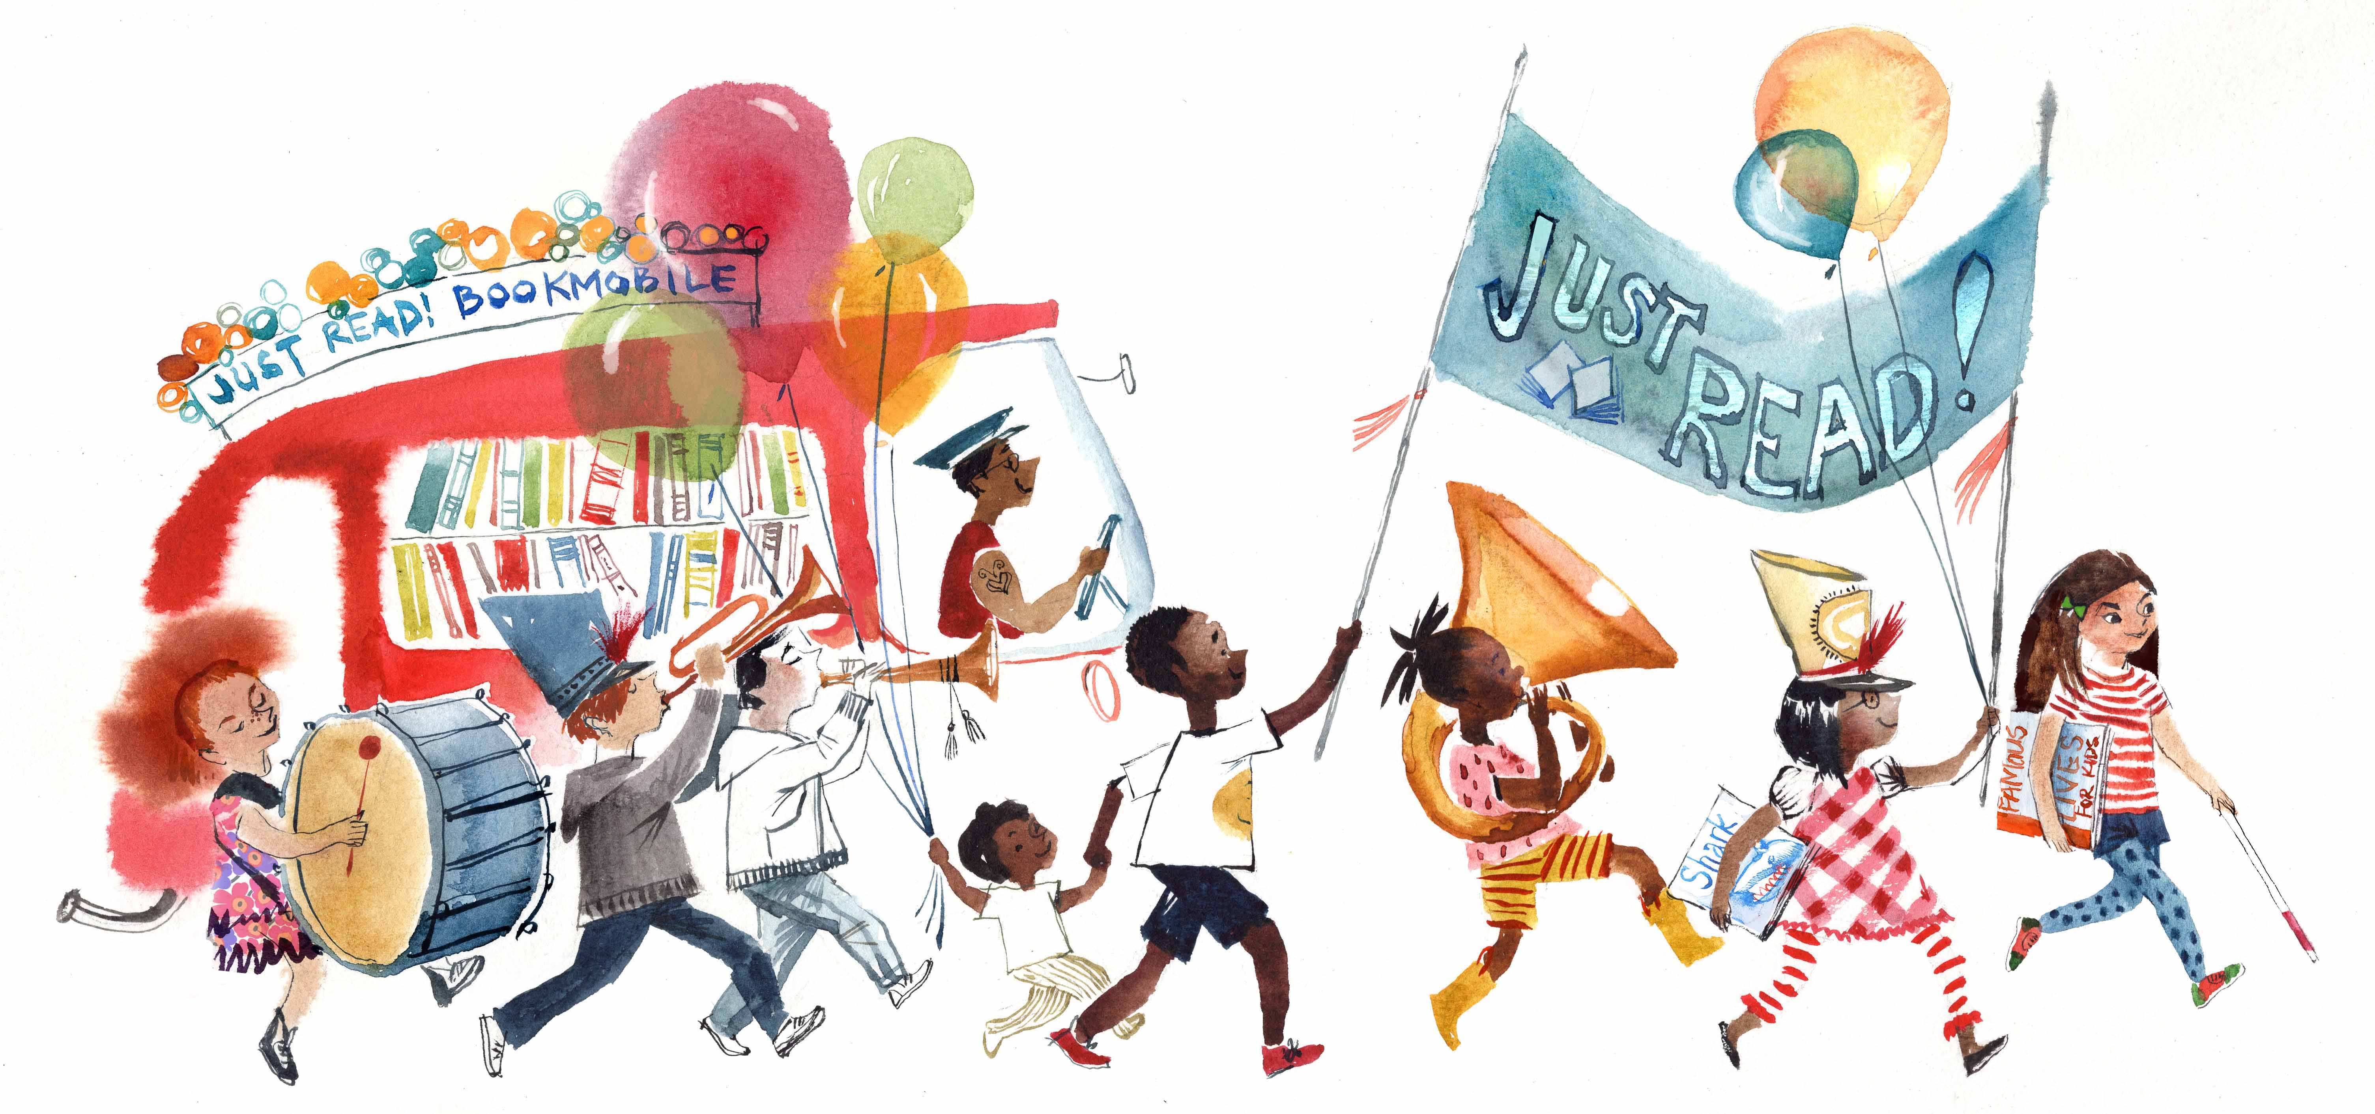
10. Host a family reading fun event. Have plenty of books available for children to read to parents, and parents to read to children. Serve book or reading-themed snacks and have books for door prizes.

Mirrors and Windows Graphic Organizer
Book Title | Mirror or Window | Explanation

APPENDIX A

APPENDIX B

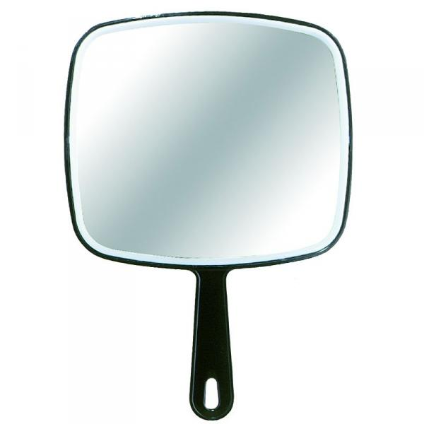

Appendix C

clown | knight
hare | moose
bear | code
read | road
farmer | tortoise
penguin | pirate

spinning | sliding
swinging | written
astronaut | messages
gorilla | exploring

Appendix D

Word Collection Sheet
When... | I see the Word... | Where...
ex: I brush my teeth | Crest | on the toothpaste tube

