Garden Grove Historical Society

Calendar of Activities

October

October 5: Public tour, 1:30 PM

October 19: Public tour, 1:30 PM

October 23 through October 25: It’s time again for the Barn and Book Sale! Doors open (or merchandise is wheeled out) at 8 AM; closing time each day is 4 PM. Join the throng and schmooze with the staff!

October 28: Board meeting, 9:30 AM

November

November 2: Public tour, 1:30 PM. This is also the start of standard time; set your clocks one hour back.

November 16: Public tour, 1:30 PM.

November 18: Board meeting, 9:30 AM.

November 28: Join the regular cast of volunteers for a festive morning of decorating the Stanley House! We meet at 9:00 AM, and usually finish up around 10:30 or 11:00. All are welcome anytime.

Note: The November newsletter will be a little late this year as the editor is on a 3-week holiday until late October

MAIL: P.O. BOX 4297, Garden Grove, CA 92842 October 2025 Office Hours: Tuesday 9 - 12; Friday 9 - 1
LOCATION: 12174 Euclid Ave., Garden Grove, CA. Volume 57 Issue 7 Phone: (714) 530-8871
Established 1966 Editor – Barbara Gossett Email: gardengrovehistsoc@att.net

The Big Trees in California History

John Russell McCarthy
This is a summary of an article that appeared in the January 1940 issue of California History Nugget

“In the last two days’ traveling we have found some trees of the Redwood species incredibly large – some of which would measure from 16 to 18 fathom (96 to 108 feet) round the trunk at the height of a man’s head from the ground.” With these words the clerk of the Joseph R. Walker expedition into California in the year 1833 told of what is thought to be the white man’s first view of the Big Trees.

By 1833, Europeans from New Spain had been in California for 64 years. They built missions, towns, and forts along the coast, living a happy and carefree life. Yet none of the first settlers nor their children, nor their grandchildren knew much about the inland wonders of California: The Big Trees were unnoticed until Americans began to make their way over the mountains.

The Spanish Americans did discover the Coast Redwood, the only other living member of the sequoia genus. Father Juan Crespi, who kept a diary of Portolá’s journey up the coast in 1769, wrote of “very high trees of a red color, not known to us…they are named redwood from their color.”

The Spanish did not know that these trees were related to even larger trees high in the inland mountains. ad been here for sixty-four years. They built missions, towns, and forts along the coast, and lived a happy and carefree way of life. Yet neither the first settlers nor their children nor grandchildren knew much about the inland wonders of California. The Spanish Americans did discover the Coast Redwood, the only other living member of the sequoia genus. Father Juan Crespi, who kept a diary of Portolá’s journey up the coast in 1769, wrote of “very high trees of a red color, not known to us…they are named redwood from their color.”

Here are some of the other adventurers who came into contact with the Big Trees:
- John Bidwell is believed to be the first to see the trees of the Calaveras Grove in Calaveras County. But if he told others of his discovery at the time, they took little interest; the acknowledged discovery came eleven years later.
- In 1852, A.T. Dowd, a miner of Murphy’s Camp, followed a wounded bear through woods that seemed very strange to him. Some of the trees in the woods were so red and huge that Dowd almost forgot about the bear! Upon his return to Camp, he told his story about the Big Trees to anyone who would listen. The trees Dowd discovered are what is now called the Calaveras North Grove. Since no seedling were found, the explorers thought that this was the last stand of some ancient and dying race of tree giants.
- Galen Clark saw the trees of the Mariposa Grove of Sierra Redwoods (Mariposa County) in 1857, and realized just how mighty and strange they were. He later built the first cabin in the grove, on the site of the present-day museum. He was named first guardian of the State Park, which combined the Mariposa Grove and the Yosemite Valley.
- In 1858, Hale Tharp, a pioneer of Three Rivers, CA, discovered the largest grove of Big Trees in the world in what is now Sequoia National Park. The forest had 3,500 trees of all ages and hundreds of seedlings.

By 1862, nearly all the groves of Big Trees in the state had been discovered. Their range was known to be a 250-mile strip in the Sierra Nevada, from Placer County near Lake Tahoe south to Tulare County, at about 5,000 to 8,000 feet above sea level.

By that time, the Big Trees had been properly named, itself a complicated procedure. Some Americans thought George Washington a suitable name, while some English scientists favored the name “Duke of Wellington.” The man who named the trees was neither English nor American, but an Austrian botanist called Endlicher. He gave them the genius name Sequoia. Unfortunately, he didn’t say why he chose that name, nor where the word came from. One thought was that it came from the Latin word meaning “sequence,” while others thought that he named them for the Cherokee scholar Sequoyah, who had created an alphabet for his language, making it the only American aboriginal language with its own system of writing. This is (as of this writing) the generally accepted explanation for the tree’s name.

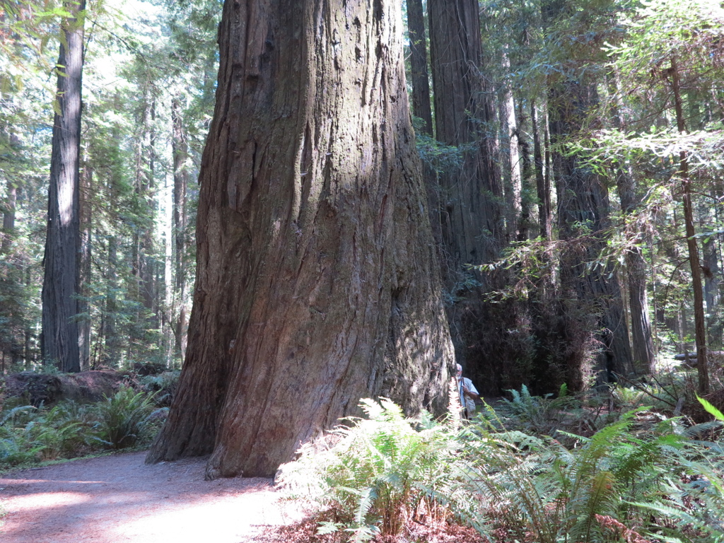
There’s a photographer hidden at the base of this sequoia

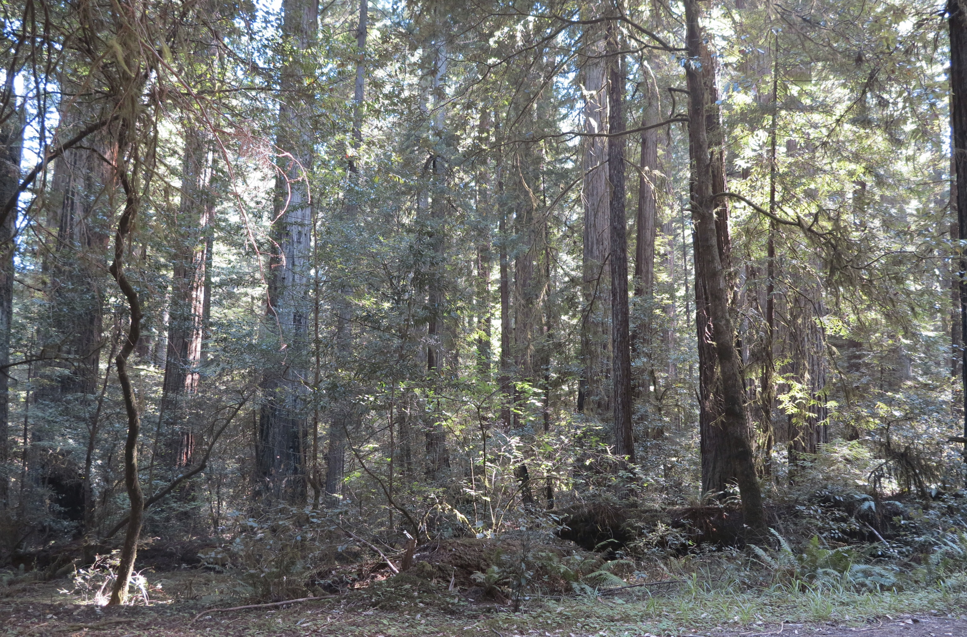
Looking at the forest AND the trees
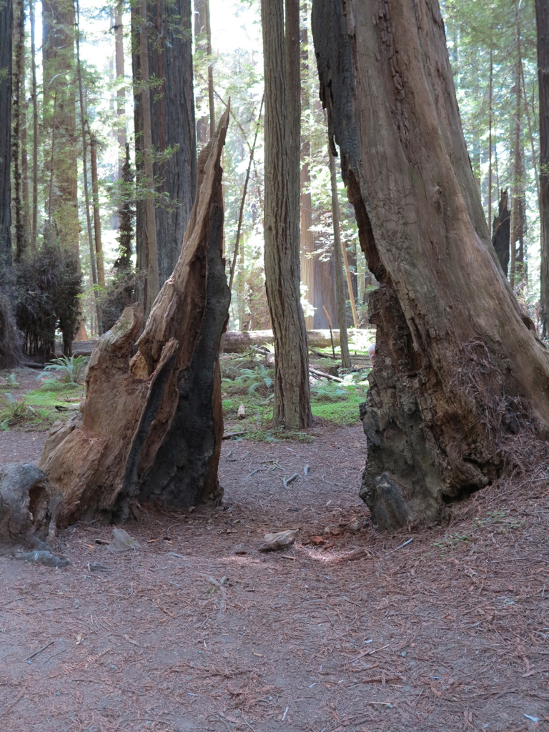
An old snag, with a new redwood growing beyond

Arla Donahew Celebrates the Big 100!

Folks came from far and near to celebrate long-time Society member Arla Donahew’s 100th birthday!

Her family came to celebrate (five generations!). There were colleagues from the Garden Grove Police Department, where she volunteers on Tuesday mornings and is famous for her home-made cookies, friends from the Senior Center, and old friends and neighbors from as far away as Seattle or as near as around the corner (yours truly). The parking lot of the Assistance League was packed!

Arla was born in St Paul, Minnesota on September 12, 1925. She moved with her family to the warm climate of Southern California as a girl, and moved to Garden Grove with her husband in 1955. She still lives in that same house, which is one block west of where a big orange grove once stood, now long since gone for houses.

Happy birthday from the Historical Society, Arla! Here are a few images from the celebration.

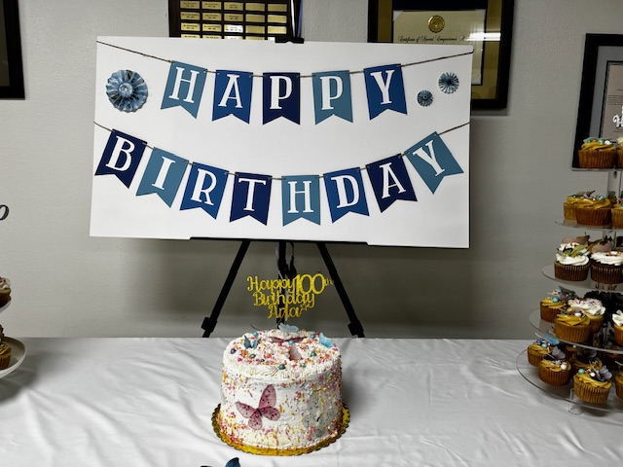

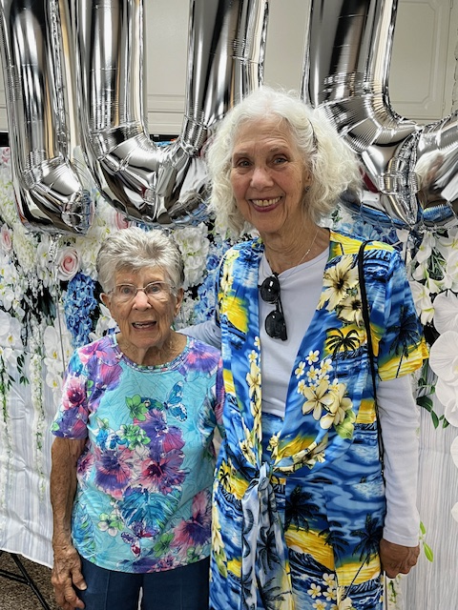
Arla and I in front of the “100” balloons

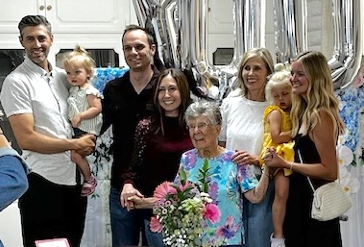
Arla and some of the family. Granddaughter Sue is behind her left shoulder
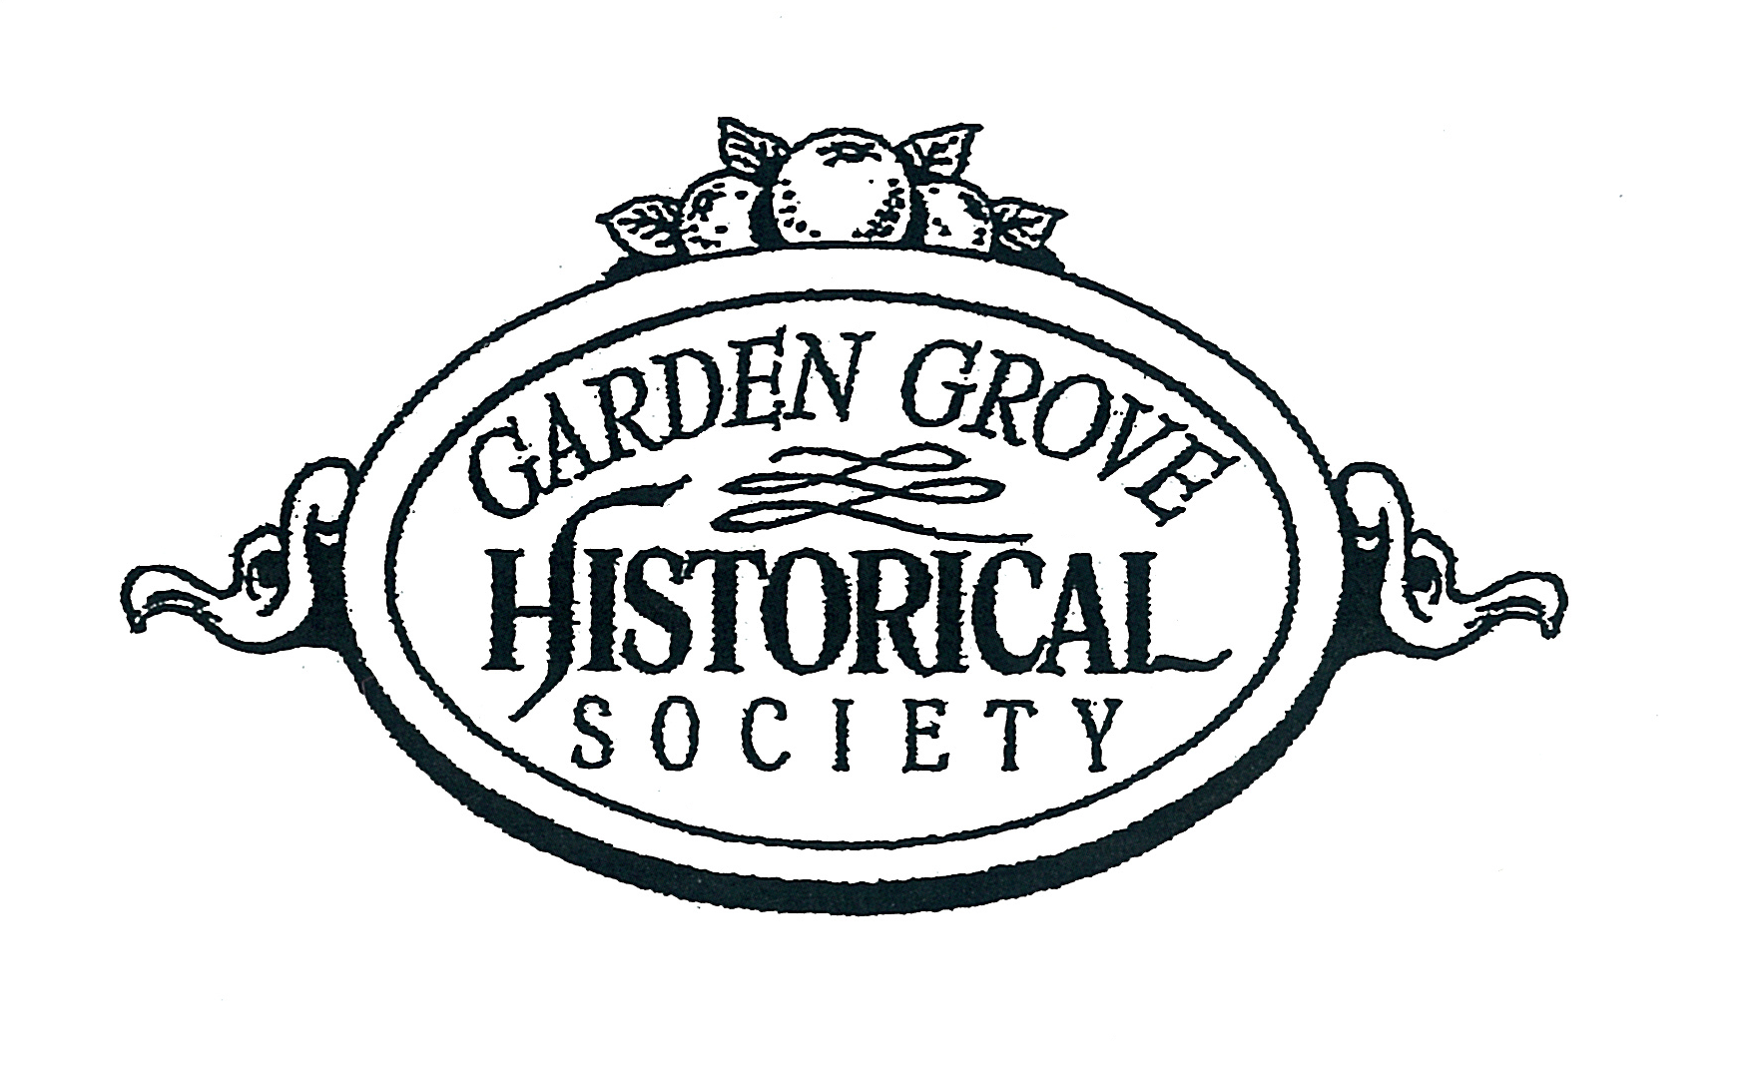
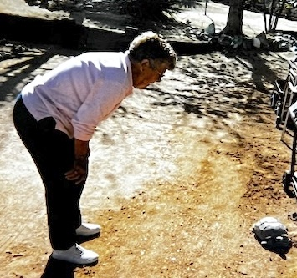
Visiting with a dessert tortoise at her home in Joshua Tree
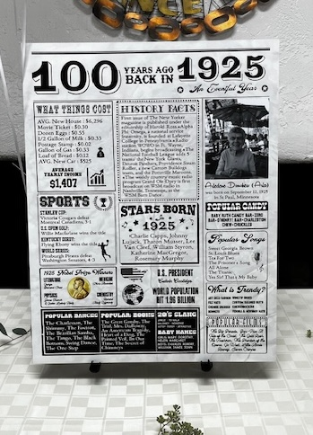
What else happened in 1925??

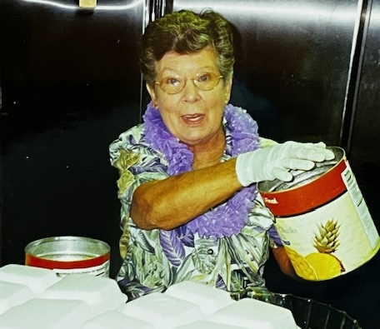
Doing prep work for a Hawaii-themed party

STANLEY RANCH MUSEUM TOURS

Tours begin at 1:30 PM on the first and third Sundays of the month.

Suggested donations are $5, and $1 for students under the age of 12.

Group tours for 8 or more can be scheduled Monday through Saturday by calling the office at (714) 530-8871.

MEMBERSHIP CATEGORIES

STUDENT $ 15
INDIVIDUAL $ 20
FAMILY $ 30
BUSINESS / ORG. $ 40
SUSTAINING $ 50
PATRON $ 100
LIFE $ 500
CENTENNIAL $1874

THE GARDEN GROVE HISTORICAL SOCIETY
12174 Euclid Street
P.O. Box 4297
GARDEN GROVE, CALIFORNIA 92843-4297

Board meetings are held on the fourth Tuesday of every month.


The Garden Grove Historical Society is a 501C(3) Non-profit organization founded in April 1966, and is not funded by any city, county, state, or federal agency. Our funding is from membership dues, fundraisers, and gifts of property or dollars. A charitable tax deduction is available for gifts

