Garden Grove Historical Society

Calendar of Activities

January

January 4: Public tour, 1:30 PM

January 18: Public tour, 1:30 PM.

January 27: Board meeting, 9:30 AM.

February

February 1: Public tour, 1:30 PM.

February 15: Public tour, 1:30 PM. This is also President’s Day weekend.

February 24: Board meeting, 9:30 AM.

March

March 1: Public tour, 1:30 PM.

March 15: Public tour, 1:30 PM.

March 24: Board meeting, 9:30 AM.

Next Barn Sale is April 23 through April 25. Contributions accepted; if the weather is bad, please bring stuff on our “volunteer days”, Tuesdays and Fridays.

MAIL: P.O. BOX 4297, Garden Grove, CA 92842 January 2026 Office Hours: Tuesday 9 - 12; Friday 9 - 1
LOCATION: 12174 Euclid Ave., Garden Grove, CA. Volume 58 Issue 1 Phone: (714) 530-8871
Established 1966 Editor – Barbara Gossett Email: gardengrovehistsoc@att.net

Dr Arthur A. Hansen
A Tribute

Orange County’s historical community lost one of its most vocal and gifted historians and history teachers when Dr. Arthur Hansen passed away on October 29. Dr. Hansen ( much better known to his students as “Art”) taught public history and Asian-American history at Cal State Fullerton (CSUF) for 43 years. He was the inspiration for many students [including me ~ ed.]. He was also an advocate for the Japanese-American community, working tirelessly to establish the Japanese-American Museum in downtown Los Angeles.

His work at CSUF also focused on oral histories. Many of the transcripts housed in the De Graaf Center for Oral and Public History at the school were done by Art’s students, having enrolled in his class on “Community History.” I first met him in that capacity while working to establish a small museum in the old oil town of Olinda; I enrolled the following semester, and unexpectedly learned that the focus of the next three years would be Garden Grove! There were quite a few oral histories collected during my time in the classes, ranging from members of the first churches in the village, to teachers, to former City employees. Two Society members who contributed oral histories were Terry Thomas and Lloyd Jones. Compact discs and typed transcripts are housed in our archives.

While Art took understandable pride in the community history work he did and inspired, I think his greatest satisfaction came from his efforts to bring to public awareness the grim history of the Japanese-American experience in the detention camps during World War II. He put tremendous effort into the founding of the Museum in LA, and also was a guiding light in creating the Nikkei Heritage Museum on the campus at CSUF. The museum opened in 2007 and hosted many fine exhibits; however, with Art’s retirement, the university scuttled the museum and it now exists as an “event space.”

Here’s a tribute which appeared in the Courier, newsletter of the OC Historical Society:

Dr. Art Hansen will be truly missed by all who knew him, including the Orange County historical community. His good work, however, will continue, through the oral history programs he started, through the interviews he conducted, through a library’s-worth of articles and books he wrote, and through the organizations he helped create and build. He will also live on through his students and their work, and through those who in turn, learned from his students.

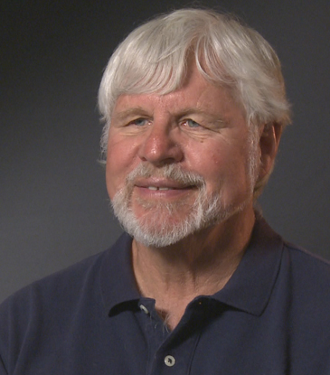

Dr Art Hansen in July, 2010. Photo from Densho.org

Recycling Tips

To Add to Your New Year’s Resolutions

The following is an entertaining as well as helpful reminder about what can and cannot be recycled when dealing with what’s left behind after opening the presents. If this is getting to you too late, save it for Christmas 2026!

Welcome to the Zero-Waste Christmas Party (Hosted by Your Recycle Bin!)

…in which every item in your house has shown up with something to say.

Meet the guests!
🎁 Cardboard Box
“Break me down before I break down!”
Strongest guest in the room. Here all season. Recycling Tip: Remove tape, flatten completely, and keep me dry. I’m one of the easiest holiday items to recycle.

✨ Ribbon
“I’m pretty, but I’m not recyclable.”
Shows up dressed in glitter and refuses to leave quietly. Recycling Tip: Keep me out of the recycling bin, but reuse me next year for gifts, crafts, or decor. I love a second chance.
📦 Bubble Wrap
“Pop me, then drop me (not in recycling).”
Everyone loves popping it… but it’s often tossed incorrectly. Recycling Tip: Take me to a soft-plastic drop-off (usually at grocery stores). Never place me with cardboard, I contaminate the batch.

🎄 Wrapping Paper
“If I’m shiny or glittery, I’m trash.”
The dramatic guest. Wants attention. Recycling Tip: Only recycle wrapping paper that passes the scrunch test: scrunch it into a ball; if it stays, it’s likely recyclable. Foil and glitter paper? Unfortunately not.
🥤 Eggnog Carton
“I’m recyclable… if you rinse me.”
The guest who needs a little help before being presentable. Recycling Tip: Rinse, cap on, then recycle. Most cartons are accepted by municipal programs now.
🥫 Glass Jar
“I’m the MVP. I last forever.”
The classy guest that can return to the party infinitely. Recycling Tip: Rinse and recycle, or reuse for holiday spices, sauces, or candle-making.

Colloquialisms from the 1880s
By Gerry Keesey Hoppe, printed in the Fedco Reporter in August, 1995. Thanks to Sara Otis for providing a stack of these clippings

When Englishman J.W. Morgan visited southern California in 1886, he kept notes on colloquial expressions and behaviors peculiar to the region. His observations were published in a book, California Impressions, #12, part of a series printed by the Santa Susana Press.

As a British tourist, Morgan had to learn various informal terms for U.S. money. A bit, he found, meant 12 ½ cents, and two bits referred to a 25-cent piece, but anyone asking for a short bit wanted 10 cents.

Someone described as “all wool and a yard wide” was a good fellow. A son of a gun or a curious cucumber was an odd person. Anyone called real cute was very knowing. Use of the term clever was a way of saying someone was foolish.

A rustler was not necessarily a thief of cattle or horses. He could be just an exceptionally hardworking fellow. Morgan observed that Americans as a group were great rustlers: characteristically so restless they seemed incapable of remaining still. Some houses had rocking chairs in every room, and men commonly rocked themselves as they discussed business.

“Men have a great habit of whittling,” Morgan wrote. “Their knives are constantly out, cutting up wood when seated or standing talking over any matter with you. If no wood is at hand, they cut at the seat they are sitting on.”

When Californians said “the thing will buzz,” they meant it was sure to succeed. Figure on it told you to estimate or rely upon something happening. Although grub meant food, anything grubby was dirty. When people mentioned a do, they were talking about the front steps of a house. Something done as hard as they can leave meant as fast as possible.

Morgan was boggled by expressions such as An old cuss, You will be a man now before your mother, Oh, mighty!, A whoop in hell, Like greased lightning and Great Scot! If he was told hitch on now, he knew he was being invited to come along. He quickly climbed on when someone called All aboard. Once arrived at the depot, he was sure to claim baggage by lending in his check. He marveled at a local religious sect called Hook and Eye because they would not use buttons on their clothing.

Morgan was charmed by California’s climate, that a morning rosebud could be in full bloom by noon. “People laugh at you if you say ‘A fine day!’ in the summer,” he wrote, “because all days are fine.”

Bolsa Grande High School Continues to Entertain

Once again, the Concert Choir from Bolsa Grande High School wowed the audience at the last (and only) general membership meeting of the year. Under the directorship of Emilio López Felix, the Choir sang a few old favorites with new arrangements, and many new, soon-to-be favorite carols.

The word is out: Emerson Hall is the place to shop after the concert. The singers and their families snapped up deals from holiday goodies and fine jewelry items that were still on display from our recent (and successful) Holiday Sale.

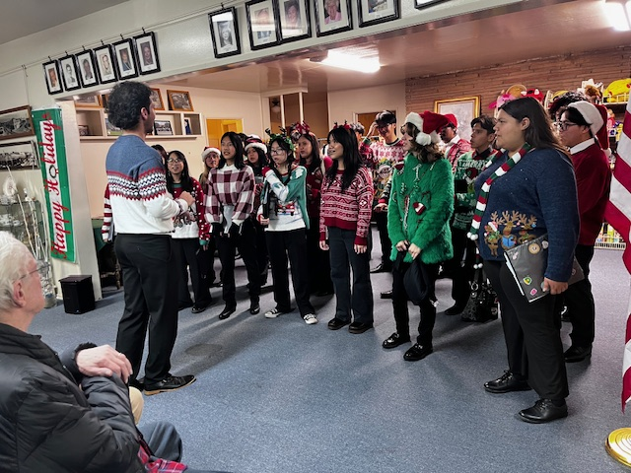
Director Emilio López Felix and the Choir

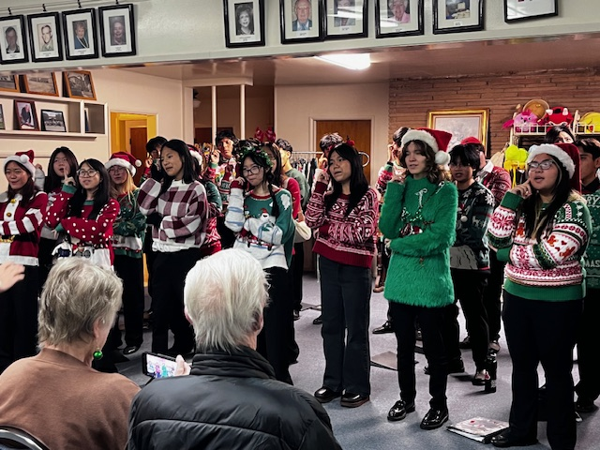

Many of the tunes involved memorizing dance moves in addition to the words and music. Lifetime members Sharon and Gary Sunda are enjoying the performance

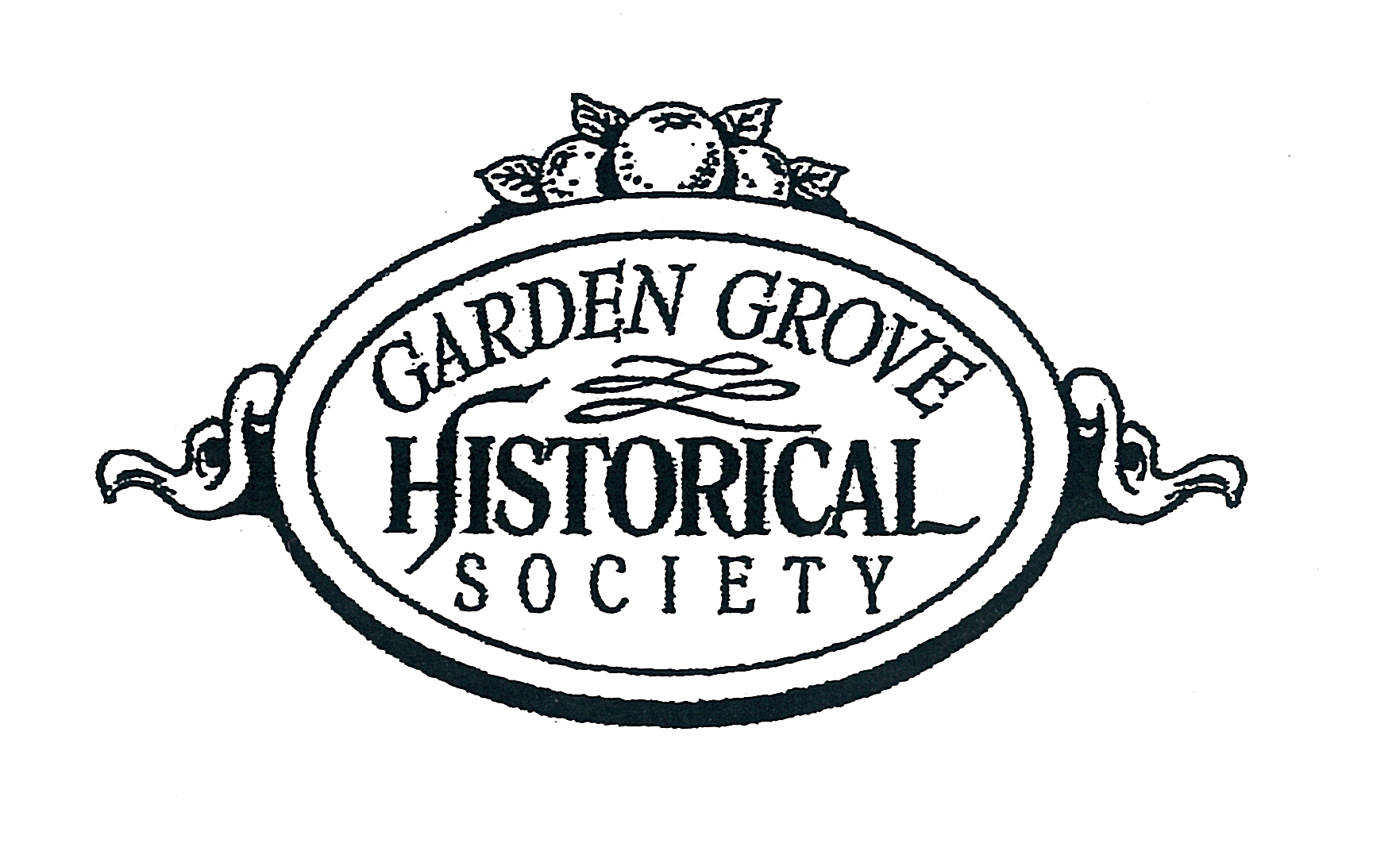

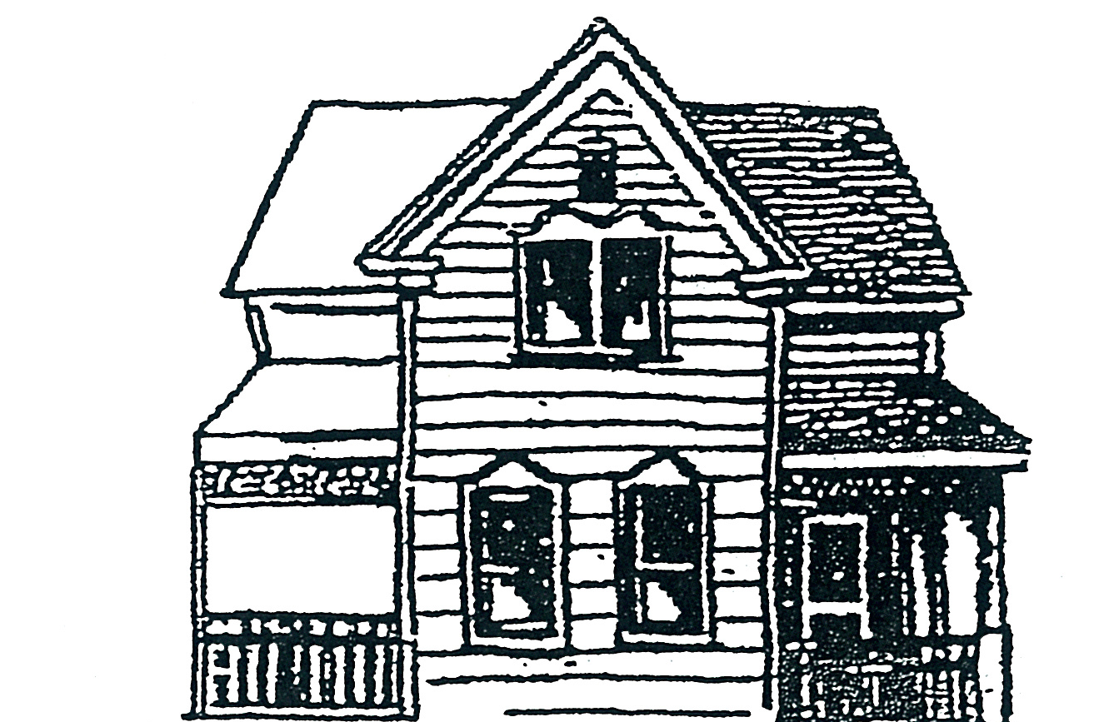

THE GARDEN GROVE HISTORICAL SOCIETY
12174 Euclid Street
P.O. Box 4297
GARDEN GROVE, CALIFORNIA 92843-4297

The Garden Grove Historical Society is a 501C(3) Non-profit organization founded in April 1966, and is not funded by any city, county, state, or federal agency. Our funding is from membership dues, fundraisers, and gifts of property or dollars. A charitable tax deduction is available for gifts

Board meetings are held on the fourth Tuesday of every month.
Volunteer days are Tuesdays and Fridays, 9 to 12

