Please return application to:
July 31ST 9am
50TH PINE VALLEY DAYS PARADE
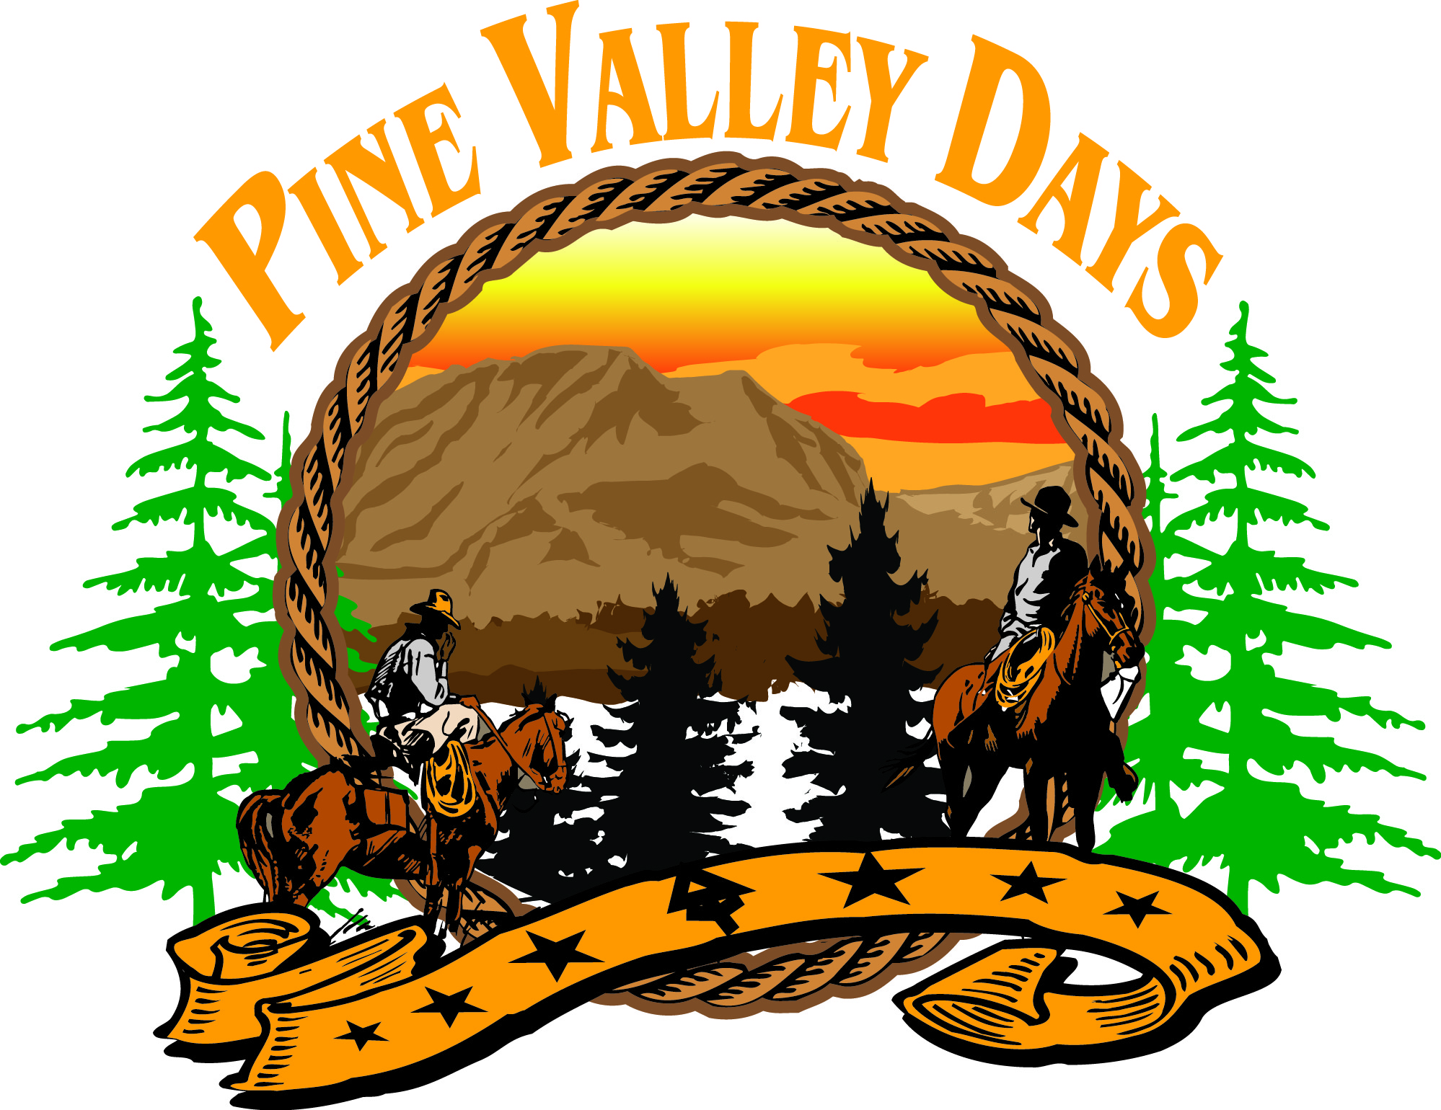

Marji Wilson
Phone: 619-861-1492
P.O.Box 62 Pine Valley, CA 91962
Email: pinevalleydaysparade@gmail.com
Contact Information
Name of Entry:
Contact Person:
How many people are in your group?_____________________________________________
Address:
Email:
Phone #:
Waiver of Liability
I/We agree to enter the Pine Valley Day’s Parade on July 30TH, 2021 with the understanding that The Mountain Empire Men’s Club and all parties involved will be held harmless of all loss, injury, and or damages resulting from participating in same including, pre-assembly, and post parade disbursement areas.
This will include all assignees and or agents of said sponsors, members, and directors of the above mentioned organization. If under 18yrs. old a parent or guardian must sign for child. NO ONE under 18 shall ride on an animal unless accompanied by an adult.
Signature of participant/ guardian
Childs Name

Please outline for us the script you would like the announcer to say about your entry.
Please send back application A.S.A.P.
Thank you so much for participating in the 50th Pine Valley Days Parade!
An email will be sent the week prior to the parade with lineup details. Lineup begins at 8am.

