You now have a new old stock next-gen RB5X and want to put it together. While you’re building, it’s important to remember these were made over 40 years ago!

Tools needed: small wrenches, Phillips and slot screw drivers, small sockets or nut drivers. A drill and bits will be needed when you start modifying the robot. List of parts you need to source and ideas and at the end.

Here is what you get from us. Some parts are old, and some are new!

Plus, this bracket, adapters and wheels. You will need to provide the coreless 360 degree servos.

Step One: Find this bracket and twist out the wheel adapters.

Step Two: Find the hub adapter and four countersunk 3mm screws and attach it to the adapter as shown.

Step Three: Locate the wheel and 4 6-32 slot head screws and nuts. Attach the adapter to the wheel as shown.

If the wheels you received have not been drilled, use a 5/16 bolt to center the adapter as shown and drill (4) 1/8 inch holes. Be sure they are centered in the webbing on the back of the wheel. Also make sure the ridge around the axle hole opening has been machined flush.

Repeat for the second wheel. (The plastic wheels are not perfect, but they will work great on this little robot).

Step Four: Mount the 2 continuous rotation servos you provided with 4 6-32 screws and nuts to the backet as shown.

Step Five: Install the wheels on the servo shaft with 1 screw each that came with the servos.

Step Six: Now we will install the caster wheels! You need to provide two 2 inch caster wheels (listed in suggested items). Included in the kit are 2 tubular adapters, 2 bolts and 2 lock washers. 6 flat washers are provided if you want to lower the caster wheels to limit the rocking, but they are not required. However, if you go too high, the robot may get hung up going over transitions in the floor. The height will vary depending on the robot’s environment.

Push the caster into the un-threaded end of the tube. You might need a little help with a hammer but be gentle. Then, line up the tube to one of the 2 holes and bolt it from the top with the lock washer under the bolt head. Tighten securely. Then repeat for the other caster. You can come back later and add flat washers if the robot rocks too much forward and back (picture shown with the flat washer spacers).

Now mount the drive assembly on the bottom plate with the two 8-32 nuts.

Step Seven: Now, we can install the skirt. Put the angle brackets onto the skirt with 6-32 nuts. *Hand-tighten the nuts.* Use the round hole-side of the angle bracket.

Now align the bracket’s elongated holes to the screw studs in the base. Add 6-32 nuts and tighten all 8 nuts now. The front is located where the large 1 ¼ inch hole for the wire to pass thru. The two small holes in the skirt are the front of the ring designed for the drive-up battery charger.

Flip it over and admire your work!

Step Eight: Attach the 4 aluminum uprights with (8) 6-32 nuts as shown. Yes, they are all the same. Hand tighten only for now.

Step Nine: Mount the blue bumper ring as shown below. Loosen or remove one upright to get the ring on. You may need to squeeze and pull a little on all pieces, as the ring is not always perfectly round. Once you get the ring on, add (8) 6-32 nuts,

Step Ten: install the battery box on the back of the control panel as shown on the left in the picture below(parts on the right for picture only). Do not overtighten these screws. Later you will drill holes for wires, add a strap to hold the battery(s) in, and add wiring, switches, and fuses (not provided in this kit). (Design subject to change)

Step Eleven: Attach the control panel to the back. The black one will hold two small automotive rocker switches, two fuse holders and a compartment for one or two 7.4 volt 2000 mah batteries. (see suggested material list)

Step Twelve: Now you need to attach the round plate to the top. Use (4) 6-32 screws that are 3/8 inch long. Might have to move things around a bit. Now double check the tightness of all fasteners.

Last step, install the three, yes, only 3 adapters as shown below on the inside of the body cylinder.

Now, drop the body cylinder over the top. You may need to squeeze or pull the body cylinder to be round. The body cylinder has pegs inside at the bottom that reset on the blue bumper ring. (zoom in the center opening) Once it is resting on the blue ring, rotate it clockwise from the top view. Now that is everything in the kit, your now on your own making it work as a robot. The 8 angle brackets below are for the switches for the contact bumpers once you source them.

**Now that your robot body build is complete, it’s time for some suggestions (parts not included).**

Get your 3d print files at thingiverse.com and print away. The cylinder pieces just snap in and connect the bumpers with 6-32 nuts. All the parts took less than half a roll of filament. No printer, no problem, try these guys (at your own risk), they have done a few thing for me. <https://craftcloud3d.com/> Also check with local library’s, schools, maker places, and someone said FedEx and UPS shipping stores?

Plastic installed. Something old, something new. These are made with a bone colored pla plus filiment. I print them standing up with the new experimental fuzzy option and tree supports to match the original pattern. Send us your pictures! Be sure to thank Kolbi for his fantastic design work, it’s amazing.

You can change all the inserts and bumpers. Any color you want or modify then in tinkercad or other 3d software. Go [www.thingiverse.com](http://www.thingiverse.com) and search for RB5X. Or, buy a 3D printer, you will never look back!

No printer, you can just buy a low-cost flexible cutting sheet in many colors and trim them to glue or tape inside the shell to cover the option’s openings.

How about a splash sheild from Tovolo? Make sure you get the large 13.5 inch one. It comes in blue, grey, and red. Barcode 47016-305 and 47005-200 and 47011-402

Or a clear domed viewing port for a Dog that mounts in a fence so he can see out. Maybe a plastic cake carrier lid. A clear candy bowl. Or ???

You can shop at Walmart for a cake carrier.

One of these https://www.walmart.com/ip/Better-Homes-Gardens-Round-Cake-Carrier-with-Clear-Plastic-Cover-13-Diameter-Dishwasher-Safe/626936773

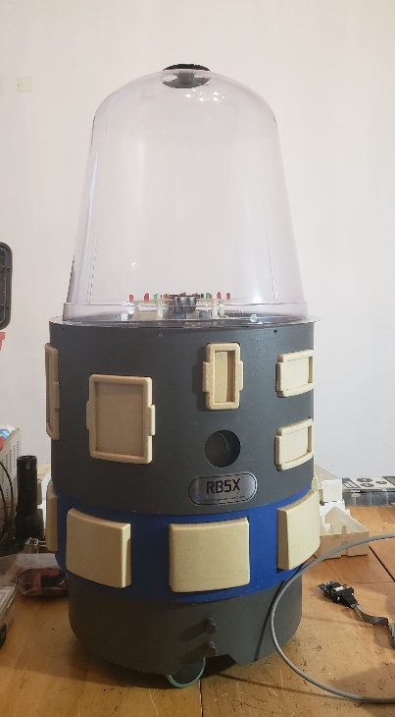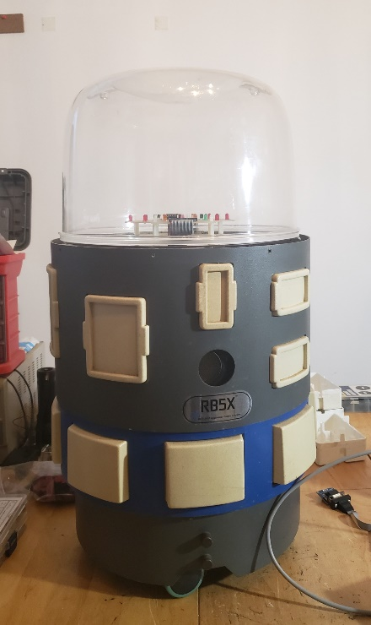

Going to Ikea? Parts number in Ikea talk “KRISPIG Cake carrier”

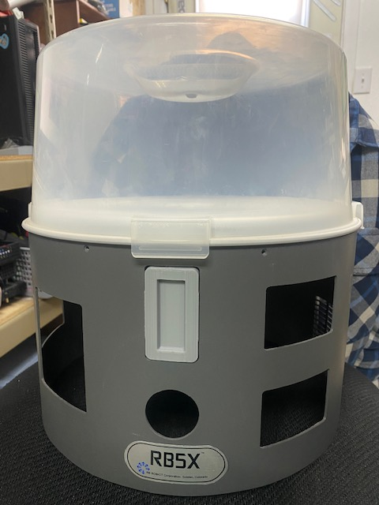

Send us your ideas to share with others! smallrobot@hotmail.com

Now, parts you need or can use to make this a working robot.

These are just easy suggestions! Amazon has been known for things to change without notice. And quality can suffer, read the reviews😊. I picked Amazon as it is sorta one stop and available anywhere. But there are many retailers with great stuff too, both brick and mortar, and online. From automotive, hobby shops, and robotics suppliers.

Pololu.com

Parallax.com

Robotshop.com

Ebay.com

Sparkfun.com

Adafruit.com

Jameco.com

Mcmaster.com

Digikey.com

Mpja.com

Mouser.com

Servocity.com

Cytron.io

Seeedstudio.com

Elecfreaks.com

ez-robot.com

and many many more!

So, the needed parts list begins. These are just suggestions. There is so many other ways to do this.

2 coreless continuous rotation servos 25-35 kg. The 25kg are faster than the oem RB5X motors the 35kg ones are the same speed, but with much more power.

[Amazon.com: Wishiot TD-8125MG 25KG Digital Servo 360 Degree Waterproof Large Torque Metal Gear for DIY Robot Robotic Arm RC Model PWM 500μs-2500μs : Toys & Games](https://www.amazon.com/gp/product/B08JCT4P3B/ref=ppx_yo_dt_b_search_asin_title?ie=UTF8&psc=1)

Or

[Amazon.com: Wishiot TD-8135MG 35KG 360 Degree Continuous Rotation Servo Digital Coreless 500μs-2500μs Large Torque Metal Gear for DIY Robot Robotic RC Model : Toys & Games](https://www.amazon.com/gp/product/B08JCVLSCK/ref=ppx_yo_dt_b_search_asin_title?ie=UTF8&psc=1)

2 inch office chair casters (find two on an old office chair?). Many options, but I have used these.

[Double Rhombus 2" Office Chair Caster Wheels Replacement, Set of 5 Heavy Duty Castors 11x22 mm Plug-in Stem 360° Rotation Quiet Smooth Rolling Universal Fit, 275-Lb Capacity, for Hardwood Carpet Floor: Amazon.com: Industrial & Scientific](https://www.amazon.com/gp/product/B0BG2K85G4/ref=ppx_yo_dt_b_search_asin_title?ie=UTF8&th=1)

Servo extension cables to get to the top platform. Some use different color wire, some you may need to trim the connector depending on what you’re connecting to. Breadboard jumpers are handy with your design work too.

[Amazon.com: Apex RC Products Futaba Style 24" / 600mm Servo Extension - 5 Pack #1021 : Toys & Games](https://www.amazon.com/gp/product/B074SYC9HM/ref=ppx_yo_dt_b_search_asin_title?ie=UTF8&psc=1)

[Amazon.com: EDGELEC 120pcs Breadboard Jumper Wires 10cm 15cm 20cm 30cm 40cm 50 cm 100cm Wire Length Optional Dupont Cable Assorted Kit Male to Female Male to Male Female to Female Multicolored Ribbon Cables : Electronics](https://www.amazon.com/EDGELEC-Breadboard-Optional-Assorted-Multicolored/dp/B07GD2BWPY/ref=sr_1_4?crid=KJ8WS5TKAMO9&dib=eyJ2IjoiMSJ9.V2RKJrLYX6VqVjMf8Hoi6B8UFYh98OmGlkXzgI3MhIT9i7FP8hWDcWd7nUWsAPlVk8u15o2ufG94aGcqrb_mQ6g60Ti5Qb0jo1BE8xJMypM3558-XqyAQUl84t5IbI3V_wbkyPBXQK_SksH8oxa3vyi2CB1IyViGIZZqrKq_duJpEAgG7MWRgtdRywxuQu-AUfoQ92pn7ol-bHeVjuLPFLtOymgxEBMzLtLwWwBgESI.wbagsT4tx-aymzxpAGY8kArinCUm5-wzYU5osBx7Gew&dib_tag=se&keywords=male%2Bto%2Bfemale%2Bjumper%2Bwire&qid=1711230389&sprefix=male%2Bto%2Bfemale%2Bjumper%2Bwire%2Caps%2C163&sr=8-4&th=1)

Switch(es) for the control panel. These fit the new back panel that is part of the kit. You only need two, but you can use them for later projects. A cheap step bit makes them a breeze to install for other projects. It’s hard to drill a square hole.

[Gadgeter 20 Pcs DC 12V 20A Amps SPST On/Off/ 2 Position Terminal Round Rocker LED Toggle Switch Blue & Red with 60pcs Nylon Female Fully-Insulated Quick Disconnects Car Auto Boat Snap Switch: Amazon.com: Industrial & Scientific](https://www.amazon.com/gp/product/B01LS1OYTW/ref=ppx_yo_dt_b_search_asin_title?ie=UTF8&psc=1)

Fuse holders for the control panel. Again, you only need 2, but you will need more in the future! You then need to visit the local auto parts for fuses with less amps, like about 3 amps, maybe 5amps if you’re going to ride around on the robot😊.

[MKBKLLJY 8Pcs Panel Mount Fuse Holder DC 12V AV250V Screw Cap Fuse Holders 5x20mm with Pre-Soldered Wires and Fast-Blow Glass Tube Fuses 10A x 8,15A x 8 - Amazon.com](https://www.amazon.com/gp/product/B0C6YJXBS4/ref=ppx_yo_dt_b_asin_title_o00_s00?ie=UTF8&psc=1)

7.4 volt 2000mah battery(ies) with charger, two will allow you to separate the motors from the electronics. These are nice, they fit in our battery compartment, and the come with two chargers. You can charge them in the robot or swap them as needed. All depends on your needs. Runs a long time even when running the motors a bunch.

[Amazon.com: URGENEX 7.4V Li-ion Battery 2000mAh 2S Battery with SM 2P Plug High Capacity for Remote Control RC Boat 2 Pack H101 RC Batteries with 2 USB Chargers : Toys & Games](https://www.amazon.com/gp/product/B08XZP4CDJ/ref=ppx_yo_dt_b_search_asin_title?ie=UTF8&psc=1)

Pigtails for the batteries. (check the polarity, some can be backwards!). Check that red goes to red before connecting!!!!!

[Amazon.com: Gikfun JST SM 2-Pins 2P Female & Male Plug Connector Wire Cables for Arduino (Pack of 10 Pairs) AE1045 : Electronics](https://www.amazon.com/Gikfun-2-Pins-Female-Connector-Arduino/dp/B01EJI8TQK/ref=sr_1_1_sspa?crid=ZOCJBUOGXFC5&dib=eyJ2IjoiMSJ9.Qvvv35lzNnWB9ytn9xOk2IGBC9quIDkxf46R__1ODgKrSsxrjiQFs8r3Hl-i_w43BUcYGMUSKc8HcWj9_gHulBxtU8uH5z4Lp3XG0xmdwnzsVaDMLYe5L7qOzFOmHDCjgoWmr8MkFWLBBLfhgDeT4qpvjRgn0RnnL_kDt5Sz0BwUYSIjMws0mQ0-KT--CWz_LzgY_hibijuzrzdlqa16pgnWCY0vykpvKnnK1oAUx9xyK9hv7Yn63fErEZjA95El46ypNOfOQft9lkBq6um0d3wdO8TK-QUcyKbKq0uHeVg.xMIvAZTKPWP_NIw_nuWpifRw8qTFAHpC7PkLzQ4g3m4&dib_tag=se&keywords=jst+sm+2+pins+plug+male+and+female&qid=1711231804&s=electronics&sprefix=jst+sm+2+pins+plug+male+and+femal%2Celectronics%2C160&sr=1-1-spons&sp_csd=d2lkZ2V0TmFtZT1zcF9hdGY&psc=1)

Bulk wire and connectors.

[18 awg Wire,18 awg PVC Electrical Wire -SCHDRA UL1007 18 Gauge Tinned Copper Wires(6 Colors 10ft Each Color)(OD: 2.0 mm),Stranded Wire-for Electronics, DIY Projects, Automotive Wiring: Amazon.com: Tools & Home Improvement](https://www.amazon.com/gp/product/B0C7T5H9DP/ref=ppx_yo_dt_b_search_asin_title?ie=UTF8&th=1)

If you do not have crimpers and connectors, something like this is useful, but you will mostly use the red terminals. Might check at your local discount store or automotive supply. You also can solder things, might be a good time to learn?

[Tnisesm 300Pcs Insulated Wire Electrical Connectors with Professional Wire Stripper/Wire Crimping Tool, Wire Cutter, Wire Crimper, Cable Stripper, Wiring Tools and Multi-Function Hand Tool: Amazon.com: Industrial & Scientific](https://www.amazon.com/Tnisesm-Electrical-Connectors-Professional-Multi-Function/dp/B0CNX2S42Y/ref=sr_1_29?crid=2BX3SQEIH759H&dib=eyJ2IjoiMSJ9.mKySplX6vsxVzCg71THf2V2hZR-kZ587GkgNXkQJ5qzIUOJWCklRw-eXlYeMa3Ma76X3w4atcLGulFhsgp6nWnh5Mb_thh1hDJ-ZJWgNh3g.Lg1kHDgmIwbqllxyqvbG-iYe3wvMHJtuII3n7o_qf3Y&dib_tag=se&keywords=automotive%2Bwiring%2Bconnectors%2Bwith%2Bcrimper&qid=1711232042&s=industrial&sprefix=automotive%2Bwiring%2Bconnectors%2Bwith%2Bcrimper%2Cindustrial%2C147&sr=1-29&th=1)

These are nice for an Arduino or other carrier boards for microcontrollers.

[Amazon.com: DAYKIT 10 Pairs 12V Male+Female 2.1x5.5MM DC Power Jack Plug Adapter Barrel Connector for CCTV Security Camera Led Strip : Electronics](https://www.amazon.com/DAYKIT-Female-2-1x5-5MM-Adapter-Connector/dp/B01J1WZENK/ref=pd_bxgy_d_sccl_1/138-8723370-1368527?pd_rd_w=FOMeF&content-id=amzn1.sym.9713b09e-9eac-42a7-88bb-ecfe516a6b92&pf_rd_p=9713b09e-9eac-42a7-88bb-ecfe516a6b92&pf_rd_r=5X2PMCQ3Q6VW64B6SYJR&pd_rd_wg=RU3Xv&pd_rd_r=542c6671-e165-40dc-836f-3985f74140a5&pd_rd_i=B01J1WZENK&psc=1)

Switches for the bumpers or ir sensors? Your choice. These ir sensor can be connected in parallel to use one microcontroller pin! You can custom build a 3d bracket to shine to the inside of the bumper?

[Amazon.com: Frienda 20 Pieces IR Infrared Obstacle Avoidance Sensor Module 3-Wire Reflective Photoelectric Sensor Module Compatible with Arduino/Raspberry Pi 3/Smart Car Robot : Electronics](https://www.amazon.com/gp/product/B08DR1W3BK/ref=ppx_yo_dt_b_search_asin_title?ie=UTF8&psc=1)

The original switches are hard to find and very costly. Something like this works, but you will need to thread the brackets and such. If anyone finds something that is an affordable exact replacement, let me know. (see below for instructions)

[Gebildet 12pcs 7mm 3V-6V-12V-24V-230V/1A Prewired Mini Momentary Push Button,SPST Nomal Open ON/Off 2 Pin Round Button for Model Railway Hobby: Amazon.com: Industrial & Scientific](https://www.amazon.com/dp/B0CJHXJWN3/ref=sspa_dk_detail_0?pd_rd_i=B083JWJPW5&pd_rd_w=Jczni&content-id=amzn1.sym.f734d1a2-0bf9-4a26-ad34-2e1b969a5a75&pf_rd_p=f734d1a2-0bf9-4a26-ad34-2e1b969a5a75&pf_rd_r=78G5M41KM9QP8FW3N9CN&pd_rd_wg=jjOmu&pd_rd_r=1aeec35c-0812-4d6f-a718-25b181fc5e66&s=industrial&sp_csd=d2lkZ2V0TmFtZT1zcF9kZXRhaWw&th=1)

If you need other voltages, this is a nice product. Works fine with the 7.4 volt battery. Same power plug as many other boards.

[Amazon.com: DGZZI 2PCS 12 V to 3.3 V / 5 V / 12 V DC-DC Voltage Converter Multi-Output Step-Down Power Supply Module for Arduino : Electronics](https://www.amazon.com/gp/product/B07RKMZY8S/ref=ppx_yo_dt_b_search_asin_title?ie=UTF8&psc=1)

Come back often for updates! Also, share anything you want to add!

So, how do you control the robot? Suggestions range from Ardinuo, Raspberry Pi, Micro:bit, ez-robot, radio control, and many many others. I would suggest to start with what you know. If you’re really new the neat part about this kit is any book, kit, or website that uses servos will adapt!

Possible books, websites, and magazines to start with:

My first suggestion is if you’re a total newbie to any of this. These will work with very little changes and some of the best instructions out there:

[cyber:bot Tutorial Series | LEARN.PARALLAX.COM](https://learn.parallax.com/tutorials/series/cyberbot-tutorial-series?_ga=2.85088412.483354732.1711232651-1335291254.1703190338)

[Robotics with the Board of Education Shield for Arduino | LEARN.PARALLAX.COM](https://learn.parallax.com/tutorials/robot/shield-bot/robotics-board-education-shield-arduino?_ga=2.192501935.483354732.1711232651-1335291254.1703190338)

[ActivityBot with C Tutorials | LEARN.PARALLAX.COM](https://learn.parallax.com/tutorials/series/activitybot-c-tutorials?_ga=2.91927071.483354732.1711232651-1335291254.1703190338)

I like the Cyberbot as it has the most built in sensors, most i/o pins, but your milage may vary. You can also control it with another Micro:bit.

Most anything by Gordon McComb

[How to Make a Robot: McComb, Gordon: 9781680454697: Amazon.com: Books](https://www.amazon.com/How-Make-Robot-Gordon-McComb/dp/1680454692/ref=sr_1_4?crid=32R2WFU4PQR63&dib=eyJ2IjoiMSJ9.rBoaAiBJxm7xUDYWTldME12gUhondPFp2T2gsGfbzuN-0I89DPSBsG-La9k8XXb9Q_0Yuukue6ewVQqSVOw1xHrxUidQOk867CVGd3g8z5bUXRtp72GESjRCIvqAq_Hr6nuls8pgjLy12MCtEOWHWb-1Yp9TwNbTcyXfMkMzHtpW-EvhHCYh-O96rYZZZvA2abm4xnOYisA0h2VsdFK16ahMm3yaziUSX_3D0FI-y1A._e8dxLx389Yo8xpUC-WkPZqEePELwnIbQ64Pe1LPqys&dib_tag=se&keywords=gordon+mccomb+arduino&qid=1711234814&sprefix=gordon+mccomb+ardino%2Caps%2C160&sr=8-4)

For those interested in the Raspberry PI family. The pico w is very affordable. The large PI series is very powerful.

[Amazon.com: Robotics at Home with Raspberry Pi Pico: Build autonomous robots with the versatile low-cost Raspberry Pi Pico controller and Python: 9781803246079: Staple, Danny: Books](https://www.amazon.com/Robotics-Home-Raspberry-Pico-autonomous/dp/1803246073/ref=sr_1_8?crid=1UXWN9CEPD5P&dib=eyJ2IjoiMSJ9.9l-xQGzPv6g9Yhn_2CxobTdVHCqowkdnC5T31K2CRIOmGBvYWsHbMp1t2C9GeqBTIjDnKI4QQeu5XTVjiIJfLvtDwVqrOwrqWiTpTTm_DRqJP2yyzGWzc6cozSIzI7rw-gPEE-x7BC7qZOhnlULv6hqT3Xgupt09RdHCo03vRKYUOsB2jmqLxPNUN4KtsszgL3oP-Q2XdNxePVR_rWfiSPMkgHU7IiZQMii7pICMFx8.PSO2KhAVKLx2MramP9-540zSxmjl4ha94fMeJxIZUis&dib_tag=se&keywords=raspberry+pi+robot+book&qid=1711234848&sprefix=raspbery+pi+robot+book%2Caps%2C174&sr=8-8)

[Learn Robotics Programming: Build and control autonomous robots using Raspberry Pi 3 and Python 1, Staple, Danny, eBook - Amazon.com](https://www.amazon.com/Learn-Robotics-Programming-autonomous-Raspberry-ebook/dp/B07DT9R42B?ref_=ast_author_dp)

Most anything by Simon Monk

[Arduino + Android Projects for the Evil Genius: Control Arduino with Your Smartphone or Tablet, Monk, Simon, eBook - Amazon.com](https://www.amazon.com/Arduino-Android-Projects-Evil-Genius-ebook/dp/B006L65MSM/ref=sr_1_13?crid=3Q6Y0L94AN8H1&dib=eyJ2IjoiMSJ9.7NDLfRIBUvC5n__PucrHmeAc5ZgEOdHdedlbjKLQCxofKNbR_qqyh6OEfw5VR4U33si_K8k8gs3mlVHT4w63I6wph3ktbDVqRSd6O7QLha5EVJWlZxa9HbNrZfpx-Oo2OLY49gR636cOTmZJ4ohWlZa6cNzxDmdrv34VnrdbyM27brPCevqAAF29uC_NSYh5IqzmQDeYlVPYAQDt898UQ_zUoWoXcBE3Q7EWNJ2IjxA.dLZgNR4m1596-hpAiBUzWhe_c6ZN5_5ox-GibmlRFhU&dib_tag=se&keywords=simon+monk+robot+books&qid=1711235387&sprefix=simon+monk+robot+books%2Caps%2C192&sr=8-13)

Magazine

[Servo Magazine - Covering the world of personal robotics | Servo Magazine](https://www.servomagazine.com/)

Switches for the 3d printed bumpers. The originals, if you can find them can be over $20 each! It’s been 40 years. But, the cure is very cool. But you will need a rare tap. 7mm x .75. It is not found in a standard set of metric taps and dies. But, Amazon does sell them. This is the one I bought, but you do not need the die, just a tap.

[Amazon.com: uxcell M7 x 0.75mm Metric Tap and Die Set, Machine Thread Screw Tap with Round Threading Die, Tap & Die Kit for Nut Screw Bolt Thread Repair : Industrial & Scientific](https://www.amazon.com/dp/B098K4J5FK?ref=ppx_yo2ov_dt_b_product_details&th=1)

These are the switches. They also come in different colors and some without wires. The wires are a nice time saver!

[Gebildet 3V-6V-12V-24V-230V/1A 10pcs 7mm Black Prewired Mini Momentary Push Button,SPST Nomal Open ON/Off 2 Pin Round Button for Model Railway Hobby: Amazon.com: Industrial & Scientific](https://www.amazon.com/gp/product/B0CJHXJWN3/ref=ppx_yo_dt_b_search_asin_title?ie=UTF8&th=1)

Tap the hole in the 8 bumper brackets. Its already the correct size.

Now, just screw the switch in snug as shown. Leave the nut and lock wash on the switch as a spacer. Add a ring terminal to ground the switch if that is the logic you are using with your microcontroller. Be sure to ground the metal plate to your battery ground on the rear panel.

Now install the 8 switches and ground them with the 6-32 nuts. Test the clearance. This should get you just the right amount. If you want them to ground/react quicker, you can move them in with the slotted bracket before tightening them. But all the way back works fine. Now you can monitor 8 bumpers or tie them all together using only one pin on your controller. Or pair them up front and back or??? Your software logic should tell you which direction you were traveling in any way!

Run power to the top.

Here we have the custom rear panel. The switches push in from the front, the fuse holders attach with a nut on the back and the screw in the middle with a nut is the ground point.

This is the rear view

Now we need the battery box.

Drill holes as shown or any other way depending on your battery choice. This is for the 7.4 battery. You can install two if you want.

Screw the battery box to the back on the panel as shown. Do not over tighten the screws.

Find the small bungee cord.

Install the bungee as shown. This is for one battery, if you’re going for two batteries, just skip the center hole.

Battery installed as shown, run the supply line out the large hole. Leave the charge connection available to recharge the battery.

Now for the wiring. You will need female spade, small ring, and butt connectors for 18 ga wire. You will need the correct power cord for your microcontroller. This one is common for several. Also, the correct connector for your battery choice.

Now make sure there is a correct size fuse in your fuse holder. The second switch and fuse holder are for a second battery if you chose, it will connect the same way but on the left.

Now you’re all ready to power up your controller and servo motors.

Soon we will install a controller, connect the servo motors, and the bump switches.